Software Requirements Specification
for
AI Career Guidance and Skill Recommendation System
Version 1.0 approved
Prepared by the Project Team
Department of Computer Science and Engineering
September 2026

Table of Contents
Table of Contents ii
Revision History ii
1. Introduction 1
1.1 Purpose 1
1.2 Document Conventions 1
1.3 Intended Audience and Reading Suggestions 1
1.4 Product Scope 1
1.5 References 1
2. Overall Description 2
2.1 Product Perspective 2
2.2 Product Functions 2
2.3 User Classes and Characteristics 2
2.4 Operating Environment 2
2.5 Design and Implementation Constraints 2
2.6 User Documentation 3
2.7 Assumptions and Dependencies 3
3. External Interface Requirements 3
3.1 User Interfaces 3
3.2 Hardware Interfaces 4
3.3 Software Interfaces 4
3.4 Communications Interfaces 4
4. System Features 4
4.1 User Registration and Profile Management 4
4.2 Skill and Interest Assessment 5
4.3 Career Recommendation Engine 6
4.4 Skill Gap Analysis and Resource Recommendation 7
4.5 Progress Dashboard 8
4.6 Administration Panel 8
5. Other Nonfunctional Requirements 9
5.1 Performance Requirements 9
5.2 Safety Requirements 9
5.3 Security Requirements 9
5.4 Software Quality Attributes 10
5.5 Business Rules 10
6. Other Requirements 11
Appendix A: Glossary 12
Appendix B: Analysis Models (Data Flow Diagrams) 12
Appendix C: To Be Determined List 15

Revision History
Name | Date | Reason For Changes | Version
Project Team | 05-Sep-2026 | Initial draft – scope and stakeholder notes | 0.1
Project Team | 08-Sep-2026 | Added functional requirements and use cases | 0.2
Project Team | 10-Sep-2026 | Added data flow diagrams and business rule table | 0.9
Project Team | 10-Sep-2026 | Reviewed draft, ready for submission | 1.0

1. Introduction

1.1 Purpose
This document is the Software Requirements Specification (SRS) for the AI Career Guidance and Skill Recommendation System, referred to throughout as ACGSRS, version 1.0. It is written for the software engineering course project and gives the development team, the course instructor, and any future maintainer a single, agreed-upon description of what the system is supposed to do before design and coding begin. It covers the complete system as planned for this semester; no sub-system has been split out separately.

1.2 Document Conventions
Requirement statements use “shall” to indicate a mandatory requirement and “should” to indicate a desirable but non-mandatory one. Each functional requirement is tagged with an identifier of the form FR-<module>-<number> (for example, FR-REG-02) so it can later be traced to design elements and test cases; non-functional requirements use the tag NFR-<number> and business rules use BR-<number>. Priority is expressed on a three-point scale – High, Medium, Low – and, unless a lower-level requirement states otherwise, it inherits the priority of the feature it belongs to.

1.3 Intended Audience and Reading Suggestions
This document is intended for four groups of readers: the student development team, who will use Sections 3 and 4 as the basis for module design; the course instructor/evaluator, who is likely to focus on Sections 1 and 2 to judge whether the scope is realistic; testers (usually the same team wearing a different hat), who will derive test cases from Section 4; and any future student who continues this project, who should start from Section 2 for context before moving into the detailed requirements. Readers who want a quick sense of what the system does can read Section 2.2 and then skip to Appendix B for the data flow diagrams.

1.4 Product Scope
Choosing a career path and figuring out which skills to learn next is something most engineering students struggle with, largely because the advice available to them is scattered across YouTube videos, senior students’ opinions, and generic online articles that do not account for a student’s actual academic record or interests. ACGSRS narrows this gap on a small scale by building a web application that collects a student’s academic background, interests, and self-rated skill levels; scores a short list of candidate careers using a rule-based filter followed by a lightweight machine-learning ranking step; identifies the gap between the student’s current skills and what the recommended track typically needs; and points to specific, curated learning resources to close that gap. The system is a proof-of-concept for academic evaluation, not a replacement for a professional career counsellor, and this limitation is stated to the user inside the application itself.

1.5 References
- IEEE Std 830-1998, IEEE Recommended Practice for Software Requirements Specifications.
- Sommerville, I., Software Engineering, 10th Edition, Pearson – general SRS structure and terminology.
- Internal meeting notes and student survey responses collected by the project team, August–September 2026 (unpublished).
- Publicly available documentation of O*NET Online, used only as a reference for how career-to-skill mapping is typically organised, not copied directly.

2. Overall Description

2.1 Product Perspective
ACGSRS is a new, self-contained web application; it does not replace or integrate with any existing college system such as the ERP or the placement portal, mainly because access to those systems was not available to a student team within the project timeline. The application follows a fairly standard three-tier architecture: a React front-end through which students fill in the assessment and view recommendations; a Flask (Python) back-end that runs the recommendation logic, handles authentication, and exposes REST endpoints; and a MySQL database that stores user profiles, assessment responses, the career-skill mapping reference data, and the curated resource list. The recommendation logic itself is a hybrid: a rule-based filter (Section 5.5) narrows down candidate careers using hard constraints, after which a scikit-learn classifier trained on a small labelled dataset ranks what remains – a pure ML approach was rejected because the training data available for a course project is too small to trust a model in isolation.

2.2 Product Functions
At a high level, the system performs the following functions; details for each are given in Section 4.
- Account registration and login for students, with a separate login for the admin/faculty role.
- A guided, multi-step skill and interest assessment form.
- Career track recommendation with a short explanation of why each track was suggested.
- Skill-gap analysis comparing the student’s current skill ratings against the target profile for the recommended track.
- Personalised learning resource suggestions mapped to the identified gaps.
- A dashboard where the student can see past assessments and track improvement over time.
- An admin panel where the faculty coordinator can update careers, skills, and resources without touching the code.
Appendix B contains a top-level data flow diagram that shows how these functions relate to one another and to the underlying data stores.

2.3 User Classes and Characteristics
User Class | Description | Technical Skill Expected
Student (primary user) | Engineering/degree student seeking career direction and a personalised skill plan. | Basic – comfortable using any typical web form or app.
Faculty / Placement Coordinator (admin) | Maintains the career-skill reference data and can view aggregate, anonymised statistics about students’ chosen tracks. | Basic to moderate – needs to fill spreadsheet-like admin forms.
Guest visitor | Anyone browsing the site before creating an account; can view sample career descriptions but cannot take the assessment. | None.

2.4 Operating Environment
- Client side: any modern browser (Chrome, Firefox, Edge) with JavaScript enabled; the layout is responsive down to a typical mobile width, though the project focuses on desktop/laptop use since that is how most students access it during lab hours.
- Server side: the prototype is deployed on a single low-cost cloud instance (or run locally for demonstration) with Python 3.11 and MySQL 8.
- No native mobile application is planned for this version.

2.5 Design and Implementation Constraints
- The project must be completed within a single academic semester by a team of three to four students, which limits how much “nice to have” functionality (Section 4, Low-priority items) can realistically be finished.
- The recommendation model is trained on a small, self-collected dataset; predictions are indicative rather than authoritative, and the UI communicates this to the user.
- No paid third-party APIs are used, since the team has no budget for this course project; external reference data is added manually rather than fetched live.
- The system must run within the free tier of the hosting service chosen for demonstration, which limits concurrent users to roughly 20–30 during a class demo.

2.6 User Documentation
A short in-app help panel (accessible from every screen) covers how to fill in the assessment, how to read the recommendation explanation, and how the confidence label in Section 4.3 should be interpreted. A one-page “Getting Started” PDF is produced alongside the source-code submission for the course evaluator; no separate printed manual is planned, since the target users are expected to be comfortable with typical web applications.

2.7 Assumptions and Dependencies
- It is assumed that students will answer the self-assessment questions reasonably honestly; the system has no way to independently verify a student’s actual skill level.
- It is assumed that the list of careers and skills curated for the prototype (roughly 12–15 career tracks) is broad enough to be useful for a general engineering audience, even though it does not cover every possible profession.
- The project depends on the continued free availability of the open-source libraries used (Flask, scikit-learn, React); none of them carry licensing terms that would restrict use in a student project.

3. External Interface Requirements

3.1 User Interfaces
- A landing page describing the project and its limitations (Section 1.4), with links to register or log in.
- A multi-step assessment wizard with a visible progress indicator (e.g., “Step 3 of 5”).
- A results page presenting recommended careers as cards, each expandable to show the reasoning and target skill profile.
- A dashboard page combining the skill-gap list, resource list, and a simple progress chart.
- A separate, simpler admin interface (data tables and forms) that does not need to match the polish of the student-facing pages, given the limited time available for UI work.
Wireframes for these screens were sketched by hand during planning and are kept in the team’s shared drive rather than reproduced here, since they are expected to change once usability feedback is collected from a small group of test users.

3.2 Hardware Interfaces
None beyond a standard computer or laptop capable of running a modern browser. The system does not interact with any specialised hardware.

3.3 Software Interfaces
Interface | Purpose
MySQL 8 database | Persistent storage for users, assessments, career-skill mappings, and resources.
Flask REST API | Exposes endpoints consumed by the React front-end (e.g., /api/assessment, /api/recommendations).
SMTP email service (college mail relay or a free-tier provider) | Sends password-reset emails and, optionally, a weekly reminder to revisit the assessment.
scikit-learn model file | Loaded by the back-end at startup to score candidate careers for a given assessment.

3.4 Communications Interfaces
All communication between the front-end and back-end uses HTTPS with JSON payloads. No other network protocol is required for this project.

4. System Features
The functional requirements are organised by system feature, which was the most natural grouping for a project of this size. Each feature below states its priority, the stimulus/response behaviour a user would notice, and the itemised functional requirements behind it.

4.1 User Registration and Profile Management
4.1.1 Description and Priority
A student needs a persistent identity in the system so assessment history and recommendations can be saved and revisited rather than lost when the browser tab closes. Priority: High.
4.1.2 Stimulus/Response Sequences
- Visitor submits the registration form → system creates the account and redirects to the assessment.
- Registered student submits login credentials → system authenticates and opens the dashboard.
- Student requests a password reset → system emails a time-limited reset link.
4.1.3 Functional Requirements
ID | Requirement | Priority
FR-REG-01 | The system shall allow a new student to register using name, college email address, branch, and year of study. | High
FR-REG-02 | The system shall verify that the email address is unique before creating the account. | High
FR-REG-03 | The system shall allow a registered student to log in using email and password. | High
FR-REG-04 | The system shall allow a student to edit their profile details (branch, year, interests) after registration. | Medium
FR-REG-05 | The system shall allow a student to reset a forgotten password via an emailed reset link. | Medium
FR-REG-06 | The system should allow login using a college Google account (OAuth), to save the student from creating a new password. | Low

4.2 Skill and Interest Assessment
4.2.1 Description and Priority
The recommendation engine is only as good as the input it receives, so the assessment form is the single most important screen in the application from a data-quality point of view. Priority: High.
4.2.2 Stimulus/Response Sequences
- Student starts the assessment → system presents Step 1 of the wizard and saves progress after every step.
- Student submits the final step → system validates completeness and timestamps the submission.
4.2.3 Functional Requirements
ID | Requirement | Priority
FR-ASM-01 | The system shall present the assessment as a multi-step form covering academic background, interest areas, and self-rated proficiency in a fixed list of skills. | High
FR-ASM-02 | The system shall let the student rate each skill on a 1–5 scale rather than a free-text field, to keep the data usable by the recommendation model. | High
FR-ASM-03 | The system shall save partially completed assessments so a student can resume later instead of restarting. | Medium
FR-ASM-04 | The system shall validate that all required questions are answered before allowing submission. | High
FR-ASM-05 | The system shall timestamp every submitted assessment so that repeat attempts can be compared later. | Medium

4.3 Career Recommendation Engine
4.3.1 Description and Priority
This is the core value proposition of the project – turning raw assessment answers into a short, digestible list of suggested career directions. The rule layer behind this feature is documented separately in Section 5.5 (Business Rules). Priority: High.
4.3.2 Stimulus/Response Sequences
- Student submits an assessment → system applies the business rules (Section 5.5), scores the surviving candidates, and displays a ranked list.
- Student selects a track as their “chosen focus” → system carries that choice into the skill-gap and dashboard features.
4.3.3 Functional Requirements
ID | Requirement | Priority
FR-REC-01 | The system shall generate a ranked list of at least two and at most four recommended career tracks based on the most recent assessment. | High
FR-REC-02 | The system shall display a short, plain-language explanation for each recommended track (for example, which of the student’s answers, or which matched business rule, contributed most). | High
FR-REC-03 | The system shall allow the student to mark one recommended track as their “chosen focus” so that later features (skill gap, resources) are built around it. | High
FR-REC-04 | The system shall recompute recommendations whenever a new assessment is submitted, without requiring manual admin intervention. | Medium
FR-REC-05 | The system should show a confidence indicator (e.g., high/medium match) alongside each recommendation, given that the underlying model is trained on limited data. | Low

4.4 Skill Gap Analysis and Resource Recommendation
4.4.1 Description and Priority
Once a track is chosen, the student needs concrete next steps rather than just a label. Priority: High.
4.4.2 Stimulus/Response Sequences
- Student opens the skill-gap view → system compares current ratings to the target profile and lists resources for the largest gaps first.
- Student marks a resource as in progress or completed → system updates the dashboard completion status.
4.4.3 Functional Requirements
ID | Requirement | Priority
FR-GAP-01 | The system shall compare the student’s current skill ratings with the target skill profile defined for the chosen career track and list the skills with the largest gap first. | High
FR-GAP-02 | The system shall recommend at least one learning resource (course, article, or practice platform) for each skill identified as a significant gap. | High
FR-GAP-03 | The system shall allow the student to mark a recommended resource as “in progress” or “completed”. | Medium
FR-GAP-04 | The system shall let an admin add, edit, or retire learning resources through the admin panel described in Section 4.6. | Medium

4.5 Progress Dashboard
4.5.1 Description and Priority
Students revisit the system over weeks, not just once, so they need a way to see whether they are actually improving. Priority: Medium.
4.5.2 Stimulus/Response Sequences
- Student opens the dashboard → system shows the current recommendation, skill gaps, and resource completion status in one screen.
- Student has two or more completed assessments → system renders a comparison chart of skill ratings over time.
4.5.3 Functional Requirements
ID | Requirement | Priority
FR-DSH-01 | The system shall show the student a summary screen listing their current recommended track, skill gaps, and resource completion status. | High
FR-DSH-02 | The system shall display a simple chart comparing skill ratings across the student’s two most recent assessments, so improvement (or lack of it) is visible at a glance. | Medium
FR-DSH-03 | The system should let a student download a one-page PDF summary of their current recommendation and skill plan. | Low

4.6 Administration Panel
4.6.1 Description and Priority
The career-skill mapping and resource list will need occasional updates that should not require a code change. Priority: High.
4.6.2 Stimulus/Response Sequences
- Admin logs in → system opens the admin panel rather than the student dashboard.
- Admin edits a career track or resource → system persists the change and it is reflected in recommendations immediately.
4.6.3 Functional Requirements
ID | Requirement | Priority
FR-ADM-01 | The system shall allow an admin user to add, edit, or remove career tracks and their associated target skill profiles. | High
FR-ADM-02 | The system shall allow an admin user to add, edit, or remove learning resources and the skills they are tagged against. | High
FR-ADM-03 | The system shall let an admin view anonymised, aggregate statistics (e.g., how many students were recommended each track) without exposing individual student data. | Medium
FR-ADM-04 | The system shall restrict admin-panel routes to users with the admin role, verified at the back-end and not only hidden in the front-end. | High

5. Other Nonfunctional Requirements

5.1 Performance Requirements
ID | Requirement
NFR-01 | The assessment results page shall load within 3 seconds under normal conditions (single demo deployment, up to ~20 concurrent users).
NFR-02 | The recommendation engine shall return a result within 2 seconds of assessment submission for a single request.

5.2 Safety Requirements
The system does not control any physical process and carries no direct safety risk. The only safety-adjacent concern the team identified is psychological: an over-confident or poorly worded recommendation could discourage a student. NFR-03 below addresses this.
ID | Requirement
NFR-03 | The system shall present every recommendation with visible wording that frames it as a suggestion based on limited data, not a determination of the student’s ability or worth, in line with the scope limitation stated in Section 1.4.

5.3 Security Requirements
ID | Requirement
NFR-04 | Passwords shall be stored as salted hashes (e.g., bcrypt); plain-text passwords shall never be written to the database or logs.
NFR-05 | Admin-only API routes shall verify the user’s role on every request at the server, not rely on the front-end hiding a button.
NFR-06 | Session tokens shall expire after a period of inactivity (e.g., 30 minutes) to reduce the risk from a shared lab computer being left logged in.

5.4 Software Quality Attributes
ID | Requirement
NFR-07 | Usability: a first-time student user shall be able to complete registration and the initial assessment without external help, verified through a small usability test with 3–5 volunteer students.
NFR-08 | Usability: error messages (e.g., invalid email, incomplete assessment) shall be shown in plain language next to the relevant field rather than as a generic pop-up.
NFR-09 | Reliability: the system shall save a student’s in-progress assessment automatically every 30 seconds, so a dropped connection does not erase their answers.
NFR-10 | Maintainability: career, skill, and resource reference data shall be stored in the database rather than hard-coded, so an admin can update it without a code change or redeployment.
NFR-11 | Maintainability: the back-end shall be organised into clearly separated modules (authentication, assessment, recommendation, admin) to make it easier for a teammate unfamiliar with a given module to pick it up during the project.

5.5 Business Rules
The recommendation engine described functionally in Section 4.3 is not a black box – a first layer of hard rules narrows down the candidate careers before the machine-learning component ranks whatever is left (Section 2.1). This section documents that rule layer two ways: first as a condition/rule decision table (Table 5-1), which is the quickest way to check the logic for gaps or overlaps, and then as a detailed rule-by-rule rationale (Table 5-2) for anyone implementing or testing it.
Table 5-1: Career-Matching Decision Table
Conditions are evaluated from the most recent assessment. A tick (✓) means the condition must be true for that rule to fire, a cross (✗) means it must be false, and a dash (—) means the rule does not depend on that condition either way.
Conditions / Actions | Rule 1 | Rule 2 | Rule 3 | Rule 4 | Rule 5 | Rule 6
C1: Interest area = “Data” | ✓ | — | — | ✓ | ✗ | —
C2: Math/Statistics rating ≥ 3 | ✓ | — | — | ✓ | — | —
C3: Branch = CS / IT | — | ✓ | — | ✓ | ✗ | —
C4: Programming rating ≥ 2 | — | ✓ | — | ✓ | — | —
C5: Communication rating ≥ 4 | — | — | ✓ | — | ✗ | —
C6: Interest area = “Business” | — | — | ✓ | — | — | —
C7: A required skill rating is left blank | ✗ | ✗ | ✗ | ✗ | ✗ | ✓
Action / Result | Recommend Data Analyst and Data Science Trainee (BR-01) | Recommend Backend Developer, Frontend Developer, QA Engineer (BR-02) | Recommend Business/Product Analyst (BR-03) | Both Data and Technical paths match: flag all, remove duplicates, cap the list to 4 before ML ranking (BR-01, BR-02, BR-05, BR-06) | No path matches: fall back to Backend Developer, QA Engineer, IT Support Analyst (BR-04) | Treat the blank rating as 1 for rule evaluation only; prompt the student to complete it (BR-07)
Rule 1 through Rule 3 isolate one career path each, exactly as BR-01–BR-03 define it, so only the conditions that path actually tests carry a ✓/✗; every other condition is a dash because it genuinely does not affect that path’s outcome. Rule 4 sets both the Data-path and Technical-path conditions to ✓ at once, which is the overlap case BR-05 and BR-06 exist to resolve. Rule 5 is the logical negation needed to guarantee no path matches at all: because each path is an AND of two conditions, a single failing condition per path (C1, C3, C5) is enough to kill it, which is why C2, C4, and C6 are correctly marked as “don’t care” once their partner condition has already failed. Rule 6 is orthogonal to the three career paths – it is about missing input, not which path matches – so C1–C6 are all dashes and only C7 drives the outcome.
Table 5-2: Business Rule Rationale
The rule layer sits entirely inside process 3.0 in the level 1 data flow diagram (Appendix B); the ML scoring step that runs afterwards does not have access to this table and only sees whatever candidate list survives it.
Rule ID | Condition | Action / Outcome | Rationale
BR-01 | Student’s stated interest area = “Data” AND self-rated Mathematics/Statistics ≥ 3 | Include “Data Analyst” and “Data Science Trainee” in the candidate list | These tracks assume at least a moderate comfort with numbers; recommending them below this threshold produced confusing results during informal testing.
BR-02 | Student’s branch = Computer Science / IT AND Programming skill ≥ 2 | Include “Backend Developer”, “Frontend Developer”, and “QA Engineer” in the candidate list | Kept deliberately low (≥2) since these are meant to be entry points, not a filter for already-strong programmers.
BR-03 | Communication skill ≥ 4 AND interest area includes “Business” | Include “Business/Product Analyst” in the candidate list | This track leans on client-facing and requirement-gathering ability more than deep technical skill.
BR-04 | No branch/interest combination matches BR-01–BR-03 | Fall back to a default set of three “general technical” tracks (Backend Developer, QA Engineer, IT Support Analyst) | Ensures the student always receives at least two recommendations rather than an empty result, even for unusual answer combinations.
BR-05 | A track is already present in the candidate list from more than one matching rule | Remove the duplicate; keep the entry once, tagged with all matching rule IDs for the explanation shown in FR-REC-02 | Avoids showing the same career twice with different reasoning, which confused testers during the walkthrough.
BR-06 | Number of remaining candidate tracks after BR-01–BR-05 exceeds 4 | Pass only the top 4 (by number of rules matched, then alphabetically as a tie-breaker) to the ML scoring step | Keeps the final list within the 2–4 range required by FR-REC-01; the ML step further narrows this down.
BR-07 | Self-rated proficiency for any skill referenced by a rule is left blank | Treat the blank as a rating of 1 (lowest) for the purpose of rule evaluation only – the dashboard still shows it as “not rated” | Prevents a missing answer from silently including a track it shouldn’t; the student is nudged to complete it in a later revision.
Two things are worth flagging about this table. First, the thresholds (e.g., “Mathematics/Statistics ≥ 3” in BR-01) were chosen informally, based on how the five students who piloted the questionnaire rated themselves, and are marked as a candidate for tuning once more response data is collected – they are not derived from any external benchmark. Second, BR-04 through BR-07 exist mainly to keep the system’s behaviour predictable at the edges (empty results, duplicate entries, missing answers) rather than to encode career-guidance expertise, which is why they read more like software guard-rails than domain rules. These rules sit entirely in the rule-filtering step shown as process 3.0 in the level 1 data flow diagram (Appendix B); the ML scoring step that runs afterwards does not have access to this table and only sees whatever candidate list survives it.

6. Other Requirements
At a minimum, the database needs to hold the following entities. This is a conceptual list rather than a full schema; the actual schema will be finalised during design.
- Student: id, name, email, password hash, branch, year of study, created date.
- Assessment: id, student id, timestamp, list of skill ratings, selected interest areas.
- CareerTrack: id, name, description, target skill profile (a set of skill–level pairs).
- Recommendation: id, assessment id, career track id, rank, explanation text, confidence label.
- Resource: id, title, type (course/article/practice), linked skill, target URL, added-by admin id.
- ResourceProgress: id, student id, resource id, status (not started/in progress/completed).
Student data such as email addresses and assessment answers is treated as sensitive within the scope of this project; it is used only to generate recommendations and is not shared outside the application, in keeping with the college’s general guidance on student data handling for course projects. No internationalisation is planned for this version – the interface is English-only, since that matches the language of instruction.

Appendix A: Glossary
Term | Meaning
ACGSRS | AI Career Guidance and Skill Recommendation System – the short name used for this project throughout the document.
Skill Gap | The difference between a student’s self-rated proficiency in a skill and the target level expected for a chosen career track.
Career Track | A defined occupational direction (e.g., Backend Developer, Data Analyst) with an associated target skill profile.
Confidence Label | A rough indicator (e.g., High/Medium) of how strongly the model supports a given recommendation, included because the training dataset is small.
Business Rule | A hard, human-authored condition (Section 5.5) applied before the ML ranking step, used to keep the candidate list sensible and predictable.
Admin | A faculty or placement-cell user with permission to maintain reference data.

Appendix B: Analysis Models
This appendix contains the data flow diagrams (DFDs) produced during requirements analysis. They show how information moves through the system independent of how the modules will eventually be coded. Standard Gane-Sarson notation is used throughout: a rounded circle represents a process, an open-ended rectangle represents a data store, and a rectangle represents an external entity.

B.1 Level 0 DFD (Context Diagram)
The context diagram treats the whole system as a single process and shows only the data that crosses its boundary – useful for confirming, at a glance, who the system talks to and what is exchanged.
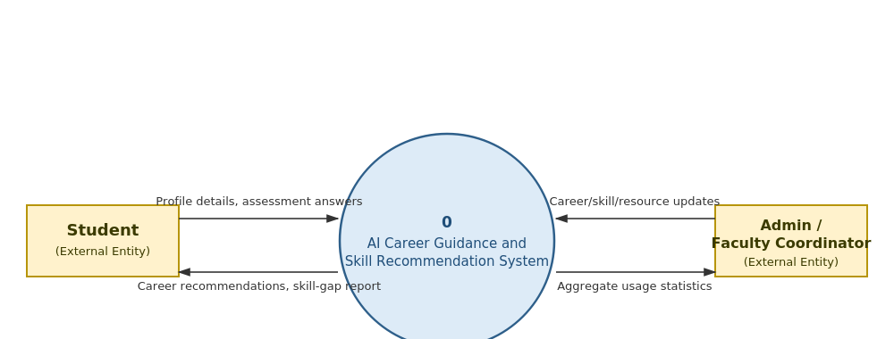
Figure B-1: Level 0 Data Flow Diagram (Context Diagram)
The system has exactly two external entities – the student and the admin/faculty coordinator. Everything else (the recommendation logic, the database, the resource catalogue) is internal detail, expanded in the level 1 diagram below.

B.2 Level 1 DFD
The level 1 diagram decomposes process 0 into six sub-processes, numbered 1.0 to 6.0, and introduces the five data stores that back them – closer to how the back-end modules described in Section 4 map onto actual data movement.
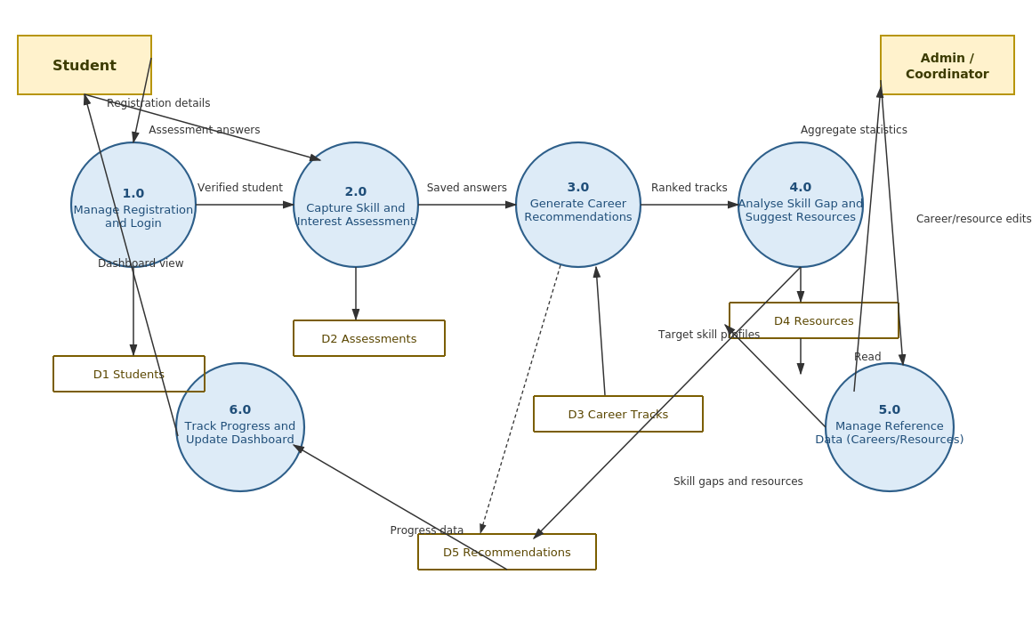
Figure B-2: Level 1 Data Flow Diagram
A few points worth noting about this diagram:
- Process 3.0 (Generate Career Recommendations) is the only process that reads from both D2 (Assessments) and D3 (Career Tracks) and writes to D5 (Recommendations) – this is deliberate, since it is the process most likely to change if the scoring logic is revised later in the project. This is also the process that applies the business rules in Section 5.5.
- Process 6.0 (dashboard) only reads existing data; it does not write back to any store except by way of the resource-progress updates a student makes, which are folded into D5 for simplicity at this level.
- Process 5.0 is kept separate from 1.0–4.0 because it is the only process an admin can trigger, which matches the access-control requirement NFR-05 in Section 5.3.
A level 2 decomposition (for example, breaking process 3.0 into rule-filtering and ML-scoring steps) was considered but left out of this document, since it would mostly duplicate the pseudocode that will appear in the design document rather than add new information at the requirements stage.

Appendix C: To Be Determined List
The items below are open questions the team flagged during requirements gathering. They are recorded here, per the standard SRS convention, so they are tracked to closure rather than forgotten before the design phase.
TBD # | Open Question | Related Section
TBD-1 | Should the assessment be re-takeable at any time, or should the system enforce a minimum gap (e.g., two weeks) between attempts, to encourage students to actually work on recommended resources before re-assessing? Provisionally decided against enforcing a gap, since it would make the prototype harder to demo and test. | 4.2, 4.3
TBD-2 | Exact final count and list of career tracks to curate – currently estimated at 12–15, pending one more round of discussion with the placement-cell coordinator. | 2.7, 5.5
TBD-3 | Whether a simple chat-style interface for follow-up questions is worth attempting – tentatively set aside as future work since it needs more natural-language handling than the team can build and test within the semester. | 2.2
TBD-4 | Final hosting provider for the graded demo, and whether the free-tier request limit (Section 2.4) will hold up during in-class evaluation. | 2.4, 5.1

