Software Requirements Specification
for
AI Career Guidance and Skill Recommendation System
Prepared for the Software Engineering Course Project
Version 1.0
Document Status: Draft for Review
Date: September 2026

Revision History
Date | Version | Description | Author
05-Sep-2026 | 0.1 | Initial draft – scope and stakeholder notes | Project Team
08-Sep-2026 | 0.2 | Added functional requirements and use cases | Project Team
10-Sep-2026 | 1.0 | Reviewed draft, ready for submission | Project Team

Table of Contents
1. Introduction
1.1 Purpose
1.2 Document Conventions
1.3 Intended Audience and Reading Suggestions
1.4 Project Scope
1.5 References
2. Overall Description
2.1 Product Perspective
2.2 Product Functions
2.3 User Classes and Characteristics
2.4 Operating Environment
2.5 Design and Implementation Constraints
2.6 Assumptions and Dependencies
3. System Features and Functional Requirements
4. External Interface Requirements
5. Non-Functional Requirements
6. Use Case Summary
7. Data Requirements
8. Data Flow Diagrams
8.1 Level 0 DFD (Context Diagram)
8.2 Level 1 DFD
9. Business Rules (Recommendation Rule Table)
10. Appendix A – Glossary
11. Appendix B – Analysis Models

1. Introduction

1.1 Purpose
This document describes the software requirements for the AI Career Guidance and Skill Recommendation System, referred to throughout this report as ACGSRS. It is written for the software engineering course project and is meant to give the development team, the course instructor, and any future maintainer a single, agreed-upon description of what the system is supposed to do before design and coding begin. The document follows the general structure recommended by IEEE Std 830, adapted slightly to fit the scale of a semester-long academic project rather than an industrial-scale product.
The requirements captured here are the result of informal interviews with five college students and one placement-cell coordinator, along with a review of three existing career-guidance platforms. They are not final in the legal sense – as is normal for a student project, some requirements may be revisited once the prototype is demonstrated to the course instructor.

1.2 Document Conventions
Requirement statements use “shall” to indicate a mandatory requirement and “should” to indicate a desirable but non-mandatory feature. Each functional requirement is tagged with an identifier of the form FR-<module>-<number> (for example, FR-REG-02) so that it can be traced later to design elements and test cases. Non-functional requirements use the tag NFR-<number>. Priority is expressed on a three-point scale: High, Medium, Low, based on discussions within the project team about what is achievable within the course timeline.

1.3 Intended Audience and Reading Suggestions
This document is intended for four groups of readers:
- The student development team, who will use Sections 3 and 4 as the basis for module design.
- The course instructor / evaluator, who is likely to focus on Sections 1, 2 and 6 to judge whether the scope is realistic.
- Testers (which, for a course project, is usually the same team wearing a different hat), who will derive test cases from Section 3.
- Any future student who picks up this project as a continuation, who should start from Section 2 for context before going into the detailed requirements.
Readers who only want a quick sense of what the system does can read Section 2.2 (Product Functions) and skip directly to Section 6 (Use Case Summary).

1.4 Project Scope
Choosing a career path and figuring out which skills to learn next is something most engineering students struggle with, largely because the advice available to them is scattered across YouTube videos, senior students’ opinions, and generic online articles that do not account for the student’s actual academic record or interests. The ACGSRS project attempts to narrow this gap on a small scale by building a web application that:
- Collects a student’s academic background, interests, and self-rated skill levels through a structured questionnaire.
- Uses a rule-based scoring method combined with a simple machine-learning classifier to suggest two or three suitable career tracks (for example, Data Analyst, Backend Developer, or QA Engineer).
- Identifies the skill gap between the student’s current level and the level typically expected for the recommended track.
- Recommends specific courses, articles, or practice platforms to close that gap, drawn from a curated internal database rather than a live internet crawl.
- Lets the student track progress over time and re-take the assessment as their skills improve.
The system is being built as a proof-of-concept for academic evaluation. It is not intended to replace a professional career counsellor, and this limitation is stated explicitly to the user inside the application. Payment processing, resume building, and direct job-application integration are outside the scope of this version and are listed under Section 2.5 as constraints and possible future work.

1.5 References
- IEEE Std 830-1998, IEEE Recommended Practice for Software Requirements Specifications.
- Sommerville, I., Software Engineering, 10th Edition, Pearson, for the general SRS template followed here.
- Internal meeting notes and student survey responses collected by the project team, August–September 2026 (unpublished).
- Publicly available documentation of O*NET Online, used only as a reference for how career-to-skill mapping is typically organised, not copied directly.

2. Overall Description

2.1 Product Perspective
ACGSRS is a new, self-contained web application. It does not replace or integrate with any existing college system such as the ERP or the placement portal, mainly because access to those systems was not available to a student team within the project timeline. The application is split into three logical parts that mirror a fairly standard three-tier architecture:
- A front-end built with React, through which students fill in the assessment form and view their recommendations and dashboard.
- A back-end service built with Python (Flask) that runs the recommendation logic, handles authentication, and exposes REST endpoints to the front-end.
- A MySQL database that stores user profiles, assessment responses, the career-skill mapping reference data, and the curated list of learning resources.
The recommendation logic itself is a light-weight hybrid: a rule-based filter narrows down candidate careers using hard constraints (branch of study, stated interest area), after which a scikit-learn classifier trained on a small labelled dataset (collected via the student survey mentioned in Section 1.1) ranks the remaining options. This hybrid approach was chosen over a pure ML approach because the training data available for a course project is too small to trust a model in isolation.

2.2 Product Functions
At a high level, the system performs the following functions. Details for each are given in Section 3.
- Account registration and login for students, with a separate login for the admin/faculty role.
- A guided, multi-step skill and interest assessment form.
- Career track recommendation with a short explanation of why each track was suggested.
- Skill-gap analysis comparing the student’s current skill ratings against the target profile for the recommended track.
- Personalised learning resource suggestions (courses, articles, practice sites) mapped to the identified gaps.
- A dashboard where the student can see past assessments and track whether their skill ratings have improved over time.
- An admin panel where the faculty coordinator can update the list of careers, skills, and learning resources without touching the code.

2.3 User Classes and Characteristics
User Class | Description | Technical Skill Expected
Student (primary user) | Engineering/degree student seeking career direction and a personalised skill plan. | Basic – comfortable using any typical web form or app.
Faculty / Placement Coordinator (admin) | Maintains the career-skill reference data and can view aggregate, anonymised statistics about students’ chosen tracks. | Basic to moderate – needs to fill spreadsheet-like admin forms.
Guest visitor | Anyone browsing the site before creating an account; can view sample career descriptions but cannot take the assessment. | None.

2.4 Operating Environment
- Client side: any modern browser (Chrome, Firefox, Edge) with JavaScript enabled; the layout is responsive down to a typical mobile screen width, though the project focuses primarily on desktop/laptop use since that is how most students access it during lab hours.
- Server side: the prototype is deployed on a single low-cost cloud instance (or, for demonstration, run locally) running Python 3.11 and MySQL 8.
- No native mobile application is planned for this version.

2.5 Design and Implementation Constraints
- The project must be completed within a single academic semester by a team of three to four students, which limits how much of the “nice to have” functionality (Section 3, Low priority items) can realistically be finished.
- The recommendation model is trained on a small, self-collected dataset; predictions should therefore be treated as indicative rather than authoritative, and the UI must communicate this to the user.
- No paid third-party APIs are used, since the team does not have a budget for this course project; any external data (for example, sample course listings) is added manually to the database rather than fetched live.
- The system must run within the free tier of the hosting service chosen for demonstration, which limits concurrent users to roughly 20–30 during a class demo.

2.6 Assumptions and Dependencies
- It is assumed that students will answer the self-assessment questions reasonably honestly; the system has no way to independently verify a student’s actual skill level.
- It is assumed that the list of careers and skills curated for the prototype (roughly 12–15 career tracks) is broad enough to be useful for a general engineering audience, even though it does not cover every possible profession.
- The project depends on the continued free availability of the open-source libraries used (Flask, scikit-learn, React) and does not anticipate licensing issues since all of them are permissively licensed.

3. System Features and Functional Requirements
Each feature below is described with a short rationale, its priority for this course project, and the individual functional requirements that make it up.

3.1 User Registration and Profile Management
Rationale: a student needs a persistent identity in the system so that assessment history and recommendations can be saved and revisited, rather than lost the moment the browser tab is closed.
ID | Requirement | Priority
FR-REG-01 | The system shall allow a new student to register using name, college email address, branch, and year of study. | High
FR-REG-02 | The system shall verify that the email address is unique before creating the account. | High
FR-REG-03 | The system shall allow a registered student to log in using email and password. | High
FR-REG-04 | The system shall allow a student to edit their profile details (branch, year, interests) after registration. | Medium
FR-REG-05 | The system shall allow a student to reset a forgotten password via an emailed reset link. | Medium
FR-REG-06 | The system should allow login using a college Google account (OAuth), to save the student from creating a new password. | Low

3.2 Skill and Interest Assessment
Rationale: the recommendation engine is only as good as the input it receives, so the assessment form is the single most important screen in the application from a data-quality point of view.
ID | Requirement | Priority
FR-ASM-01 | The system shall present the assessment as a multi-step form covering academic background, interest areas, and self-rated proficiency in a fixed list of skills (e.g., programming, communication, analytical thinking). | High
FR-ASM-02 | The system shall let the student rate each skill on a 1–5 scale rather than a free-text field, to keep the data usable by the recommendation model. | High
FR-ASM-03 | The system shall save partially completed assessments so a student can resume later instead of restarting. | Medium
FR-ASM-04 | The system shall validate that all required questions are answered before allowing submission. | High
FR-ASM-05 | The system shall timestamp every submitted assessment so that repeat attempts can be compared later. | Medium

3.3 Career Recommendation Engine
Rationale: this is the core value proposition of the project – turning raw assessment answers into a short, digestible list of suggested career directions.
ID | Requirement | Priority
FR-REC-01 | The system shall generate a ranked list of at least two and at most four recommended career tracks based on the most recent assessment. | High
FR-REC-02 | The system shall display a short, plain-language explanation for each recommended track (for example, which of the student’s answers contributed most to the match). | High
FR-REC-03 | The system shall allow the student to mark one recommended track as their “chosen focus” so that later features (skill gap, resources) are built around it. | High
FR-REC-04 | The system shall recompute recommendations whenever a new assessment is submitted, without requiring manual admin intervention. | Medium
FR-REC-05 | The system should show a confidence indicator (e.g., high/medium match) alongside each recommendation, given that the underlying model is trained on limited data. | Low

3.4 Skill Gap Analysis and Resource Recommendation
ID | Requirement | Priority
FR-GAP-01 | The system shall compare the student’s current skill ratings with the target skill profile defined for the chosen career track and list the skills with the largest gap first. | High
FR-GAP-02 | The system shall recommend at least one learning resource (course, article, or practice platform) for each skill identified as a significant gap. | High
FR-GAP-03 | The system shall allow the student to mark a recommended resource as “in progress” or “completed”. | Medium
FR-GAP-04 | The system shall let an admin add, edit, or retire learning resources through the admin panel described in Section 3.6. | Medium

3.5 Progress Dashboard
ID | Requirement | Priority
FR-DSH-01 | The system shall show the student a summary screen listing their current recommended track, skill gaps, and resource completion status. | High
FR-DSH-02 | The system shall display a simple chart comparing skill ratings across the student’s two most recent assessments, so improvement (or lack of it) is visible at a glance. | Medium
FR-DSH-03 | The system should let a student download a one-page PDF summary of their current recommendation and skill plan. | Low

3.6 Administration Panel
ID | Requirement | Priority
FR-ADM-01 | The system shall allow an admin user to add, edit, or remove career tracks and their associated target skill profiles. | High
FR-ADM-02 | The system shall allow an admin user to add, edit, or remove learning resources and the skills they are tagged against. | High
FR-ADM-03 | The system shall let an admin view anonymised, aggregate statistics (e.g., how many students were recommended each track) without exposing individual student data. | Medium
FR-ADM-04 | The system shall restrict admin-panel routes to users with the admin role, verified at the back-end and not only hidden in the front-end. | High

4. External Interface Requirements

4.1 User Interfaces
- A landing page describing the project and its limitations (see Section 2.5), with links to register or log in.
- A multi-step assessment wizard with a visible progress indicator (e.g., “Step 3 of 5”).
- A results page presenting recommended careers as cards, each expandable to show the reasoning and target skill profile.
- A dashboard page combining the skill-gap list, resource list, and progress chart described in Section 3.5.
- A separate, simpler admin interface (data tables and forms) that does not need to match the polish of the student-facing pages, given the limited time available for UI work.
Wireframes for these screens were sketched by hand during planning and are kept in the team’s shared drive rather than reproduced here, since they are expected to change once usability feedback is collected from a small group of test users.

4.2 Hardware Interfaces
None beyond a standard computer or laptop capable of running a modern browser. The system does not interact with any specialised hardware.

4.3 Software Interfaces
Interface | Purpose
MySQL 8 database | Persistent storage for users, assessments, career-skill mappings, and resources.
Flask REST API | Exposes endpoints consumed by the React front-end (e.g., /api/assessment, /api/recommendations).
SMTP email service (college mail relay or a free-tier provider) | Sends password-reset emails and, optionally, a weekly reminder to revisit the assessment.
scikit-learn model file | Loaded by the back-end at startup to score candidate careers for a given assessment.

4.4 Communication Interfaces
All communication between the front-end and back-end uses HTTPS with JSON payloads. No other network protocol is required for this project.

5. Non-Functional Requirements

5.1 Performance Requirements
ID | Requirement
NFR-01 | The assessment results page shall load within 3 seconds under normal conditions (single demo deployment, up to ~20 concurrent users).
NFR-02 | The recommendation engine shall return a result within 2 seconds of assessment submission for a single request.

5.2 Security Requirements
ID | Requirement
NFR-03 | Passwords shall be stored as salted hashes (e.g., bcrypt); plain-text passwords shall never be written to the database or logs.
NFR-04 | Admin-only API routes shall verify the user’s role on every request at the server, not rely on the front-end hiding a button.
NFR-05 | Session tokens shall expire after a period of inactivity (e.g., 30 minutes) to reduce the risk from a shared lab computer being left logged in.

5.3 Usability Requirements
ID | Requirement
NFR-06 | A first-time student user shall be able to complete registration and the initial assessment without external help, verified through a small usability test with 3–5 volunteer students.
NFR-07 | Error messages (e.g., invalid email, incomplete assessment) shall be shown in plain language next to the relevant field rather than as a generic pop-up.

5.4 Reliability and Availability
ID | Requirement
NFR-08 | The system shall save a student’s in-progress assessment automatically every 30 seconds, so a dropped connection does not erase their answers.
NFR-09 | Since this is a course prototype rather than a production system, formal uptime guarantees are not required; however, the system should be available during the scheduled demo and evaluation window.

5.5 Maintainability and Portability
- Career, skill, and resource reference data shall be stored in the database rather than hard-coded, so an admin can update it without a code change or redeployment.
- The back-end shall be organised into clearly separated modules (authentication, assessment, recommendation, admin) to make it easier for a teammate unfamiliar with a given module to pick it up during the project.

6. Use Case Summary
The table below lists the primary use cases identified for this system. Detailed use-case descriptions (actors, pre-conditions, main flow, alternate flow) are maintained separately in the project’s design document to keep this SRS focused on requirements rather than design.
Use Case | Primary Actor | Brief Description
Register Account | Student | Create a new account with basic profile details.
Log In | Student, Admin | Authenticate and access the appropriate dashboard.
Complete Assessment | Student | Answer the multi-step skill and interest questionnaire.
View Recommendations | Student | See ranked career suggestions with reasoning.
View Skill Gap and Resources | Student | See which skills need work and what resources to use.
Track Progress | Student | Compare current and past assessments over time.
Manage Reference Data | Admin | Add/edit/remove career tracks, skills, and resources.
View Aggregate Statistics | Admin | See anonymised trends across the student population.

7. Data Requirements
At a minimum, the database needs to hold the following entities. This is a conceptual list rather than a full schema; the actual schema will be finalised during design.
- Student: id, name, email, password hash, branch, year of study, created date.
- Assessment: id, student id, timestamp, list of skill ratings, selected interest areas.
- CareerTrack: id, name, description, target skill profile (a set of skill–level pairs).
- Recommendation: id, assessment id, career track id, rank, explanation text, confidence label.
- Resource: id, title, type (course/article/practice), linked skill, target URL, added-by admin id.
- ResourceProgress: id, student id, resource id, status (not started/in progress/completed).
Student data such as email addresses and assessment answers is treated as sensitive within the scope of this project; it is used only to generate recommendations and is not shared outside the application, in keeping with the college’s general guidance on student data handling for course projects.

8. Data Flow Diagrams
Data flow diagrams (DFDs) are included here to show how information moves through the system, independent of how the modules will eventually be coded. Standard Gane-Sarson notation is used: a rounded circle represents a process, an open-ended rectangle represents a data store, and a rectangle represents an external entity. These diagrams were sketched during the design discussions and cleaned up for this document; they are expected to be refined once the database schema is finalised.

8.1 Level 0 DFD (Context Diagram)
The context diagram treats the whole system as a single process and shows only the data that crosses its boundary. It is the simplest possible view of the system and is mainly useful for confirming, at a glance, who the system talks to and what is exchanged.
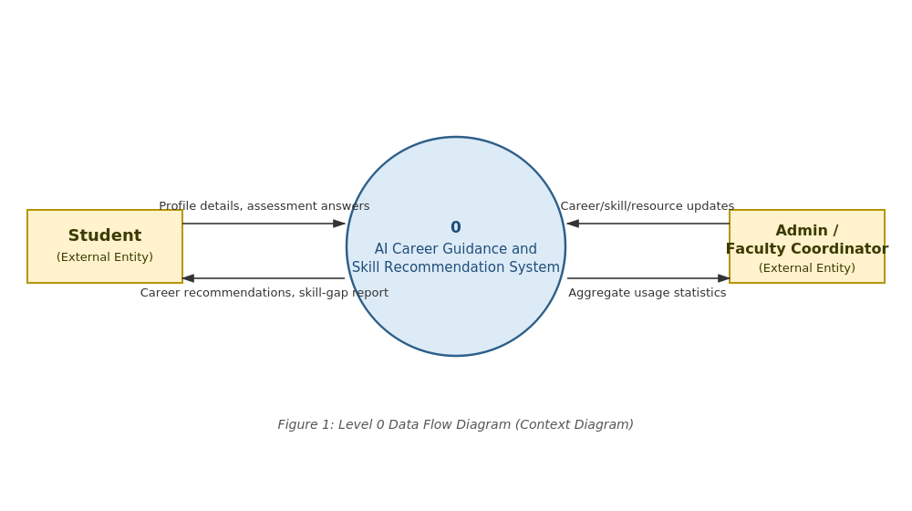
As the diagram shows, the system has exactly two external entities – the student and the admin/faculty coordinator. Everything else (the recommendation logic, the database, the resource catalogue) is internal detail that is expanded in the level 1 diagram below.

8.2 Level 1 DFD
The level 1 diagram decomposes process 0 into six sub-processes, numbered 1.0 to 6.0, and introduces the five data stores that back them. This is closer to how the back-end modules described in Section 3 map onto actual data movement.
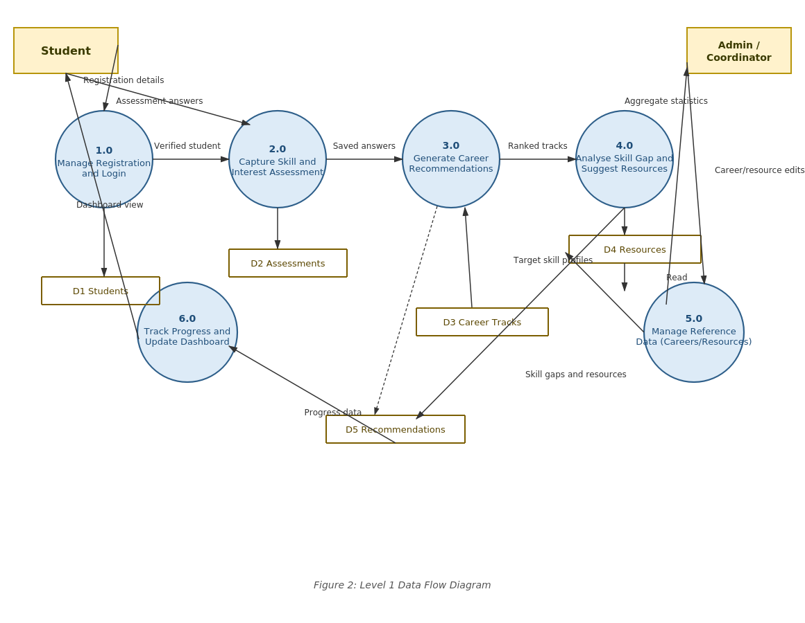
A few points worth noting about this diagram:
- Process 3.0 (Generate Career Recommendations) is the only process that reads from both D2 (Assessments) and D3 (Career Tracks) and writes to D5 (Recommendations) – this is deliberate, since it is the process most likely to change if the scoring logic is revised later in the project.
- Process 6.0 (dashboard) only reads existing data; it does not write back to any store except by way of the resource-progress updates a student makes, which are folded into D5 for simplicity at this level.
- Process 5.0 is kept separate from 1.0–4.0 because it is the only process an admin can trigger, which matches the access-control requirement NFR-04 in Section 5.2.
A level 2 decomposition (for example, breaking process 3.0 into rule-filtering and ML-scoring steps) was considered but left out of this document, since it would mostly duplicate the pseudocode that will appear in the design document rather than add new information at the requirements stage.

9. Business Rules (Recommendation Rule Table)
The recommendation engine described functionally in Section 3.3 is not a black box – a first layer of hard rules narrows down the candidate careers before the machine-learning component ranks whatever is left (see Section 2.1). The table below documents that rule layer so that it can be reviewed, argued with, and tested independently of the model. Rules are evaluated top to bottom; a career track is only passed on to the scoring step if it satisfies every rule that applies to it.
Rule ID | Condition | Action / Outcome | Rationale
BR-01 | Student’s stated interest area = “Data” AND self-rated Mathematics/Statistics ≥ 3 | Include “Data Analyst” and “Data Science Trainee” in the candidate list | These tracks assume at least a moderate comfort with numbers; recommending them below this threshold produced confusing results during informal testing.
BR-02 | Student’s branch = Computer Science / IT AND Programming skill ≥ 2 | Include “Backend Developer”, “Frontend Developer”, and “QA Engineer” in the candidate list | Kept deliberately low (≥2) since these are meant to be entry points, not a filter for already-strong programmers.
BR-03 | Communication skill ≥ 4 AND interest area includes “Business” | Include “Business/Product Analyst” in the candidate list | This track leans on client-facing and requirement-gathering ability more than deep technical skill.
BR-04 | No branch/interest combination matches BR-01–BR-03 | Fall back to a default set of three “general technical” tracks (Backend Developer, QA Engineer, IT Support Analyst) | Ensures the student always receives at least two recommendations rather than an empty result, even for unusual answer combinations.
BR-05 | A track is already present in the candidate list from more than one matching rule | Remove the duplicate; keep the entry once, tagged with all matching rule IDs for the explanation shown in FR-REC-02 | Avoids showing the same career twice with different reasoning, which confused testers during the walkthrough.
BR-06 | Number of remaining candidate tracks after BR-01–BR-05 exceeds 4 | Pass only the top 4 (by number of rules matched, then alphabetically as a tie-breaker) to the ML scoring step | Keeps the final list within the 2–4 range required by FR-REC-01; the ML step further narrows this down.
BR-07 | Self-rated proficiency for any skill referenced by a rule is left blank | Treat the blank as a rating of 1 (lowest) for the purpose of rule evaluation only – the dashboard still shows it as “not rated” | Prevents a missing answer from silently including a track it shouldn’t; the student is nudged to complete it in a later revision.
Two things are worth flagging about this table. First, the thresholds (e.g., “Mathematics/Statistics ≥ 3” in BR-01) were chosen informally, based on how the five students who piloted the questionnaire rated themselves, and are marked as a candidate for tuning once more response data is collected – they are not derived from any external benchmark. Second, BR-04 through BR-07 exist mainly to keep the system’s behaviour predictable at the edges (empty results, duplicate entries, missing answers) rather than to encode career-guidance expertise, which is why they read more like software guard-rails than domain rules.
These rules sit entirely in the rule-filtering step shown as part of process 3.0 in the level 1 DFD (Section 8.2); the ML scoring step that runs afterwards does not have access to this table and only sees whatever candidate list survives it.

10. Appendix A – Glossary
Term | Meaning
ACGSRS | AI Career Guidance and Skill Recommendation System – the short name used for this project throughout the document.
Skill Gap | The difference between a student’s self-rated proficiency in a skill and the target level expected for a chosen career track.
Career Track | A defined occupational direction (e.g., Backend Developer, Data Analyst) with an associated target skill profile.
Confidence Label | A rough indicator (e.g., High/Medium) of how strongly the model supports a given recommendation, included because the training dataset is small.
Admin | A faculty or placement-cell user with permission to maintain reference data.

11. Appendix B – Analysis Notes
This section records a few open questions the team flagged during requirements gathering, mainly so they are not forgotten before the design phase:
- Should the assessment be re-takeable at any time, or should the system enforce a minimum gap (e.g., two weeks) between attempts, to encourage students to actually work on the recommended resources before re-assessing? The team has provisionally decided against enforcing a gap, since this is a prototype and adding a restriction would make it harder to demo and test.
- How many career tracks should be curated for the first version? The team settled on roughly 12–15 tracks common to engineering graduates, based on discussion with the placement-cell coordinator, with the understanding that this list is easy to extend later through the admin panel.
- Whether to add a simple chat-style interface for follow-up questions was discussed and set aside as future work, since it would require a level of natural-language handling beyond what the team can build and test within the semester.
These notes are informational and do not carry the same weight as the numbered requirements in Sections 3 and 5; they are included mainly for the benefit of whoever continues this project after the course ends.

