# Capstone Project-The Battle of Neighbourhoods

As part of the final project , I have chosen to explore Zomato restaurants dataset in the city of New Delhi.

**Introduction**

New Delhi is the capital city of India. It is a part of the city of Delhi’s 11 districts. The city itself has a population of 257,803. However, the much larger metro area has a population that exceeds 26 million which has proven helpful in collecting data.

Considering the population, we can assume that it has diverse culture which comes with diverse food items. There are many restaurants in New Delhi City, each belonging to different categories like Chinese , Italian , French etc.

So as part of this project , we will list and visualize all major parts of New Delhi City .

**Business Problem**

Travel companies are always in a search to provide best services in order to charge good amount of money to the customers by taking them to the particular food joints they have tie-ups with. Now this does not necessarily mean that those food joints serve the best variational food. To simply put it, local people know more(better) about the place/neighbourhood food than the travel agency "claim to know". So, the problem is how to determine these places in the neighbourhood?

**Data**

For this project we need the following data : New Delhi Restaurants data that contains list Locality, Restaurant name, Rating along with their latitude and longitude.

Data source : [Zomato Kaggle dataset](https://www.kaggle.com/shrutimehta/zomato-restaurants-data)

Description : This data set contains the required information. And we will use this data set to explore various locality of new Delhi city. Nearby places in each locality of new Delhi city.

Data source : [Fousquare API](https://developer.foursquare.com/)

Description : By using this API we will get all the venues in each neighbourhood.

**Approach**

Collect the new Delhi city data from [Zomato Kaggle dataset](https://www.kaggle.com/shrutimehta/zomato-restaurants-data)

Using FourSquare API, we will find all venues for each neighbourhood.

Filter out all venues that are nearby by locality.

Using aggregative rating for each restaurant to find the best places.

Visualize the Ranking of neighbourhoods using folium library(python)

**Analysis**

Check code for analysis-<https://github.com/Aditi2693/Capstone_Coursera/commit/e40d21eb17cce7befe6e2992c843caa06cb35d61>

**Results**

1. The highest rated restaurant in top 10 places of New Delhi:-

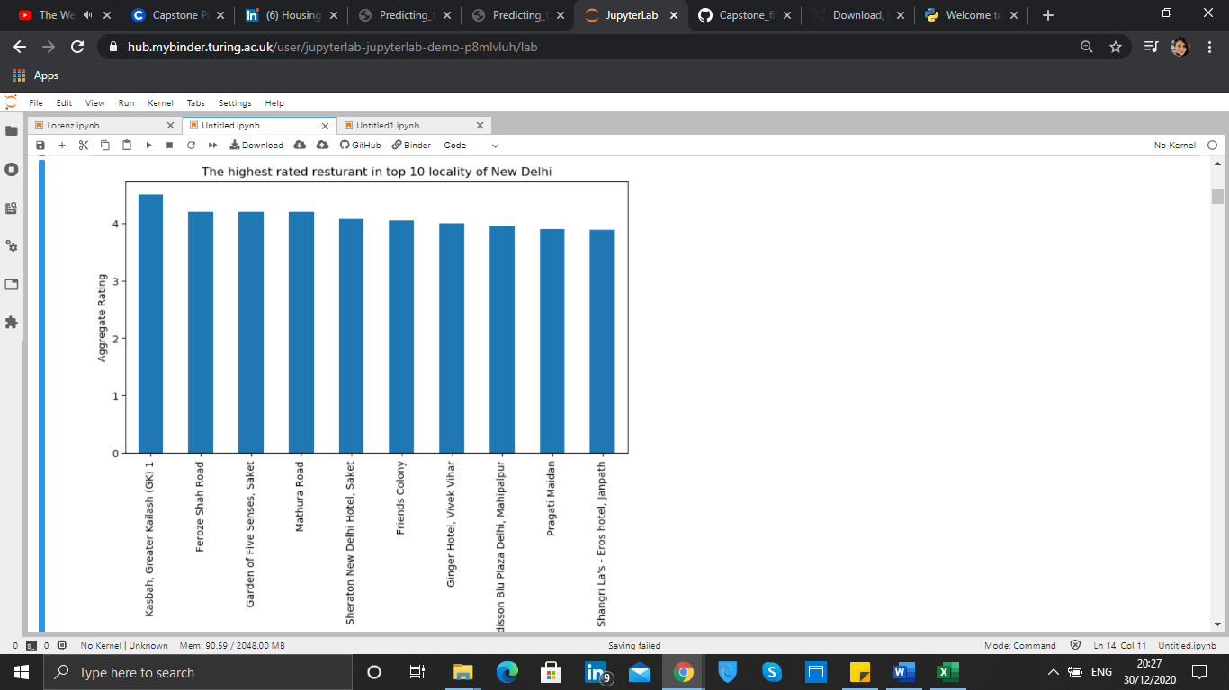

## Using k means we segregated the clusters which resulted to the below outcome-

## Cluster 1:

The Pizza Place are most recommended venues nearby the locations.

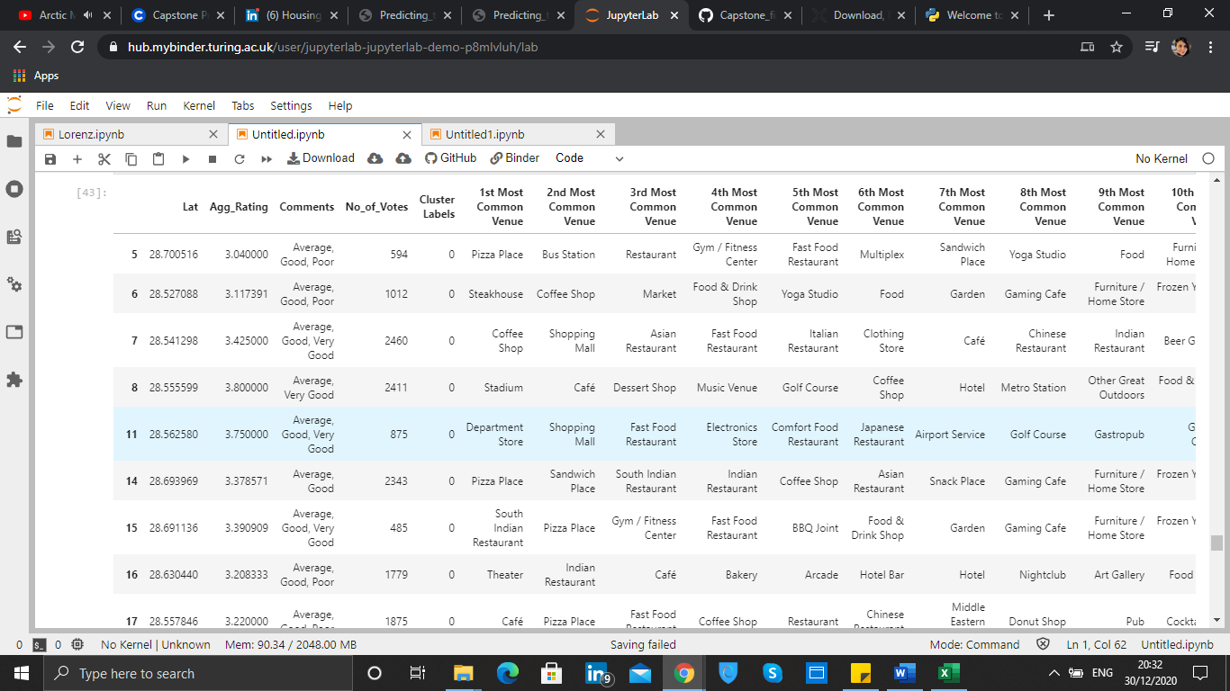

**Cluster 2:**

It is recommended for the Hotel venues:

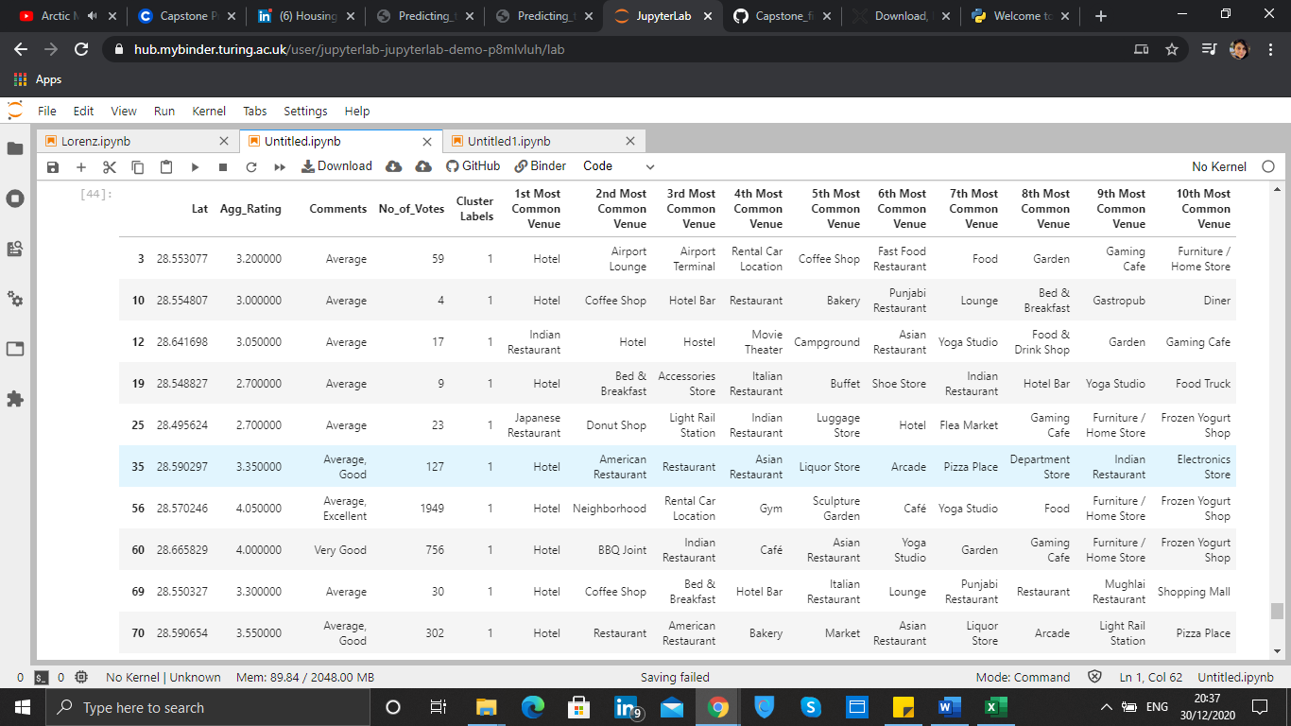

**Cluster 3:**

It seems like Indian restaurant place,

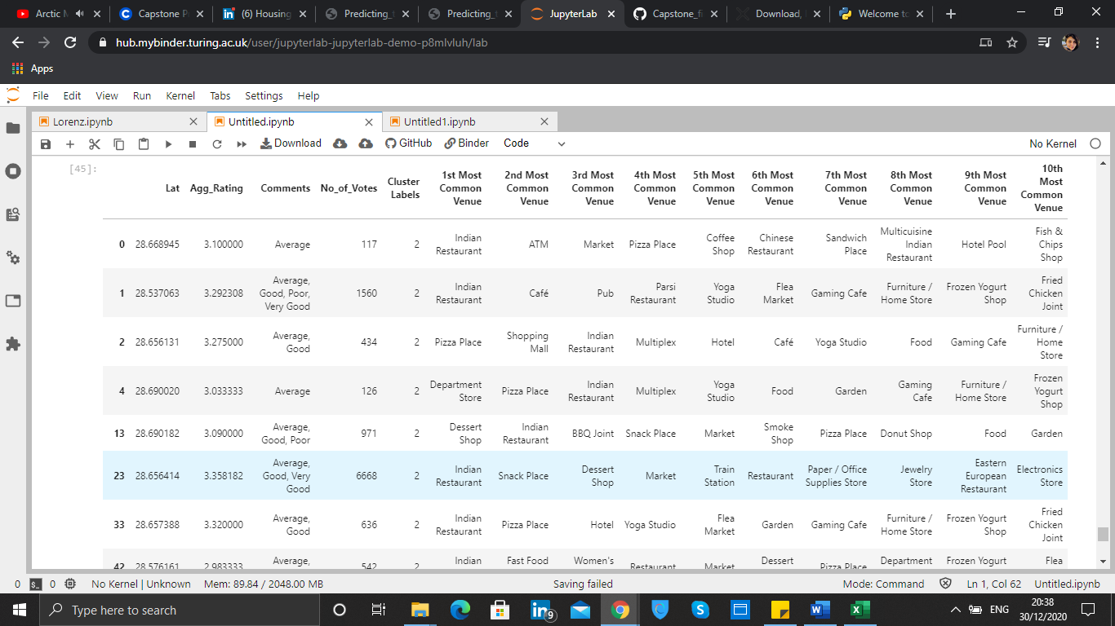

**Cluster 4:**

It is most recommended for Pizza Place:

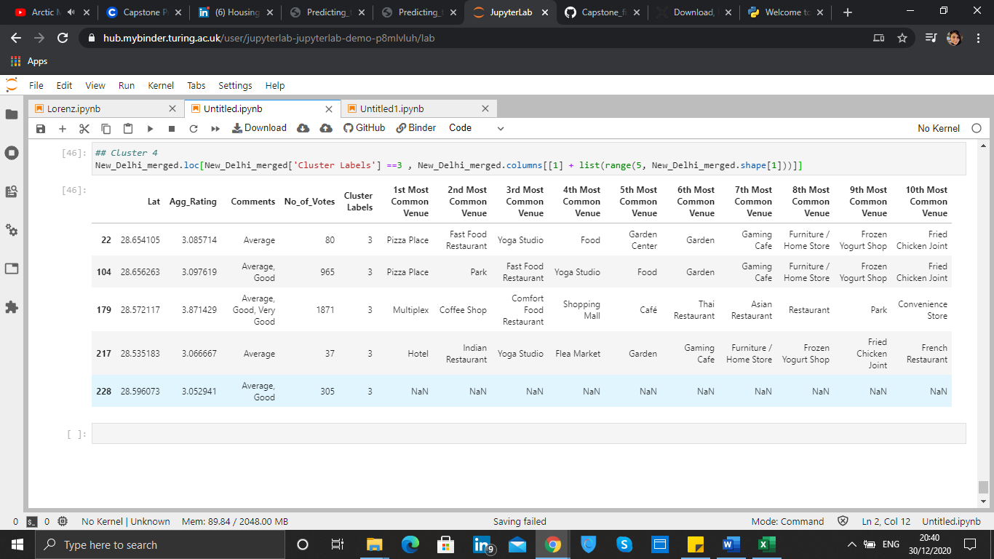

# Discussion-

So, the main question was if the travellers were to search for the most recommended food joint in a particular location, they would now get a suggestion of what sort of restaurants are available in their locality and what type of variational food do they serve.

So, using k means has helped us narrow down a list of suggested food joints in New Delhi according to different localities.

# Conclusion

* Greater Kailash, Feroze shah road, Saket and Mathura have best rated restaurants in New Delhi.
* Most recommended places considering ratings for the restaurants, Pizza places are more popular.
* Hotels and Indian restaurants are the second most popular choice.