First one:

sudo apt-get update
sudo apt-get install python3 python3-pip
sudo pip3 install python-can

sudo modprobe vcan
sudo ip link add dev vcan0 type vcan
sudo ip link add dev vcan1 type vcan
sudo ip link set up vcan0
sudo ip link set up vcan1

ifconfig -a

sudo pip3 install python-can

sudo python3 can_simulator.py
for vcan0
sudo modprobe vcan
candump vcan0
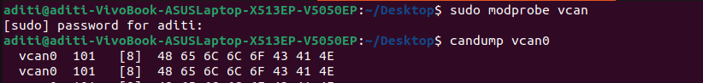
for vcan1
sudo modprobe vcan
candump vcan1
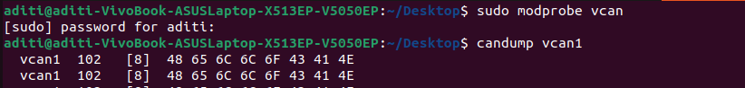
Second one:
sudo python3 central_control_unit.py
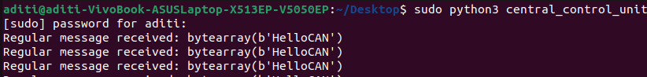
below part is not mendatory
cansend vcan0
cansend vcan0 123#11223344AABBCCDD
cansend vcan0 5A1#1122334455667788

cansend vcan1
cansend vcan1 456#11223344AABBCCDD

python3 can_visualizer.py
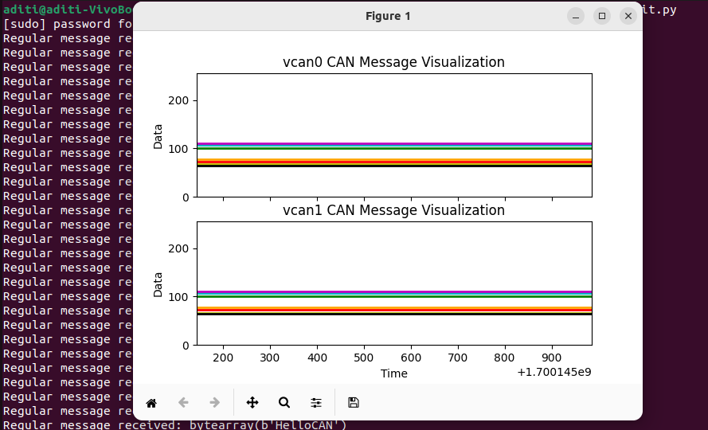

eisob gulo eksathe run korte hobe

python3 check3.py

