Name: - Aditi Chandra Date: -
UID: -TNU2023036200011
Experiment-02
Topic: - To find the rotation of frames using SCI lab.
Objective: -The objective of this lab report is to investigate the rotation of frames using Sci Lab. The report will discuss the theoretical background, the meaning of individual and successive rotations, the experimental setup, and the results and discussion of a sample simulation.
Theory: -The objective of this lab report is to investigate the rotation of frames using Sci Lab. The report will discuss the theoretical background, the meaning of individual and successive rotations, the experimental setup, and the results and discussion of a sample simulation.
Individual Rotation: - Individual rotation refers to the rotation of a point or object about a single axis.
Successive Rotation: -Successive rotation involves applying multiple rotations one after the other. The overall effect is obtained by multiplying the corresponding rotation matrices.
Code: -
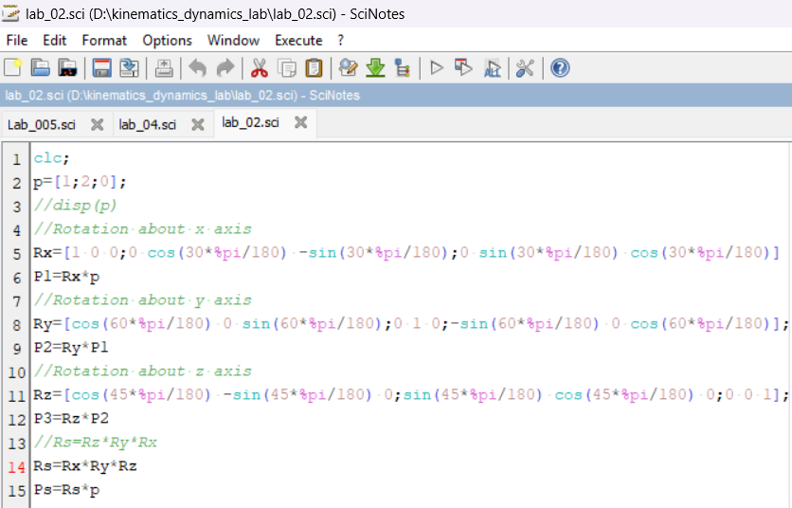
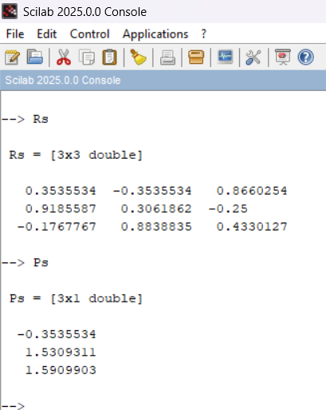
Result: -

Discussion: -The results obtained from the Sci Lab simulation are consistent with the expected theoretical solutions. Rotating the point by 30⁰ ,60⁰ and then by another 45⁰ results in the new coordinates as expected.

