Name: - Aditi Chandra Date: -
UID: - TNU2023036200011
Experiment-05
Topic: - Trajectory Visualization of a 2R Robot
Objective: - To simulate and visualize the trajectory of a 2R planar robot manipulator using SciLab.
Theory: - The 2R robotic arm consists of two rotational joints, and its trajectory planning and visualization are fundamental for understanding its movement and control. This experiment uses SciLab to compute the positions of the robot's links and end-effector, and plots its trajectory in a 2D plane.
Background of Sci Lab: - Sci Lab was developed by researchers from INRIA (French Institute for Research in Computer Science and Automation) in the late 1980s. It has since evolved into a comprehensive computational platform that competes with commercial software like MATLAB. Sci Lab is available for free and supports various operating systems, including Windows, macOS, and Linux.
Simulation Setup: -
• Software Used:
- SciLab for kinematic calculations and plotting.
• Parameters Defined in Code:
- Link lengths: l1=1,l2=1l_1 = 1, l_2 = 1.
- Desired end-effector position: px=0.2,py=0.1p_x = 0.2, p_y = 0.1.
• Methodology:
- The forward and inverse kinematics of the 2R robot are computed.
- Both possible configurations (elbow-up and elbow-down) are calculated.
- Axes, links, and end-effector positions are visualized using plots.
- 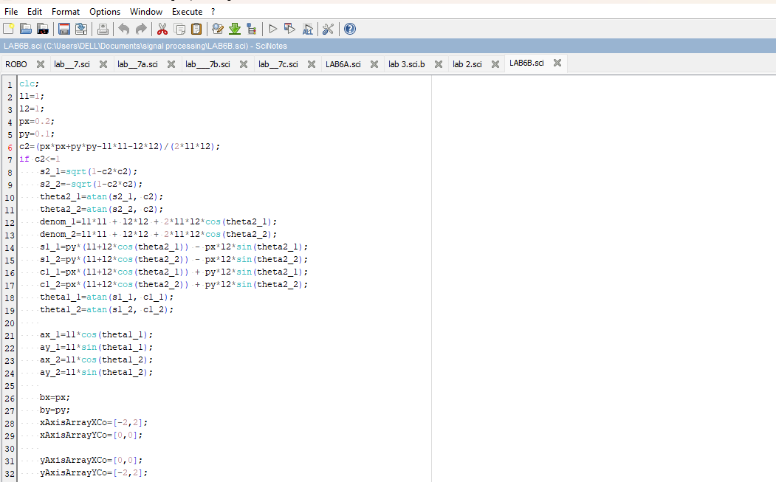
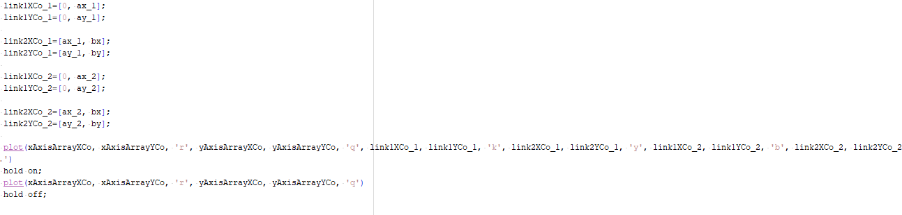
Result: - 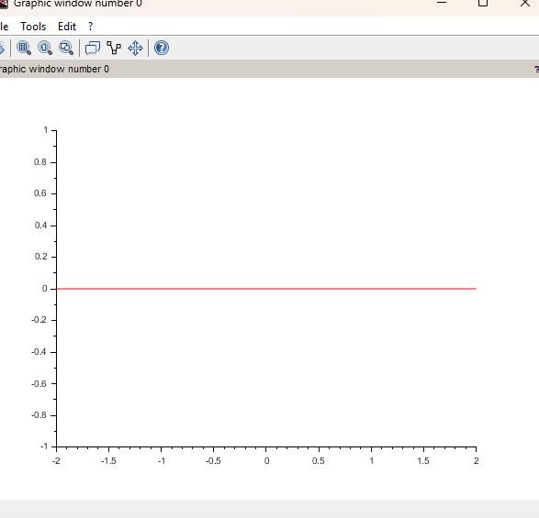

Discussion: - The SciLab code effectively computes the joint angles using inverse kinematics, ensuring the desired end-effector position is achieved. The visualization validates the calculations, highlighting both possible configurations. Limitations in the code include hard-coded parameters, which can be improved by making it dynamic for user input or extending it to include trajectory planning over time.

