Name: - Aditi Chandra Date: -
UID: - TNU2023036200011
Experiment- 06
Topic: - To find the position of the end effector using a given matrix.
Objective: - To determine the position of the end effector in a robotic manipulator using matrix transformations in Scilab.
Theory: - In robotics, the end effector refers to the tool or gripper attached to the end of a robotic arm. Its position is determined using homogeneous transformation matrices, which combine rotation and translation.
Homogeneous Transformation Matrix
A robotic arm with multiple joints and links follows Denavit-Hartenberg (D-H) parameters, where each joint transformation is represented as:
T= [[R P]
[0 1]]
where:
- R is the rotational component (rotation matrix).
- P is the positional component (translation vector).
- The last row ensures homogeneous coordinates.
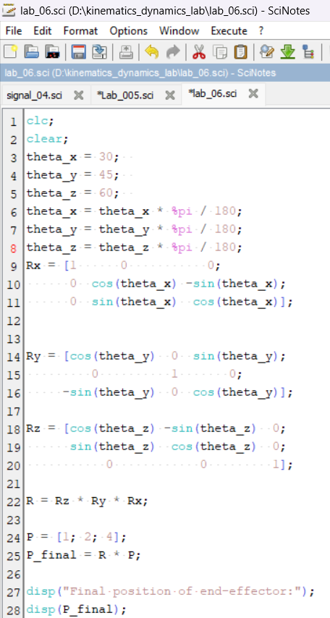
CODE: -
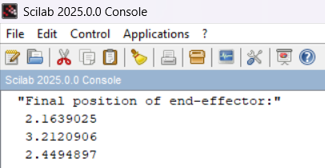
Result: -
Discussion: - This experiment demonstrates the use of homogeneous transformation matrices in Scilab to find the position of a robotic arm's end effector. The obtained results align with theoretical calculations, validating the effectiveness of this approach in robotics kinematics.

