Name: - Aditi Chandra Date: -
UID: - TNU2023036200011
Experiment-07
Topic: - Generating Trajectory for a 2R Robot in SciLab
Objective: - To generate and analyze the trajectory of a 2R planar robot using SciLab, focusing on both joint space and task space trajectory planning.
Theory: - The 2R robot is a planar manipulator with two rotational joints. Trajectory generation involves defining a path for the robot's end-effector or joints to follow over time. This process is crucial for applications such as pick-and-place operations, assembly tasks, and motion planning in robotics.
Background of Sci Lab: - Sci Lab was developed by researchers from INRIA (French Institute for Research in Computer Science and Automation) in the late 1980s. It has since evolved into a comprehensive computational platform that competes with commercial software like MATLAB. Sci Lab is available for free and supports various operating systems, including Windows, macOS, and Linux.
Simulation Setup: -
• Software: SciLab
• Robot Model: 2R planar robot
• Approach:
- Define the robot's kinematic parameters (link lengths, joint angles).
- Use forward and inverse kinematics to calculate the end-effector position.
- Implement trajectory generation algorithms (e.g., polynomial interpolation, trapezoidal velocity profiles).
4.Simulate the trajectory in SciLab.
- 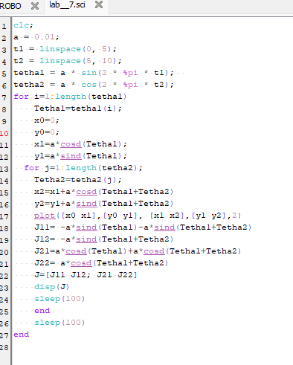

Result: - 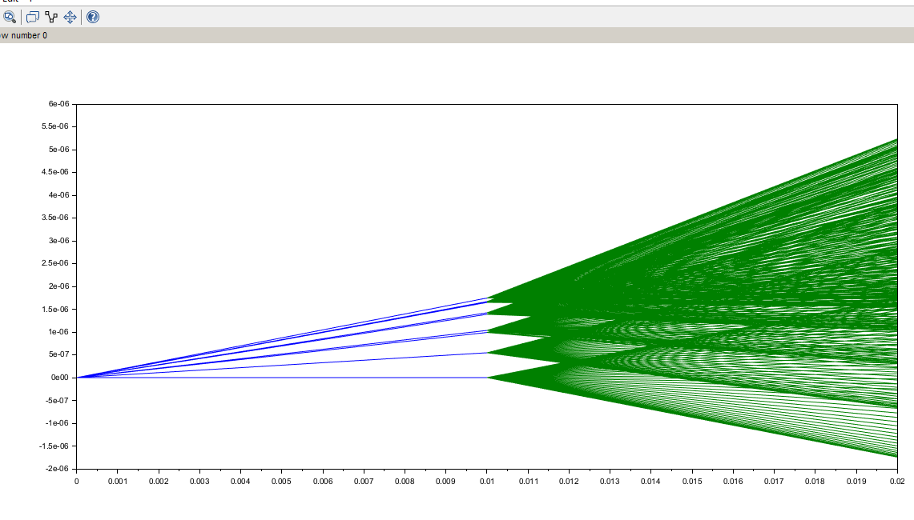

Discussion: - This experiment demonstrated the importance of precise kinematic analysis and trajectory planning for a 2R robot. Joint space trajectories are simpler but may not result in smooth end-effector motion, while task space trajectories ensure accurate end-effector paths but require more complex computations. Using SciLab, the generated trajectories were validated and visualized effectively, showcasing the software's utility in robotic simulations. This approach is foundational for real-world applications, where smooth and efficient robot motion is critical.

