**Report**

**on**

**FRONT-END ENGINEERING**

**CS186**

by

**Aditi Bhardwaj**

**2110990078**

**G5**

**3rd YEAR**

**INSTRUCTOR’S NAME – MR. LAVISH ARORA**

**Batch 2021**

**Session 2023-24**



The project is based on an E-COMMERCE website. The website is called **Masic beauty**, it offers a wide range of fragrances and bath body products.

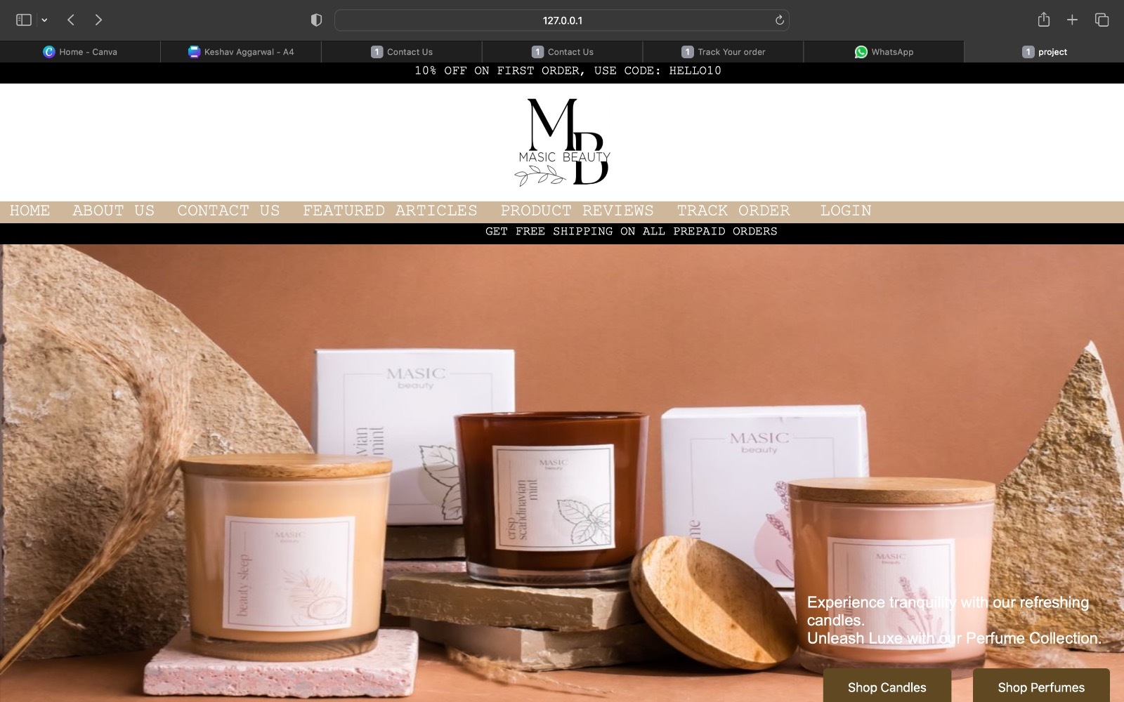

The page shown above is the **HOME PAGE** of the website, you can see the Logo of the website which says MASIC BEAUTY.

On the top the user can see the **NAVIGATION PANEL** i.e the header, which is helpful in browsing throughout different pages in the website.

There are different options available on the navigation panel like LOGIN, TRACK ORDER, PRODUCT REVIEWS, FEATURED ARTICLES, CONTACT US, ABOUT US and HOME.

The **SHOP CANDLES** button will take you to a page designed specially for candles. Where the user can browse through the various types of candles available on the shopping website.

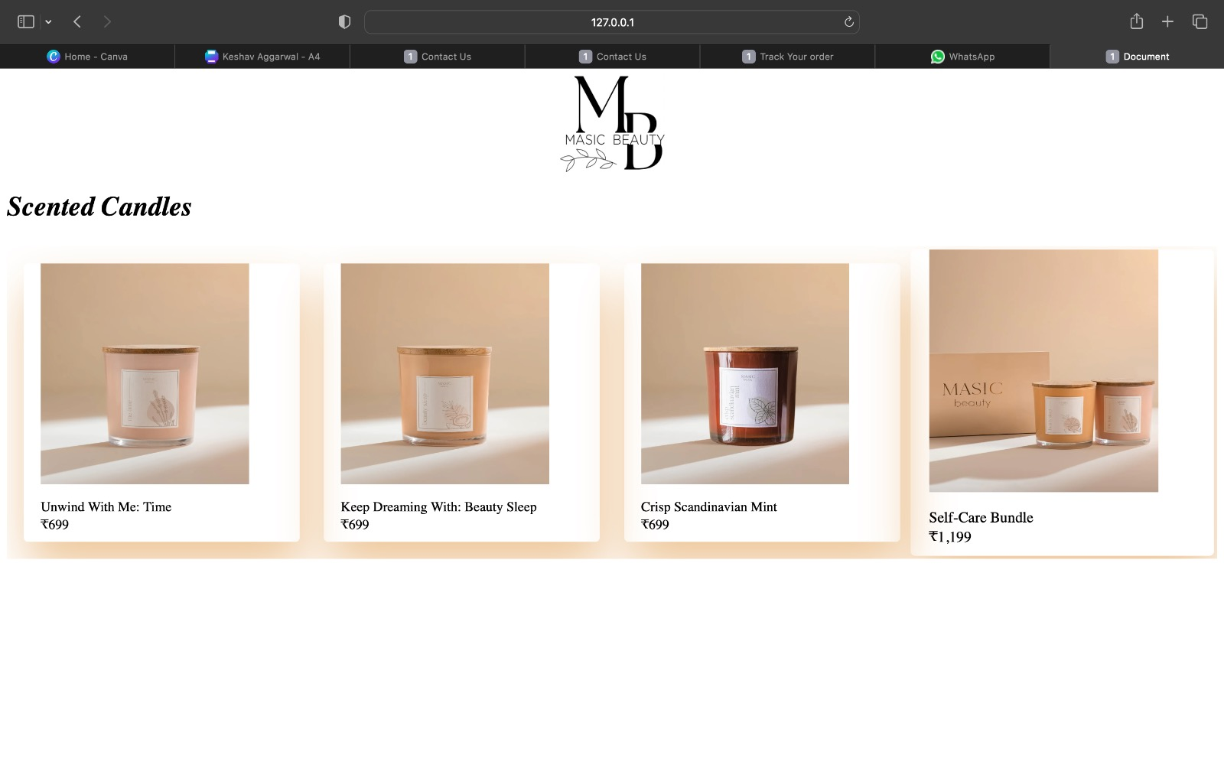

The **SHOP PERFUMES** button will take you to a page designed especially for our luxury range of fragrances. Where the user can browse through the various types of perfumes available on the shopping website.

.

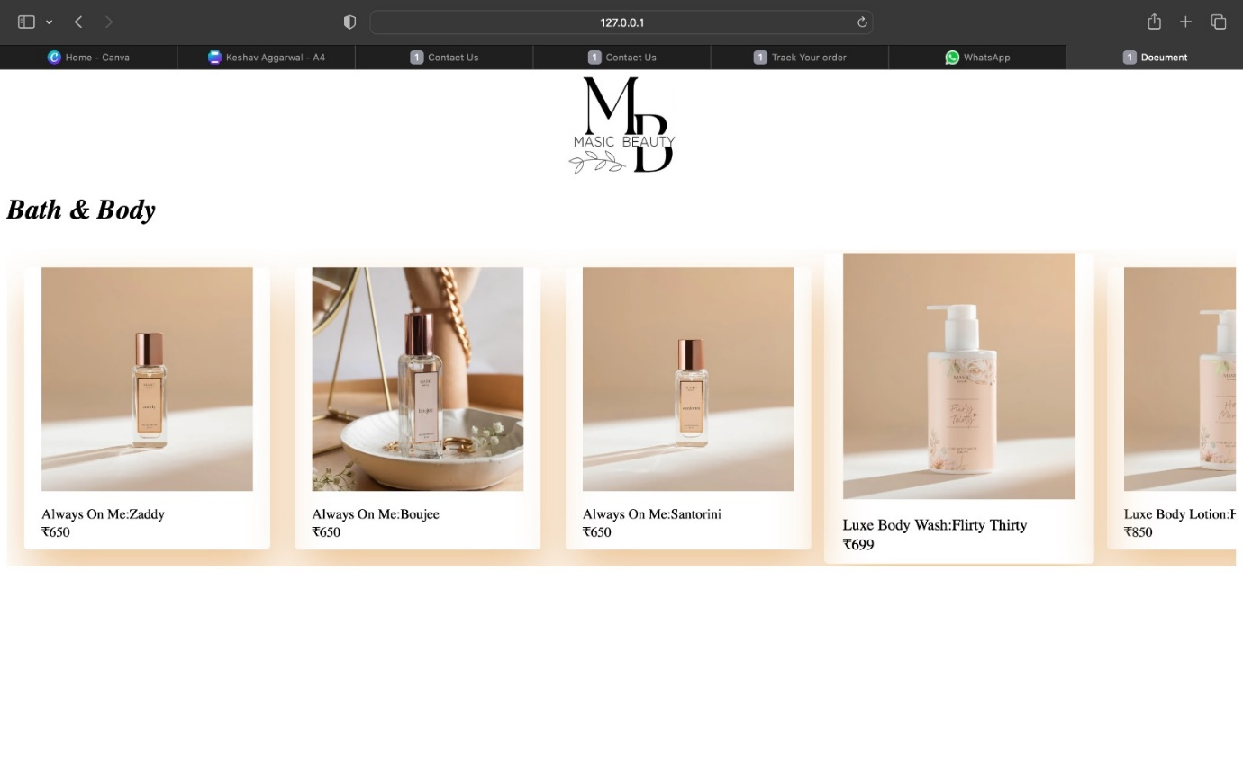

Then comes the **FEATURED ARTICLE** section of the Home page, which features various articles about Masic Beauty.

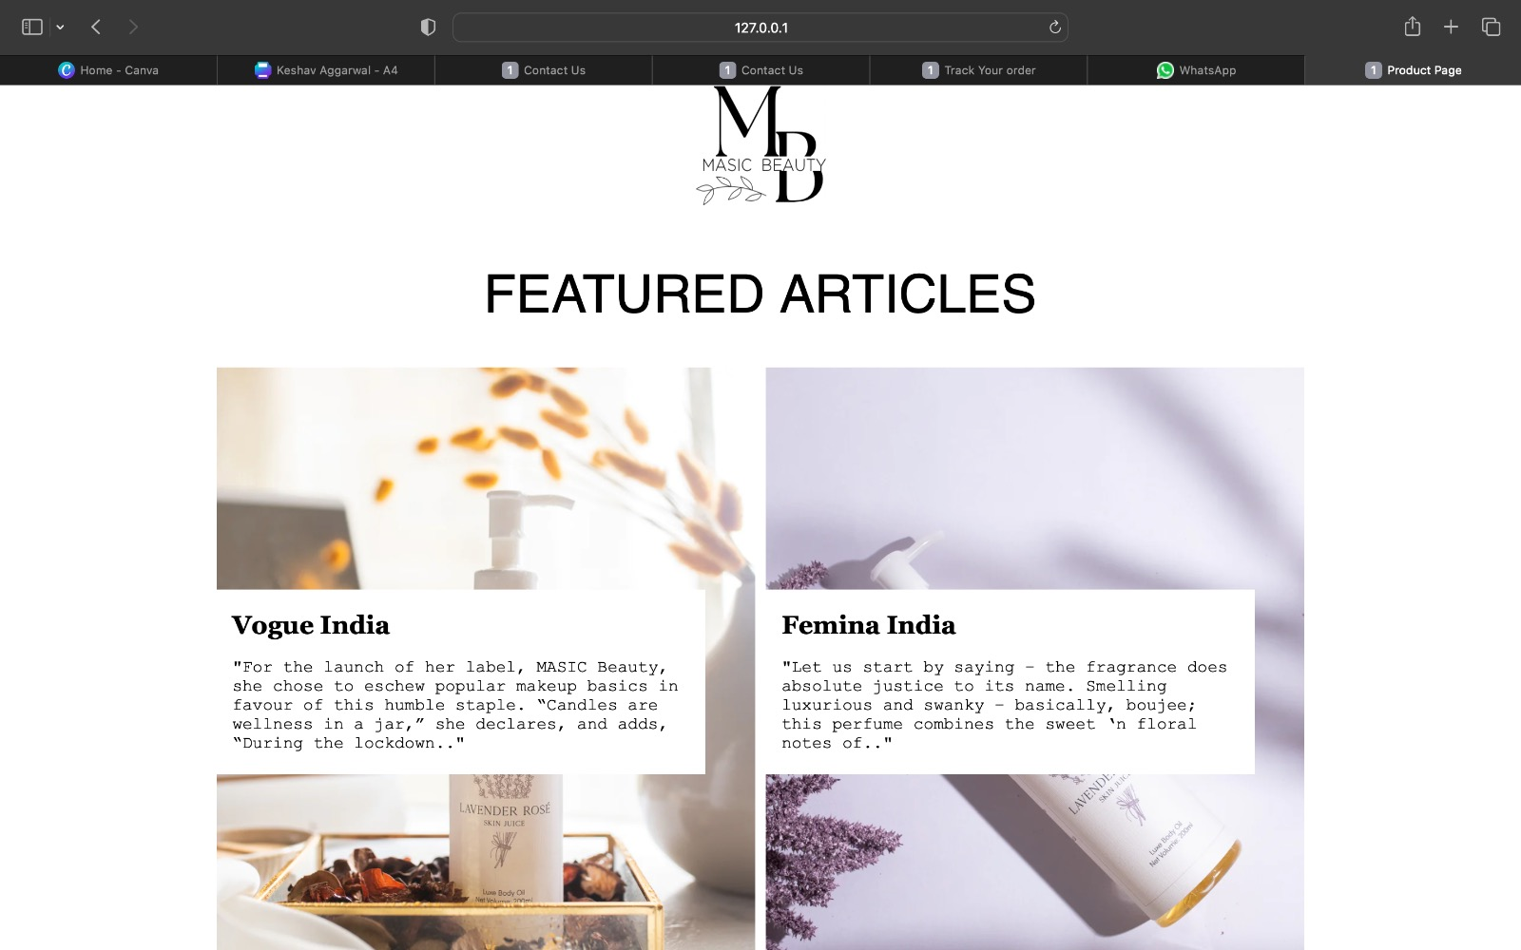

After this, there is a **PRODUCT REVIEW** section.

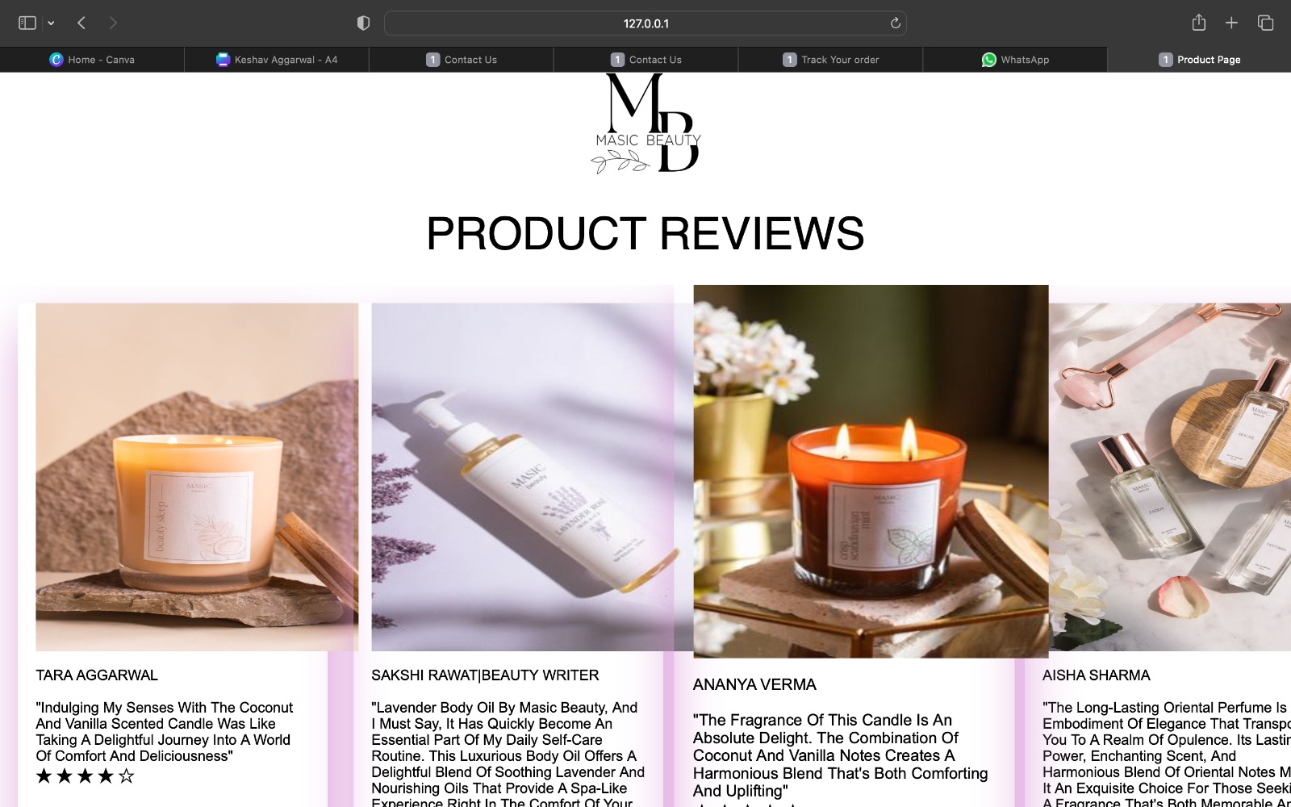

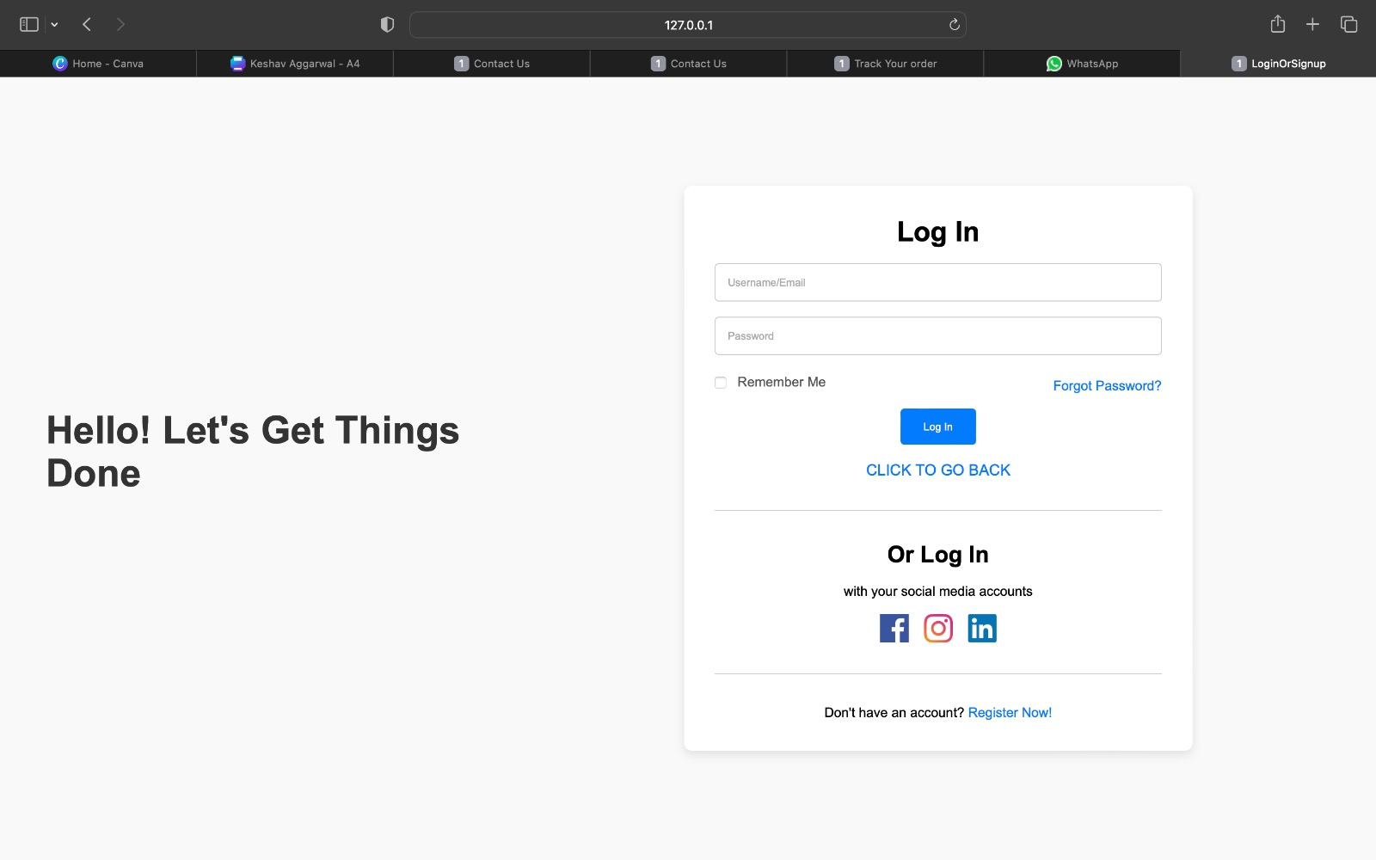

This is the **LOGIN PAGE** of the website where users can Login to their MASIC BEAUTY account by using their e-mail id and password. The users can also Login using Google and Facebook accounts. Also, if a user doesn’t have an account in MASIC BEAUTY then the user can sign up by clicking on “CLICK HERE” below the Login Button which will land the user to the **SIGN UP PAGE**.

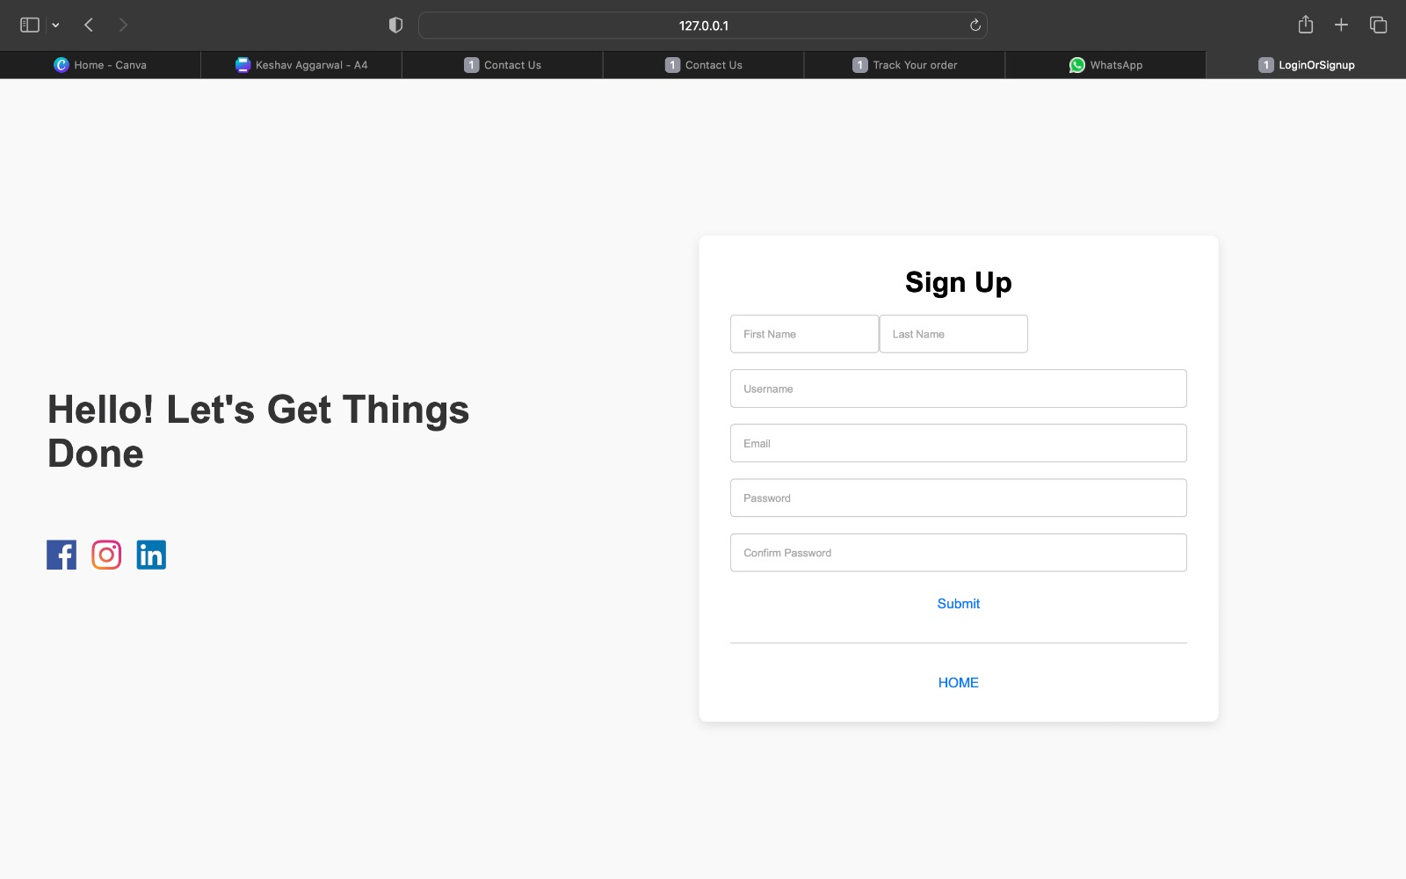

This is the **SIGN-UP PAGE** of the website where users can register themselves on MASIC BEAUTY by providing us with their personal details such as first name, last name, e-mail id, phone number and the password they would like to choose for their account. The users can also register via their Google and Facebook accounts.

Also, the user can return to the **LOGIN PAGE** by clicking on “RETURN TO LOGIN” option below the Sign in button.

