INTERNSHIP TASK 1
WEB SCRAPING USING PYTHON
A Practical Web Scraping Project
Student Name | ____________________________
Internship Organization | ____________________________
Internship Role | ____________________________
Date of Submission | ____________________________

1. Introduction
Web scraping is the process of collecting publicly available information from a website and converting it into a structured format that can be used for analysis. In this task, Python was used to collect book information from Books to Scrape, a website designed for web-scraping practice. The project demonstrates how a web page can be accessed, its HTML structure can be parsed, relevant information can be extracted, and the resulting dataset can be saved as a CSV file.

2. Objective
- To understand the basic concept of web scraping.
- To learn how to work with HTML structure.
- To use Python libraries for extracting information from web pages.
- To collect relevant information and create a custom dataset.
- To handle multiple web pages using pagination.
- To save the collected information in CSV format.

3. Website Used
Website: Books to Scrape
The website was selected because it provides a practice environment for web scraping. The project collected information from five catalogue pages.

4. Tools and Technologies
Tool / Technology | Purpose
Python | Programming language used for the scraping program
Requests | Sends HTTP requests and retrieves web page HTML
BeautifulSoup | Parses HTML and extracts required elements
Pandas | Creates and processes the structured dataset
CSV | Stores the final scraped dataset
Visual Studio Code | Used to write and execute the Python program

5. Data Fields Collected
Field | Description
Book Title | Name/title of the book
Price | Displayed price of the book
Rating | Star rating converted into a number from 1 to 5
Availability | Availability status of the book
Product URL | Link to the individual book page

6. Methodology
1. Created a Python file named task1.py in Visual Studio Code.
2. Installed the required Python libraries: requests, beautifulsoup4, and pandas.
3. Set the website URL and HTTP request headers.
4. Used the Requests library to retrieve each catalogue page.
5. Used BeautifulSoup to parse the HTML document.
6. Located the book elements using the relevant HTML tags and CSS classes.
7. Extracted the title, price, rating, availability, and product URL.
8. Repeated the process for five catalogue pages.
9. Stored the extracted records in a Pandas DataFrame.
10. Removed duplicate book records.
11. Exported the final DataFrame to books_dataset.csv.

7. Python Code
The main Python libraries used in the project were Requests, BeautifulSoup, and Pandas. The program sends requests to the website, parses the returned HTML, extracts the required fields, and writes the final dataset to a CSV file.
import requests
from bs4 import BeautifulSoup
import pandas as pd
BASE_URL = "https://books.toscrape.com/"
response = requests.get(BASE_URL)
soup = BeautifulSoup(response.text, "html.parser")
books = soup.find_all("article", class_="product_pod")
# Extract required fields from each book
# Store records in a Pandas DataFrame
# Export the result using:
df.to_csv("books_dataset.csv", index=False)

8. Results
The program successfully scraped five catalogue pages and collected 100 book records. The final dataset contains five columns: Book Title, Price, Rating, Availability, and Product URL. The dataset was successfully exported as books_dataset.csv.

9. Dataset Summary
Item | Result
Pages scraped | 5
Records collected | 100
Columns | 5
Output file | books_dataset.csv
Output format | CSV

10. Rating Distribution
The scraped dataset produced the following rating counts:
Rating | Number of Books
1 | 22
2 | 19
3 | 22
4 | 18
5 | 19

11. Output File
The final CSV file generated by the program is named books_dataset.csv. It contains the structured information extracted from the five scraped pages and can be opened using Microsoft Excel, Google Sheets, or another spreadsheet/data-analysis application.

12. Screenshots / Evidence
The following screenshots should be attached to the final internship submission:
- Website used for scraping.
- HTML structure inspected using browser Developer Tools.
- Python code in Visual Studio Code.
- Terminal showing successful scraping of five pages and 100 records.
- CSV dataset opened in Excel or another spreadsheet application.
- Final project folder containing task1.py and books_dataset.csv.

Execution screenshot: Screenshot 2026-09-25 104717.png
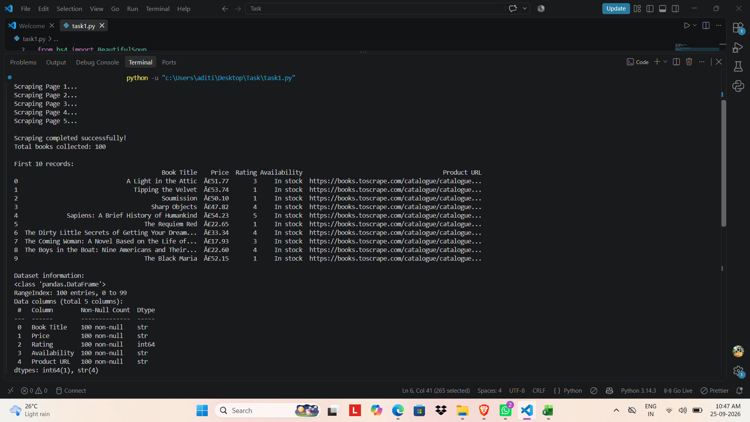
Execution screenshot: Screenshot 2026-09-25 104736.png
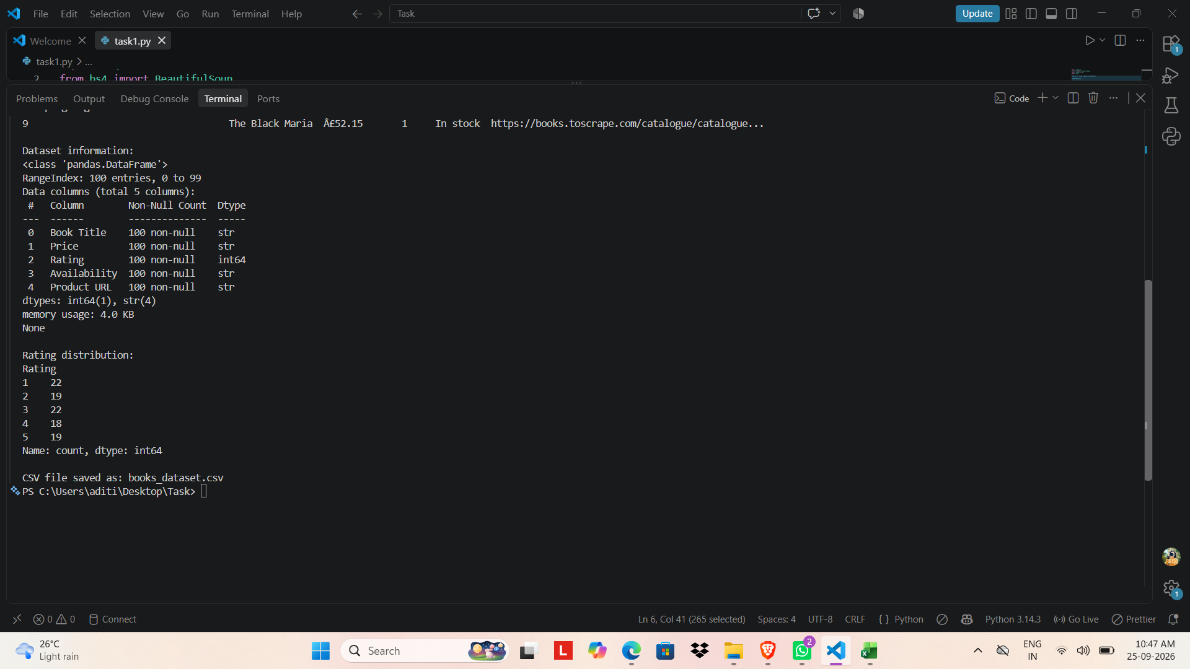

15. Limitations
- Web pages may change their HTML structure, which can affect the scraper.
- Internet connectivity is required to retrieve the web pages.
- Scraping should respect website terms, access rules, and reasonable request rates.
- This project uses a practice website; real-world websites may require additional handling for JavaScript, authentication, or anti-bot systems.

16. Conclusion
This task provided practical experience in web scraping using Python. The project demonstrated how to retrieve web pages, inspect HTML structure, extract relevant information with BeautifulSoup, process records using Pandas, handle multiple pages, and create a structured CSV dataset. The completed dataset and execution evidence can be submitted as part of the internship task.

- task1.py – Python scraping program
- books_dataset.csv – scraped dataset
- Internship report – this document
- Python code screenshot
- Terminal/output screenshot
- Dataset/Excel screenshot
- Project folder screenshot

13. Screenshot Evidence
The following screenshots document the implementation, successful execution, generated dataset, and project files for Internship Task 1.
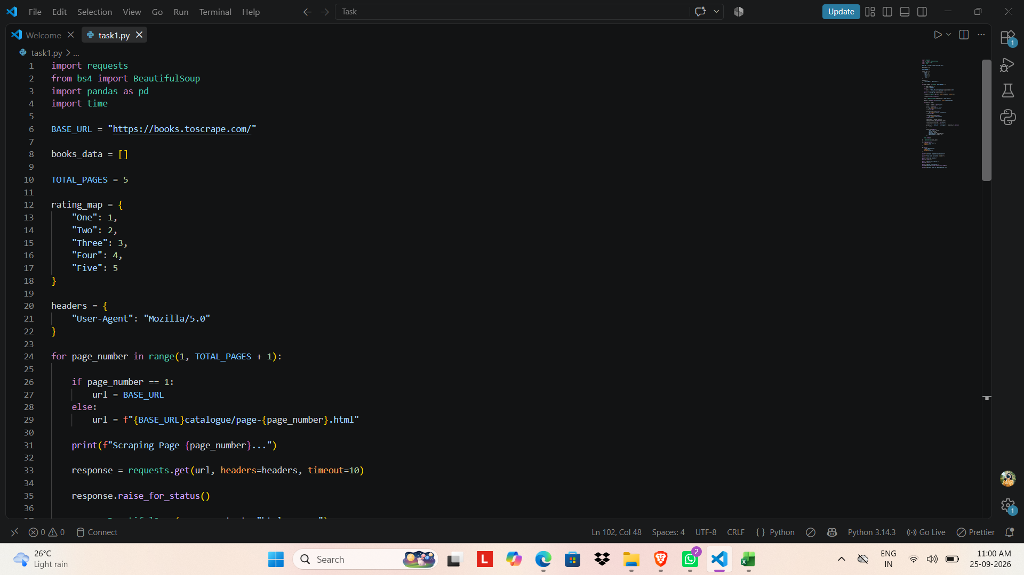
Figure 1: Python code setup using Requests, BeautifulSoup, and Pandas.
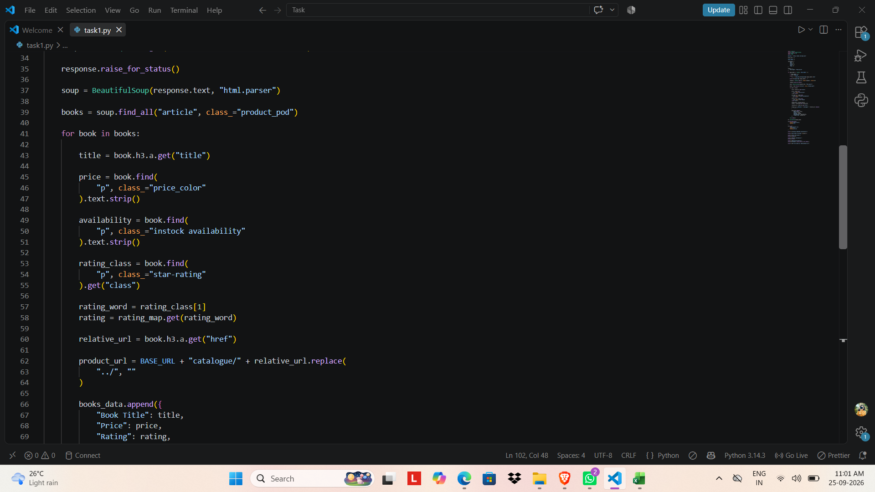
Figure 2: HTML parsing and extraction of book title, price, availability, rating, and URL.
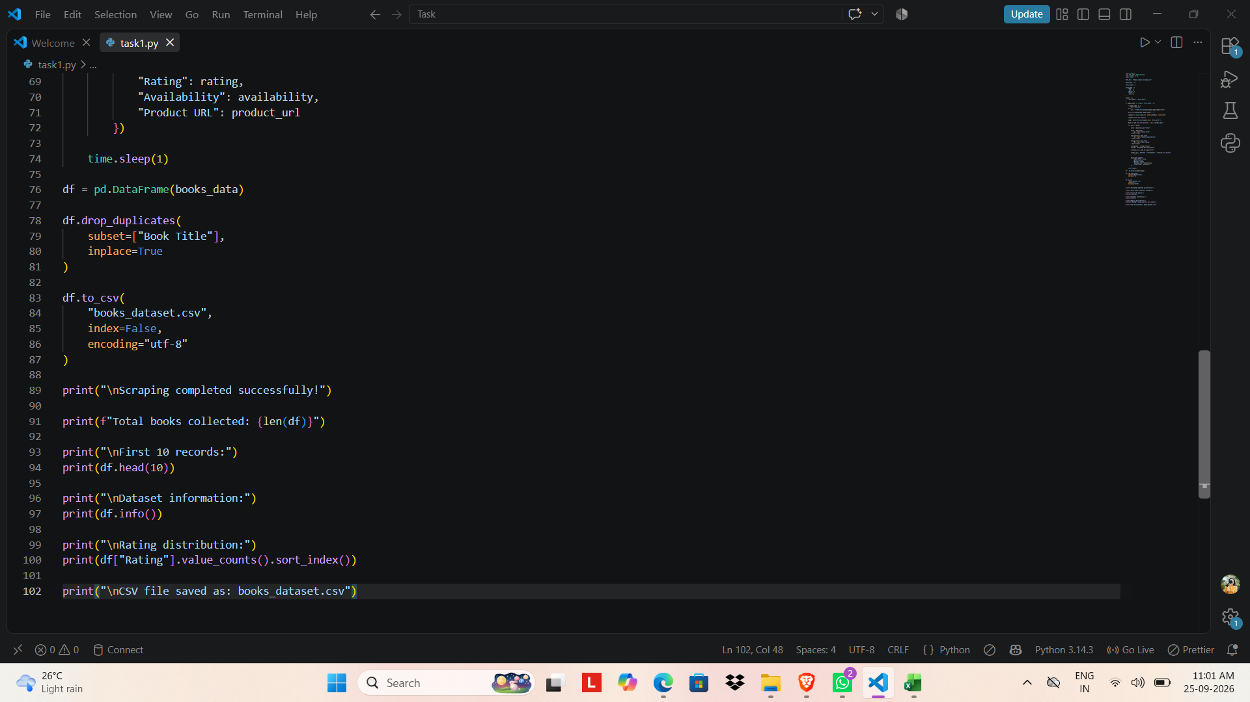
Figure 3: DataFrame creation, CSV export, and output summary code.
Figure 4: Successful scraping of five catalogue pages and collection of 100 books.
Figure 5: Dataset information, rating distribution, and successful CSV file generation.
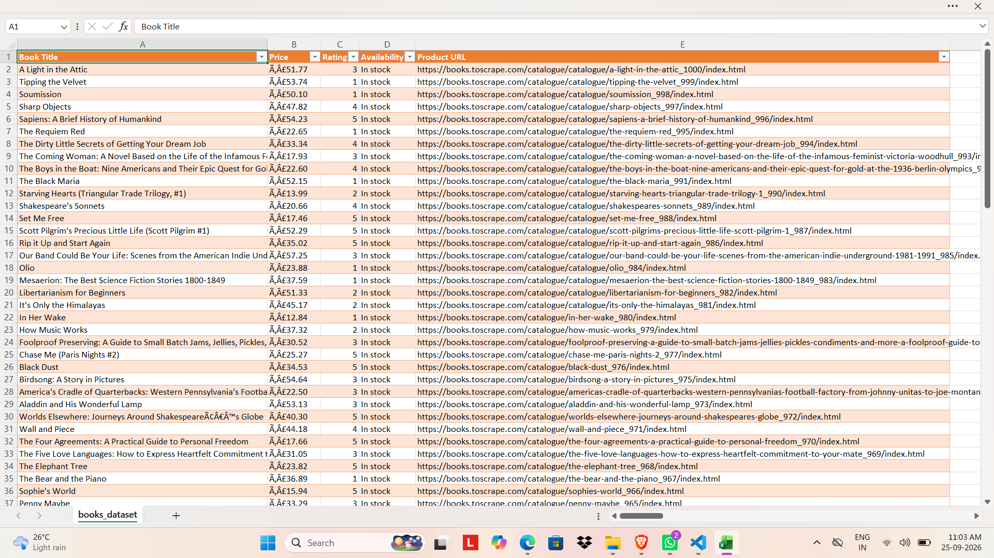
Figure 6: Generated books_dataset.csv opened in Excel with the five collected fields.
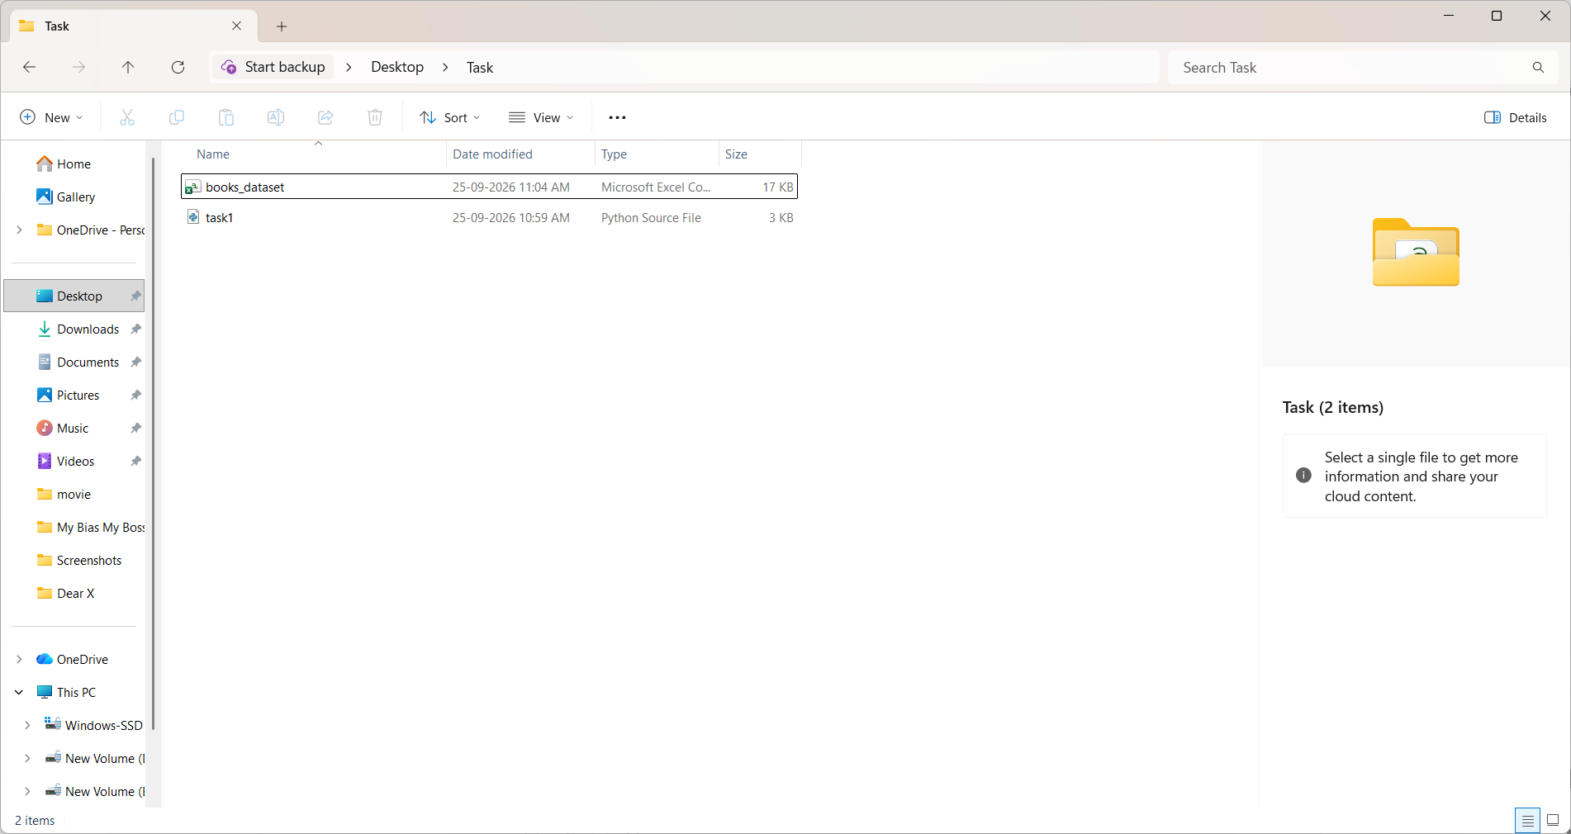
Figure 7: Final project folder containing task1.py and books_dataset.csv.

14. Final Submission Checklist
- task1.py – Python scraping program
- books_dataset.csv – scraped dataset
- Internship report with screenshot evidence
- Python code screenshots
- Terminal/output screenshots
- Dataset/Excel screenshot
- Project folder screenshot

