Assignment 6:- Project
Topic:- GroTrack — Household Grocery Inventory & Food Waste Tracker

1. Project Overview
GroTrack is an offline Android application that helps households manage grocery inventory, monitor expiry dates, maintain shopping lists, and reduce food waste.

2. Key Features
- Batch Management: Tracks separate purchases with individual quantities and expiry dates.
- Expiry Alerts: Uses WorkManager to notify users about groceries nearing or past expiry.
- Smart Shopping List: Suggests restocking items below minimum stock levels.
- Consumption & Waste Tracking: Records usage and discarded food with a transaction history.

3. Technology Stack
- Language: Java
- UI: XML and Material Components
- Database: Room with SQLite
- Background Tasks: AndroidX WorkManager

4. Database Design
The application uses four main tables:
- Products: Grocery details and minimum stock levels.
- Grocery Batches: Purchase quantities, dates, expiry dates, and prices.
- Shopping List Items: Planned purchases and purchase status.
- Stock History: Records purchases, consumption, and waste.

Feature / Screen 1: Home Dashboard Screen & Expiry Metrics

Partition 1: XML Layout Code | Partition 2: Java Implementation Code
<!-- activity_dashboard.xml excerpt -->  <ScrollView  xmlns:android="http://schemas.android.com/apk/res/android"  xmlns:app="http://schemas.android.com/apk/res-auto"  android:layout_width="match_parent"  android:layout_height="match_parent"  android:background="@color/grotrack_background"  android:fillViewport="true">  <LinearLayout  android:layout_width="match_parent"  android:layout_height="wrap_content"  android:orientation="vertical"  android:padding="20dp">  <!-- App Header Branding -->  <LinearLayout  android:layout_width="match_parent"  android:layout_height="wrap_content"  android:gravity="center_vertical"  android:orientation="horizontal">  <ImageView  android:layout_width="52dp"  android:layout_height="52dp"  android:src="@drawable/ic_grotrack_logo" />  <LinearLayout  android:layout_width="wrap_content"  android:layout_height="wrap_content"  android:orientation="vertical"  android:paddingStart="12dp">  <TextView  android:layout_width="wrap_content"  android:layout_height="wrap_content"  android:text="GroTrack"  android:textColor="@color/grotrack_dark_green"  android:textSize="25sp"  android:textStyle="bold" />  <TextView  android:layout_width="wrap_content"  android:layout_height="wrap_content"  android:text="Track Smart. Waste Less."  android:textColor="@color/grotrack_secondary"  android:textSize="13sp" />  </LinearLayout>  </LinearLayout>  <!-- Metric Summary Cards -->  <LinearLayout  android:layout_width="match_parent"  android:layout_height="wrap_content"  android:layout_marginTop="16dp"  android:orientation="horizontal">  <com.google.android.material.card.MaterialCardView  android:layout_width="0dp"  android:layout_height="92dp"  android:layout_weight="1"  app:cardBackgroundColor="@color/grotrack_light_green"  app:cardCornerRadius="18dp">  <LinearLayout  android:layout_width="match_parent"  android:layout_height="match_parent"  android:gravity="center"  android:orientation="vertical">  <TextView  android:id="@+id/homeProductCount"  android:layout_width="wrap_content"  android:layout_height="wrap_content"  android:text="0"  android:textColor="@color/grotrack_dark_green"  android:textSize="25sp"  android:textStyle="bold" />  <TextView  android:layout_width="wrap_content"  android:layout_height="wrap_content"  android:text="Products" />  </LinearLayout>  </com.google.android.material.card.MaterialCardView>  <com.google.android.material.card.MaterialCardView  android:layout_width="0dp"  android:layout_height="92dp"  android:layout_weight="1"  app:cardBackgroundColor="#FFF4D8"  app:cardCornerRadius="18dp">  <LinearLayout  android:layout_width="match_parent"  android:layout_height="match_parent"  android:gravity="center"  android:orientation="vertical">  <TextView  android:id="@+id/homeExpiringCount"  android:layout_width="wrap_content"  android:layout_height="wrap_content"  android:text="0"  android:textColor="#8A5A00"  android:textSize="25sp"  android:textStyle="bold" />  <TextView  android:layout_width="wrap_content"  android:layout_height="wrap_content"  android:text="Expiring soon" />  </LinearLayout>  </com.google.android.material.card.MaterialCardView>  <com.google.android.material.card.MaterialCardView  android:layout_width="0dp"  android:layout_height="92dp"  android:layout_weight="1"  app:cardBackgroundColor="#FCE8E6"  app:cardCornerRadius="18dp">  <LinearLayout  android:layout_width="match_parent"  android:layout_height="match_parent"  android:gravity="center"  android:orientation="vertical">  <TextView  android:id="@+id/homeLowStockCount"  android:layout_width="wrap_content"  android:layout_height="wrap_content"  android:text="0"  android:textColor="@color/grotrack_expired"  android:textSize="25sp"  android:textStyle="bold" />  <TextView  android:layout_width="wrap_content"  android:layout_height="wrap_content"  android:text="Low stock" />  </LinearLayout>  </com.google.android.material.card.MaterialCardView>  </LinearLayout>  <!-- Quick Access Navigation Cards -->  <LinearLayout  android:layout_width="match_parent"  android:layout_height="wrap_content"  android:orientation="horizontal">  <com.google.android.material.card.MaterialCardView  android:id="@+id/navInventoryCard"  android:layout_width="0dp"  android:layout_height="84dp"  android:layout_weight="1">  <TextView android:text="My Inventory" />  </com.google.android.material.card.MaterialCardView>  <com.google.android.material.card.MaterialCardView  android:id="@+id/navShoppingCard"  android:layout_width="0dp"  android:layout_height="84dp"  android:layout_weight="1">  <TextView android:text="Shopping List" />  </com.google.android.material.card.MaterialCardView>  </LinearLayout>  </LinearLayout>  </ScrollView> | // DashboardActivity.java excerpt  public class DashboardActivity extends AppCompatActivity {  private final ExecutorService executor =  Executors.newSingleThreadExecutor();  private GroTrackDatabase database;  private TextView productsCount, expiringCount;  private TextView lowStockCount, inventoryDetails;  @Override  protected void onCreate(Bundle savedInstanceState) {  SplashScreen.installSplashScreen(this);  super.onCreate(savedInstanceState);  WindowCompat.setDecorFitsSystemWindows(  getWindow(), true);  setContentView(R.layout.activity_dashboard);  database = GroTrackDatabase.getInstance(  getApplicationContext());  ExpiryWorkScheduler.schedulePeriodic(  getApplicationContext());  productsCount = findViewById(R.id.homeProductCount);  expiringCount = findViewById(R.id.homeExpiringCount);  lowStockCount = findViewById(R.id.homeLowStockCount);  inventoryDetails = findViewById(R.id.homeInventoryDetails);  findViewById(R.id.navInventoryCard)  .setOnClickListener(v -> startActivity(  new Intent(this, MainActivity.class)));  findViewById(R.id.navShoppingCard)  .setOnClickListener(v -> startActivity(  new Intent(this, ShoppingListActivity.class)));  findViewById(R.id.navWasteCard)  .setOnClickListener(v -> startActivity(  new Intent(this, WasteHistoryActivity.class)));  findViewById(R.id.navInsightsCard)  .setOnClickListener(v -> startActivity(  new Intent(this, InsightsActivity.class)));  }  @Override  protected void onResume() {  super.onResume();  loadDashboard();  }  private void loadDashboard() {  executor.execute(() -> {  LocalDate today = LocalDate.now();  List<Product> products =  database.productDao().getAll();  List<InventoryItem> batches =  database.batchDao().getInventory();  long weekStart = today.minusDays(6)  .atStartOfDay(ZoneId.systemDefault())  .toInstant().toEpochMilli();  long tomorrow = today.plusDays(1)  .atStartOfDay(ZoneId.systemDefault())  .toInstant().toEpochMilli();  List<HistoryItem> waste = database  .stockHistoryDao()  .getWasteHistory(weekStart, tomorrow, null);  DashboardSummary summary =  calculate(products, batches, waste, today);  runOnUiThread(() -> render(summary));  });  }  private void render(DashboardSummary summary) {  productsCount.setText(  String.valueOf(summary.products));  expiringCount.setText(  String.valueOf(summary.expiring));  lowStockCount.setText(  String.valueOf(summary.low));  inventoryDetails.setText(  "Expired batches with stock: " + summary.expired  + "\nProducts below minimum: " + summary.low);  }  }

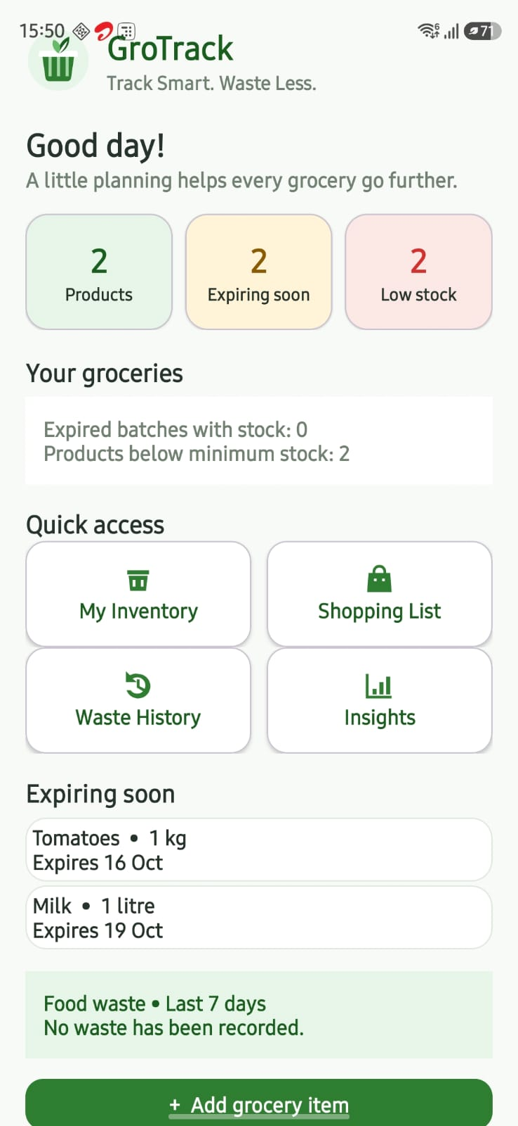
Feature / Screen 2: My Inventory Screen with Multi-Parameter Filters & Search

Partition 1: XML Layout Code | Partition 2: Java Implementation Code
<!-- activity_main.xml excerpt -->  <LinearLayout  xmlns:android="http://schemas.android.com/apk/res/android"  xmlns:app="http://schemas.android.com/apk/res-auto"  android:id="@+id/main"  android:layout_width="match_parent"  android:layout_height="match_parent"  android:orientation="vertical"  android:background="@color/grotrack_background"  android:padding="16dp">  <!-- Screen Title and Navigation -->  <LinearLayout  android:layout_width="match_parent"  android:layout_height="wrap_content"  android:gravity="center_vertical"  android:orientation="horizontal">  <Button  android:id="@+id/inventoryHomeButton"  android:layout_width="wrap_content"  android:layout_height="wrap_content"  android:text="‹ Home" />  <TextView  android:layout_width="wrap_content"  android:layout_height="wrap_content"  android:layout_marginStart="8dp"  android:text="My Inventory"  android:textColor="@color/grotrack_dark_green"  android:textSize="24sp"  android:textStyle="bold" />  </LinearLayout>  <!-- Real-time Text Filter -->  <EditText  android:id="@+id/searchInput"  android:layout_width="match_parent"  android:layout_height="wrap_content"  android:hint="Search product name"  android:singleLine="true" />  <!-- Material Category Chip Group -->  <HorizontalScrollView  android:layout_width="match_parent"  android:layout_height="wrap_content"  android:scrollbars="none">  <com.google.android.material.chip.ChipGroup  android:id="@+id/categoryFilterGroup"  android:layout_width="wrap_content"  android:layout_height="wrap_content"  app:singleSelection="true"  app:selectionRequired="true" />  </HorizontalScrollView>  <!-- Expiry Status Filter Spinner -->  <Spinner  android:id="@+id/statusFilter"  android:layout_width="match_parent"  android:layout_height="wrap_content" />  <!-- Batches Recycler View -->  <androidx.recyclerview.widget.RecyclerView  android:id="@+id/inventoryList"  android:layout_width="match_parent"  android:layout_height="0dp"  android:layout_weight="1" />  </LinearLayout> | // MainActivity.java excerpt  public class MainActivity extends AppCompatActivity {  private static final String[] CATEGORIES = {  "All categories", "Dairy", "Vegetables",  "Fruits", "Grains", "Packaged Food", "Other"};  private static final String[] STATUSES = {  "All statuses", "Fresh", "Expiring Soon", "Expired"};  private final ExecutorService databaseExecutor =  Executors.newSingleThreadExecutor();  private GroTrackDatabase database;  private InventoryAdapter adapter;  private final List<InventoryItem> inventory = new ArrayList<>();  private EditText searchInput;  private ChipGroup categoryFilterGroup;  private Spinner statusFilter;  @Override  protected void onCreate(Bundle savedInstanceState) {  super.onCreate(savedInstanceState);  setContentView(R.layout.activity_main);  database = GroTrackDatabase.getInstance(this);  RecyclerView list = findViewById(R.id.inventoryList);  list.setLayoutManager(new LinearLayoutManager(this));  adapter = new InventoryAdapter(new InventoryAdapter.Actions() {  @Override public void addBatch(InventoryItem item) {  showBatchDialog(item.productId, item.name, item.unit);  }  @Override public void edit(InventoryItem item) {  loadProductForEdit(item.productId);  }  @Override public void delete(InventoryItem item) {  confirmDelete(item);  }  @Override public void consume(InventoryItem item) {  showTransactionDialog(item, false);  }  @Override public void waste(InventoryItem item) {  showTransactionDialog(item, true);  }  });  list.setAdapter(adapter);  searchInput = findViewById(R.id.searchInput);  categoryFilterGroup = findViewById(R.id.categoryFilterGroup);  statusFilter = findViewById(R.id.statusFilter);  setupCategoryFilters();  setupSpinner(statusFilter, STATUSES);  searchInput.addTextChangedListener(new TextWatcher() {  public void beforeTextChanged(CharSequence s, int st, int c, int a) {}  public void onTextChanged(CharSequence s, int st, int b, int c) {  applyFilters();  }  public void afterTextChanged(Editable s) {}  });  categoryFilterGroup.setOnCheckedStateChangeListener(  (g, ids) -> applyFilters());  statusFilter.setOnItemSelectedListener(  new SimpleSelectionListener(this::applyFilters));  }  private void applyFilters() {  String query = searchInput.getText()  .toString().trim().toLowerCase(Locale.ROOT);  View checked = categoryFilterGroup.findViewById(  categoryFilterGroup.getCheckedChipId());  String cat = checked instanceof Chip ?  ((Chip) checked).getText().toString() : CATEGORIES[0];  String filterStat = statusFilter.getSelectedItem().toString();  List<InventoryItem> filtered = new ArrayList<>();  for (InventoryItem item : inventory) {  if (item.archived || !item.name.toLowerCase(Locale.ROOT).contains(query)) continue;  if (!CATEGORIES[0].equals(cat) && !cat.equals(item.category)) continue;  if (!STATUSES[0].equals(filterStat) && !filterStat.equals(status(item.expiryDate))) continue;  filtered.add(item);  }  adapter.submit(filtered);  }  }

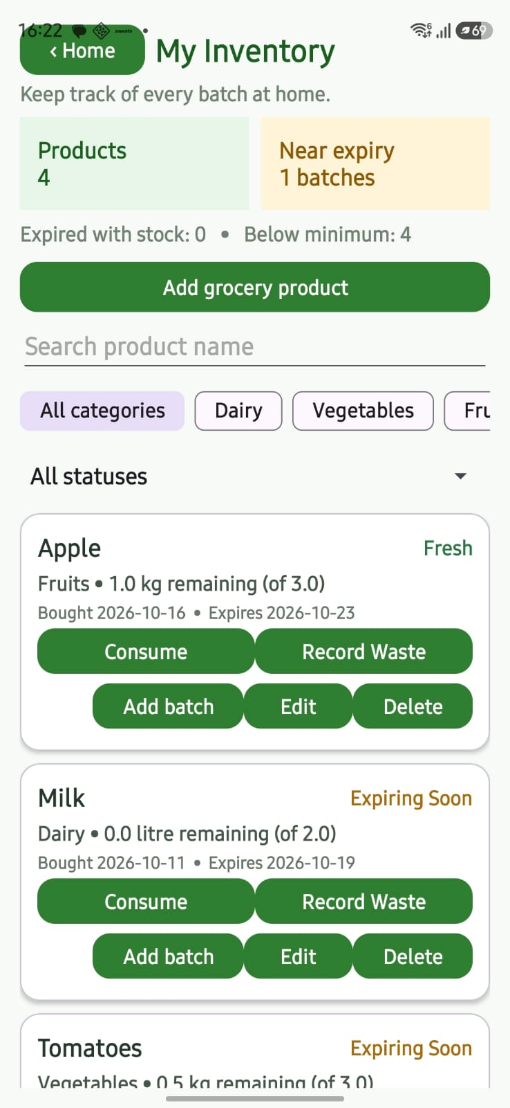
Feature / Screen 3: Add / Edit Grocery Product & Initial Batch Dialog

Partition 1: XML Layout Code | Partition 2: Java Implementation Code
<!-- dialog_product.xml -->  <ScrollView  xmlns:android="http://schemas.android.com/apk/res/android"  android:layout_width="match_parent"  android:layout_height="wrap_content"  android:fillViewport="true">  <LinearLayout  android:layout_width="match_parent"  android:layout_height="wrap_content"  android:orientation="vertical"  android:padding="20dp">  <EditText  android:id="@+id/productNameInput"  android:layout_width="match_parent"  android:layout_height="wrap_content"  android:hint="Product name"  android:inputType="textCapSentences" />  <Spinner  android:id="@+id/productCategoryInput"  android:layout_width="match_parent"  android:layout_height="wrap_content" />  <Spinner  android:id="@+id/productUnitInput"  android:layout_width="match_parent"  android:layout_height="wrap_content" />  <EditText  android:id="@+id/minimumStockInput"  android:layout_width="match_parent"  android:layout_height="wrap_content"  android:hint="Minimum stock level (0 or more)"  android:inputType="numberDecimal" />  <TextView  android:id="@+id/batchHeading"  android:layout_width="match_parent"  android:layout_height="wrap_content"  android:text="Initial purchase batch"  android:textStyle="bold"  android:textSize="18sp"  android:paddingTop="12dp" />  <EditText  android:id="@+id/quantityInput"  android:layout_width="match_parent"  android:layout_height="wrap_content"  android:hint="Purchased quantity (>0)"  android:inputType="numberDecimal" />  <EditText  android:id="@+id/priceInput"  android:layout_width="match_parent"  android:layout_height="wrap_content"  android:hint="Purchase price (optional)"  android:inputType="numberDecimal" />  <Button  android:id="@+id/purchaseDateButton"  android:layout_width="match_parent"  android:layout_height="wrap_content"  android:text="Purchase date" />  <Button  android:id="@+id/expiryDateButton"  android:layout_width="match_parent"  android:layout_height="wrap_content"  android:text="Expiry date" />  </LinearLayout>  </ScrollView> | // MainActivity.java - showProductDialog  private void showProductDialog(Product existing) {  View form = LayoutInflater.from(this)  .inflate(R.layout.dialog_product, null);  EditText name = form.findViewById(R.id.productNameInput);  EditText minimum = form.findViewById(R.id.minimumStockInput);  EditText quantity = form.findViewById(R.id.quantityInput);  EditText price = form.findViewById(R.id.priceInput);  Spinner category = form.findViewById(R.id.productCategoryInput);  Spinner unit = form.findViewById(R.id.productUnitInput);  setupSpinner(category, PRODUCT_CATEGORIES);  setupSpinner(unit, UNITS);  Button purchaseDate = form.findViewById(R.id.purchaseDateButton);  Button expiryDate = form.findViewById(R.id.expiryDateButton);  LocalDate[] dates = {LocalDate.now(), LocalDate.now().plusDays(7)};  setDateButton(purchaseDate, dates, 0, "Purchase date");  setDateButton(expiryDate, dates, 1, "Expiry date");  if (existing != null) {  name.setText(existing.name);  minimum.setText(number(existing.minimumStock));  category.setSelection(indexOf(PRODUCT_CATEGORIES, existing.category));  unit.setSelection(indexOf(UNITS, existing.unit));  unit.setEnabled(false); // Lock unit to preserve batch consistency  form.findViewById(R.id.batchHeading).setVisibility(View.GONE);  quantity.setVisibility(View.GONE);  price.setVisibility(View.GONE);  purchaseDate.setVisibility(View.GONE);  expiryDate.setVisibility(View.GONE);  }  AlertDialog dialog = new AlertDialog.Builder(this)  .setTitle(existing == null ? "Add grocery product" : "Edit product")  .setView(form)  .setNegativeButton("Cancel", null)  .setPositiveButton(existing == null ? "Save product" : "Save changes", null)  .create();  dialog.setOnShowListener(d -> dialog.getButton(  AlertDialog.BUTTON_POSITIVE).setOnClickListener(v -> {  String pName = name.getText().toString().trim();  Double min = parseNonNegative(minimum, "Minimum stock");  if (pName.isEmpty()) { name.setError("Required"); return; }  if (min == null) return;  String cat = category.getSelectedItem().toString();  String un = unit.getSelectedItem().toString();  if (existing == null) {  Double qty = parsePositive(quantity, "Quantity");  if (qty == null) return;  Double cost = parseOptionalNonNegative(price, "Price");  if (cost == INVALID) return;  Product product = new Product();  product.name = pName; product.category = cat;  product.unit = un; product.minimumStock = min;  GroceryBatch batch = makeBatch(qty, cost, dates[0], dates[1]);  databaseExecutor.execute(() -> {  RoomTransaction.run(database, () -> {  long id = database.productDao().insert(product);  product.id = id; batch.productId = id;  long bId = database.batchDao().insert(batch);  database.stockHistoryDao().insert(  purchaseHistory(id, bId, product.name, product.unit, batch.purchasedQuantity));  });  runOnUiThread(() -> {  dialog.dismiss(); loadInventory(); toast("Product and batch saved");  });  });  }  }));  dialog.show();  }

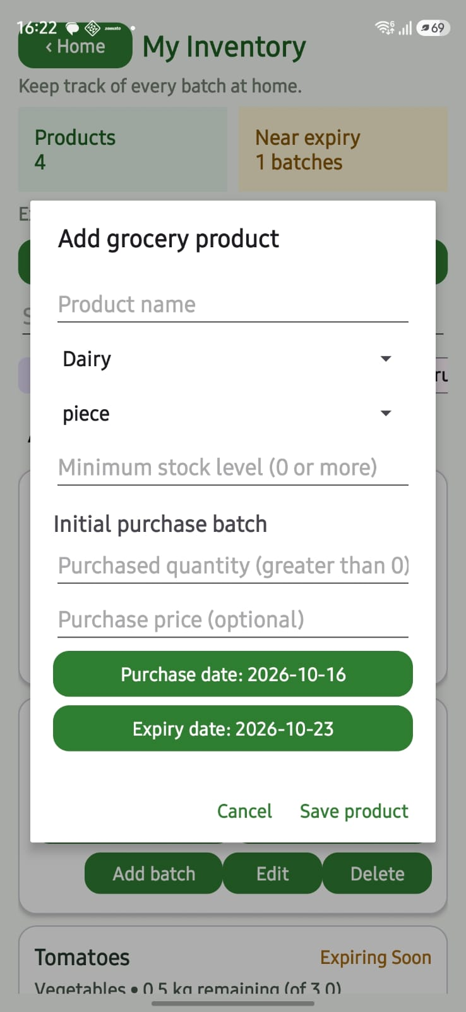
Feature / Screen 4: Add New Purchase Batch Dialog (Repeat Purchases)

Partition 1: XML Layout Code | Partition 2: Java Implementation Code
<!-- dialog_batch.xml -->  <LinearLayout  xmlns:android="http://schemas.android.com/apk/res/android"  android:layout_width="match_parent"  android:layout_height="wrap_content"  android:orientation="vertical"  android:padding="20dp">  <EditText  android:id="@+id/batchQuantityInput"  android:layout_width="match_parent"  android:layout_height="wrap_content"  android:hint="Purchased quantity (greater than 0)"  android:inputType="numberDecimal" />  <EditText  android:id="@+id/batchPriceInput"  android:layout_width="match_parent"  android:layout_height="wrap_content"  android:hint="Purchase price (optional)"  android:inputType="numberDecimal" />  <Button  android:id="@+id/batchPurchaseDateButton"  android:layout_width="match_parent"  android:layout_height="wrap_content"  android:text="Purchase date"  android:textAllCaps="false" />  <Button  android:id="@+id/batchExpiryDateButton"  android:layout_width="match_parent"  android:layout_height="wrap_content"  android:text="Expiry date"  android:textAllCaps="false" />  </LinearLayout> | // MainActivity.java - showBatchDialog  private void showBatchDialog(long productId, String productName, String productUnit) {  View form = LayoutInflater.from(this)  .inflate(R.layout.dialog_batch, null);  EditText quantity = form.findViewById(R.id.batchQuantityInput);  EditText price = form.findViewById(R.id.batchPriceInput);  Button purchase = form.findViewById(R.id.batchPurchaseDateButton);  Button expiry = form.findViewById(R.id.batchExpiryDateButton);  LocalDate[] dates = {LocalDate.now(), LocalDate.now().plusDays(7)};  setDateButton(purchase, dates, 0, "Purchase date");  setDateButton(expiry, dates, 1, "Expiry date");  AlertDialog dialog = new AlertDialog.Builder(this)  .setTitle("Record purchase: " + productName + " (" + productUnit + ")")  .setView(form)  .setNegativeButton("Cancel", null)  .setPositiveButton("Save batch", null)  .create();  dialog.setOnShowListener(d -> dialog.getButton(  AlertDialog.BUTTON_POSITIVE).setOnClickListener(v -> {  Double qty = parsePositive(quantity, "Purchased quantity");  if (qty == null) return;  Double cost = parseOptionalNonNegative(price, "Purchase price");  if (cost == INVALID) return;  GroceryBatch batch = makeBatch(qty, cost, dates[0], dates[1]);  batch.productId = productId;  databaseExecutor.execute(() -> {  RoomTransaction.run(database, () -> {  long batchId = database.batchDao().insert(batch);  database.stockHistoryDao().insert(  purchaseHistory(productId, batchId, productName, productUnit, batch.purchasedQuantity));  });  runOnUiThread(() -> {  dialog.dismiss();  loadInventory();  toast("Purchase batch recorded");  });  });  }));  dialog.show();  }

Feature / Screen 5: Stock Consumption & Food Waste Action Dialog
.
Partition 1: XML Layout Code | Partition 2: Java Implementation Code
<!-- dialog_stock_transaction.xml -->  <LinearLayout  xmlns:android="http://schemas.android.com/apk/res/android"  android:layout_width="match_parent"  android:layout_height="wrap_content"  android:orientation="vertical"  android:padding="20dp">  <EditText  android:id="@+id/transactionQuantityInput"  android:layout_width="match_parent"  android:layout_height="wrap_content"  android:hint="Quantity (greater than 0)"  android:inputType="numberDecimal" />  <!-- Reason dropdown displayed only when action is Waste -->  <Spinner  android:id="@+id/wasteReasonInput"  android:layout_width="match_parent"  android:layout_height="wrap_content" />  </LinearLayout> | // MainActivity.java - showTransactionDialog  private void showTransactionDialog(InventoryItem selected, boolean waste) {  View form = LayoutInflater.from(this)  .inflate(R.layout.dialog_stock_transaction, null);  EditText quantity = form.findViewById(R.id.transactionQuantityInput);  Spinner reason = form.findViewById(R.id.wasteReasonInput);  String[] reasons = {"Select a reason", "Expired", "Spoiled", "Excess purchase", "Other"};  reason.setAdapter(new ArrayAdapter<>(this, android.R.layout.simple_spinner_dropdown_item, reasons));  reason.setVisibility(waste ? View.VISIBLE : View.GONE);  String action = waste ? "WASTED" : "CONSUMED";  AlertDialog dialog = new AlertDialog.Builder(this)  .setTitle(waste ? "Record food waste" : "Record consumption")  .setMessage(selected.name + " • " + selected.remainingQuantity + " " + selected.unit + " available")  .setView(form)  .setNegativeButton("Cancel", null)  .setPositiveButton(waste ? "Record waste" : "Record consumption", null)  .create();  dialog.setOnShowListener(d -> dialog.getButton(  AlertDialog.BUTTON_POSITIVE).setOnClickListener(v -> {  Double amount = parsePositive(quantity, "Quantity");  if (amount == null) return;  String selectedReason = null;  if (waste) {  selectedReason = reason.getSelectedItem().toString();  if (reasons[0].equals(selectedReason)) {  Toast.makeText(this, "Choose a waste reason", Toast.LENGTH_SHORT).show();  return;  }  }  final String reasonValue = selectedReason;  databaseExecutor.execute(() -> {  String error = null;  try {  RoomTransaction.run(database, () -> {  int changed = database.batchDao().subtractStock(selected.batchId, amount);  if (changed != 1) {  throw new IllegalArgumentException("Quantity exceeds available stock.");  }  Product product = database.productDao().getById(selected.productId);  StockHistory history = new StockHistory();  history.productId = product.id;  history.batchId = selected.batchId;  history.productName = product.name;  history.unit = product.unit;  history.actionType = action;  history.quantity = amount;  history.reason = reasonValue;  history.timestamp = System.currentTimeMillis();  database.stockHistoryDao().insert(history);  });  } catch (Exception ex) {  error = ex.getMessage();  }  String message = error;  runOnUiThread(() -> {  if (message == null) {  dialog.dismiss();  loadInventory();  toast(waste ? "Waste recorded" : "Consumption recorded");  } else toast(message);  });  });  }));  dialog.show();  }

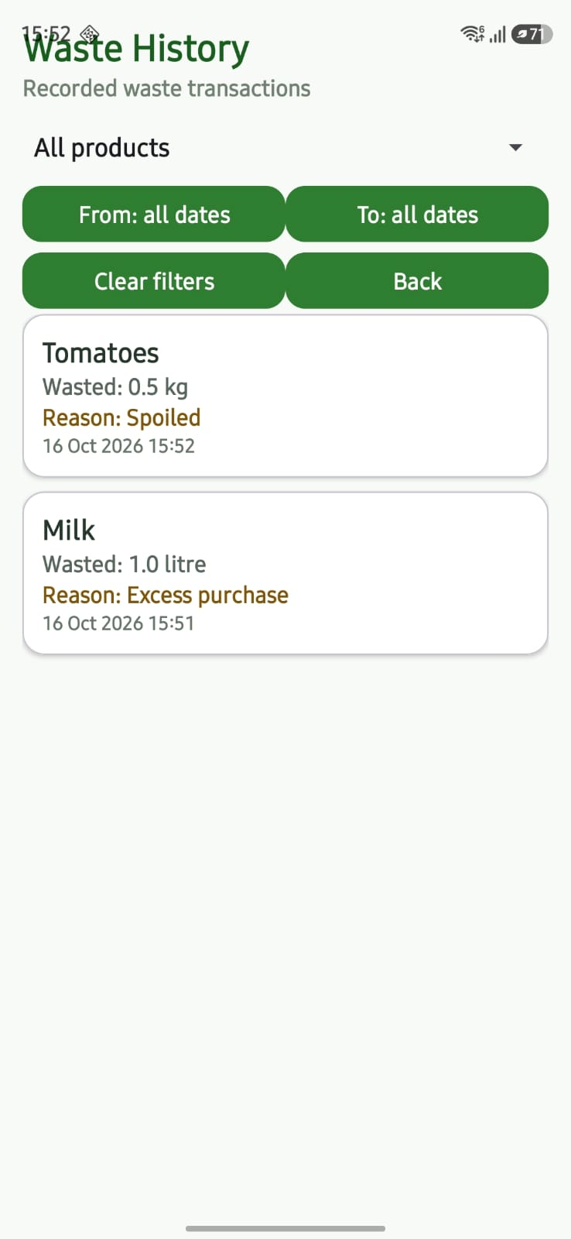
Feature / Screen 6: Smart Shopping List Screen & Purchase Conversion

Partition 1: XML Layout Code | Partition 2: Java Implementation Code
<!-- activity_shopping_list.xml -->  <LinearLayout  xmlns:android="http://schemas.android.com/apk/res/android"  android:layout_width="match_parent"  android:layout_height="match_parent"  android:orientation="vertical"  android:padding="16dp"  android:background="@color/grotrack_background">  <TextView  android:layout_width="match_parent"  android:layout_height="wrap_content"  android:text="Shopping List"  android:textSize="26sp"  android:textStyle="bold"  android:textColor="@color/grotrack_dark_green" />  <TextView  android:layout_width="match_parent"  android:layout_height="wrap_content"  android:text="Items enter inventory only after recording purchase."  android:textColor="@color/grotrack_secondary"  android:paddingBottom="8dp" />  <LinearLayout  android:layout_width="match_parent"  android:layout_height="wrap_content"  android:orientation="horizontal">  <Button  android:id="@+id/suggestLowStockButton"  android:layout_width="0dp"  android:layout_height="wrap_content"  android:layout_weight="1"  android:text="Suggest low stock" />  <Button  android:id="@+id/addShoppingItemButton"  android:layout_width="0dp"  android:layout_height="wrap_content"  android:layout_weight="1"  android:text="Add item" />  </LinearLayout>  <androidx.recyclerview.widget.RecyclerView  android:id="@+id/shoppingList"  android:layout_width="match_parent"  android:layout_height="0dp"  android:layout_weight="1" />  </LinearLayout> | // ShoppingListActivity.java - showPurchaseDialog  private void showPurchaseDialog(ShoppingListItem listed) {  View form = LayoutInflater.from(this)  .inflate(R.layout.dialog_batch, null);  EditText quantity = form.findViewById(R.id.batchQuantityInput);  EditText price = form.findViewById(R.id.batchPriceInput);  Button purchaseDate = form.findViewById(R.id.batchPurchaseDateButton);  Button expiryDate = form.findViewById(R.id.batchExpiryDateButton);  quantity.setText(number(listed.quantity));  LocalDate[] dates = {LocalDate.now(), LocalDate.now().plusDays(7)};  setDateButton(purchaseDate, dates, 0, "Purchase date");  setDateButton(expiryDate, dates, 1, "Expiry date");  AlertDialog dialog = new AlertDialog.Builder(this)  .setTitle("Record purchase: " + listed.itemName)  .setMessage("Inventory stock changes only when purchase is saved.")  .setView(form)  .setNegativeButton("Cancel", null)  .setPositiveButton("Save purchase", null)  .create();  dialog.setOnShowListener(d -> dialog.getButton(  AlertDialog.BUTTON_POSITIVE).setOnClickListener(v -> {  Double amount = parsePositive(quantity, "Purchased quantity");  if (amount == null) return;  Double cost = parseOptionalPrice(price);  if (cost == INVALID) return;  executor.execute(() -> {  RoomTransaction.run(database, () -> {  ShoppingListItem fresh = database.shoppingListDao().getById(listed.id);  Product product = fresh.productId == null ?  database.productDao().findActiveByNameAndUnit(fresh.itemName, fresh.unit) :  database.productDao().getById(fresh.productId);  if (product == null || product.archived) {  product = new Product();  product.name = fresh.itemName; product.category = "Other";  product.unit = fresh.unit; product.minimumStock = 0;  product.id = database.productDao().insert(product);  }  GroceryBatch batch = new GroceryBatch();  batch.productId = product.id;  batch.purchasedQuantity = amount;  batch.remainingQuantity = amount;  batch.purchaseDate = dates[0].format(DateTimeFormatter.ISO_LOCAL_DATE);  batch.expiryDate = dates[1].format(DateTimeFormatter.ISO_LOCAL_DATE);  batch.purchasePrice = cost;  long batchId = database.batchDao().insert(batch);  StockHistory history = new StockHistory();  history.productId = product.id; history.batchId = batchId;  history.productName = product.name; history.unit = product.unit;  history.actionType = "PURCHASE"; history.quantity = amount;  history.timestamp = System.currentTimeMillis();  database.stockHistoryDao().insert(history);  fresh.purchased = true;  database.shoppingListDao().update(fresh);  });  runOnUiThread(() -> {  dialog.dismiss(); loadItems(); toast("Batch created in inventory");  });  });  }));  dialog.show();  }

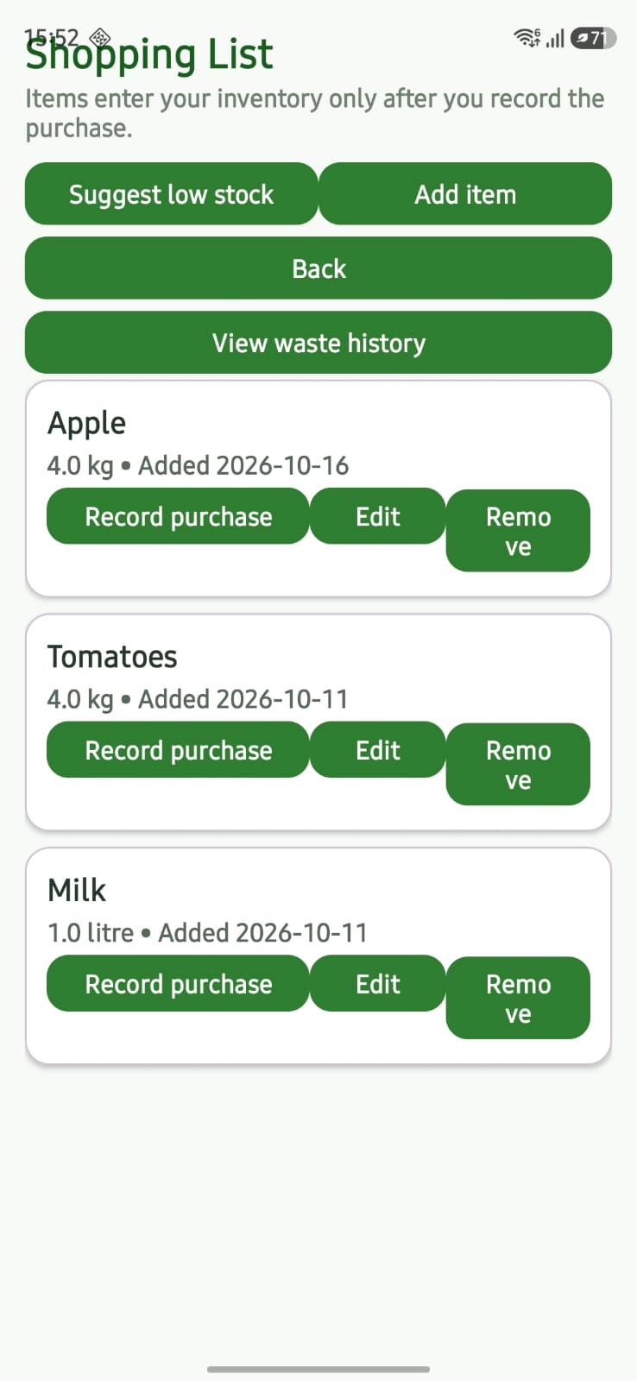

Feature / Screen 8: Waste History & Date Range Filtering Screen

Partition 1: XML Layout Code | Partition 2: Java Implementation Code
<!-- activity_waste_history.xml -->  <LinearLayout  xmlns:android="http://schemas.android.com/apk/res/android"  android:layout_width="match_parent"  android:layout_height="match_parent"  android:orientation="vertical"  android:padding="16dp"  android:background="@color/grotrack_background">  <TextView  android:layout_width="match_parent"  android:layout_height="wrap_content"  android:text="Waste History"  android:textSize="26sp"  android:textStyle="bold"  android:textColor="@color/grotrack_dark_green" />  <Spinner  android:id="@+id/wasteProductFilter"  android:layout_width="match_parent"  android:layout_height="wrap_content" />  <!-- Calendar Range Selectors -->  <LinearLayout  android:layout_width="match_parent"  android:layout_height="wrap_content"  android:orientation="horizontal">  <Button  android:id="@+id/wasteFromDateButton"  android:layout_width="0dp"  android:layout_height="wrap_content"  android:layout_weight="1"  android:text="From: all dates" />  <Button  android:id="@+id/wasteToDateButton"  android:layout_width="0dp"  android:layout_height="wrap_content"  android:layout_weight="1"  android:text="To: all dates" />  </LinearLayout>  <androidx.recyclerview.widget.RecyclerView  android:id="@+id/wasteHistoryList"  android:layout_width="match_parent"  android:layout_height="0dp"  android:layout_weight="1" />  </LinearLayout> | // WasteHistoryActivity.java excerpt  public class WasteHistoryActivity extends AppCompatActivity {  private final ExecutorService executor =  Executors.newSingleThreadExecutor();  private GroTrackDatabase database;  private WasteHistoryAdapter adapter;  private Spinner productFilter;  private LocalDate fromDate, toDate;  private List<ProductOption> productOptions = new ArrayList<>();  private void chooseDate(boolean isFrom) {  LocalDate initial = isFrom ? (fromDate == null ? LocalDate.now() : fromDate)  : (toDate == null ? LocalDate.now() : toDate);  new DatePickerDialog(this, (picker, year, month, day) -> {  LocalDate chosen = LocalDate.of(year, month + 1, day);  LocalDate newFrom = isFrom ? chosen : fromDate;  LocalDate newTo = isFrom ? toDate : chosen;  if (newFrom != null && newTo != null && newFrom.isAfter(newTo)) {  Toast.makeText(this, "Start date cannot exceed end date",  Toast.LENGTH_SHORT).show();  return;  }  if (isFrom) fromDate = chosen; else toDate = chosen;  updateDateLabels();  loadHistory();  }, initial.getYear(), initial.getMonthValue() - 1, initial.getDayOfMonth()).show();  }  private void loadHistory() {  if (productOptions.isEmpty()) return;  long start = fromDate == null ? 0 :  fromDate.atStartOfDay(ZoneId.systemDefault()).toInstant().toEpochMilli();  long end = toDate == null ? 0 :  toDate.plusDays(1).atStartOfDay(ZoneId.systemDefault()).toInstant().toEpochMilli();  Object selected = productFilter.getSelectedItem();  Long productId = selected instanceof ProductOption ?  ((ProductOption) selected).id : null;  executor.execute(() -> {  List<HistoryItem> data = database.stockHistoryDao()  .getWasteHistory(start, end, productId);  runOnUiThread(() -> adapter.submit(data));  });  }  }

Feature / Screen 9: Consumption & Waste Analytics Insights Screen
Calculates household waste metrics across 7, 30, 90 day, and all-time windows. Groups waste by physical measurement unit to avoid conflating incompatible units, and ranks the most wasted products.
Partition 1: XML Layout Code | Partition 2: Java Implementation Code
<!-- activity_insights.xml -->  <ScrollView  xmlns:android="http://schemas.android.com/apk/res/android"  android:layout_width="match_parent"  android:layout_height="match_parent"  android:fillViewport="true"  android:background="@color/grotrack_background">  <LinearLayout  android:layout_width="match_parent"  android:layout_height="wrap_content"  android:orientation="vertical"  android:padding="18dp">  <TextView  android:layout_width="match_parent"  android:layout_height="wrap_content"  android:text="GroTrack Insights"  android:textSize="26sp"  android:textStyle="bold"  android:textColor="@color/grotrack_dark_green" />  <Spinner  android:id="@+id/insightPeriodFilter"  android:layout_width="match_parent"  android:layout_height="wrap_content" />  <TextView  android:id="@+id/insightWasteRecordCount"  android:layout_width="match_parent"  android:layout_height="wrap_content"  android:background="#FFF4D8"  android:padding="14dp"  android:text="Waste records: 0"  android:textStyle="bold" />  <TextView  android:id="@+id/insightWasteQuantity"  android:layout_width="match_parent"  android:layout_height="wrap_content"  android:padding="12dp"  android:background="@color/grotrack_card"  android:text="Wasted quantity by unit" />  <TextView  android:id="@+id/insightTopWasted"  android:layout_width="match_parent"  android:layout_height="wrap_content"  android:padding="12dp"  android:background="@color/grotrack_card"  android:text="Most frequently wasted products" />  </LinearLayout>  </ScrollView> | // InsightsActivity.java - summarize  private Summary summarize(List<Product> products, List<InventoryItem> batches, List<HistoryItem> waste) {  int expiring = 0, expired = 0, low = 0, activeProducts = 0;  Map<Long, Double> quantities = new HashMap<>();  for (Product product : products) if (!product.archived) activeProducts++;  for (InventoryItem batch : batches) {  if (batch.archived) continue;  quantities.put(batch.productId,  quantities.getOrDefault(batch.productId, 0d) + batch.remainingQuantity);  if (batch.remainingQuantity <= 0) continue;  try {  long days = ChronoUnit.DAYS.between(LocalDate.now(), LocalDate.parse(batch.expiryDate));  if (days < 0) expired++; else if (days <= 3) expiring++;  } catch (Exception ignored) {}  }  for (Product p : products) {  if (!p.archived && quantities.getOrDefault(p.id, 0d) < p.minimumStock) low++;  }  Map<String, BigDecimal> units = new TreeMap<>();  Map<String, WasteStat> productsWasted = new HashMap<>();  for (HistoryItem item : waste) {  String unit = item.unit == null ? "unit not set" : item.unit;  BigDecimal quantity = BigDecimal.valueOf(item.quantity);  units.put(unit, units.getOrDefault(unit, BigDecimal.ZERO).add(quantity));  String name = item.productName == null ? "Removed product" : item.productName;  String key = name.toLowerCase(Locale.ROOT) + "\0" + unit.toLowerCase(Locale.ROOT);  WasteStat stat = productsWasted.computeIfAbsent(key, k -> new WasteStat(name, unit));  stat.count++;  stat.quantity = stat.quantity.add(quantity);  }  List<WasteStat> ranked = new ArrayList<>(productsWasted.values());  ranked.sort((l, r) -> {  int cmp = Integer.compare(r.count, l.count);  return cmp != 0 ? cmp : r.quantity.compareTo(l.quantity);  });  return new Summary(activeProducts, expiring, expired, low, waste.size(), units, ranked);  }

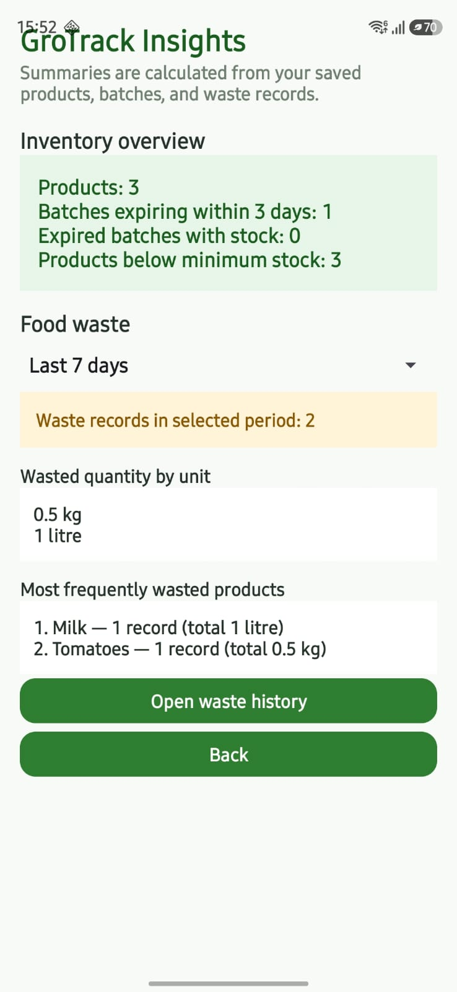
Feature / Screen 10: System Notifications

Partition 1: XML Layout Code | Partition 2: Java Implementation Code
<manifest  xmlns:android="http://schemas.android.com/apk/res/android"  xmlns:tools="http://schemas.android.com/tools">  <!-- Android 13+ Runtime Post Notification Permission -->  <uses-permission android:name="android.permission.POST_NOTIFICATIONS" />  <application  android:allowBackup="true"  android:icon="@mipmap/ic_launcher"  android:label="@string/app_name"  android:theme="@style/Theme.GroTrack">  <!-- Notification Channel Configuration Strings -->  <!-- Channel ID: grotrack_expiry_channel -->  <!-- Channel Name: Expiry Alerts -->  <!-- Channel Importance: IMPORTANCE_DEFAULT -->  <activity  android:name=".DashboardActivity"  android:exported="true"  android:theme="@style/Theme.GroTrack.Starting">  <intent-filter>  <action android:name="android.intent.action.MAIN" />  <category android:name="android.intent.category.LAUNCHER" />  </intent-filter>  </activity>  </application>  </manifest> | // ExpiryCheckWorker.java - doWork  public class ExpiryCheckWorker extends Worker {  public static final String KEY_TEST_RUN = "testRun";  public ExpiryCheckWorker(@NonNull Context context, @NonNull WorkerParameters parameters) {  super(context, parameters);  }  @NonNull @Override  public Result doWork() {  try {  List<InventoryItem> items = GroTrackDatabase.getInstance(getApplicationContext())  .batchDao().getInventory();  LocalDate today = LocalDate.now();  int expiring = 0, expired = 0;  List<String> examples = new ArrayList<>();  for (InventoryItem item : items) {  if (item.archived || item.remainingQuantity <= 0 || item.expiryDate == null) continue;  LocalDate expiry = LocalDate.parse(item.expiryDate);  long days = ChronoUnit.DAYS.between(today, expiry);  if (days < 0) {  expired++;  if (examples.size() < 3) examples.add(item.name + " (expired)");  } else if (days <= 3) {  expiring++;  if (examples.size() < 3) examples.add(item.name + (days == 0 ? " (today)" : " (" + days + "d)"));  }  }  boolean testRun = getInputData().getBoolean(KEY_TEST_RUN, false);  if (expiring + expired == 0 && !testRun) return Result.success();  if (!ExpiryNotifications.canNotify(getApplicationContext())) return Result.success();  String title = expiring + expired == 0 ? "GroTrack expiry check" : "Groceries need attention";  String message = expiring + " expiring soon, " + expired + " expired with stock.";  if (!examples.isEmpty()) message += " " + String.join(", ", examples);  ExpiryNotifications.show(getApplicationContext(), title, message);  return Result.success();  } catch (Exception ex) {  return Result.retry();  }  }  }



