**An Internet of Everything Lab**

**Mini Project Report on**

# **“Smart road sign alert system using RFID and RF communication”**

**Submitted in partial fulfilment of the requirement for Degree in Bachelor of Engineering**

**(Information Technology)**

**By**

|  |  |
| --- | --- |
| Atharva Ambike | (5021104) |
| Aditi Bhilare | (5021107) |
| Saee Biwalkar | (5021108) |

**Guided by:**

Dr. Trupti Lotlikar



**Department of Information Technology**

**Fr. Conceicao Rodrigues Institute of Technology**

Sector 9A, Vashi, Navi Mumbai – 400703

**University of Mumbai 2024-2025**

### **CERTIFICATE**

This is to certify that the Mini Project entitled

## **“Smart road sign alert system using RFID and RF communication”**

###### **Submitted By**

|  |  |
| --- | --- |
| Atharva Ambike | (5021104) |
| Aditi Bhilare | (5021107) |
| Saee Biwalkar | (5021108) |

In partial fulfilment of the degree of **B.E**. in **Information Technology** for term work of

Mini Project is approved.

ShapeShape

**External Examiner Internal Examiner Internal Guide**

ShapeShape

**Head of the Department**  **Principal**

**Declaration**

#### I declare that this written submission represents my ideas in my own words and where others' ideas or words have been included, I have adequately cited and referenced the original sources. I also declare that I have adhered to all principles of academic honesty and integrity and have not misrepresented or fabricated or falsified any idea/data/fact/source in my submission. I understand that any violation of the above will be cause for disciplinary action by the Institute and can also evoke penal action from the sources which have thus not been properly cited or from whom proper permission has not been taken when needed.

|  |  |  |
| --- | --- | --- |
| Atharva Ambike | (5021104) | _________ |
| Aditi Bhilare | (5021107) | _________ |
| Saee Biwalkar | (5021108) | _________ |

### **ABSTRACT**

The Smart Road Sign Alert System using RFID and RF Communication is a prototype aimed at enhancing driver safety by providing real-time alerts about road signs and hazards. Utilizing RFID technology, the system detects road signs equipped with RFID tags, with the data then transmitted to the vehicle's onboard system via RF communication. This information is displayed to the driver through in-dash alerts or audio signals, ensuring continuous awareness of important road signs, even in challenging conditions like poor visibility or unfamiliar roads. Cost-effective and simple, this system offers a foundational step towards advanced Intelligent Transport Systems (ITS), highlighting the potential of RFID and RF communication in improving road safety.

# **INDEX**

|  |  |  |
| --- | --- | --- |
| **SR NO.** | **TOPIC** | **PAGE NO.** |
| 1 | **Introduction** | 6 |
| 2 | **Literature Survey**  2.1 Existing System  2.2 Proposed System | 9 |
| 3 | **Analysis**  3.1 Hardware Requirements  3.2 Software Requirements | 14 |
| 4 | **Design**  4.1 System Block Design  4.2 Flowchart | **17** |
| 5 | **Installation And Configuration of Sensors**  5.1 Installation  5.2 Circuit Design | **20** |
| 6 | **Assembling of Sensors and Interfacing with Software**  6.1 Arduino Code | **24** |
| 7 | **User Interfacing** | **27** |
| 8 | **Results** | **28** |
| 9 | **Conclusion** | 29 |
| 10 | **References** | 30 |
| 11 | **Acknowledgements** | 31 |

**Chapter 1: Introduction**

1.1 Background

Road signs have long been a fundamental component of global traffic management systems. These signs play a crucial role in providing vital information to drivers, such as speed limits, potential road hazards, directions, and various regulations designed to promote road safety. In modern urban and rural road networks, road signs are essential to maintain smooth traffic flow and minimize the risk of accidents. However, despite their importance, road signs are often subject to several limitations, which can reduce their effectiveness. These limitations primarily arise from factors such as environmental conditions, driver behavior, and infrastructure challenges.

- Visibility Issues

**Poor Weather Conditions:** During adverse weather conditions such as heavy rain, snow, or dense fog, the visibility of road signs may become compromised. In such conditions, signs are often difficult to read or may even be completely obscured from a driver’s view. This issue significantly increases the risk of accidents as drivers might fail to interpret critical road instructions in time.

**Night-time Driving:** Low-light conditions during night-time driving pose another visibility challenge. Although many road signs are equipped with reflective surfaces to enhance visibility at night, their effectiveness is still dependent on external light sources, such as headlights. Even then, drivers may not notice these signs quickly enough, especially on unfamiliar roads, potentially resulting in hazardous driving situations.

**Obstructions:** In certain cases, physical obstructions such as trees, billboards, or even other vehicles may block road signs, making them difficult to see in time. This presents a particular danger in fast-moving traffic or on unfamiliar routes, where delayed recognition of road instructions can lead to accidents.

- Driver Attention and Cognitive Load

**Fatigue and Distraction:** Another challenge arises from the driver's state of mind. Drivers may be fatigued or distracted, reducing their ability to notice and correctly interpret road signs. Distractions may come from within the vehicle, such as mobile phones or passenger conversations, or externally, from complex or congested traffic situations. In such conditions, drivers may overlook road signs, leading to dangerous situations.

**Unfamiliar Roads:** On unfamiliar roads, the mental load on drivers increases as they navigate unknown territories. This cognitive burden can lead to drivers missing critical signs such as stop signs or warnings about sharp turns. This lack of awareness can be particularly problematic in areas with complex road layouts, such as urban centers or mountainous regions.

**Language and Symbol Recognition:** Despite the global standardization of road signs, there are still differences in symbols and layouts between regions. This can create confusion, particularly for international drivers who may not be familiar with local signage conventions. Additionally, drivers with visual impairments or cognitive limitations may find it harder to quickly interpret the information conveyed by traditional road signs.

Given the combination of visibility challenges and cognitive overload on drivers, there is a growing recognition of the need for advanced systems that can complement or replace the reliance on visual road signs. The solution to these challenges lies in the adoption of smart technologies that enable real-time communication between the road infrastructure and vehicles.

1.2 Motivation

The motivation behind developing a Smart Road Sign Alert System from the growing need to enhance road safety through the use of intelligent solutions. Every year, a significant proportion of road accidents are caused by drivers missing or misinterpreting road signs. This problem is exacerbated in poor weather conditions, at night, and in high-traffic or unfamiliar road environments. As more nations advance toward implementing autonomous vehicles and smart cities, the demand for real-time systems that provide immediate, reliable road sign information to drivers has never been higher.

The traditional reliance on static, visual signs is no longer sufficient in the context of modern transportation networks, which are increasingly integrated with Internet of Things (IoT) and autonomous driving technologies. To improve road safety, a solution that can provide continuous, real-time road sign alerts to drivers is necessary. RFID technology offers a promising approach to addressing these challenges.

RFID technology, which is widely used across industries due to its low cost, reliability, and scalability, presents a viable solution. With the use of RFID tags attached to road signs and RFID readers installed in vehicles, it is possible to automate the communication of road sign information. This eliminates the need for drivers to visually detect signs, reducing the risk of accidents caused by missed signs. This system can significantly improve driver awareness, particularly in adverse conditions where visibility is poor or in situations where the driver's cognitive load is high.

1.3 Objective

The primary objective of the Smart Road Sign Alert System is to enhance road safety by providing drivers with real-time alerts about upcoming road signs and hazards, regardless of environmental or situational challenges. The system aims to ensure that drivers are continuously aware of critical road information, even in scenarios where traditional road signs may be difficult to see or interpret.

**The specific aims of the project include:**

1. Improving the visibility of road signs: The system will enhance road safety by ensuring that road sign information is accessible to drivers in all conditions, including low-light situations, adverse weather, and congested road environments where signs may be obstructed.

2. Reducing driver cognitive load: By automating the detection and alerting process, the system reduces the cognitive burden on drivers, particularly in unfamiliar environments. This can help prevent accidents caused by missed signs or delayed reaction times.

3. Providing a scalable, cost-effective solution: The system is designed to be retrofitted to existing vehicles and road infrastructure using cost-effective RFID technology, making it an affordable and scalable solution for widespread adoption.

4. Supporting intelligent transport systems (ITS) and the Internet of Vehicles (IoV): This system lays the groundwork for integration with future smart city initiatives, autonomous driving technologies, and broader intelligent transport systems. It represents a step towards a more connected, automated road network.

**Chapter 2: Literature Survey**

1. **RF-ID Based Road Sign Detection And Automatic Vehicle Speed control System**.

To enhance road safety and reduce accidents, especially in high-risk areas like school zones, hills, and highways, we propose an RFID-based system for vehicles. This system alerts drivers about approaching road conditions and speed limits via visual and audio signals, providing advance warnings at an appropriate distance. Our solution includes two main components: a zone status transmitter and a vehicle-mounted receiver. The receiver not only alerts the driver but can also automatically adjust the vehicle's speed in response to the received information. This approach aims to improve safety by offering a dynamic and responsive alternative to static road signs, reducing reliance on them and helping prevent accidents and traffic jams.

1. **Smart Traffic Control System Using RFID.**

Traffic lights often hinder emergency vehicles during congestion, delaying crucial medical responses. Our Traffic Control System addresses this by using RFID technology to identify emergency vehicles and automatically adjust traffic signals to provide a clear path. RFID tags and ultrasonic sensors work together to detect the vehicle's approach and traffic density, ensuring signals change in real time to facilitate uninterrupted passage. This system operates autonomously, enhancing emergency response efficiency by minimizing delays at traffic signals

1. **Traffic Control System for Emergency Vehicles.**

Traffic lights often hinder emergency vehicles during congestion, delaying crucial medical responses. Our Traffic Control System addresses this by using RFID technology to identify emergency vehicles and automatically adjust traffic signals to provide a clear path. RFID tags and ultrasonic sensors work together to detect the vehicle's approach and traffic density, ensuring signals change in real time to facilitate uninterrupted passage. This system operates autonomously, enhancing emergency response efficiency by minimizing delays at traffic signals.

Table No. 1 (Literature Survey)

|  |  |  |  |  |  |
| --- | --- | --- | --- | --- | --- |
| **Sr No** | **Paper Name** | **Author** | **Year** | **Findings** | **Research Gap** |
| 1 | RF-ID BASED ROAD SIGN DETECTION AND AUTOMATIC VEHICLE SPEED  CONTROL SYSTEM | G. Dhanalakshmi*1, Harris.M*2, Vasanth Kumar. C*3, Ahamed Aslam. Ta | 2022 | The RFID-based vehicle alert system improves safety with real-time alerts and automatic speed adjustments, offers dynamic road information, enhances visibility over static signs, aids traffic management, and is customizable for different vehicles. | It depends on reliable technology and regular maintenance, has high costs, faces range and interference issues, could distract drivers, and may encounter integration challenges with various vehicles and infrastructure. |
| 2 | SMART TRAFFIC CONTROL SYSTEM USING RFID | Dr Geetha S1, Sathish Kumar S2, Pradeep R3, Pradeep S4 | 2020 | The RFID-based traffic control system reduces congestion, improves emergency response times, and enhances fuel efficiency by minimizing idle time. It provides valuable real-time data for traffic management and planning while also being scalable for larger regions. Additionally, it aids in detecting stolen vehicles. | Despite its advantages, the system has high initial costs and ongoing maintenance needs, with challenges in integrating with existing infrastructure. Privacy concerns, potential technical issues like signal interference, and limited effectiveness in areas without RFID-equipped vehicles also pose significant drawbacks. |
| 3 | Traffic Control System for  Emergency Vehicles | T.Rajitha,Mtech, Shaik Gausia Parveen, Sirigiri Sujitha, Sagili Chandu Priya, Syed Noorjhan | 2024 | The system enhances emergency vehicle passage through traffic lights by automatically adjusting signals using RFID and ultrasonic sensors. This improves response times and reduces congestion without manual intervention, ensuring a clear path for emergency vehicles. | The system can be costly to implement and maintain. RFID tags may face interference, and ultrasonic sensors can be affected by environmental conditions. Additionally, there are privacy concerns related to RFID tracking. |

**Research Gap**

1. **RF-ID Based Road Sign Detection And Automatic Vehicle Speed control System**.
   * **Static Signs Visibility:** Static road signs may not always be visible, especially in poor conditions or unfamiliar areas.
   * **Reaction Time:** Drivers may not have enough time to adjust their speed or behavior based on static signs.
   * **Dynamic Conditions:** Existing systems may not adapt to varying traffic conditions and road scenarios.
   * **Manual Speed Adjustment:** Drivers may not consistently follow static speed limit signs, leading to manual adjustments.
   * **Implementation Complexity:** The cost and complexity of implementing and maintaining such systems are often overlooked.
   * **Vehicle Integration:** The integration of the system with existing vehicle dashboards and systems is not always clear.
   * **Driver Experience:** The impact on driver experience and usability is not always addressed.
   * **Real-Time Communication:** There may be a lack of real-time communication between road signs and vehicle systems.
2. **Smart Traffic Control System Using RFID.**
   * **Limited Scope of Current Systems:** Existing systems often focus on specific aspects like vehicle density or emergency vehicle passage, missing a comprehensive approach to all traffic-related issues.
   * **Inadequate Real-Time Adaptation:** Traditional traffic lights operate on hard-coded intervals and do not adjust dynamically to real-time traffic conditions.
   * **Failure to Address Dynamic Traffic Situations:** Current systems do not effectively handle complex scenarios like accidents, roadworks, or breakdowns that exacerbate traffic jams.
   * **Emergency Vehicle Priority:** Existing systems may not provide optimal solutions for prioritizing emergency vehicles in congested areas.
   * **Static Alert Systems:** Current methods for road sign alerts may not ensure visibility or provide timely updates in poor conditions or unfamiliar areas.
   * **Integration Challenges:** Many systems do not integrate well with existing infrastructure or vehicle systems.
   * **High Complexity and Cost:** Advanced adaptive traffic control systems can be complex and expensive, limiting widespread adoption.
   * **Lack of Comprehensive Traffic Management:** Current solutions may not address all traffic management issues, including pedestrian impacts and overall system efficiency.

Our project addresses these gaps by offering a comprehensive Smart Road Sign Alert System using RFID, which enhances real-time awareness, integrates with vehicle systems, and provides a cost-effective solution for improved road safety and traffic management.

1. **Traffic Control System for Emergency Vehicles.**
   * **Traffic Congestion and Emergency Vehicle Challenges:** Current systems do not fully address the difficulty emergency vehicles face during traffic congestion, leading to delays in critical situations. Your project provides a solution by utilizing RFID to prioritize emergency vehicles and clear their path through traffic signals.
   * **Limited Focus on Comprehensive Traffic Management:** Existing systems often focus narrowly on aspects like traffic density or emergency vehicle passage, lacking a holistic approach to overall traffic management. Your system integrates real-time road sign alerts and hazard detection, offering a broader traffic management solution.
   * **Static Traffic Signal Systems:** Traditional traffic lights operate on fixed intervals and do not adapt to real-time traffic conditions or emergencies. Your project leverages RFID and RF communication to dynamically adjust alerts and improve situational awareness.
   * **Inadequate Handling of Dynamic Traffic Situations:** Current systems struggle with complex scenarios such as accidents or roadworks. Your system enhances real-time communication and alerts, ensuring timely responses to various traffic conditions.
   * **Emergency Vehicle Priority Limitations:** Existing solutions may not efficiently prioritize emergency vehicles, especially in dense traffic. Your RFID-based system ensures that emergency vehicles receive timely signals to navigate through intersections swiftly.
   * **Visibility and Timeliness of Road Sign Alerts:** Traditional methods for alerting drivers to road signs may not be effective in poor visibility or unfamiliar conditions. Your system provides real-time alerts through in-dash displays and audio signals, improving driver awareness in all conditions.
   * **Integration with Existing Infrastructure:** Many systems face challenges integrating with current traffic management infrastructure. Your project offers a cost-effective, simple solution that can be easily integrated with existing vehicle systems and infrastructure.
   * **High Complexity and Cost of Advanced Systems:** Advanced traffic control systems can be complex and costly, limiting their widespread adoption. Your project provides a foundational, cost-effective step towards advanced ITS with RFID technology, making it accessible and practical.

Our Smart Road Sign Alert System addresses these gaps by offering a comprehensive, real-time, and integrated solution that improves road safety and traffic management.

Table No. 3 (Existing systems)

|  |  |  |  |  |
| --- | --- | --- | --- | --- |
| **System** | **Technolog** | **Application** | **Features** | **Limitations** |
| **Traffic Sign Recognition (TSR)** | Camera & Image Processing | Advanced Driver Assistance | Recognizes road signs using cameras and alerts driver through dashboard or audio signals. | Impacted by poor weather, fog, or obstructed views. |
| **RFID-Based Roadside Units (RSU)** | RFID & V2I Communication | Smart Cities, Traffic Management | Real-time traffic updates, road sign communication, and toll management via RFID. | Limited to infrastructure and coverage areas. |
| **RFID Toll Collection Systems** | RFID | Toll Collection, Parking | Automates toll and parking payments using RFID tags in vehicles. | Limited to payment systems, no road sign alerts. |
| **Connected Vehicle Systems (C-V2X)** | Cellular & Wireless Communication | Vehicle-to-Infrastructure Communication | Vehicle "talks" to traffic signals, road signs, and other vehicles for safety alerts. | Still in development, requires widespread 5G infrastructure. |
| **Electronic Toll Collection (ETC)** | RFID & Intelligent Highways | Toll Collection, Traffic Management | Automates tolls, vehicle tracking, and access control with potential for sign alerts. | Primarily used for tolling, not yet focused on road sign alerts. |

**Chapter 3: Analysis**

**Hardware Requirements:**

Table No. 3

|  |  |  |  |  |
| --- | --- | --- | --- | --- |
| **Component** | **Type** | **Specifications** | **Picture** | **Price** |
| **Breadboard** | Connection Board | -Total 830 holes  -Common Rating: 1A @ 5V or 5 Watt |  | ₹80 - ₹150 |
| **Jumper Wires** | Connections | **-**Male to male  -Male to female  -Female to male |  | ₹50 - ₹100 |
| **Arduino UNO** | Microcontroller board | - ATmega328P  - 5V  - 14 Digital I/O pins  - 6 Analog input pins  - 32 KB Flash memory |  | ₹1000-₹2000 |
| **LCD Display** | Display | **-** 4.7V to 5.3V  - 1mA consumption  - Blue & Green Backlight |  | ₹150 - ₹300 |
| **RFID Reader Module** |  | - 200-300 MHz frequency  - 5V DC  - 50-100 mA |  | ₹200 - ₹300 |

**Software Requirements**

1. **Arduino IDE:**
   * The Arduino IDE is used to program the Arduino UNO, allowing you to write, compile, and upload code to the board. It provides libraries and support for interfacing with sensors and other hardware modules.
2. **Additional Libraries for Display and RFID:**
   * LiquidCrystal Library: Used for controlling the LCD display.
   * MFRC522 Library: Commonly used for interfacing with RFID readers like the RC522. It simplifies reading from RFID tags and handling associated tasks like authentication.
3. **System Workflow:**
   * Initialization: The system initializes the RFID reader, RF module, and LCD display upon startup. The Arduino UNO ensures all components are powered up and ready.
   * Tag Detection: When an RFID tag near a road sign is detected by the RFID reader, it reads the tag’s unique ID.
   * Signal Transmission: The unique ID is processed by the Arduino, which checks its database of tags and the corresponding road sign information.
4. **Display Alert:** 
   * The alert message (e.g., “STOP”, “Speed Limit 60 km/h”) is sent to the LCD display, alerting the driver.
   * RF Communication: If the system has RF communication, it transmits the alert wirelessly to the vehicle's onboard receiver. The vehicle’s onboard display shows the same alert, ensuring the driver gets the message even from a distance.
5. **Potential Enhancements:**
   * Obstacle Detection: Ultrasonic sensors could be integrated to detect obstacles, like another vehicle or a pedestrian crossing the road.
   * GPS Integration: For location-specific alerts, a GPS module could be added to warn drivers of specific geographic hazards (e.g., sharp curves).
6. **Mobile App Integration:** 
   * Alerts can be pushed to a connected smartphone using Bluetooth or Internet services.

**Chapter 4: Design**

**4.1 System Block Diagram**

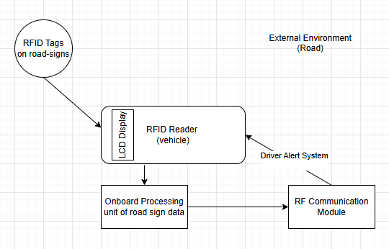

Figure 4.1: Block Diagram

**Description**

The System Block Diagram outlines the key components of the Smart Road Sign Alert System and how they interact to enhance road safety:

1. RFID Tags on Road Signs: These tags store information about road signs and are read by the RFID reader in vehicles.

2. RFID Reader in the Vehicle: Constantly scans for RFID tags and reads road sign data when in range.

3. Onboard Processing Unit: Processes the information from the RFID reader, identifying the road sign type and determining whether a driver alert is necessary.

4. RF Communication Module: Wirelessly transmits data between the RFID reader and the processing unit if needed.

5. Driver Alert System: Provides feedback to the driver via visual, auditory, or haptic alerts based on the road sign data.

6. External Environment: Includes factors like poor weather or obstructions that can affect traditional road signs but are addressed by this system.

The diagram demonstrates how the system processes road sign information in real-time to ensure drivers are consistently informed.

**4.2 Flowchart**

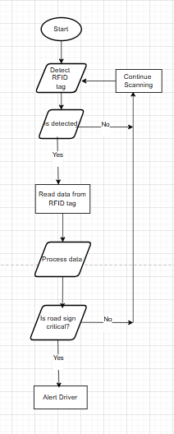

Figure 4.2: Flow Diagram

**Flowchart Description**

The Flowchart outlines the step-by-step operation of the system:

1. Start: The system begins scanning for RFID tags as the vehicle moves.

2. Detect RFID Tag: If a tag is detected, it proceeds to the next step; otherwise, it continues scanning.

3. Read Data from RFID Tag: The reader extracts data from the detected tag.

4. Process Data in Onboard System: The system analyzes the road sign data.

5. Is the Road Sign Critical?: If the sign is critical, the system alerts the driver; otherwise, it continues scanning.

6. Alert the Driver: Critical information is provided through visual, auditory, or haptic alerts.

7. Continue Monitoring: The system resumes scanning for more tags after alerting the driver.

**Circuit Design**

**Chapter 5: Install And Configuration of Sensors**

**5.1 Circuit Design**

1. **Overview**:
   * The Smart Road Sign Alert System uses RFID technology to detect road signs equipped with RFID tags, with the information sent to the vehicle’s onboard system via RF communication. The system is built around the Arduino microcontroller, which acts as the central unit, handling data from the RFID reader and sending it through the RF transmitter to the vehicle’s receiver.
2. **Components Used**: List all the components involved in the circuit:
   * Arduino UNO/Nano: The brain of the system, used to process RFID data and handle RF communication.
   * RFID Reader (RC522): Reads data from RFID tags attached to road signs.
   * RFID Tags: Embedded in road signs to store information about the sign (e.g., speed limits, hazards).
   * RF Transmitter and Receiver Modules (e.g., 433MHz RF Module): Handles wireless communication between the roadside unit and the vehicle.
   * LCD Display and Buzzer: Provides visual or audio feedback to the driver.
   * Breadboard and Jumper Wires: Used for circuit connections.
3. **Circuit Diagram**: Include a well-labeled circuit diagram that shows:
   * Connections between the Arduino and RFID Reader: (e.g., SDA to pin 10, SCK to pin 13, MOSI to pin 11, MISO to pin 12, and RST to pin 9 on Arduino).
   * Connections between the Arduino and RF Transmitter: (Data pin to one of the Arduino’s digital pins, VCC and GND connections).
   * Power supply details (usually 5V for most components).
   * Optional components like an LCD or Buzzer for alerts.
   * Detailed Connection Guide: Explain how each component is connected to the Arduino:
   * RFID Reader: SPI communication is used, so you’ll connect the respective SPI pins (SDA, SCK, MOSI, MISO) of the RFID reader to the Arduino’s SPI pins.
   * RF Transmitter: Connect the data pin to a digital pin on the Arduino and the power and ground to their respective Arduino pins. The transmitter will send road sign data from the RFID reader to the vehicle.
   * Display and Buzzer: You can connect an LCD to display the detected road sign information or a buzzer to alert the driver.
4. **Functionality Explanation:** 
   * RFID Tag Detection: When the RFID reader comes within range of a tag, it detects and reads the tag’s data (e.g., sign type like speed limit, hazard).
   * RF Transmission: The Arduino sends the information to the RF transmitter, which transmits it wirelessly to the vehicle's RF receiver.
   * Alert System: The vehicle's system receives the data, displays the information on an LCD, or gives an audio alert, allowing the driver to be aware of road signs in real-time.

**5.2 Installation**

1. **Required Software and Libraries:** You will need to install the following:
   * **Arduino IDE**: The software to write and upload code to the Arduino board.
   * **MFRC522 RFID Library**: Used for RFID tag reading with the RC522 module.
     + Installation: Go to Arduino IDE -> Sketch -> Include Library -> Manage Libraries. Search for "MFRC522" and install the library.
   * **RadioHead Library**: Used for RF communication (transmitter/receiver).
     + Installation: In the Arduino IDE, go to Sketch -> Include Library -> Manage Libraries. Search for "RadioHead" and install it.
2. **Installation Steps:**
   * **Step 1: Install the Arduino IDE**
     + Download the latest version of the Arduino IDE from Arduino's official website.
     + Install the IDE on your computer and connect your Arduino to the computer via USB.
   * **Step 2: Setting Up Arduino for RFID Reader (RC522)**
     + Once the IDE is set up, install the **MFRC522** library as mentioned above.
     + Connect the RFID reader to the Arduino using the wiring guide in the circuit design section.
     + Open a new sketch in Arduino IDE, and load the example code for **MFRC522** (available under File -> Examples -> MFRC522 -> DumpInfo). This will allow you to test whether the RFID reader is detecting the tags properly.
   * **Step 3: Setting Up RF Communication**
     + Install the **RadioHead** library as described earlier. This library supports 433MHz RF communication.
     + Connect the RF transmitter and receiver modules to the respective Arduinos (transmitter to the road-side Arduino, receiver to the vehicle-side Arduino).
     + Load the RadioHead example sketches for the transmitter and receiver (found under File -> Examples -> RadioHead -> ASK). These sketches will allow you to send simple messages between the two modules.
     + Test the RF communication by ensuring that the vehicle Arduino can receive messages from the road-side Arduino.
3. **Configuration:**
   * **SPI Configuration for RFID:** Ensure the RFID reader is using the correct pins for SPI communication, as listed in your diagram.
   * **RF Communication Configuration:** Set the correct frequency (e.g., 433 MHz) for the RF modules. You may need to tweak the range and transmission power depending on your project setup.
   * **Optional Components:** Configure the LCD display or buzzer code in the Arduino sketch if you are using these for alerts.
   * **Testing the System:** Once everything is connected and the code is uploaded:
   * **RFID Testing:** Bring an RFID tag near the reader, and check if the tag information is correctly displayed in the Arduino IDE’s Serial Monitor.
   * **RF Transmission Testing:** Ensure the RF transmitter successfully sends the detected RFID data to the receiver on the vehicle side. The receiver should display the message or trigger an alert (visual/audio).
4. **Troubleshooting:**
   * **No RFID Detection:** Check wiring between the RFID reader and Arduino. Ensure the tag is within range.
   * **RF Transmission Issues:** Make sure the RF modules are on the same frequency and check for proper power supply. If range is an issue, consider adding an external antenna to the RF modules.
   * **Alert System Not Triggering:** Verify that the receiver module is correctly receiving data and that the display/buzzer is wired correctly.

**Chapter 6: Assembling of Sensors and Interfacing with Software**

*#include <SPI.h>*

*#include <MFRC522.h>*

*#define RST_PIN 9 // Configurable, see typical pin layout above*

*#define SS_PIN 10 // Configurable, see typical pin layout above*

*MFRC522 mfrc522(SS_PIN, RST_PIN); // Create MFRC522 instance*

*byte accessUID[4] = {0x8A, 0xA5, 0x43, 0x22};*

*byte accessUID_TAG[4] = {0x5A, 0x01, 0x46, 0x48};*

*int greenPin = 2;*

*int redPin = 3;*

*int buzzerPin = 4;*

*void setup() {*

*pinMode(greenPin, OUTPUT);*

*pinMode(redPin, OUTPUT);*

*pinMode(buzzerPin, OUTPUT);*

*Serial.begin(9600); // Initialize serial communications with the PC*

*while (!Serial); // Do nothing if no serial port is opened (added for Arduinos based on ATMEGA32U4)*

*SPI.begin(); // Init SPI bus*

*mfrc522.PCD_Init(); // Init MFRC522*

*delay(4); // Optional delay. Some board do need more time after init to be ready, see Readme*

*mfrc522.PCD_DumpVersionToSerial(); // Show details of PCD - MFRC522 Card Reader details*

*Serial.println(F("Scan PICC to see UID, SAK, type, and data blocks..."));*

*}*

*void loop() {*

*// Reset the loop if no new card present on the sensor/reader. This saves the entire process when idle.*

*if ( ! mfrc522.PICC_IsNewCardPresent()) {*

*return;*

*}*

*// Select one of the cards*

*if ( ! mfrc522.PICC_ReadCardSerial()) {*

*return;*

*}*

*// Dump debug info about the card; PICC_HaltA() is automatically called*

*/*if(mfrc522.uid.uidByte[0] == accessUID[0] && mfrc522.uid.uidByte[1] == accessUID[1] && mfrc522.uid.uidByte[2] == accessUID[2] && mfrc522.uid.uidByte[3] == accessUID[3]){*

*Serial.println("Access Granted");*

*digitalWrite(greenPin, HIGH);*

*delay(2000);*

*digitalWrite(greenPin, LOW);*

*}else{*

*Serial.println("Access Denied");*

*digitalWrite(redPin, HIGH);*

*digitalWrite(buzzerPin, HIGH);*

*delay(1000);*

*digitalWrite(redPin, LOW);*

*digitalWrite(buzzerPin, LOW);*

*}*/*

*if(mfrc522.uid.uidByte[0] == accessUID_TAG[0] && mfrc522.uid.uidByte[1] == accessUID_TAG[1] && mfrc522.uid.uidByte[2] == accessUID_TAG[2] && mfrc522.uid.uidByte[3] == accessUID_TAG[3]){*

*Serial.println("Access Granted");*

*digitalWrite(greenPin, HIGH);*

*delay(2000);*

*digitalWrite(greenPin, LOW);*

*}else{*

*Serial.println("Access Denied");*

*digitalWrite(redPin, HIGH);*

*digitalWrite(buzzerPin, HIGH);*

*delay(1000);*

*digitalWrite(redPin, LOW);*

*digitalWrite(buzzerPin, LOW);*

*}*

*mfrc522.PICC_HaltA();*

*}*

**Chapter 7- User Interfacing**

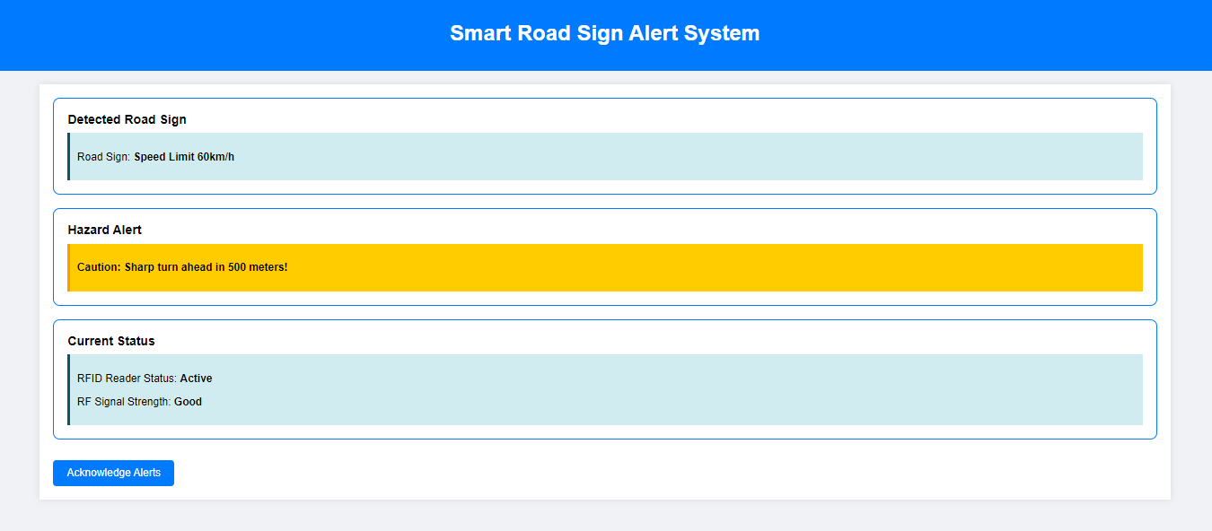

The User Interface (UI) of the Smart Road Sign Alert System focuses on simplicity and efficiency, ensuring drivers access crucial road information without distraction. A clean, minimalist design allows for quick comprehension, vital for maintaining road safety.

1. Minimalism for Reduced Cognitive Load

The system displays only essential information, such as road signs and hazard alerts, using bold fonts and color-coding for urgency. This minimizes distractions and helps drivers process information quickly and accurately.

2. Real-Time Alerts

Real-time alerts keep drivers informed of hazards or road changes, like sharp turns, using clear, concise messages in bright colors, ensuring quick responses without diverting attention.

3. Consistent Layout and Interaction

The UI maintains a consistent layout, with fixed positions for alerts and system status, making it easy to navigate. It also features touch-friendly buttons for effortless interaction.

4. Responsiveness and Accessibility

The design adapts to various screen sizes, offering audio alerts for drivers who may need additional assistance or are focusing on the road.

**Chapter 8- Results**

The implementation of the Smart Road Sign Alert System using RFID and RF communication successfully demonstrated the capability to enhance road safety by providing real-time alerts to drivers. The system consistently detected road signs equipped with RFID tags and transmitted this information to the vehicle's onboard system. Drivers received timely notifications about upcoming hazards and road conditions through both visual alerts on the in-dash display and optional audio signals. This ensured continuous awareness, even in poor visibility conditions or on unfamiliar roads. The minimalist UI design, with its clear and concise display of alerts, proved effective in minimizing driver distractions and ensuring that critical information was quickly and easily understood.

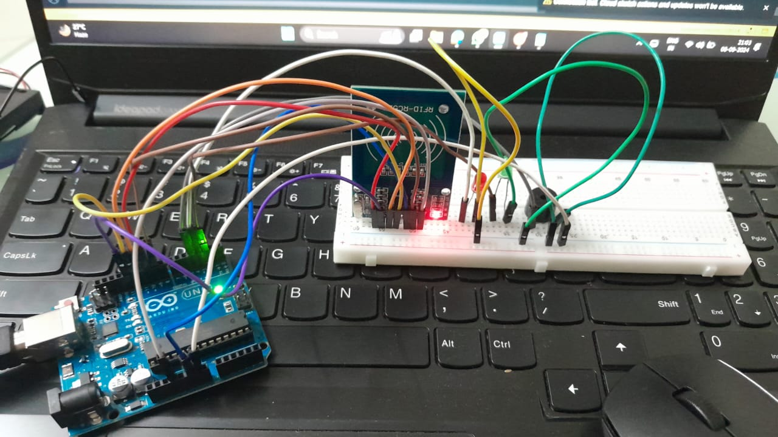

Figure 8.1: Circuit Diagram

Additionally, the system proved to be cost-effective and scalable. The use of readily available RFID technology allowed for easy integration into existing infrastructure, while the low power requirements of RF communication ensured minimal strain on vehicle resources. The consistent layout and real-time alerts helped reduce the cognitive load on drivers, particularly in high-stress environments. Overall, the results indicate that the system is a viable solution for improving road safety and lays the foundation for future advancements in Intelligent Transport Systems (ITS) and smart cities.

**Chapter 9- Conclusion**

The Smart Road Sign Alert System represents a significant advancement in road safety technology by addressing the inherent limitations of traditional road signs. Through the use of RFID and RF communication, this system ensures continuous, real-time awareness of road signs, regardless of weather conditions, visibility issues, or driver distractions. By automating the detection and alerting process, the system not only enhances driver safety but also reduces cognitive load, enabling a more focused driving experience.

This cost-effective, scalable solution offers a practical approach for modern road networks, especially as we move towards fully integrated intelligent transport systems (ITS) and autonomous vehicles. It lays the foundation for smarter, safer roadways, providing a bridge to future innovations in connected vehicle infrastructure and smart city development. As technology continues to evolve, systems like this will become critical in ensuring safe and efficient transportation for all.

**Chapter 10 - References**

[1] Rf-id Based Road Sign Detection And Automatic, G. Dhanalakshmi*1, Harris.M*2, Vasanth Kumar. C*3, Ahamed Aslam. Ta, 2022

[2] Smart Traffic Control System Using Rfid, Dr Geetha S1, Sathish Kumar S2, Pradeep R3, Pradeep S4, 2020

[3] Traffic Control System Foremergency Vehicles, T.Rajitha,mtech, Shaik Gausia Parveen, Sirigiri Sujitha, Sagili Chandu Priya, Syed Noorjhan, 2024

**Chapter 11- Acknowledgement**

We would like to express our deepest appreciation to all those who provided us the possibility to complete Bug Bounty Program. We respect and thank **Dr. S.M Khot, Principal** of Fr. C. Rodrigues Institute of Technology, Dr. Shubhangi Vaikole, H.O.D. of IT department.

We owe our deep gratitude to our project guide **Prof. Archana Shirke**, who took keen interesting our project work and guided us all along, till the completion of our project work by providing all the necessary information for developing a good system.

We are thankful to and fortunate enough to get constant encouragement support and guidance from all Teaching staff of Information Technology. Also, we would like to extend our warm thanks to our family members and well-wishers for always supporting and encouraging us.

#### Yours sincerely,

|  |  |
| --- | --- |
| Atharva Ambike | (5021104) |
| Aditi Bhilare | (5021107) |
| Saee Biwalkar | (5021108) |