Trader Performance Analysis Based on Bitcoin Market Sentiment
Submitted By:
Aditi Badgujar
Date: 02 June 2026

1. INTRODUCTION
This project analyzes the relationship between Bitcoin market sentiment and trader performance using two datasets: the Bitcoin Fear & Greed Index dataset and historical trader data from Hyperliquid. The objective is to identify patterns between market sentiment and trading outcomes, and to determine how sentiment influences profitability, trading activity, and trader behavior.

2. DATA PREPARATION
The trader dataset and the Bitcoin Fear & Greed Index dataset were loaded into Python using Pandas. Date columns were converted into a common format and both datasets were merged using the Date field. Additional analysis fields such as trade outcome (Win/Loss) were created based on the Closed PnL values.

3. ANALYSIS AND VISUALIZATIONS
3.1 Average Profit by Sentiment

The analysis shows that Extreme Greed generated the highest average profit per trade (67.89), followed by Fear (54.29). Neutral and Extreme Fear periods produced lower average profits. This suggests that positive market sentiment may improve trading performance.

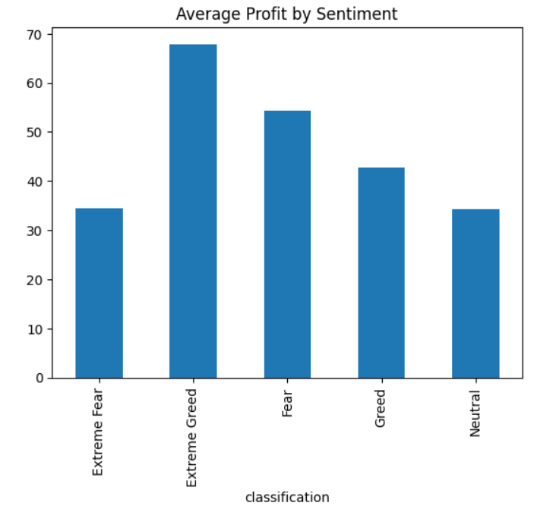
3.2 Total Profit by Sentiment
Fear generated the highest total profit (3.36 million), followed by Extreme Greed (2.72 million). Although Extreme Greed had the highest average profitability, Fear produced the highest overall profit because of higher trading activity.
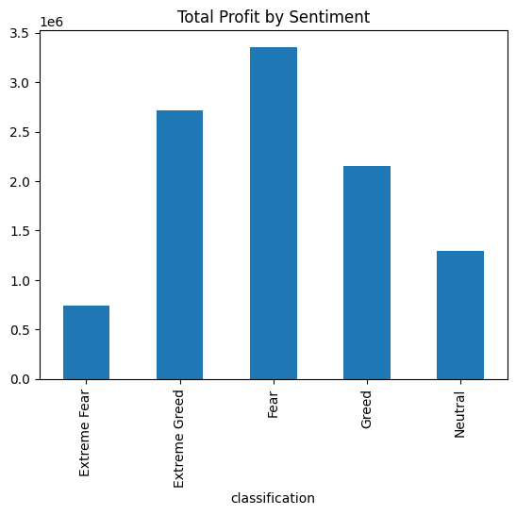
3.3 Win Rate by Sentiment
Extreme Greed achieved the highest win rate (46.49%), while Extreme Fear recorded the lowest win rate (37.06%). This indicates that traders were more successful during periods of strong positive market sentiment.

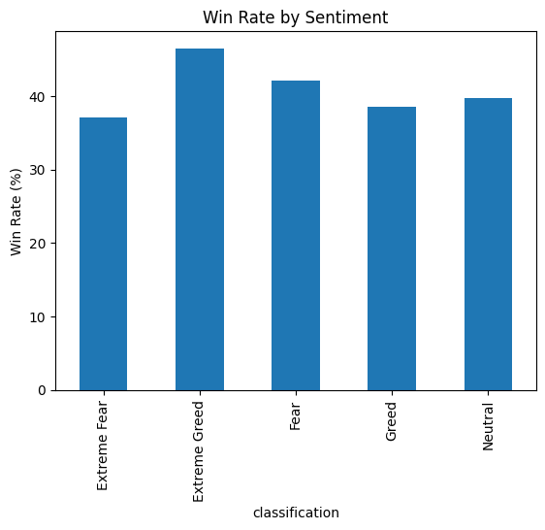

3.4 Average Trade Size by Sentiment
Fear periods showed the largest average trade size (USD 7,816), while Extreme Greed showed the smallest average trade size (USD 3,112). This suggests traders were willing to commit larger capital amounts during uncertain market conditions.

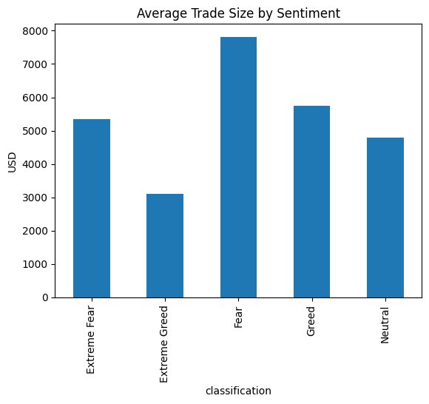
4. KEY INSIGHTS
- Fear recorded the highest trading activity with 61,837 trades.
- Extreme Greed produced the highest average profit per trade.
- Fear generated the highest total profit due to larger trading volume.
- Losses exceeded wins across all sentiment categories.
- Extreme Greed achieved the highest win rate (46.49%).
- Extreme Fear recorded the lowest win rate (37.06%).
- Fear periods had the largest average trade sizes.

5. CONCLUSION
The analysis demonstrates that market sentiment has a measurable impact on trader performance. Extreme Greed periods were associated with the highest average profitability and win rates, while Fear periods generated the highest total profit because of increased trading activity. These findings suggest that market sentiment can be an important factor when evaluating trading strategies and understanding trader behavior.

