Web Application: UI Requirements

There are total 3 forms

* Home/ Who We Are
* That’s The Bird
* Contact US

Home and Contact Us forms will have just text. There is a form named “Bird Field Guide”, but that has to be added in second phase and its design is similar to That’s the Bird.

**Home**



**That’s The Bird Form**



There are 3 tabs, say Criteria 1, Criteria 2 and Criteria 3.

**Criteria 1**

When tab Criteria 1 is selected, a check-box list with colou names and a sample is displayed. User selects 1 or more colours and click SUBMIT.

On submission, a list of records is displayed.

Each record has Field1, Field2, Field3 and the Field4 which is the image. First row will be the headings. There can be as many as 500 records in this list. User will scroll through the list.

**Criteria 2**



Similar to Criteria1, a list of records will be displayed on selection of the criteria, similar to above in Criteria 1

**Criteria 3**



Multiple options can be selected by the user. On SUBMIT a list of records is displayed similar to Criteria 1.

I have downloaded a free template from the Internet and customized it for this application. I liked it because it is fancy but at the same time simple and neat.

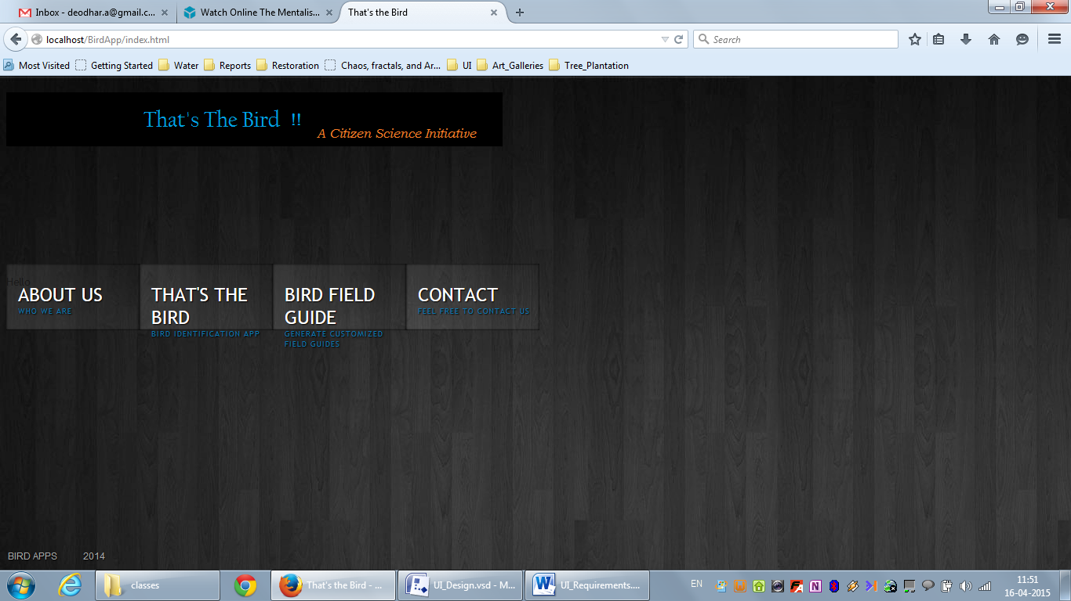

**On mouse hover**

