**QUESTIONS**

Ques1. Make a relational schema that represents data and relationships depicted in this diagram:

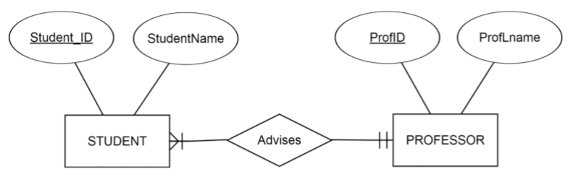

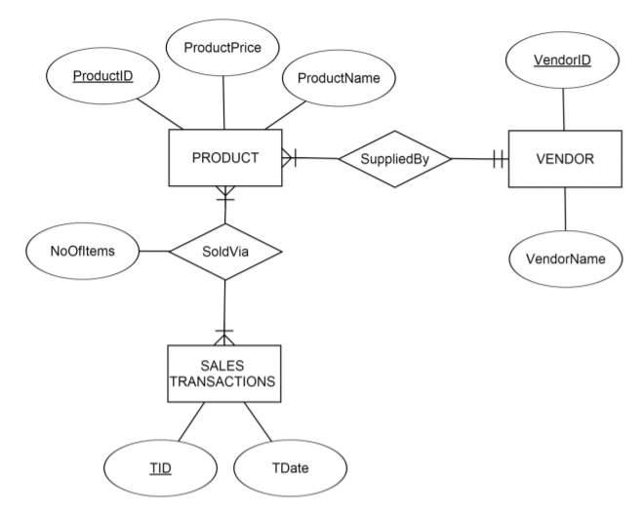Ques2. Make a relational schema that represents data and relationships depicted in this diagram:

Ques3. Which table of data (Table A or Table B) corresponds with the relation depicted below?

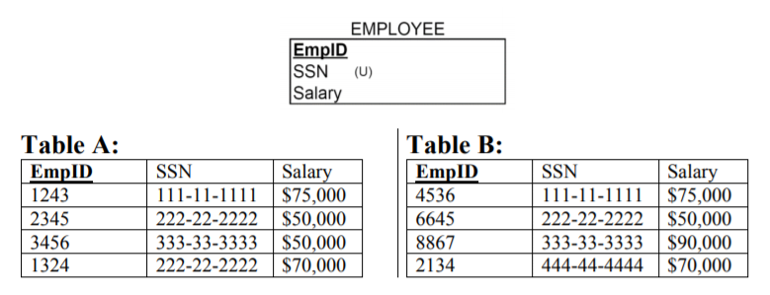

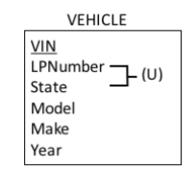Ques4a. Describe in the words the data that would be contained in a table made to reflect the relation depicted below?

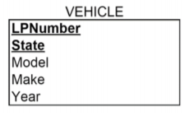Ques4b. Describe in the words the data that would be contained in a table made to reflect the relation depicted below?

Ques5. Create a relational schema of Investco Scout is an investment research company. Create the ER diagram for the Investco Scout Funds Database, which is supposed to contain the following information:

* It will keep track of investment companies, the mutual funds they manage, and securities contained in the mutual funds.
* For each investment company, Investco Scout will keep track of a unique investment company identifier, a unique investment company name, and the names of the investment company’s multiple locations.
* For each mutual fund, Investco Scout will keep track of a unique mutual fund identifier, the mutual fund name, and the mutual fund inception date.
* For each security, Investco Scout will keep track of a unique security identifier, as well as the security name and type
* Investment companies can manage multiple mutual funds. Investco Scout will not keep track of investment companies that do not manage any mutual funds. A mutual fund is managed by one investment company.
* A mutual fund contains one or many securities. A security can be included in many mutual funds. Investco Scout will keep track of securities that are not included in any mutual funds
* For each instance of a security included in a mutual fund, Investco Scout will keep track of the amount included.

Ques6. Create a relational schema of Snooty Fashions is an exclusive custom fashion design business. Create the ER diagram for the Snooty Fashions Operations Database based on the following data collection requirements:

* For each designer, the database must keep track of a unique designer identifier, unique SSN, and a name (which is composed of a first and a last name).
* For each customer, the database must keep track of a unique customer identifier, his/her name (which is composed of a first and a last name), and multiple phone numbers.
* For each tailoring technician, the database must keep track of a unique SSN and a name (which is composed of a first and a last name).
* For each outfit, the database must keep track of a unique outfit identifier, the outfit’s planned date of completion, and its price.
* For each fashion show, the database must keep track of a unique show identifier, as well as the date and location of the show.
* Each designer designs many outfits. Each outfit has only one designer.
* Each outfit is sold (in advance) to exactly one customer. Customers can buy one or many outfits (Snooty Fashions will not keep track of customers who have not made any purchases yet).
* Each tailoring technician must work on at least one outfit, but can work on many. Each outfit has at least one tailoring technician working on it, but can have many tailoring technicians working on it
* Snooty Fashions will keep track of the date when a tailoring technician started working on a particular outfit
* Each designer can participate in a number of fashion shows, but does not have to participate in any. Each fashion show can feature one or two Snooty Fashions designers (Snooty Fashions will not keep track of fashion shows that do not feature Snooty Fashions designers).