Sales and Profit Analysis by Category

# **Introduction**

This document presents a sales and profit analysis across three product categories: Electronics, Furniture, and Stationery. The analysis is based on the provided data, which details sales and profit figures for each category. Visualizations are included to facilitate a clearer understanding of the data.

# **Data Summary**

The following table summarizes the sales and profit figures for each product category:

|  |  |  |
| --- | --- | --- |
| Category | Sales | Profit |
| Electronics | 10000 | 2000 |
| Furniture | 15000 | 3000 |
| Stationery | 5000 | 1000 |

# **Sales Analysis**

* Furniture demonstrates the highest sales figures, reaching $15,000, significantly outperforming Electronics ($10,000) and Stationery ($5,000). * Furniture accounts for the largest proportion of total sales. This is clearly visible in the pie chart. * The combined sales across all three categories total $30,000.

Bar chart showing sales for each category (sales_bar_chart.png)

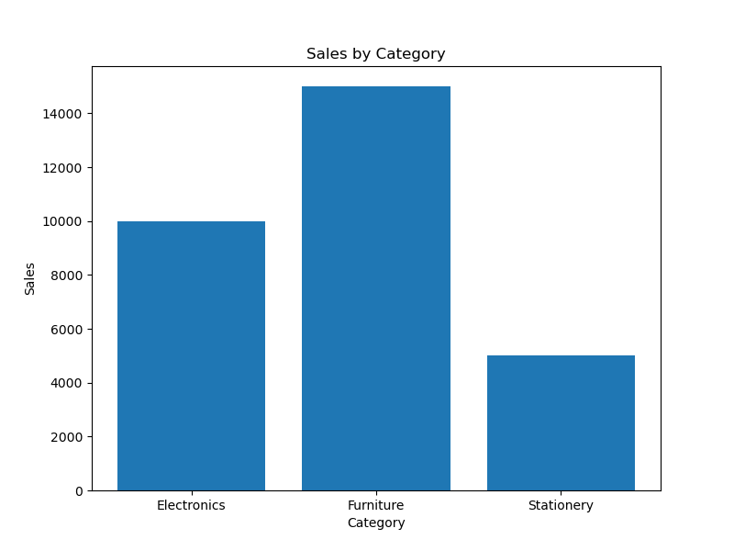

Pie chart showing the proportion of total sales for each category (sales_pie_chart.png)

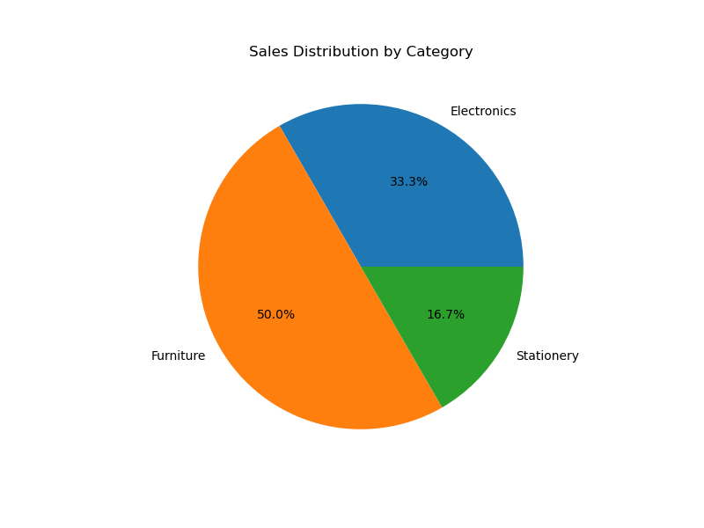

# **Profit Analysis**

* Similar to sales, Furniture also generated the highest profit ($3,000), followed by Electronics ($2,000), and Stationery ($1,000). * While Furniture has the highest sales and profit, it is important to consider profit margins (profit as a percentage of sales) for a more complete comparison of the profitability of each category. This analysis requires further calculation. * The total profit across all categories is $6,000.

Bar chart showing profit for each category (profit_bar_chart.png)

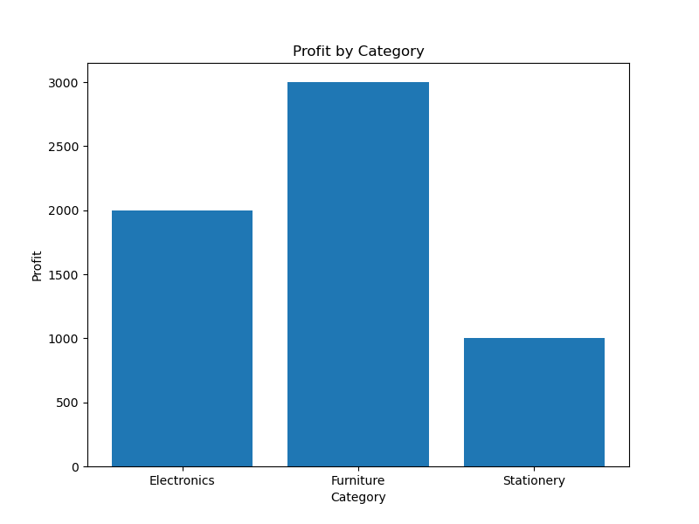

Pie chart showing the proportion of total profit for each category (profit_pie_chart.png)

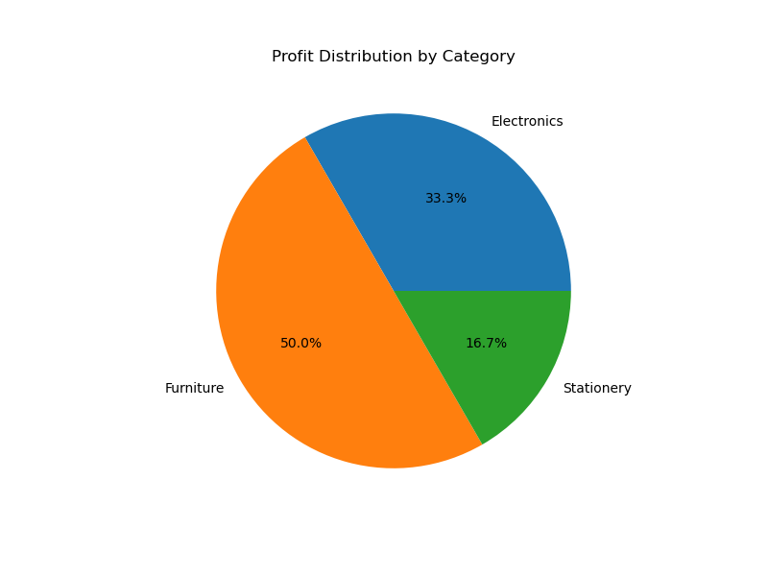

# **Conclusion**

The analysis reveals that Furniture is the most successful category in terms of both sales and profit. While Electronics also generated substantial revenue, further investigation into profit margins is recommended to determine the relative profitability of each category. This would provide a more nuanced understanding of the overall performance and inform future strategic decision-making.