**Name: Aditi Kohale**

**Course: C, DSA and C++**

**Topic: Linked List – Assignment 1**

**Q. Linked List of Malls:**

**Code:**

#include<stdio.h>

#include<stdlib.h>

struct mall

{

char mName[20];

int shops;

float revenue;

struct mall *next;

};

struct mall *head=NULL;

void printLL()

{

struct mall *temp=head;

while(temp!=NULL)

{

printf("| %s",temp->mName);

printf("|| %d",temp->shops);

printf("|| %f |->",temp->revenue);

temp=temp->next;

}

}

struct mall *createNode()

{

struct mall *newNode=(struct mall*) malloc(sizeof(struct mall));

getchar();

printf("Enter mall Name:\n");

char ch;

int i=0;

while((ch=getchar())!='\n')

{

(*newNode).mName[i]=ch;

i++;

}

printf("Enter No. of Shops:\n");

scanf("%d",&newNode->shops);

printf("Enter the Revenue:\n");

scanf("%f",&newNode->revenue);

newNode->next=NULL;

return newNode;

}

void addNode()

{

struct mall *newNode=createNode();

struct mall *temp=head;

if(head==NULL)

{

head=newNode;

}

else

{

while(temp->next!=NULL)

{

temp=temp->next;

}

temp->next=newNode;

}

}

void main()

{

int count;

printf("Enter the no. of malls you want:\n");

scanf("%d",&count);

for(int i=1;i<=count;i++)

{

addNode();

}

printf("The malls are:\n");

printLL();

}

**Output:**

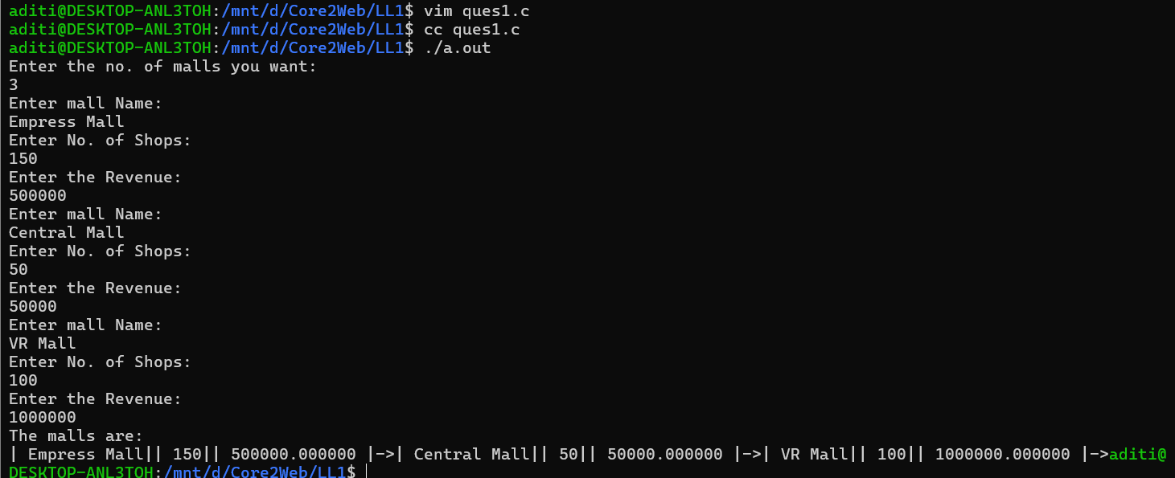

**Q.2. Linked List of States in India:**

**Code:**

#include<stdio.h>

#include<stdlib.h>

struct state

{

char sName[20];

float popul;

float budget;

float literacy;

struct state *next;

};

struct state *head=NULL;

void printLL()

{

struct state *temp=head;

int i=1;

while(temp!=NULL)

{

printf("State%d:\n",i++);

printf("|State Name: %s|\n",temp->sName);

printf("|Population: %f|\n",temp->popul);

printf("|Budget: %f|\n",temp->budget);

printf("|Literacy: %f| -->\n",temp->literacy);

temp=temp->next;

}

}

struct state *createNode()

{

struct state *newNode=(struct state*) malloc(sizeof(struct state));

getchar();

printf("Enter State Name:\n");

char ch;

int i=0;

while((ch=getchar())!='\n')

{

(*newNode).sName[i]=ch;

i++;

}

printf("Enter Population:\n");

scanf("%f",&newNode->popul);

printf("Enter Budget:\n");

scanf("%f",&newNode->budget);

printf("Enter Literacy:\n");

scanf("%f",&newNode->literacy);

newNode->next=NULL;

return newNode;

}

void addNode()

{

struct state *newNode=createNode();

struct state *temp=head;

if(head==NULL)

{

head=newNode;

}

else

{

while(temp->next!=NULL)

{

temp=temp->next;

}

temp->next=newNode;

}

}

void main()

{

int count;

printf("Enter the no. of states you want:\n");

scanf("%d",&count);

for(int i=1;i<=count;i++)

{

addNode();

}

printf("The states are:\n");

printLL();

}

**Output:**

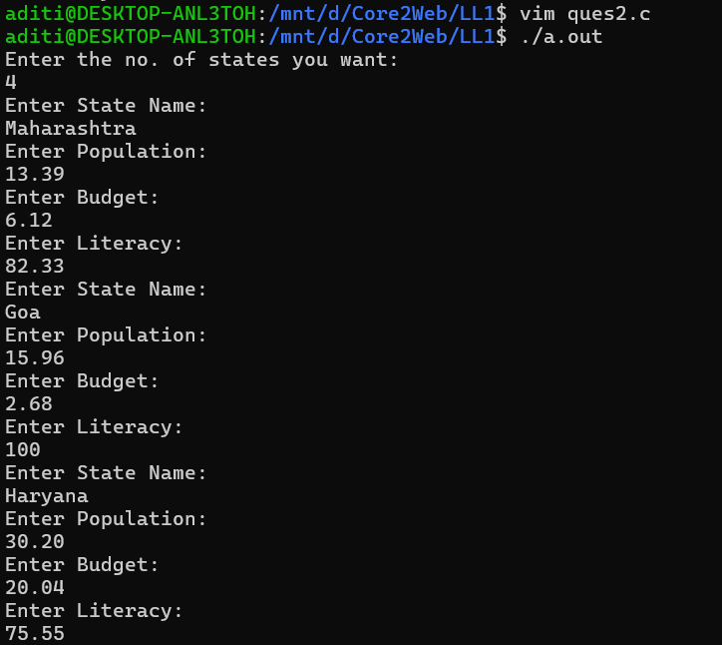

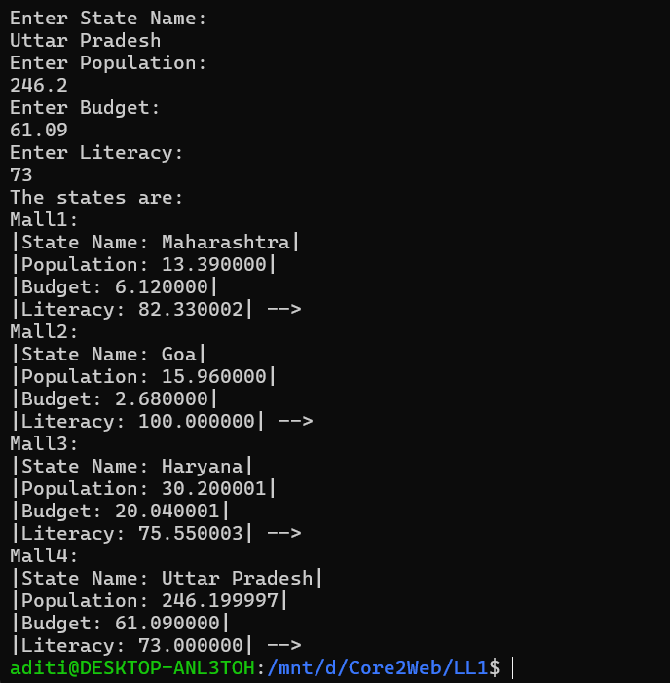

**Q.3. Linked List of Festivals in India:**

**Code:**

#include<stdio.h>

#include<stdlib.h>

struct festival

{

char fName[20];

struct festival *next;

};

struct festival *head=NULL;

void printLL()

{

struct festival *temp=head;

while(temp!=NULL)

{

printf("| %s | -->",temp->fName);

temp=temp->next;

}

}

struct festival *createNode()

{

struct festival *newNode=(struct festival*) malloc(sizeof(struct festival));

printf("Enter Festival Name:\n");

char ch;

int i=0;

while((ch=getchar())!='\n')

{

(*newNode).fName[i]=ch;

i++;

}

(*newNode).fName[i]='\0';

newNode->next=NULL;

return newNode;

}

void addNode()

{

struct festival *newNode=createNode();

struct festival *temp=head;

if(head==NULL)

{

head=newNode;

}

else

{

while(temp->next!=NULL)

{

temp=temp->next;

}

temp->next=newNode;

}

}

void main()

{

int count;

printf("No. of Festivals you want to enter:\n");

scanf("%d",&count);

getchar();

for(int i=1;i<=count;i++)

{

addNode();

}

printf("The festivals are:\n");

printLL();

}

**Output:**

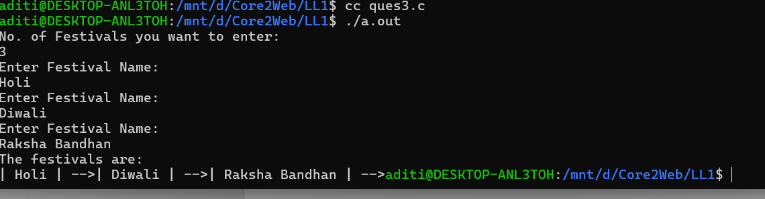

**Q. Count No. of Nodes in above example:**

**Code:**

#include<stdio.h>

#include<stdlib.h>

struct festival

{

char fName[20];

struct festival *next;

};

struct festival *head=NULL;

void printLL()

{

struct festival *temp=head;

while(temp!=NULL)

{

printf("| %s | -->",temp->fName);

temp=temp->next;

}

printf("\n");

}

struct festival *createNode()

{

struct festival *newNode=(struct festival*) malloc(sizeof(struct festival));

printf("Enter Festival Name:\n");

char ch;

int i=0;

while((ch=getchar())!='\n')

{

(*newNode).fName[i]=ch;

i++;

}

(*newNode).fName[i]='\0';

newNode->next=NULL;

return newNode;

}

void addNode()

{

struct festival *newNode=createNode();

struct festival *temp=head;

if(head==NULL)

{

head=newNode;

}

else

{

while(temp->next!=NULL)

{

temp=temp->next;

}

temp->next=newNode;

}

}

int countNodes()

{

int count=0;

struct festival *temp=head;

while(temp!=NULL)

{

count++;

temp=temp->next;

}

return count;

}

void main()

{

int num;

printf("No. of Festivals you want to enter:\n");

scanf("%d",&num);

getchar();

for(int i=1;i<=num;i++)

{

addNode();

}

printf("The festivals are:\n");

printLL();

int count = countNodes();

printf("There are %d nodes in the list.\n",count);

}

**Output:**

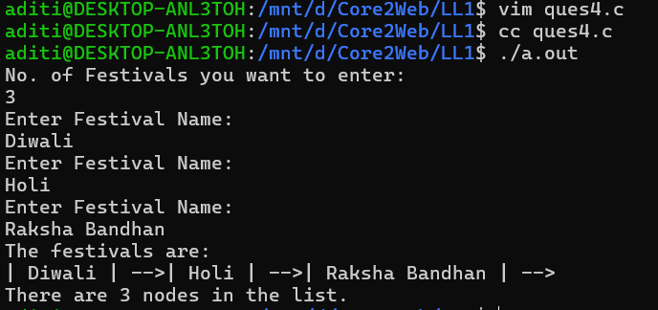

**Q. 5. Demo Structure with integer data. Take the number of nodes from the user and print the addition of the data:**

**Code:**

#include<stdio.h>

#include<stdlib.h>

struct Demo

{

int data;

struct Demo *next;

};

struct Demo *head=NULL;

int sumNode()

{

int sum=0;

struct Demo *temp=head;

if(head==NULL)

{

printf("Linked List is Empty.\n");

return 0;

}

else

{

while(temp!=NULL)

{

sum=sum+temp->data;

temp=temp->next;

}

return sum;

}

}

void printLL()

{

printf("The Linked list is:\n");

struct Demo *temp=head;

while(temp!=NULL)

{

printf("%d->",temp->data);

temp=temp->next;

}

printf("\n");

}

struct Demo *createNode()

{

struct Demo *newNode=(struct Demo*)malloc(sizeof(struct Demo));

printf("Enter data:\n");

scanf("%d",&newNode->data);

newNode->next=NULL;

return newNode;

}

void addNode()

{

struct Demo *newNode=createNode();

if(head==NULL)

{

head=newNode;

}

else

{

struct Demo *temp=head;

while(temp->next!=NULL)

{

temp=temp->next;

}

temp->next=newNode;

}

}

void main()

{

int count;

printf("Enter the no. of nodes:\n");

scanf("%d",&count);

for(int i=1;i<=count;i++)

{

addNode();

}

printLL();

int sum=sumNode();

printf("The sum of Nodes is %d\n",sum);

}

**Output:**

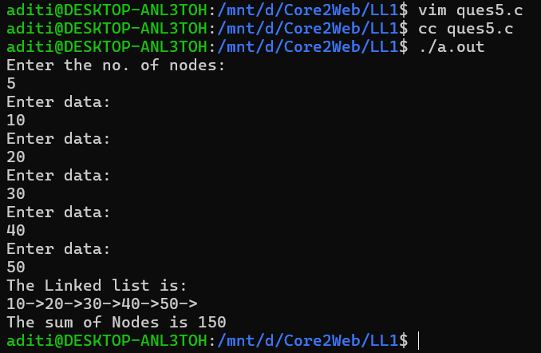

**Q.6. Print the Addition of the first and the last node from the above code:**

**Code:**

#include<stdio.h>

#include<stdlib.h>

struct Demo

{

int data;

struct Demo *next;

};

struct Demo *head=NULL;

int countNode()

{

int count=0;

if(head==NULL)

{

return 0;

}

else

{

struct Demo *temp=head;

while(temp!=NULL)

{

count++;

temp=temp->next;

}

return count;

}

}

int sumNode()

{

int count=countNode();

int sum=0;

if (head==NULL)

{

printf("The linked list is empty\n");

return 0;

}

else

{

if(count==1)

{

return head->data;

}

else

{

struct Demo *temp=head;

sum=temp->data;

while(temp->next!=NULL)

{

temp=temp->next;

}

sum=sum+temp->data;

return sum;

}

}

}

void printLL()

{

printf("The Linked list is:\n");

struct Demo *temp=head;

while(temp!=NULL)

{

printf("%d->",temp->data);

temp=temp->next;

}

printf("\n");

}

struct Demo *createNode()

{

struct Demo *newNode=(struct Demo*)malloc(sizeof(struct Demo));

printf("Enter data:\n");

scanf("%d",&newNode->data);

newNode->next=NULL;

return newNode;

}

void addNode()

{

struct Demo *newNode=createNode();

if(head==NULL)

{

head=newNode;

}

else

{

struct Demo *temp=head;

while(temp->next!=NULL)

{

temp=temp->next;

}

temp->next=newNode;

}

}

void main()

{

int count;

printf("Enter the no. of nodes:\n");

scanf("%d",&count);

for(int i=1;i<=count;i++)

{

addNode();

}

printLL();

int sum=sumNode();

printf("The sum of First and Last Nodes is %d\n",sum);

}

**Output:**

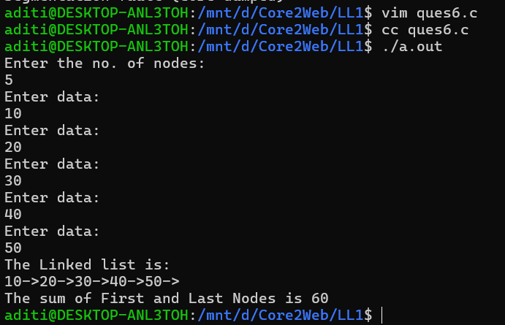

**Q.7. Print the maximum integer from the above nodes:**

**Code:**

#include<stdio.h>

#include<stdlib.h>

struct Demo

{

int data;

struct Demo *next;

};

struct Demo *head=NULL;

int countNode()

{

int count=0;

if(head==NULL)

{

return 0;

}

else

{

struct Demo *temp=head;

while(temp!=NULL)

{

count++;

temp=temp->next;

}

return count;

}

}

int maxNode()

{

int count=countNode();

if(head==NULL)

{

printf("Linked list is empty.\n");

return -1;

}

else

{

if(count==1)

{

return head->data;

}

else

{

struct Demo *temp=head;

int max=temp->data;

while(temp!=NULL)

{

if(temp->data>max)

{

max=temp->data;

}

temp=temp->next;

}

return max;

}

}

}

void printLL()

{

printf("The Linked list is:\n");

struct Demo *temp=head;

while(temp!=NULL)

{

printf("%d->",temp->data);

temp=temp->next;

}

printf("\n");

}

struct Demo *createNode()

{

struct Demo *newNode=(struct Demo*)malloc(sizeof(struct Demo));

printf("Enter data:\n");

scanf("%d",&newNode->data);

newNode->next=NULL;

return newNode;

}

void addNode()

{

struct Demo *newNode=createNode();

if(head==NULL)

{

head=newNode;

}

else

{

struct Demo *temp=head;

while(temp->next!=NULL)

{

temp=temp->next;

}

temp->next=newNode;

}

}

void main()

{

int count;

printf("Enter the no. of nodes:\n");

scanf("%d",&count);

for(int i=1;i<=count;i++)

{

addNode();

}

printLL();

int max=maxNode();

printf("The maximum integer node is %d\n",max);

}

**Output:**

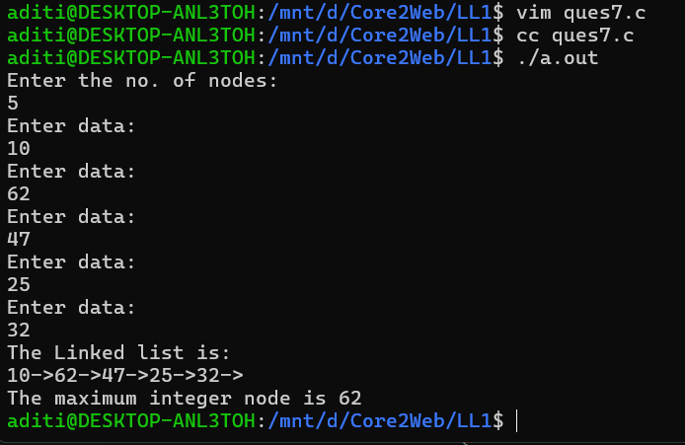

**Q.8. Print the minimum node from the above example:**

**Code:**

#include<stdio.h>

#include<stdlib.h>

struct Demo

{

int data;

struct Demo *next;

};

struct Demo *head=NULL;

int countNode()

{

int count=0;

if(head==NULL)

{

return 0;

}

else

{

struct Demo *temp=head;

while(temp!=NULL)

{

count++;

temp=temp->next;

}

return count;

}

}

int minNode()

{

int count=countNode();

if(head==NULL)

{

printf("Linked list is empty.\n");

return -1;

}

else

{

if(count==1)

{

return head->data;

}

else

{

struct Demo *temp=head;

int min=temp->data;

while(temp!=NULL)

{

if(temp->data<min)

{

min=temp->data;

}

temp=temp->next;

}

return min;

}

}

}

void printLL()

{

printf("The Linked list is:\n");

struct Demo *temp=head;

while(temp!=NULL)

{

printf("%d->",temp->data);

temp=temp->next;

}

printf("\n");

}

struct Demo *createNode()

{

struct Demo *newNode=(struct Demo*)malloc(sizeof(struct Demo));

printf("Enter data:\n");

scanf("%d",&newNode->data);

newNode->next=NULL;

return newNode;

}

void addNode()

{

struct Demo *newNode=createNode();

if(head==NULL)

{

head=newNode;

}

else

{

struct Demo *temp=head;

while(temp->next!=NULL)

{

temp=temp->next;

}

temp->next=newNode;

}

}

void main()

{

int count;

printf("Enter the no. of nodes:\n");

scanf("%d",&count);

for(int i=1;i<=count;i++)

{

addNode();

}

printLL();

int min=minNode();

printf("The minimum integer node is %d\n",min);

}

**Output:**

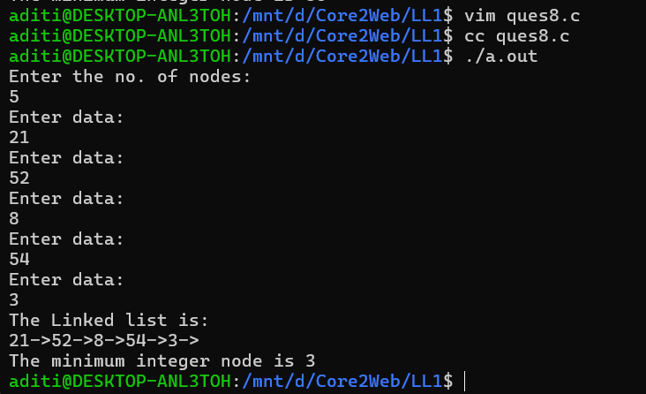

**Q.9. Check the prime number present in the above nodes:**

**Code:**

#include<stdio.h>

#include<stdlib.h>

struct Demo

{

int data;

struct Demo *next;

};

struct Demo *head=NULL;

int countNode()

{

int count=0;

if(head==NULL)

{

return 0;

}

else

{

struct Demo *temp=head;

while(temp!=NULL)

{

count++;

temp=temp->next;

}

return count;

}

}

void primeNode()

{

int count=countNode();

if(head==NULL)

{

printf("The linked list is empty, hence no Prime Numbers\n");

}

else

{

struct Demo *temp=head;

while(temp!=NULL)

{

if(temp->data==0 || temp->data==1)

{

printf("%d is neither prime nor composite\n",temp->data);

}

else

{

int flag=0;

for(int i=2;i*i<=temp->data;i++)

{

if(temp->data%i==0)

{

flag=1;

break;

}

}

if(flag==0)

{

printf("%d\n",temp->data);

}

}

temp=temp->next;

}

}

}

void printLL()

{

printf("The Linked list is:\n");

struct Demo *temp=head;

while(temp!=NULL)

{

printf("%d->",temp->data);

temp=temp->next;

}

printf("\n");

}

struct Demo *createNode()

{

struct Demo *newNode=(struct Demo*)malloc(sizeof(struct Demo));

printf("Enter data:\n");

scanf("%d",&newNode->data);

newNode->next=NULL;

return newNode;

}

void addNode()

{

struct Demo *newNode=createNode();

if(head==NULL)

{

head=newNode;

}

else

{

struct Demo *temp=head;

while(temp->next!=NULL)

{

temp=temp->next;

}

temp->next=newNode;

}

}

void main()

{

int count;

printf("Enter the no. of nodes:\n");

scanf("%d",&count);

for(int i=1;i<=count;i++)

{

addNode();

}

printLL();

printf("The Primes nos. from the above node data are:\n");

primeNode();

}

**Output:**

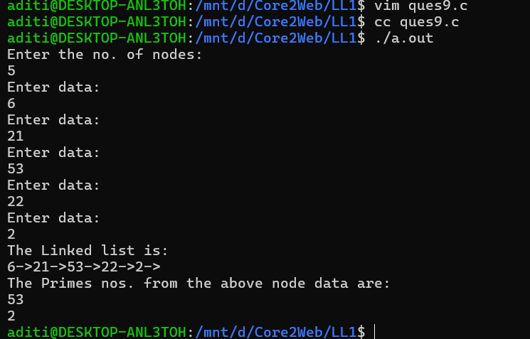

**Q.10. Write a real-time example of linked list and print its data. Take 5 nodes from the user:**

**Code:**

#include<stdio.h>

#include<stdlib.h>

struct menu

{

char name[20];

float price;

struct menu *next;

};

struct menu *head=NULL;

struct menu *createNode()

{

struct menu *newNode=(struct menu*)malloc(sizeof(struct menu));

printf("Enter the dish name:\n");

char ch;

int i=0;

getchar();

while((ch=getchar())!='\n')

{

(*newNode).name[i]=ch;

i++;

}

(*newNode).name[i]='\0';

printf("Enter the price of the dish\n");

scanf("%f",&newNode->price);

newNode->next=NULL;

return newNode;

}

void addNode()

{

struct menu *newNode=createNode();

if(head==NULL)

{

head=newNode;

}

else

{

struct menu *temp=head;

while(temp->next!=NULL)

{

temp=temp->next;

}

temp->next=newNode;

}

}

void printLL()

{

struct menu *temp=head;

while(temp!=NULL)

{

printf("|%s||%f|->",temp->name,temp->price);

temp=temp->next;

}

}

void main()

{

int count;

printf("Enter the no. of nodes:\n");

scanf("%d",&count);

for(int i=1;i<=count;i++)

{

addNode();

}

printf("The Menu is:\n");

printLL();

}

**Output:**

