**Design Document for GeoExplore**

Group HB4_3

Ethan Messmer: % contribution

Yusef Harb: % contribution

Aditi Nanchani: % contribution

Sam Richter: % contribution

Block Diagram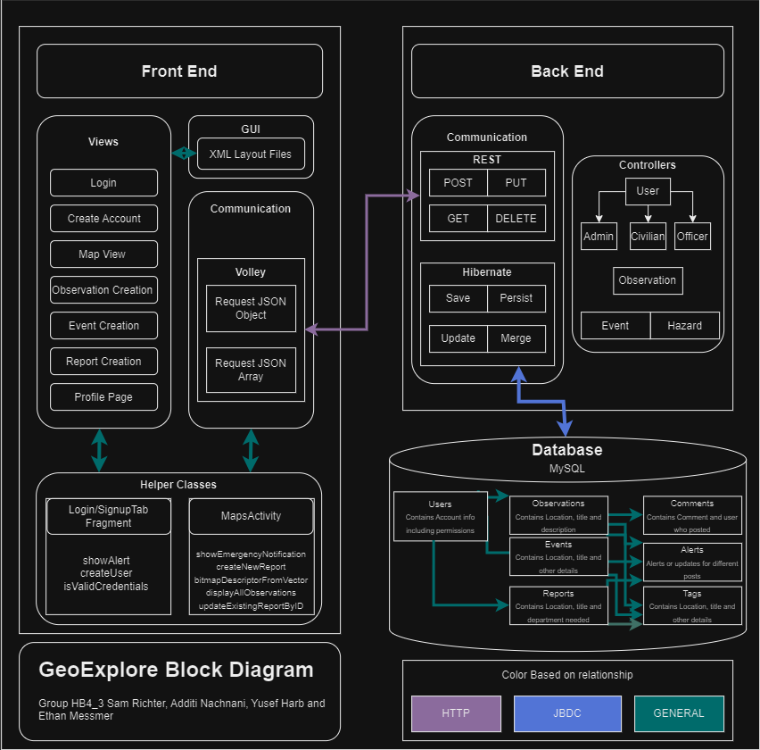

(Might need to zoom in a little)

**Frontend** (currently implemented)

*CreateAccount* (User)

* Create account generates a page with the following elements:
  + EditText: Email
  + EditText: Password
  + EditText: First Name
  + EditText: Last Name
  + Button: Signup
* Upon clicking the ‘Signup’ button, the values of the First Name, Last Name, Password, and

Email are sent as a POST request to the server.

*Login* (Admin, User, Business (yet to implement))

* Create account generates a page with the following elements:
  + EditText: Email
  + EditText: Password
  + Button: Login
* Login Screen takes user input of their Email and password, and if that Email

and password are valid, it will take the user to the google map view, where they are logged in

as that user and can create map markers.

*CreateObservation* (User, Admin)

* Creates an observation maker on the map with the following elements:
  + Long: ID
  + latLng: Longitude
  + latLng: Latitude
  + EditText: Title
  + EditText: Description
* Create Observation takes user input of the Title and Description and where they clicked on the screen and is sent as a POST request to the server where it is also assigned an ID. The marker is then displayed on the map with a symbol. Similar logic is applied for *CreateReport* and *CreateEvent.*

**Backend**

*Markers* (Alerts, Events, Observations, Reports)

* All share the same data entries:
  + ID: Long
  + Title: String
  + Description: String
  + Location: Geometry
  + Creator: User
  + Time Created: Date [String]
  + Time Updated: Date [String]
  + Metadata: String
  + Tags: MarkerTag [set]
* … And also have unique data:
  + Events:
    - Attendees: User [set]
  + Observations:
    - Confirmed by: User [set]
    - Comments: Comment [set]
  + Reports:
    - Confirmed by: User [set]

DB Schema

