Vehicle Type and Injury Severity
Patterns in Victorian road crash data from 2012 to 2024

Authors
Aditi Narkar
Zafirah Nadeem

Summary
This project examined whether injury severity differed among vehicle groups in the supplied Victorian crash records. We linked person, vehicle, crash, weather and road-surface tables, then compared the percentage of people with serious or fatal injuries. We also used logistic regression to compare vehicle groups while accounting for age group, speed zone, weather, road surface and crash type. In the simple comparison, serious or fatal injuries were recorded for 46.5% of people in the motorcycle group and 15.0% in the car/light-vehicle group. The adjusted model showed higher odds for motorcycles than cars in the measured data. These results describe associations, not causes. Some people could not be linked to a vehicle, the “Other” group is mixed, and people from the same crash may have related outcomes.

Introduction
People involved in the same type of crash can have different injuries. Vehicle type may be related to that difference, but crash conditions and the people involved may also matter. This project asks: how do serious and fatal injury percentages compare across vehicle groups, and how do those comparisons look after taking age group, speed zone, weather, road surface and crash type into account? The analysis uses the supplied Victorian crash records and describes patterns in those records.

Methodology
We used two R scripts. The first joins and prepares the records and makes the basic tables and chart. The second fits logistic regression models and checks predictions on crashes held aside from model fitting. The supplied files contain about 425,000 person records from 2012 through September 2024. The work was manageable in base R, so Hadoop and Spark were not needed.

Data and study group
The analysis combined five supplied CSV tables: Person, Vehicle, Accident, Atmospheric Condition and Road Surface Condition. Person records were the starting point because injury severity is recorded for each person. A person was linked to a vehicle by accident number and vehicle ID. Crash, weather and surface details were then linked by accident number. The final data cover one record per included person, not one record per crash.

Preparing the data
Person records were joined to Vehicle by crash number and vehicle ID, then to crash, weather and road-surface records by crash number. Injury severity was grouped as serious/fatal (serious injury or fatality) or lower severity (other injury or not injured). Vehicle descriptions were grouped into car/light vehicle, motorcycle, truck/heavy vehicle, bus and other. People without a matched vehicle and matched vehicles marked not known/not applicable were excluded. The mixed “Other” group includes 18,202 bicyclists among 21,506 people. Missing predictors were kept as Unknown.
Some crashes have more than one weather or road-surface entry. To avoid duplicating people, the script selected sequence 1 for each crash, or sequence 0 when sequence 1 was not present. It checked for duplicate person, vehicle and crash keys and recorded the exclusions. The join kept 425,352 person rows without multiplying them; 404,683 people had both a known vehicle group and a classified injury outcome.

Statistical analysis
The first analysis calculated the serious/fatal percentage in each vehicle group. The second used logistic regression, a method that estimates the chance of a two-category outcome. It compared vehicle groups while accounting for age group, speed zone, weather, road surface and crash type. The car/light-vehicle group was the comparison reference. Speed-zone codes outside 30 to 110 were combined as Unknown/other. A further model allowed vehicle-group differences to vary by speed zone.
For a prediction check, crashes were split into training and test groups, so people from the same crash stayed together. About 80% of crashes were used to fit the model and 20% were held back to check its predictions. Both steps use base R and can be rerun from the project folder with scripts/01_prepare_data.R followed by scripts/02_person2_model.R.

Results
The simple comparison showed differences by vehicle group. After adjustment, the motorcycle estimate remained higher than the car/light-vehicle estimate. Patterns also varied by speed zone, but some zone groups were small. On held-out crashes, the model ranked outcomes better than chance but detected few serious/fatal cases at the 0.5 cutoff.

Simple comparison
The table shows the number of included people in each group and the percentage with a serious or fatal injury. These are direct percentages; they do not adjust for age or crash conditions.
Vehicle group | People | Serious/fatal | Percent
Car/light vehicle | 342,297 | 51,376 | 15.0%
Motorcycle | 26,941 | 12,537 | 46.5%
Truck/heavy vehicle | 9,016 | 722 | 8.0%
Bus | 4,923 | 310 | 6.3%
Other | 21,506 | 6,288 | 29.2%
The motorcycle group had the highest percentage in this table (46.5%), compared with 15.0% for car/light vehicles. The “Other” group was also high at 29.2%, but it mostly represents bicyclists and should not be read as one single vehicle type.
Figure 1. Serious/fatal injury percentage among people in each vehicle group. The sample size is shown beside each bar.
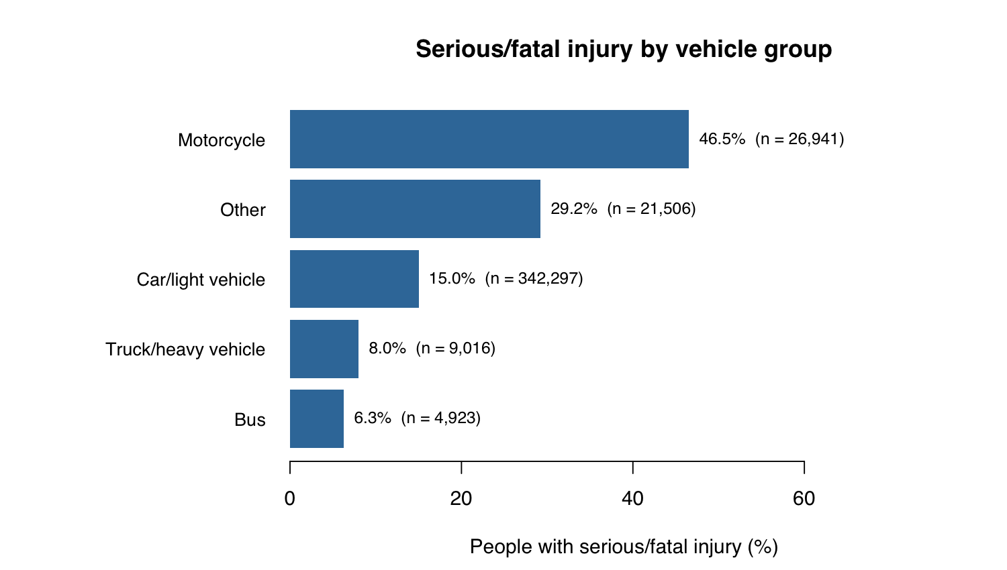

Adjusted comparison
After accounting for the measured factors, the estimated odds of serious/fatal injury were higher for motorcycles and the mixed Other group than for car/light vehicles. Odds compare the relative balance of serious/fatal and lower-severity outcomes; they are not the same as injury probabilities. The intervals below come from the fitted model and do not account for multiple people being linked to the same crash, so they may be too narrow.
Vehicle group | Adjusted odds ratio | 95% interval
Car/light vehicle (reference) | 1.00 | Reference
Motorcycle | 5.60 | 5.40 to 5.80
Other | 3.77 | 3.63 to 3.92
Bus | 0.39 | 0.34 to 0.44
Truck/heavy vehicle | 0.38 | 0.35 to 0.42
For example, the motorcycle estimate was 5.60. This means the model estimated higher odds than for car/light vehicles after adjusting for the listed factors. It does not mean that motorcycle occupants were 5.6 times as likely to be seriously injured, and it does not show that the vehicle type caused the injury.
Figure 2. Model-predicted probability for each vehicle group at one fixed profile: age 30–39, speed zone 60, clear weather, dry road and collision with another vehicle.
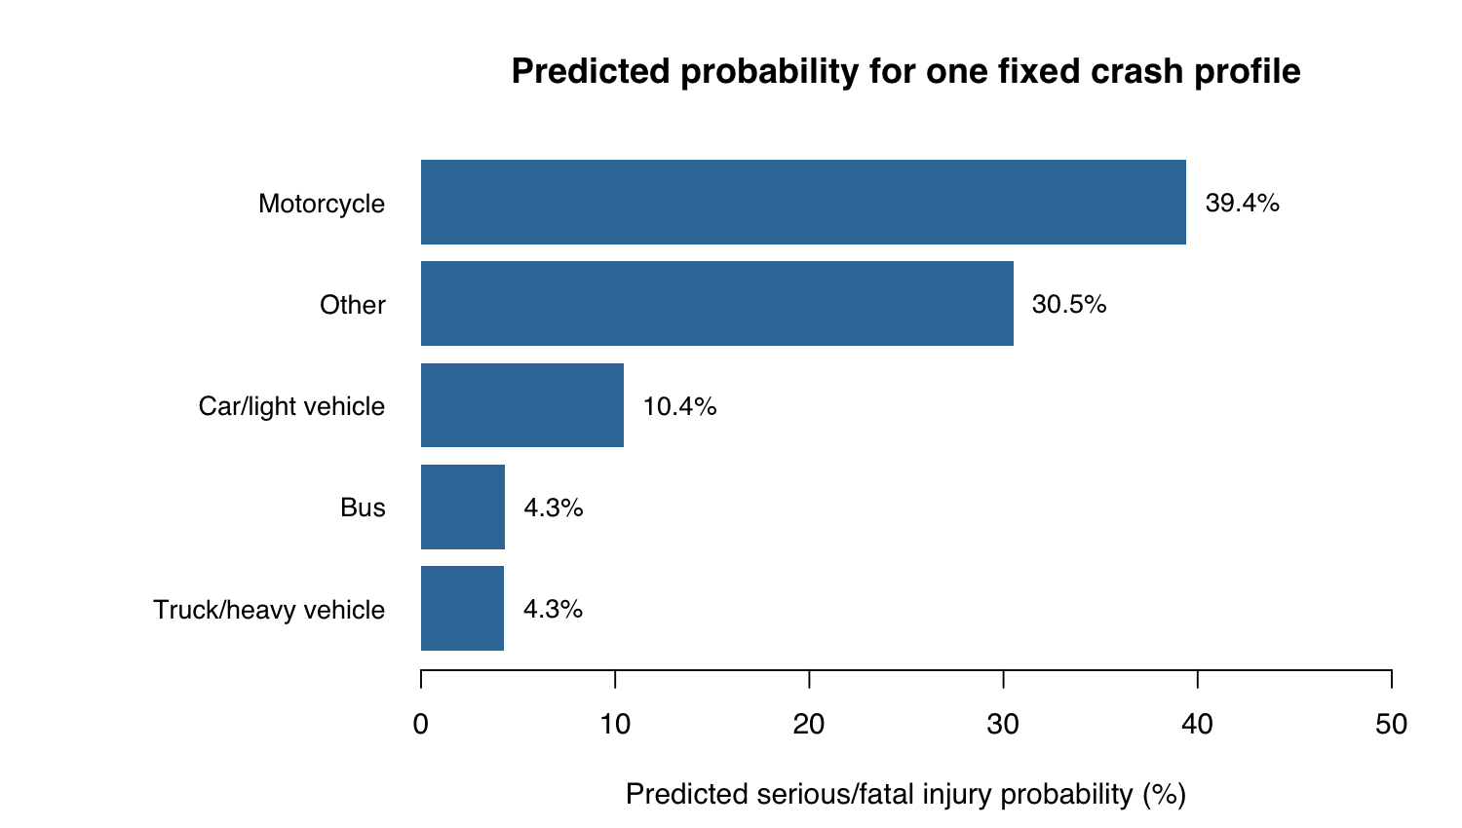

Speed-zone patterns
The model fit improved when vehicle-group comparisons were allowed to differ by speed zone (likelihood-ratio test: 39 degrees of freedom, p < 0.001). This suggests that the pattern was not identical across zones in this large dataset. However, some cells were very small. For example, the 75 zone had only 34 car/light-vehicle people and one or fewer people in each other group. Results for rare combinations are uncertain, so the interaction should be interpreted carefully rather than as a precise pattern for every zone.

Prediction check
The held-out test group contained 81,327 people from 35,997 crashes. The model’s ROC AUC was 0.758, so it ranked serious/fatal cases above lower-severity cases better than chance overall. At a 0.5 cutoff, it detected only 11.7% of serious/fatal cases, while correctly identifying 98.0% of lower-severity cases. Accuracy was 82.8%, but lower-severity cases were more common, so this accuracy figure alone is not a good summary.
Test measure | Result | Plain meaning
ROC AUC | 0.758 | How well the model ranks higher-risk cases
Brier score | 0.125 | Average error in predicted probabilities; lower is better
Conclusion
Motorcycle-linked people had the highest serious/fatal percentage, and the difference remained after adjustment for measured factors. This is an association, not proof of cause. Further work should account for people sharing crashes, refine the mixed “Other” group and test the model on crashes from a later period.

