**Task-1**

**Subtask-1 : AWS Client**

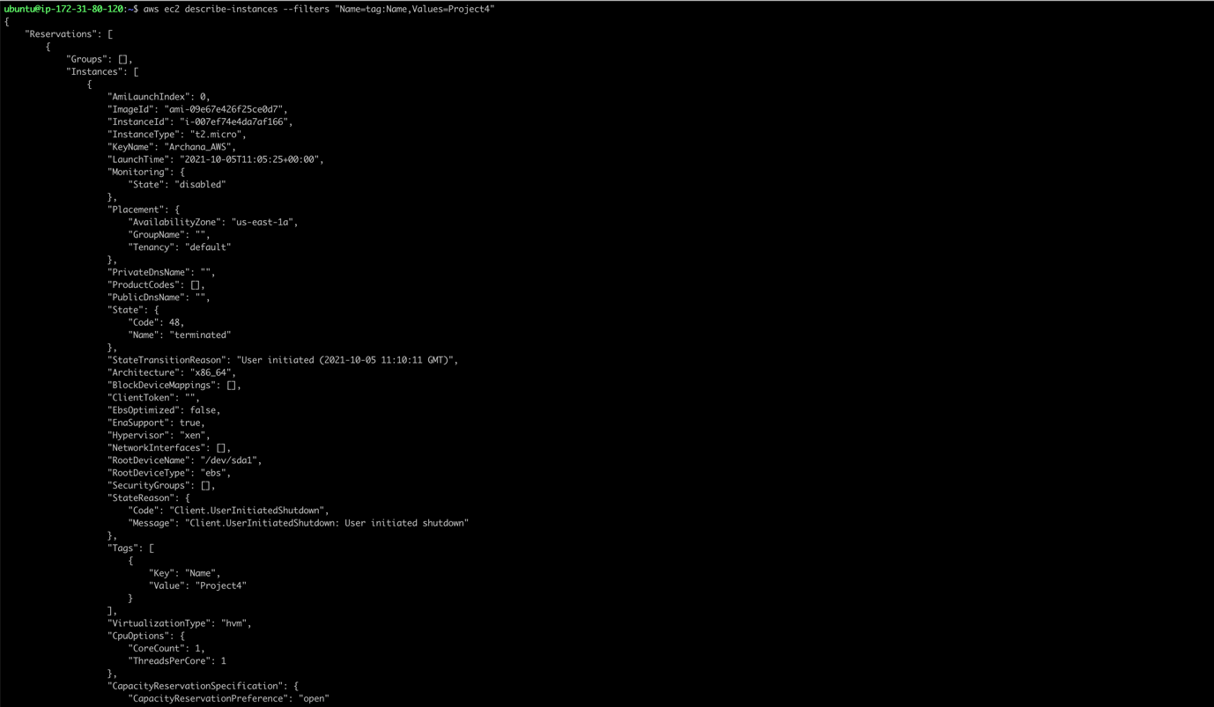

**Subtask-1- S3 bucket to state management**

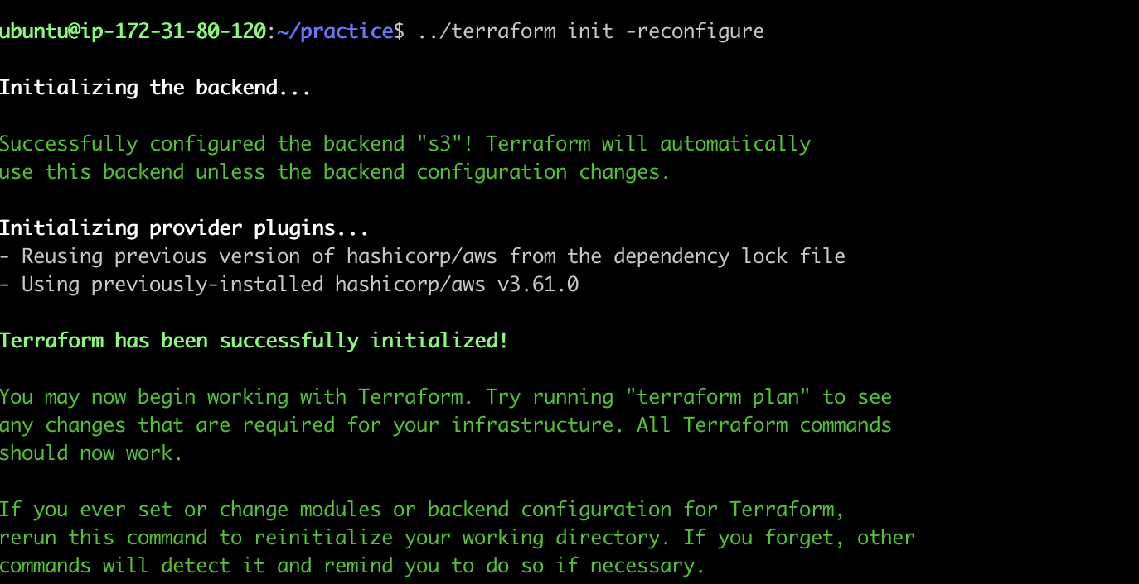

**Subtask-2**

**(output of terraform apply)**

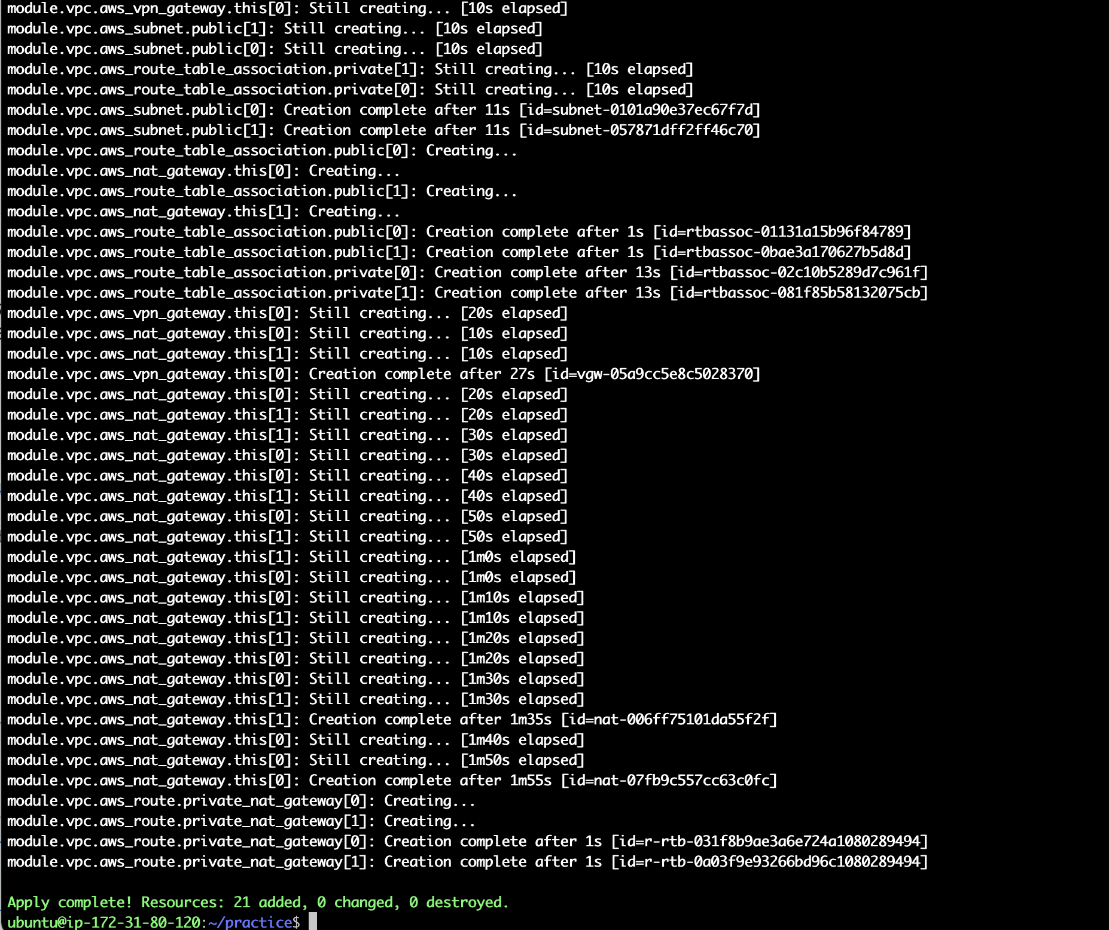

**Some Screenshots from AWS Console after resource creation**

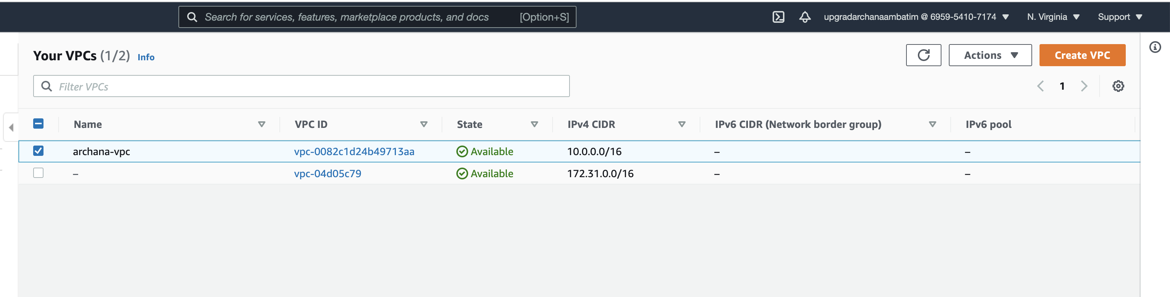

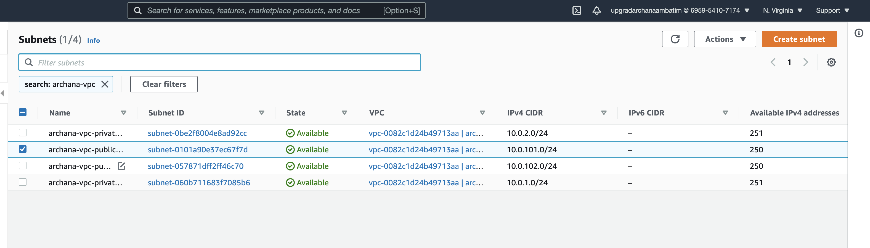

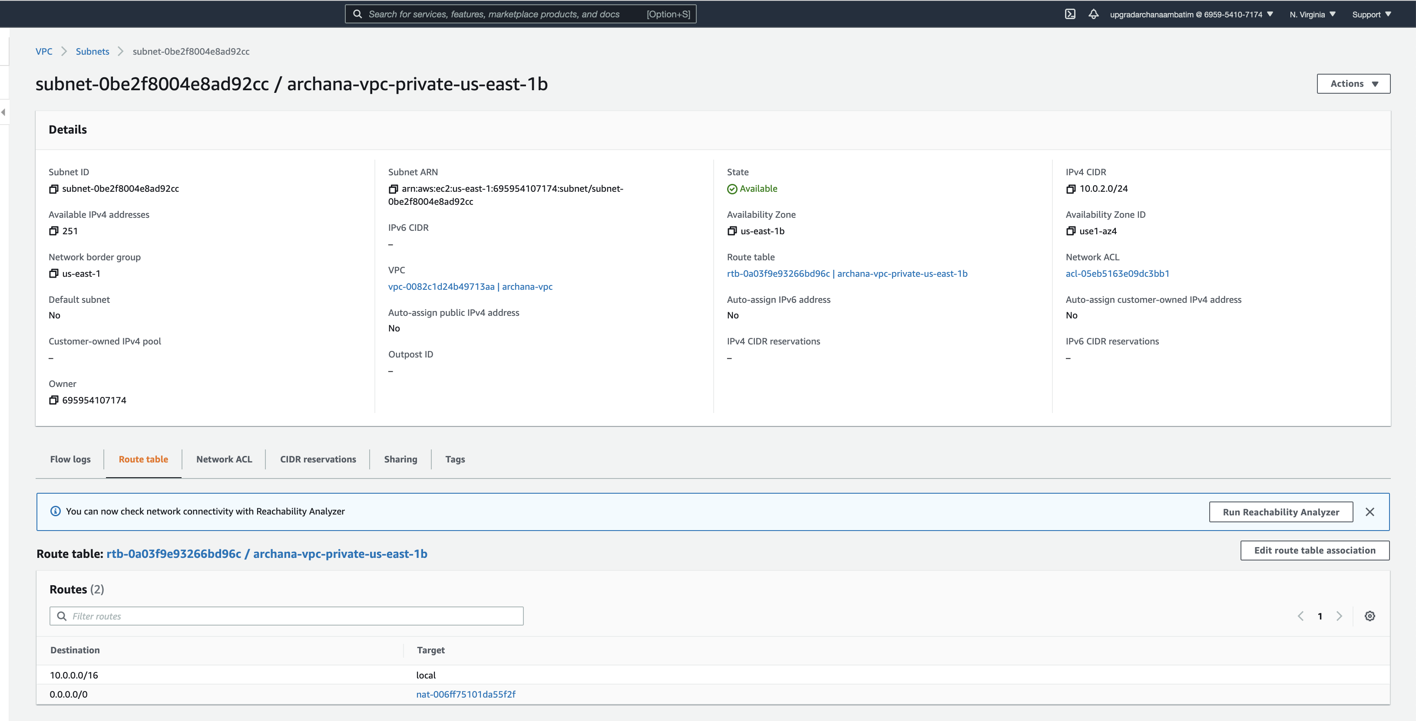

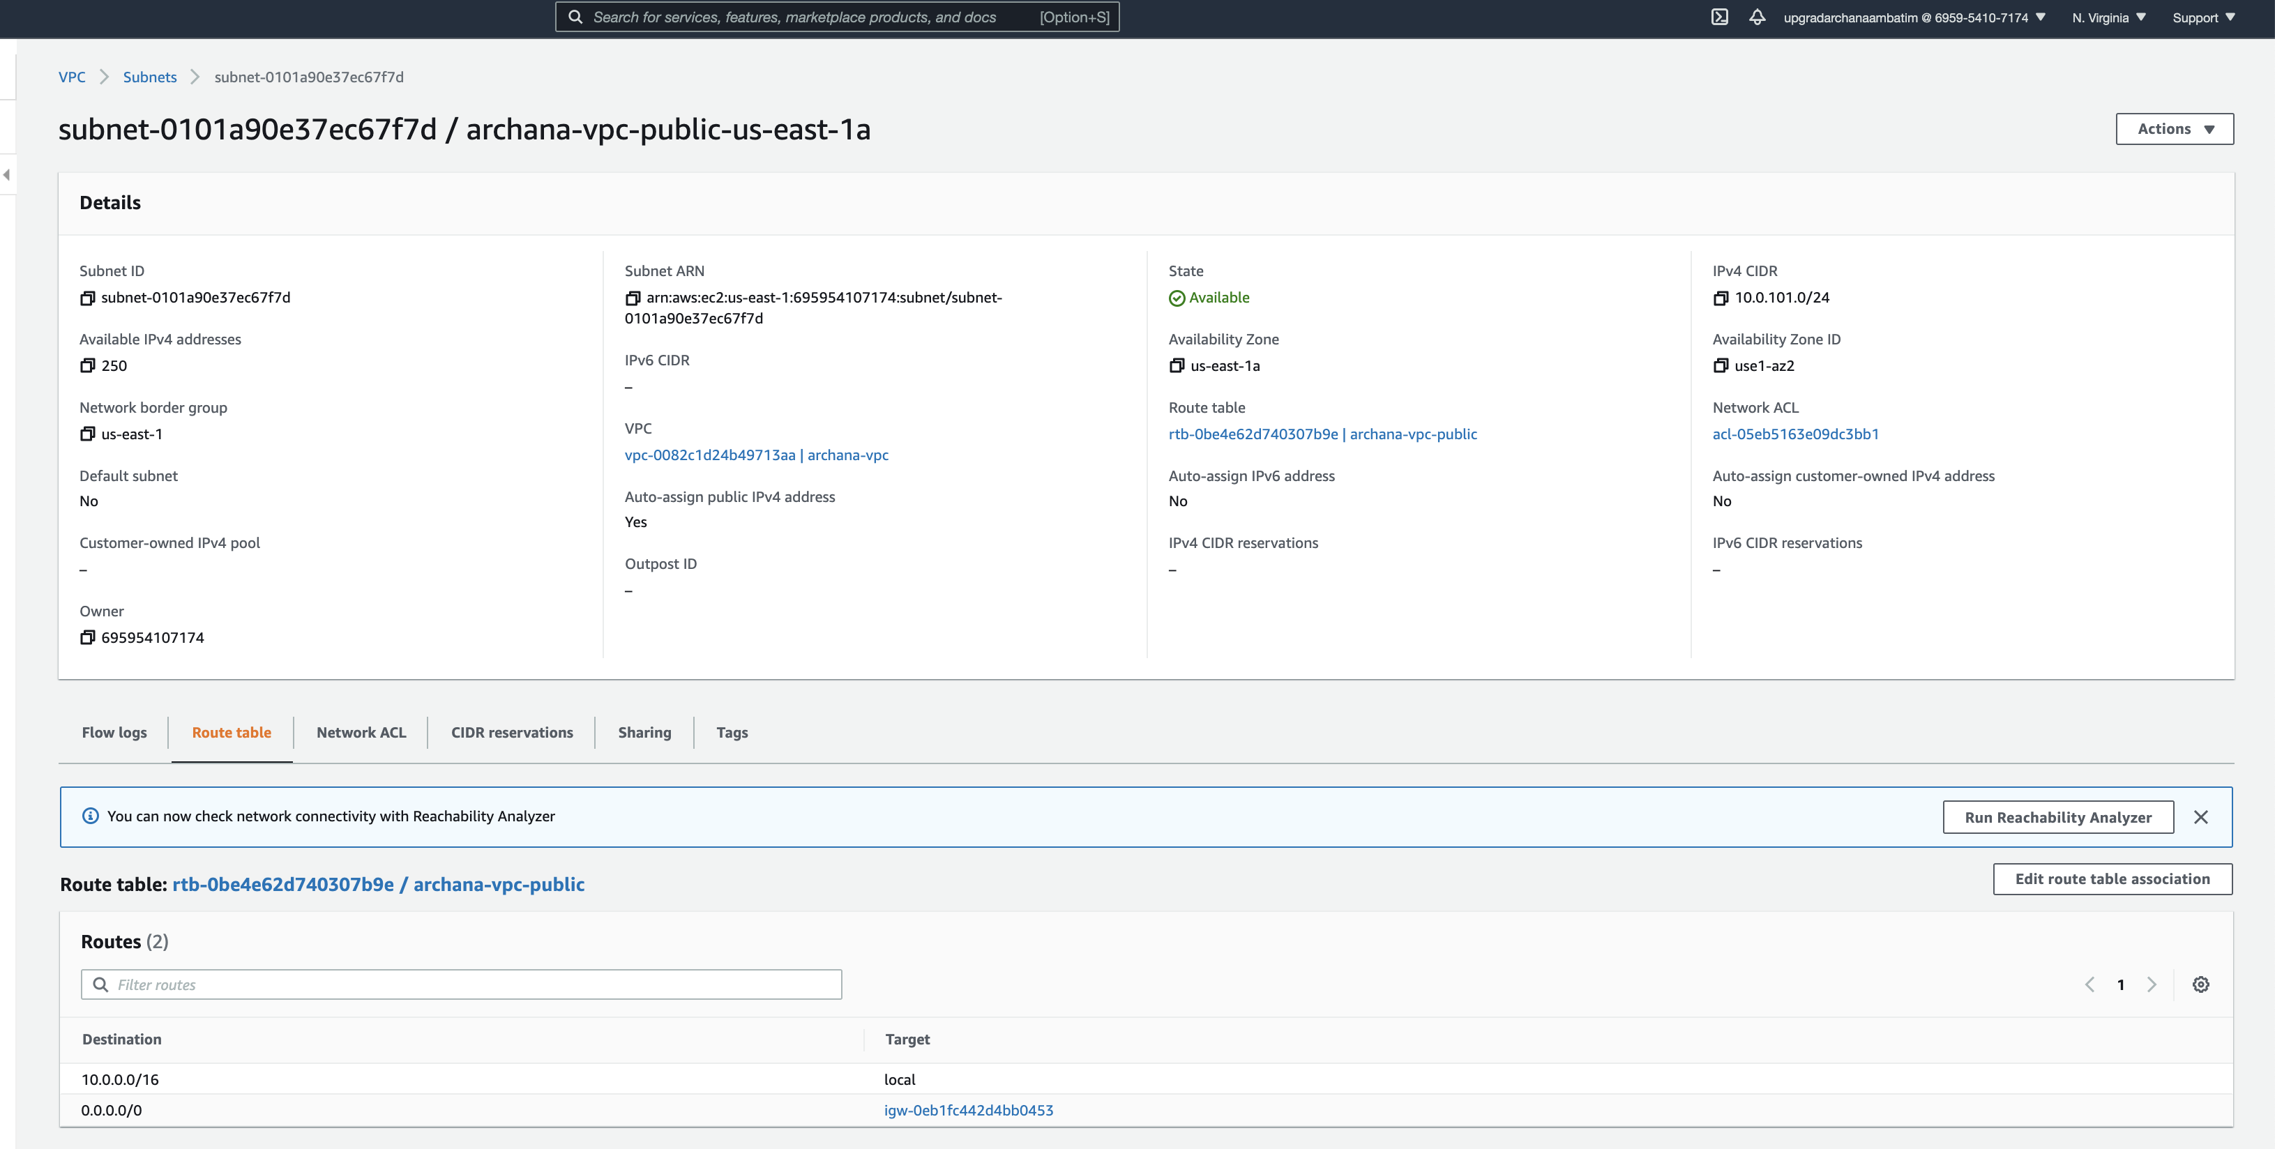

**Subtask-3**

**Security group creation**

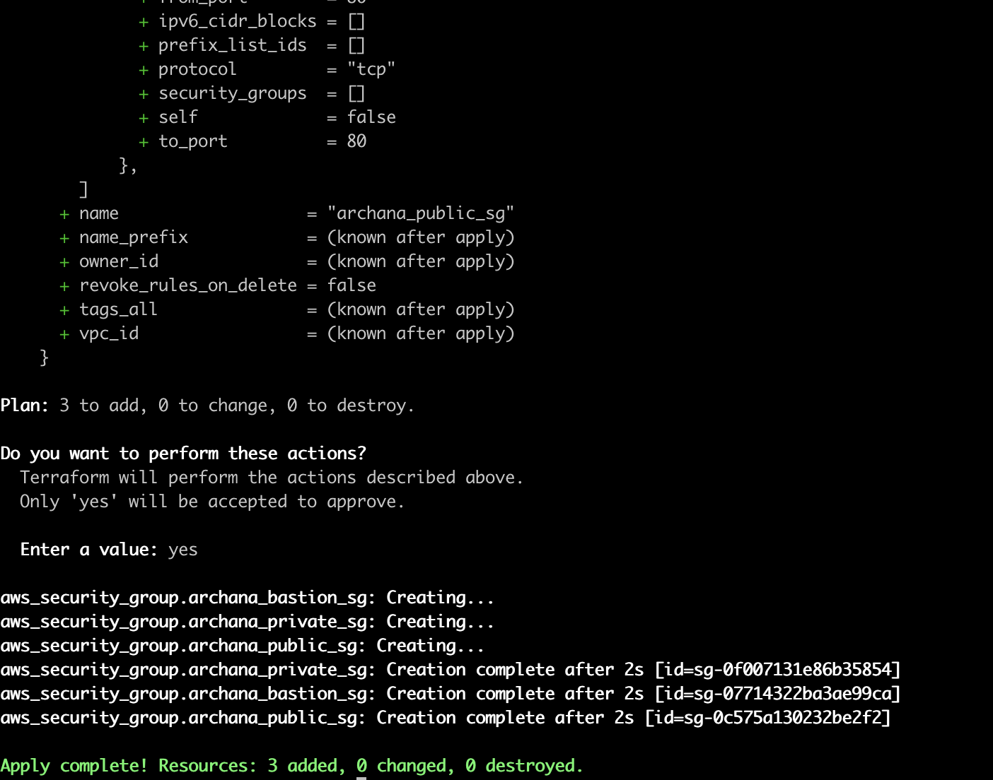

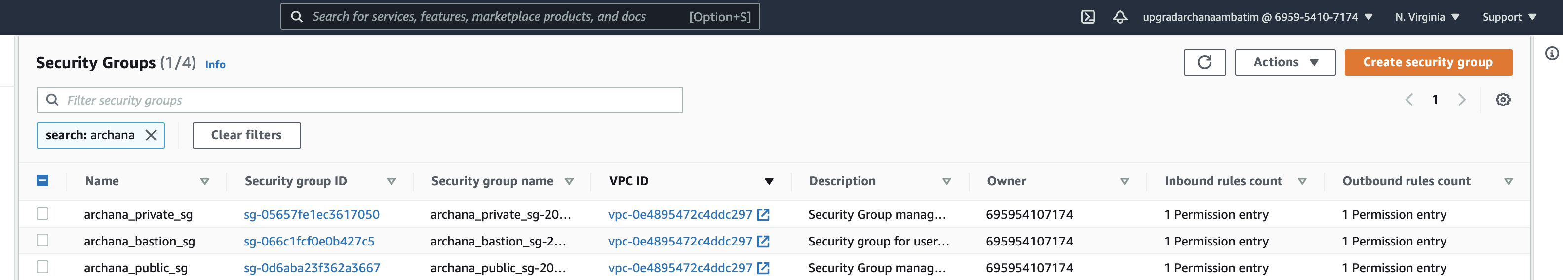

**Subtask -4**

