**Task3**

Subtask-1

Github Repo

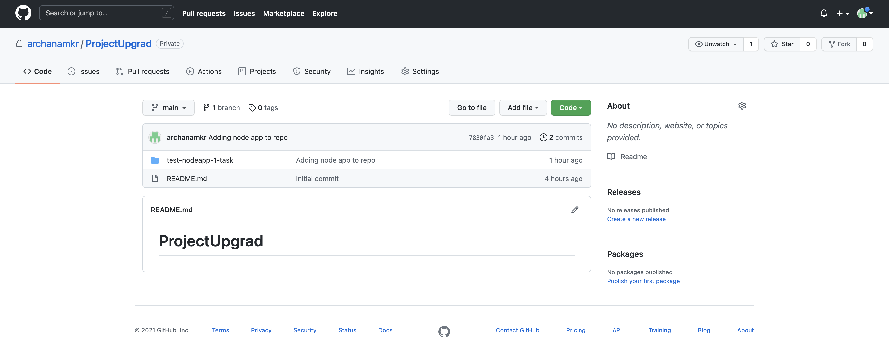

NODE app testing in local env

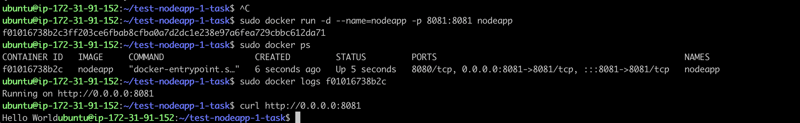

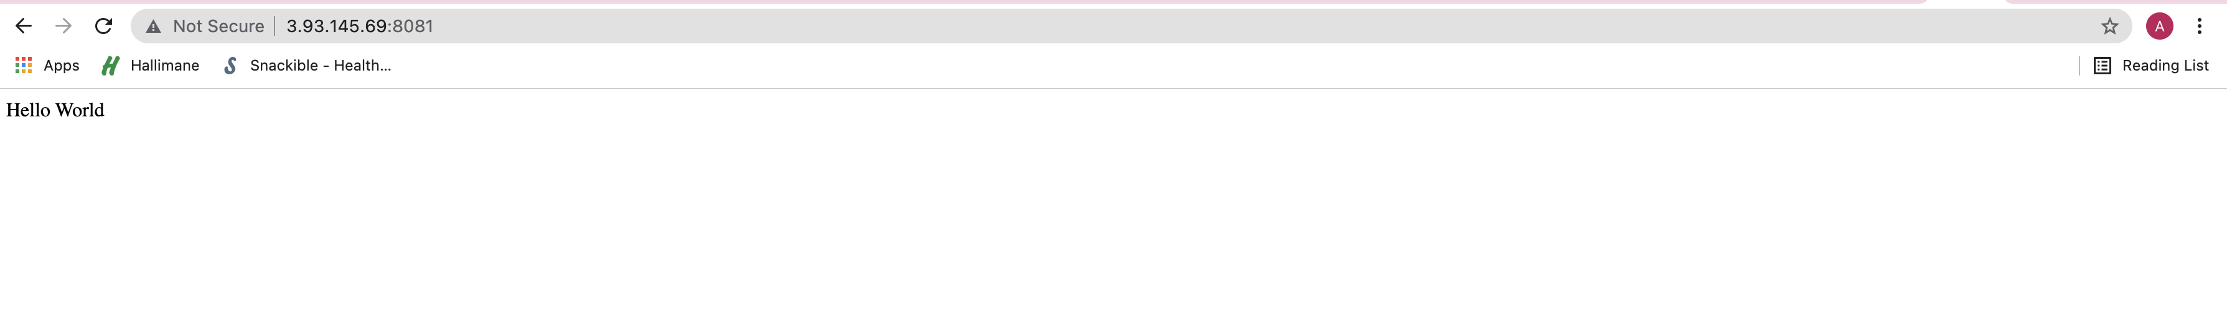

Adding Docker File to github repo

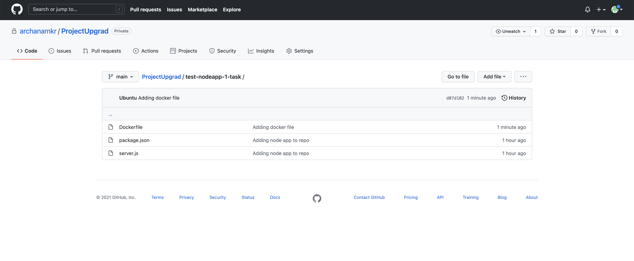

Credentials in Jenkins

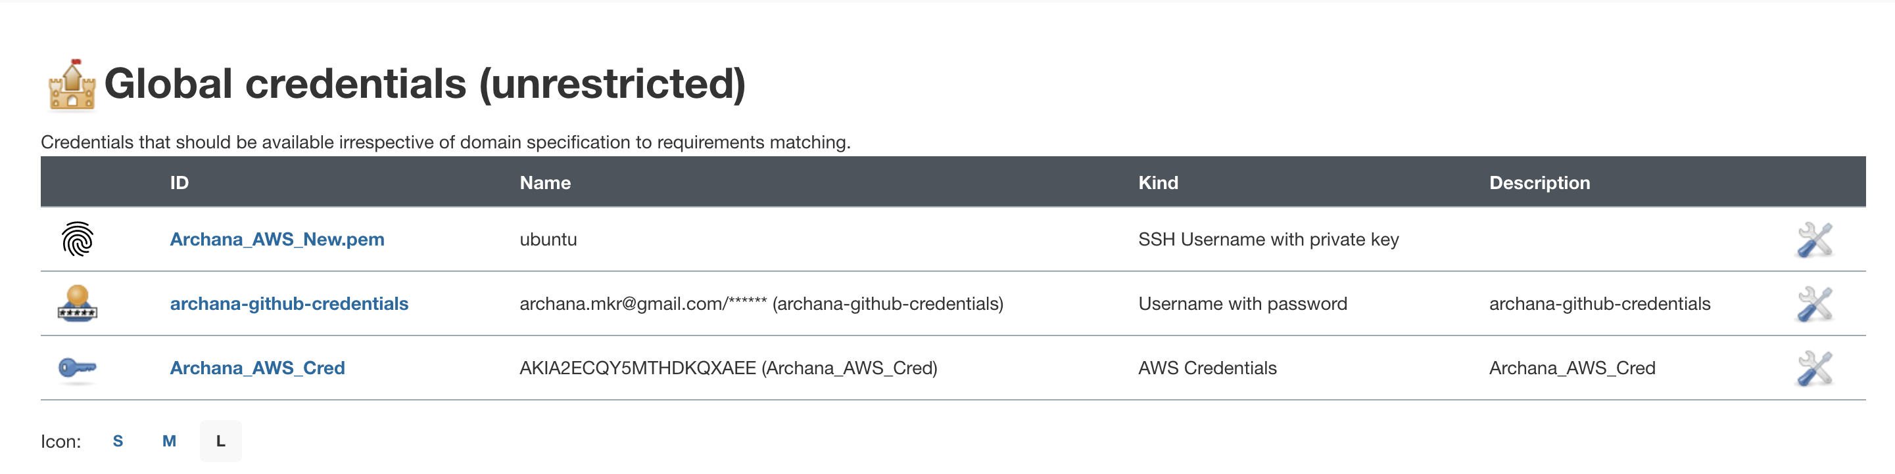

**Jenkins Pipeline Output**

Started by user Archana

Obtained task3/archana_jenkins from git https://github.com/archanamkr/ProjectUpgrad.git

Running in Durability level: MAX_SURVIVABILITY

[Pipeline] Start of Pipeline

[Pipeline] node

Running on Jenkins in /var/lib/jenkins/workspace/Archana_Pipeline

[Pipeline] {

[Pipeline] stage

[Pipeline] { (Declarative: Checkout SCM)

[Pipeline] checkout

Selected Git installation does not exist. Using Default

The recommended git tool is: NONE

using credential archana-github-credentials

> git rev-parse --resolve-git-dir /var/lib/jenkins/workspace/Archana_Pipeline/.git # timeout=10

Fetching changes from the remote Git repository

> git config remote.origin.url https://github.com/archanamkr/ProjectUpgrad.git # timeout=10

Fetching upstream changes from https://github.com/archanamkr/ProjectUpgrad.git

> git --version # timeout=10

> git --version # 'git version 2.25.1'

using GIT_ASKPASS to set credentials archana-github-credentials

> git fetch --tags --force --progress -- https://github.com/archanamkr/ProjectUpgrad.git +refs/heads/*:refs/remotes/origin/* # timeout=10

> git rev-parse refs/remotes/origin/main^{commit} # timeout=10

Checking out Revision 585c0763cacc08d531951175dd0f519cbd21f46a (refs/remotes/origin/main)

> git config core.sparsecheckout # timeout=10

> git checkout -f 585c0763cacc08d531951175dd0f519cbd21f46a # timeout=10

Commit message: "Update archana_jenkins"

> git rev-list --no-walk 585c0763cacc08d531951175dd0f519cbd21f46a # timeout=10

[Pipeline] }

[Pipeline] // stage

[Pipeline] withEnv

[Pipeline] {

[Pipeline] withEnv

[Pipeline] {

[Pipeline] stage

[Pipeline] { (Demo)

[Pipeline] echo

GitHub Jenkins integration is successful !!!

[Pipeline] }

[Pipeline] // stage

[Pipeline] stage

[Pipeline] { (clone GIT Repo)

[Pipeline] checkout

The recommended git tool is: NONE

No credentials specified

> git rev-parse --resolve-git-dir /var/lib/jenkins/workspace/Archana_Pipeline/.git # timeout=10

Fetching changes from the remote Git repository

> git config remote.origin.url https://github.com/archanamkr/NodeApp.git/ # timeout=10

Fetching upstream changes from https://github.com/archanamkr/NodeApp.git/

> git --version # timeout=10

> git --version # 'git version 2.25.1'

> git fetch --tags --force --progress -- https://github.com/archanamkr/NodeApp.git/ +refs/heads/*:refs/remotes/origin/* # timeout=10

> git rev-parse refs/remotes/origin/main^{commit} # timeout=10

Checking out Revision 7fecfa7a2398a067d8d2f942ee72ab797249ce8e (refs/remotes/origin/main)

> git config core.sparsecheckout # timeout=10

> git checkout -f 7fecfa7a2398a067d8d2f942ee72ab797249ce8e # timeout=10

Commit message: "Add files via upload"

> git rev-list --no-walk 7fecfa7a2398a067d8d2f942ee72ab797249ce8e # timeout=10

[Pipeline] }

[Pipeline] // stage

[Pipeline] stage

[Pipeline] { (Docker Image build)

[Pipeline] echo

Docker Image build starts

[Pipeline] script

[Pipeline] {

[Pipeline] isUnix

[Pipeline] sh

+ docker build -t archana-project-repository:LATEST .

Sending build context to Docker daemon 196.1kB

Step 1/7 : FROM node:alpine3.11

---> 483a477e5fe0

Step 2/7 : WORKDIR /usr/src/app

---> Using cache

---> 85f1377aaa32

Step 3/7 : COPY package.json ./

---> Using cache

---> 77e1fd526ef1

Step 4/7 : RUN npm install

---> Using cache

---> f51a3553a523

Step 5/7 : COPY . .

---> 102ab54d3331

Step 6/7 : EXPOSE 8080

---> Running in 25da0bbb617f

Removing intermediate container 25da0bbb617f

---> 9de25af05259

Step 7/7 : CMD [ "node", "server.js" ]

---> Running in 772ba43e0ec9

Removing intermediate container 772ba43e0ec9

---> a0935b58760c

Successfully built a0935b58760c

Successfully tagged archana-project-repository:LATEST

[Pipeline] }

[Pipeline] // script

[Pipeline] }

[Pipeline] // stage

[Pipeline] stage

[Pipeline] { (Logging into AWS ECR)

[Pipeline] script

[Pipeline] {

[Pipeline] sh

+ docker login --username AWS --password-stdin 695954107174.dkr.ecr.us-east-1.amazonaws.com

+ aws ecr get-login-password --region us-east-1

WARNING! Your password will be stored unencrypted in /var/lib/jenkins/.docker/config.json.

Configure a credential helper to remove this warning. See

https://docs.docker.com/engine/reference/commandline/login/#credentials-store

Login Succeeded

[Pipeline] }

[Pipeline] // script

[Pipeline] }

[Pipeline] // stage

[Pipeline] stage

[Pipeline] { (Pushing Docker image to ECR)

[Pipeline] script

[Pipeline] {

[Pipeline] sh

+ docker tag archana-project-repository:LATEST 695954107174.dkr.ecr.us-east-1.amazonaws.com/archana-project-repository:LATEST

[Pipeline] sh

+ docker push 695954107174.dkr.ecr.us-east-1.amazonaws.com/archana-project-repository:LATEST

The push refers to repository [695954107174.dkr.ecr.us-east-1.amazonaws.com/archana-project-repository]

b2514cfa9e88: Preparing

1f46bb8030ea: Preparing

33c957cf928d: Preparing

a33d164d9128: Preparing

cee4c91969ab: Preparing

3ba4ca62071f: Preparing

9e7c1fb3f2f2: Preparing

39982b2a789a: Preparing

3ba4ca62071f: Waiting

9e7c1fb3f2f2: Waiting

39982b2a789a: Waiting

1f46bb8030ea: Layer already exists

cee4c91969ab: Layer already exists

a33d164d9128: Layer already exists

33c957cf928d: Layer already exists

3ba4ca62071f: Layer already exists

9e7c1fb3f2f2: Layer already exists

39982b2a789a: Layer already exists

b2514cfa9e88: Pushed

LATEST: digest: sha256:cdd2417477c83122ce7491312538712d6fc8c3e6a981bd869acb9b1cd5bd12a6 size: 1992

[Pipeline] }

[Pipeline] // script

[Pipeline] }

[Pipeline] // stage

[Pipeline] stage

[Pipeline] { (deploy to app host)

[Pipeline] sshagent

[ssh-agent] Using credentials ubuntu

[ssh-agent] Looking for ssh-agent implementation...

[ssh-agent] Exec ssh-agent (binary ssh-agent on a remote machine)

$ ssh-agent

SSH_AUTH_SOCK=/tmp/ssh-W3v0G3LYVf03/agent.3123

SSH_AGENT_PID=3126

Running ssh-add (command line suppressed)

Identity added: /var/lib/jenkins/workspace/Archana_Pipeline@tmp/private_key_15590570484812650846.key (/var/lib/jenkins/workspace/Archana_Pipeline@tmp/private_key_15590570484812650846.key)

[ssh-agent] Started.

[Pipeline] {

[Pipeline] sh

+ ssh -o StrictHostKeyChecking=no ubuntu@54.164.53.129 docker rm -f node-app

Error: No such container: node-app

[Pipeline] sh

+ ssh -o StrictHostKeyChecking=no ubuntu@54.164.53.129 docker run -p 8081:8081 -d --name node-app 695954107174.dkr.ecr.us-east-1.amazonaws.com/archana-project-repository:LATEST

459e3a5619b6a9b9c42b0e5d38b68ab4d338861fa917d15c5cd1fbb5a0e1df98

[Pipeline] }

$ ssh-agent -k

unset SSH_AUTH_SOCK;

unset SSH_AGENT_PID;

echo Agent pid 3126 killed;

[ssh-agent] Stopped.

[Pipeline] // sshagent

[Pipeline] }

[Pipeline] // stage

[Pipeline] }

[Pipeline] // withEnv

[Pipeline] }

[Pipeline] // withEnv

[Pipeline] }

[Pipeline] // node

[Pipeline] End of Pipeline

Finished: SUCCESS