**By Aditi Singh**

**Roll No: 202401100300014**

**Course: B.Tech CSE (AI)**

**Date: 11-03-2025**

Simple Game AI for Rock-Paper-Scissors

Project Report

**Introduction**

Rock-Paper-Scissors is a game that is often used as a decision-making tool. The game involves three choices: **Rock, Paper, and Scissors**. The rules are simple:

* **Rock beats Scissors**
* **Scissors beats Paper**
* **Paper beats Rock**
* **Same choices result in a Draw**

This project implements a **basic AI** using Python to play Rock-Paper-Scissors against the user. The AI makes random choices, and the program determines the winner based on the rules.

**Method:**

The implementation follows these steps:

1. **User Input:** The player selects one of the three choices.
2. **AI Decision:** The AI randomly selects **Rock, Paper, or Scissors**.
3. **Game Logic:** The winner is determined based on predefined rules.
4. **Score Tracking:** The number of wins and losses are counted.
5. **Graphical Representation:** A **bar chart** is used to display the score.

The program runs inside a loop until the user decides to exit.

**Code:**

import random

import matplotlib.pyplot as plt

choices = ["rock","paper","scissor"]

score = 0

negative = 0

while True:

  print("Choices")

  print("1. Rock")

  print("2. Paper")

  print("3. Scisor")

  user_input = int(input("Enter choice : "))

  if user_input <1 and user_input>3:

    continue

  ai_input = random.choice(choices)

  print("AI choice : ",ai_input)

  if user_input == 1:   #rock

    if ai_input == "scissor":

      print("You Win")

      score += 1

    elif ai_input == "paper":

      print("You Lose")

      negative += 1

    elif ai_input == "rock":

      print("Draw")

  elif user_input == 2:  #paper

    if ai_input == "scissor":

      print("You Lose")

      negative += 1

    elif ai_input == "paper":

      print("Draw")

    elif ai_input == "rock":

      score +=1

      print("You Win")

  elif user_input == 3:

    if ai_input == "scissor":

      print("Draw")

    elif ai_input == "paper":

      print("You Win")

      score += 1

    elif ai_input == "rock":

      print("You Lose")

      negative +=1

  print("Enter 0 to Exit")

  print("Enter 1 to Play Again")

  play_again = int(input("Enter choice : "))

  if play_again == 0:

    break

print("Your Score is : ",score)

print("AI Score is : ",negative)

plt.bar(["Wins", "Losses"], [score, negative], color=['green', 'red'])

plt.show()

**Output:**

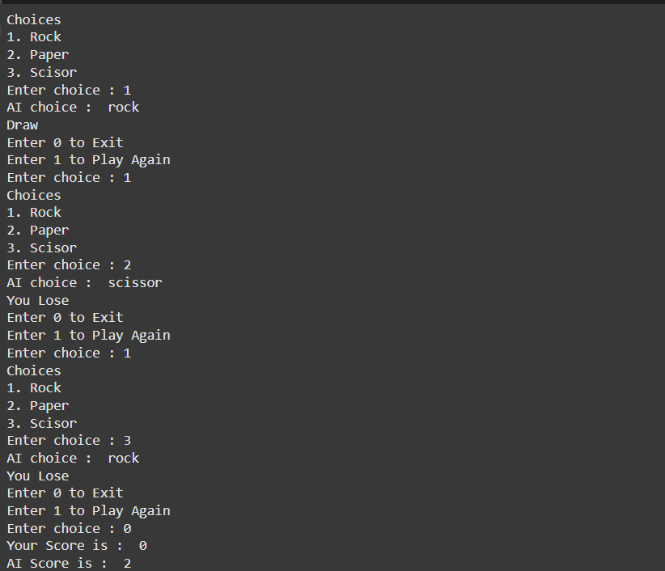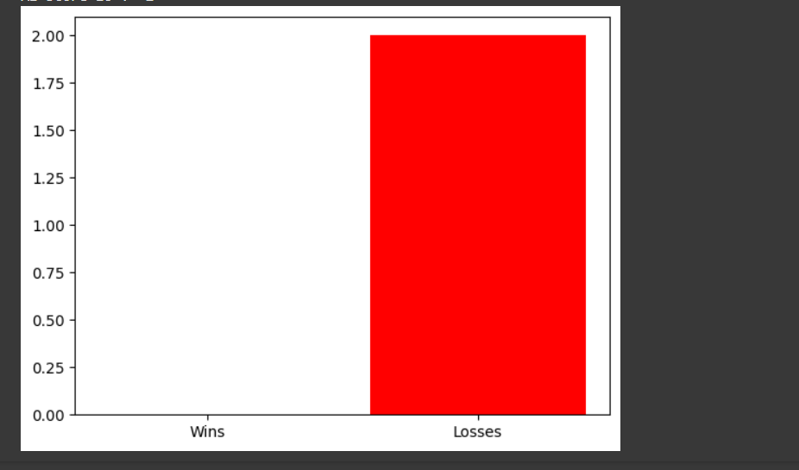

**6. References**

1. Game Rules: [Wikipedia – Rock Paper Scissors](https://en.wikipedia.org/wiki/Rock_paper_scissors)