**WEB DESIGN WORKSHOP(K24IT12P)**

**PHOTOGRAPHY PORTFOLIO WEBSITE**

**Project Report**

**BACHELOR OF TECHNOLOGY**

**in**

**Computer Science Engineering(AI)**



Submitted by: Aditi Singh(14), Anushka Rajput(59), Anushka Shakya(60), Aryan Tomar(72)

Submitted To: Shivansh Prasad

Table of Contents

|  |  |  |
| --- | --- | --- |
| S. No. | Topic | Page No. |
| 1 | Project Description | 3 |
| 2 | Team Information | 3 |
| 3 | Tools Used | 3 |
| 4 | Features of the Website | 4 |
| 5 | Flowcharts and Screenshots | 5 |
| 6 | Future Implementation | 7 |
| 7 | Conclusion | 8 |

Project Description

The Photography Portfolio Website is an interactive platform designed to showcase and organize photographs under multiple genres like nature, humans, paradise, and animals. It provides users with a space to explore visually captivating galleries, interact with a structured design, and securely access features like user authentication. This project emphasizes creativity, usability, and future scalability, ensuring a smooth experience for users.

Team Information

* Aryan Tomar
* Aditi Singh
* Anushka Shakya
* Anushka Rajput

Tools Used

1. HTML5: For structuring the website and organizing content.
2. CSS3: For styling, layout, and responsive design, including the use of Flexbox and media queries.
3. Image Editing Tools: For optimizing and compressing images to enhance loading times.
4. Hosting Platform: A shared server was used for deploying and hosting the website.

Features of the Software

1. Top Bar:
   1. Includes navigation links to About Us, Gallery, Contact, Privacy Policy, and SignUp/Login.
2. Gallery Section:
   1. Displays categorized images with links to individual pages like Nature, Animals, Humans, and Paradise.
3. Contact Us:
   1. Provides contact details (email, phone number, and address) for user inquiries and feedback.
4. Privacy Policy:
   1. Details measures to ensure user data security and transparency.
5. User Authentication:
   1. Includes SignUp and Login buttons for account creation and secure access.

Flowcharts and Screenshots

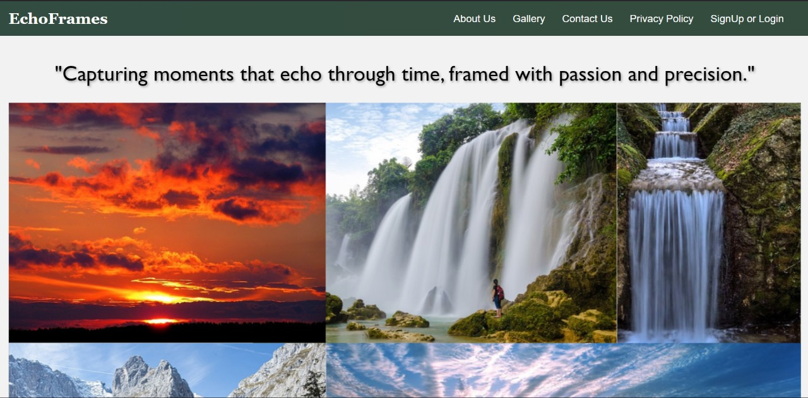

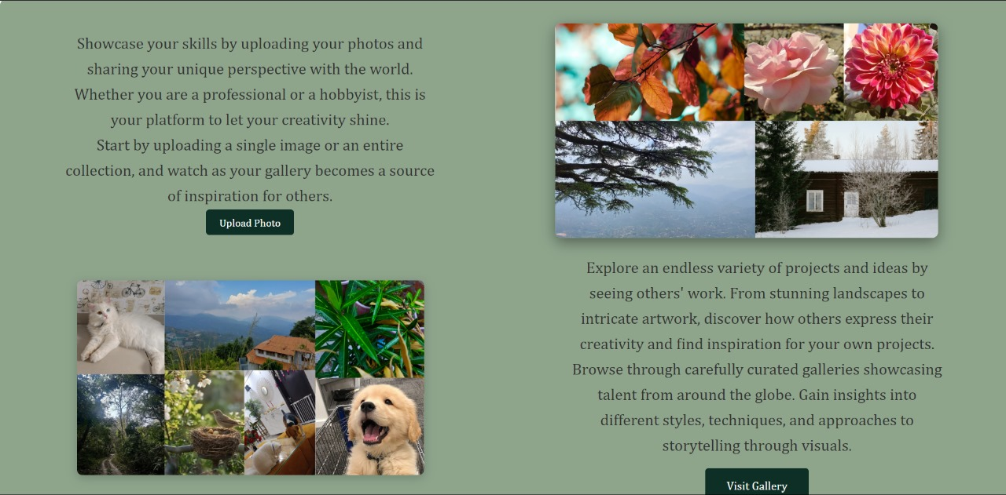

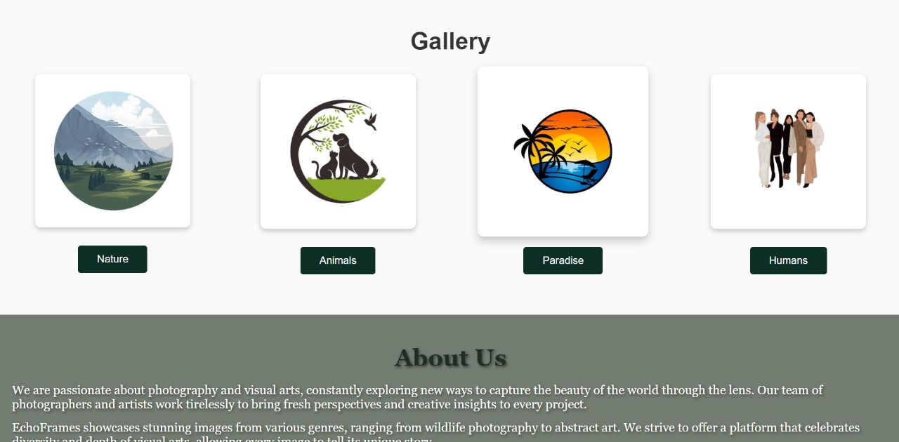

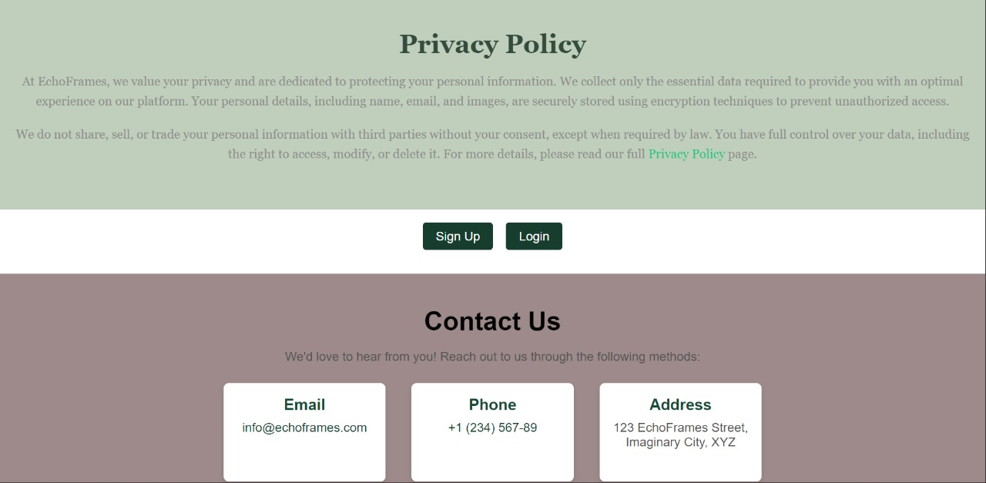

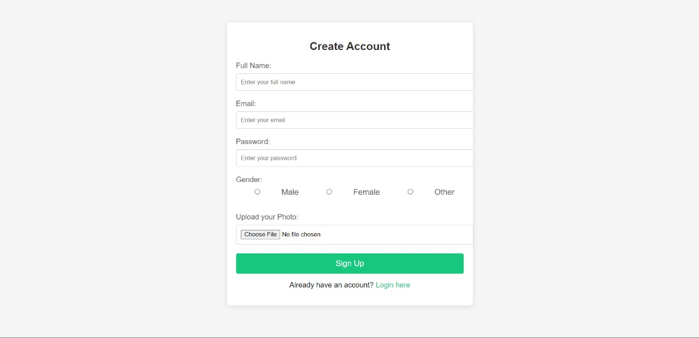

Future Implementation

1. User Profiles:
   * Enable users to create portfolios showcasing their photography collections.
2. Interactive Features:
   * Introduce comment sections for feedback on photos.
   * Add features like “Photo of the Day” or voting systems.
3. Advanced Galleries:
   * Implement filters and search functionalities for easier navigation.
4. Mobile Application:
   * Develop a mobile-friendly app to expand accessibility.
5. AI Tools:
   * Integrate automatic photo tagging and categorization for better organization.

Conclusion

The Photography Portfolio Website serves as an engaging platform for photographers and enthusiasts alike. It combines visually appealing galleries, intuitive navigation, and secure features, providing a strong foundation for future enhancements. With planned updates and scalability, the website has the potential to become a prominent hub for photography communities worldwide.