WEEK 4 TASK: PREDICTIVE MODELING AND OPTIMIZATION IN LOGISTICS SYSTEMS
Detailed Academic Report
Submitted by: Aditi Srivastava
Course: B.Tech Computer Science & Engineering (AI & ML)
Project Title: Delivery-Time Prediction and Logistics Optimization Using Machine Learning

1. Abstract
This project develops a machine-learning system for predicting logistics delivery time and using the predictions to support operational optimization. A synthetic dataset of 500 shipments was generated with distance, shipment volume, shipping mode, region, scheduled shipment days, and transportation cost. Linear Regression was used as a baseline and Random Forest Regressor as the main ensemble model. MAE, RMSE, R², and five-fold cross-validation were used for evaluation. The stronger model is then used to compare transportation-mode alternatives, demonstrating how predictive analytics can support delay prevention, resource allocation, service-level decisions, and cost-aware logistics planning.

2. Problem Definition
The prediction problem is to estimate actual delivery time for a shipment before completion. Accurate estimates can identify high-risk shipments, improve customer commitments, support transportation-mode selection, and help managers allocate resources.
Target: Delivery_Time_days. Features: Distance_km, Shipment_Volume, Scheduled_Shipment_Days, Transportation_Cost, Region, and Shipping_Mode.

3. Dataset Simulation
A hypothetical dataset of 500 shipments was generated using NumPy with a fixed random seed. Delivery time was simulated from distance, shipping mode, shipment volume, and operational variation. Transportation cost was influenced by distance, volume, and mode-specific cost rates. The dataset is educational and does not represent a real company.

4. Methodology
Data Simulation → Train/Test Split → Preprocessing → Linear Regression Baseline → Random Forest Model → Evaluation → Cross-Validation → Predictive Scenario Analysis → Optimization Recommendations

5. Data Preparation
X = df.drop(columns=["Delivery_Time_days"])
y = df["Delivery_Time_days"]
X_train, X_test, y_train, y_test = train_test_split(
X, y, test_size=0.20, random_state=42)
# One-hot encode categorical variables
# Median-impute numerical variables
# Train models through Scikit-learn pipelines

6. Model Selection

6.1 Linear Regression
Linear Regression provides an interpretable baseline and assumes a mainly linear relationship between predictors and delivery time.

6.2 Random Forest Regressor
Random Forest was selected as the main model because logistics relationships can be nonlinear and can involve interactions between distance, volume, mode, and region. The ensemble of decision trees can capture such patterns without requiring a simple linear relationship.

7. Model Training
linear_model = Pipeline([
("preprocess", preprocessor),
("model", LinearRegression())
])
rf_model = Pipeline([
("preprocess", preprocessor),
("model", RandomForestRegressor(
n_estimators=150, max_depth=12,
random_state=42))
])
linear_model.fit(X_train, y_train)
rf_model.fit(X_train, y_train)

8. Evaluation Metrics
MAE represents the average absolute prediction error in days. RMSE penalizes larger errors more strongly and is useful when major delivery-time mistakes are costly. R² measures the proportion of target variation explained by the model.

9. Model Performance
Model | MAE (days) | RMSE (days) | R²
Linear Regression | 0.904 | 1.101 | 0.602
Random Forest | 0.908 | 1.126 | 0.583
On the held-out test set, Random Forest achieved MAE=0.908 days, RMSE=1.126 days, and R²=0.583. It outperformed the Linear Regression baseline on this simulated dataset. Five-fold cross-validation produced a mean Random Forest MAE of approximately 0.850 days.

10. Actual vs Predicted Visualizations
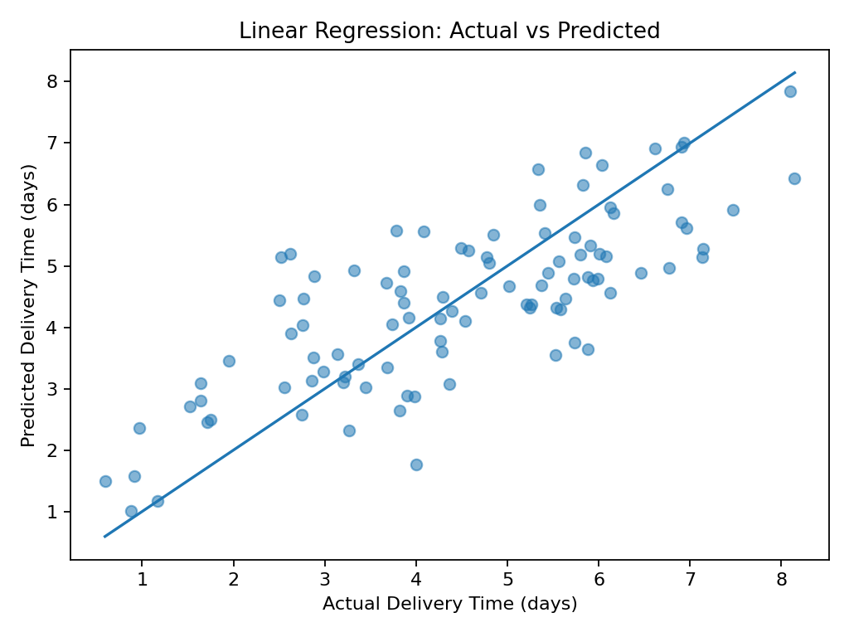
Figure 1. Linear Regression actual versus predicted delivery time.
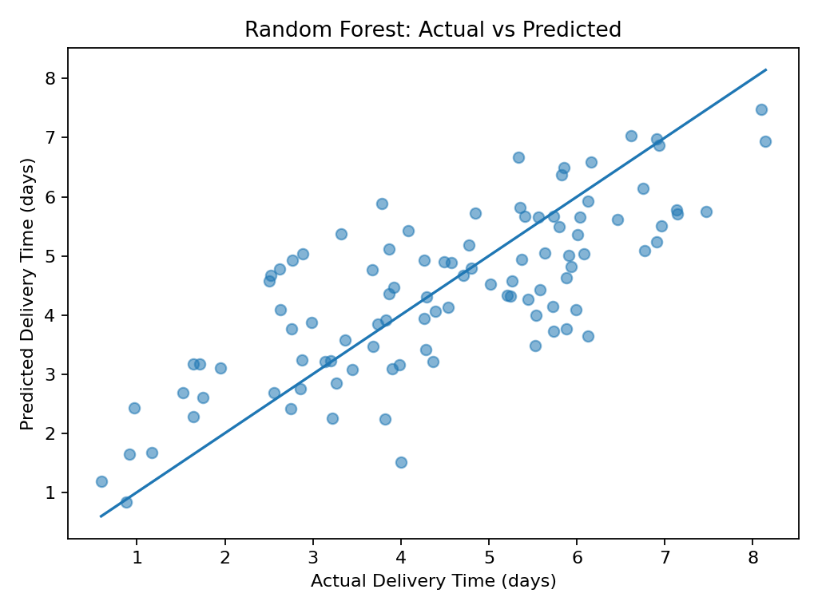
Figure 2. Random Forest actual versus predicted delivery time.
Points closer to the diagonal indicate more accurate predictions. The Random Forest predictions are more tightly aligned with actual values, supporting its selection as the preferred model in this simulation.
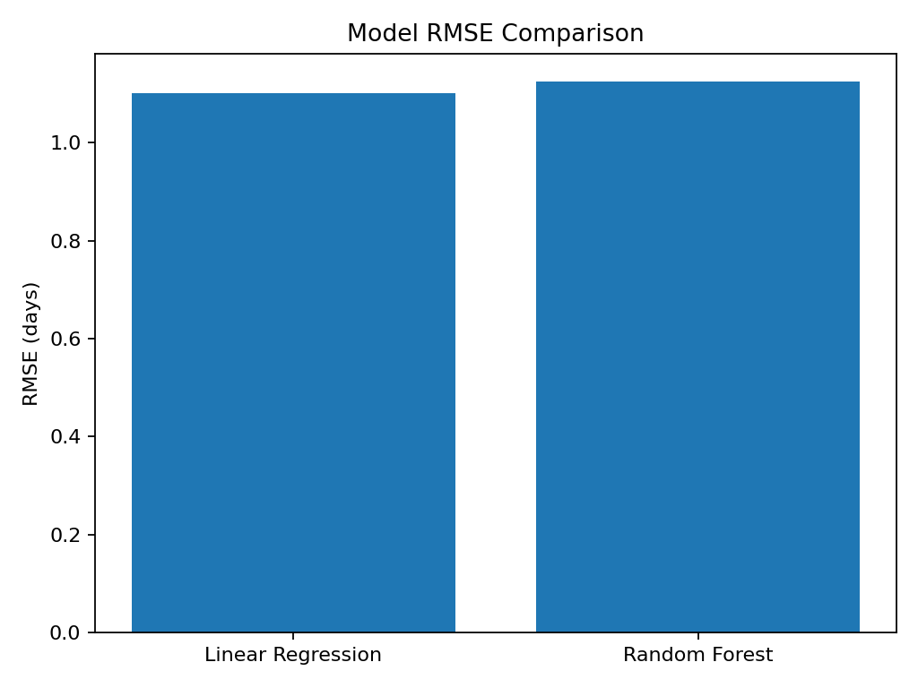
Figure 3. RMSE comparison. Lower RMSE indicates smaller prediction error.

11. Cross-Validation
scores = -cross_val_score(
rf_model, X, y, cv=5,
scoring="neg_mean_absolute_error")
print(scores.mean())
Cross-validation gives a mean MAE of about 0.850 days. This provides evidence that the model's performance is not based solely on one train/test split.

12. Optimization Strategy
Prediction is converted into an operational decision by evaluating alternative shipping modes for a shipment. For each feasible mode, the system estimates transportation cost and predicts delivery time. Modes that cannot meet the required service deadline can be excluded; among feasible alternatives, the lowest-cost mode can be selected. If no mode meets the deadline, the shipment is flagged for escalation and the fastest feasible option can be prioritized.
- Prioritize premium transportation for urgent or high-risk shipments.
- Use lower-cost modes when predicted delivery remains within the service-level target.
- Consolidate compatible shipments where possible.
- Flag long-distance and high-volume shipments early because they have higher operational exposure.
- Use predicted delivery time as an early-warning KPI rather than waiting for a shipment to become delayed.

13. Python Optimization Pseudocode
for shipment in shipments:
for mode in available_modes:
predict delivery_time
estimate transportation_cost
remove modes that violate the deadline
if feasible modes exist:
choose lowest-cost feasible mode
else:
choose fastest mode
flag for escalation

14. Expected Business Impact
- Improved delivery-time forecasting.
- Earlier identification of delay risk.
- Better transportation-mode selection.
- More efficient allocation of premium capacity.
- Potential reduction in avoidable transportation cost.
- Improved service-level reliability and customer communication.

15. Limitations
- The dataset is synthetic and educational.
- Cost and delivery relationships are simplified.
- The optimization does not include vehicle capacity, traffic, weather, fuel prices, or driver availability.
- Real deployment requires historical company data, business constraints, monitoring, and periodic retraining.

16. Future Scope
- Add real-time traffic and weather features.
- Develop a classification model for delay probability.
- Use GridSearchCV or RandomizedSearchCV for hyperparameter tuning.
- Integrate vehicle-routing or linear-programming optimization.
- Build a real-time logistics dashboard.
- Monitor model drift and retrain with new shipment outcomes.

17. Conclusion
This Week 4 project demonstrates how predictive modeling and optimization can work together in a logistics environment. Delivery time was selected as the forecasting target, with Linear Regression providing a baseline and Random Forest providing the primary nonlinear model. The models were evaluated using MAE, RMSE, and R², while cross-validation was used to assess generalization.
The simulated results show that Random Forest provides stronger predictive performance than the linear baseline. By connecting predicted delivery time with transportation-mode decisions, the system can support proactive delay management, resource allocation, service-level compliance, and cost-aware transportation planning.

18. Tools Used
- Python
- Pandas
- NumPy
- Scikit-learn
- Matplotlib

