Assignment No:2

Title
Implementation of Tower of Hanoi Using State Space Search Program:-
def tower_of_hanoi(n, source, auxiliary, destination): if n == 0: return

# Move n-1 disks from source to auxiliary tower_of_hanoi(n - 1, source, destination, auxiliary)

# Move the largest disk to destination print(f"Move disk {n} from {source} -> {destination}")

# Move n-1 disks from auxiliary to destination tower_of_hanoi(n - 1, auxiliary, source, destination)

# Main program
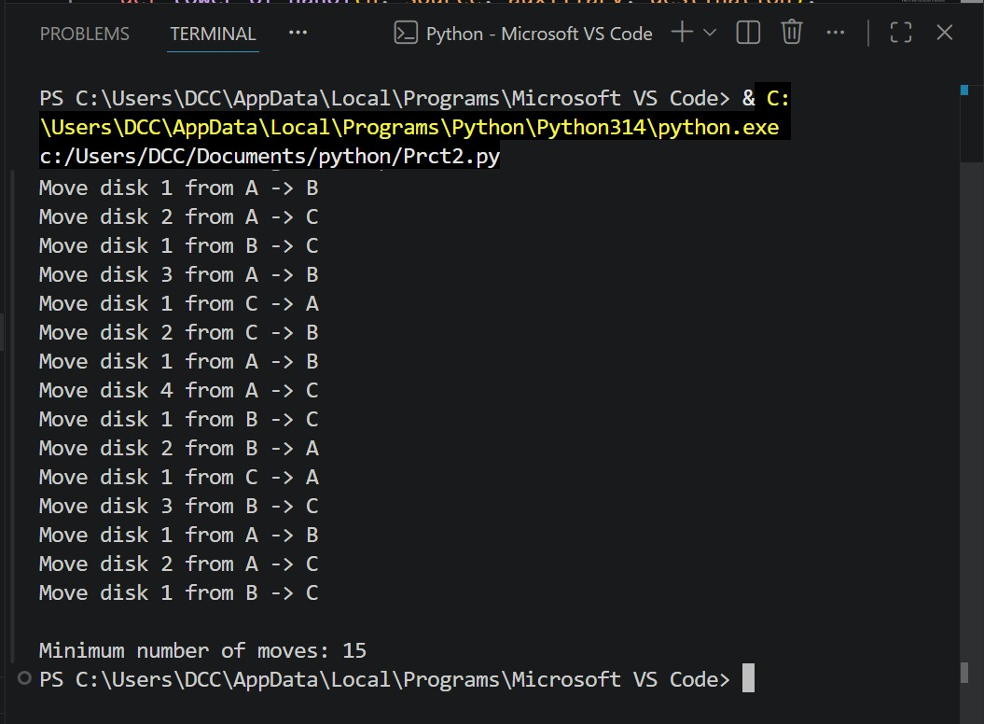
n = int(input("Enter number of disks: "))

print("
\
nTower of Hanoi using State Space Search:")

tower_of_hanoi(n, 'A', 'B', 'C')

print("
\
nMinimum number of moves:", 2**n
-

1)

Output:
-

