Government Polytechnic Pune -16
(An Autonomous Institute of Government of Maharashtra)
University Road, Shivajinagar, Pune-411016
Department of Computer Engineering Academic Year 2024-25


Micro Project Report On

“ANVAY — Smart Indoor Navigation & Emergency Guidance System”

SUBMITTED BY:

Group Members | Enrollment No.
Mhasade Harshad | 2306118
Mohite Swaraj | 2306121
Nalawade Sarthak | 2306129

Under the Guidance of:

Mrs .S J Shirskar

Government Polytechnic Pune -16
(An Autonomous Institute of Government of Maharashtra)
University Road, Shivajinagar, Pune-411016
Department of Computer Engineering Academic Year 2024-25

CERTIFICATE

This is to certify that the micro-project work entitled “ANVAY — Smart Indoor Navigation and Emergency Guidance System” is a bonafide work carried out by

Group Members | Enrollment No.
Mhasade Harshad | 2306118
Mohite Swaraj | 2306121
Nalawade Sarthak | 2306129

of class Third Year in partial fulfilment of the requirement for the completion of Course of Software Engineering and Testing (CM41206) in Diploma in Computer Engineering from Government Polytechnic Pune.

Course Guide | Head Of Department | Principal
(Mrs.S J Shirskar) | (Smt. J.R.Hange) | (Dr. R.K.Patil)

ACKNOWLEDGMENT

The success of any project depends largely on the encouragement and guidelines of many others. This research project would not have been possible without their support. We take this opportunity to express our gratitude to the people who have been instrumental in the successful completion of this project.
First and foremost, we wish to record our sincere gratitude to the Management of this college and to our Respected Principal Dr. R.K.Patil, for his constant support and encouragement in the preparation of this report and for the availability of library facilities needed to prepare this report.
Our sincere thanks to Smt. J.R.Hange, Head of Computer Department, Government Polytechnic, Pune who was abundantly helpful and offered invaluable assistance, support and guidance.
We express our sincere gratitude to our Guide, Smt. S J Shirkar for guiding us in investigations of this project and in carrying out experimental work. Our numerous discussions were extremely helpful. We are highly indebted to her for her guidance and constant supervision as well as for providing necessary information regarding the project & also for his support in completing the project. We hold him in esteem for guidance, encouragement and inspiration received from him.
We wish to thank our parents for financing our studies and helping us throughout our life for achieving perfection and excellence. Their personal help in making this report and project worth presentation is gratefully acknowledged. Last but not the least we thank the Almighty for continuous strength we were bestowed for completion of this project.

Contents

Sr. No. | Title
1 | 1. INTRODUCTION
1 | 1.1 Problem Statement
1 | 1.2 Literature Survey
1 | 1.3 Motivation
1 | 1.4 Background
2 | 2. LITERATURE REVIEW
2 | 2.1 Existing Indoor Navigation Systems and Technologies
2 | 2.2 Initiatives and Technological Development
3 | 2.3 Developed and Developing Countries
3 | 3. PROBLEM AND VISION OF ANVAY
3 | 3.1 Problem and Vision of ANVAY
4 | 3.2 Objectives
4 | 3.3 Core Features and Approach
4 | 3.4 Approach of the Proposed System
4 | 4. ARCHITECTURE
4 | 4.1 ER Diagram (Entities, Attributes & Relationships)
4 | 4.2 Use Case Diagram
4 | 4.3 Data Flow Diagram
4 | 4.4 Sequence Diagram
4 | 4.5 Class Diagram
5 | 5. IMPLEMENTATION AND OUTPUT
5 | 5.1 Objectives & 5.2 Technologies Used
5 | 5.3 Modules & 5.4 Features of ANVAY
7 | 5.5 Application Output
7 | 6. TESTING
7 | 6.1 Software Testing Methodology & 6.2 Test Cases
7 | 7. APPLICATION OVERVIEW
7 | 7.1 Navigation Workflow & 7.2 Admin Workflow
8 | 8. ADVANTAGES AND LIMITATIONS
8 | 8.1 Advantages
8 | 8.2 Limitations
- | CONCLUSION
- | REFERENCES

CHAPTER 1: INTRODUCTION

1.1 PROBLEM STATEMENT
ANVAY is a Smart Indoor Navigation and Emergency Guidance System developed as an Android application for the Computer/IT Building of Government Polytechnic Pune. The application provides users with searchable indoor locations, interactive floor maps, route generation, multi-floor navigation, dynamic route recalculation, AR-based directional guidance and emergency guidance towards designated safe exits.
Large educational campuses and institutional buildings often contain multiple departments, classrooms, laboratories, administrative offices, staircases, washrooms, and emergency exits distributed across different floors. For new students, visitors, staff, and external guests, locating a specific destination or navigating from one room to another can be difficult and time-consuming when they are unfamiliar with the building layout.
Traditional navigation aids such as physical signboards, wall-mounted floor plans, and verbal directions provide only limited assistance. They do not provide real-time location feedback, multi-floor path planning, dynamic route recalculation, or specialized emergency guidance. In situations where a particular corridor, staircase, or passage becomes obstructed due to maintenance or hazards, users cannot easily identify alternate pathways.
Indoor navigation presents a distinct engineering challenge because conventional GPS-based systems lose signal integrity inside multi-story concrete structures. Consequently, indoor navigation requires spatial modeling of the building layout, floor-level partitioning, graph-based node-edge path networks, and real-time user assistance. ANVAY solves this problem through an interactive, robust Android mobile solution tailored for institutional campuses.
The system aims to make navigation within the campus simpler, faster, and safer by providing users with optimal routes based on their selected destination and guiding them towards designated safe exits during emergency situations.

1.2 LITERATURE SURVEY

Existing navigation applications such as Google Maps provide highly effective outdoor navigation using GPS and mapping technologies. However, indoor environments present different challenges because GPS signals may be weak or unavailable and buildings contain multiple floors and interconnected indoor spaces.
Indoor navigation systems generally use technologies and techniques such as:
- Wi-Fi-based positioning
- Bluetooth/BLE beacons
- QR-code-based positioning
- Sensor-based positioning
- Predefined indoor maps
- Graph-based pathfinding
- Augmented Reality (AR) navigation
Research and existing applications demonstrate that indoor maps can represent rooms, corridors, staircases and other important locations as connected nodes and paths. Pathfinding algorithms can then determine a suitable route between a user's current position and destination.
However, many existing navigation solutions focus primarily on finding locations and providing routes. Emergency situations require additional functionality such as identifying safe exits, avoiding blocked or dangerous paths and providing users with an alternative route.
ANVAY combines indoor mapping, route planning, dynamic routing, AR-based guidance and emergency guidance into a single application designed for a specific institutional environment.

Sr. No. | System / Approach | Features | Limitations
1 | Google Maps | Outdoor navigation, GPS, route planning | Limited accuracy for indoor multi-floor navigation
2 | Static Floor Plans | Shows rooms, floors and building layout | Does not provide interactive navigation
3 | Signboards | Simple directional guidance | Difficult for unfamiliar users; no dynamic routing
4 | QR-Based Indoor Navigation | Provides location information through QR codes | Requires users to scan codes at designated locations
5 | BLE/Wi-Fi Indoor Navigation | Indoor positioning and navigation | Requires additional infrastructure and deployment
6 | ANVAY | Indoor maps, search, navigation, dynamic routing, AR guidance and emergency guidance | Currently designed for the defined campus/building environment

Table 1.1 Existing Systems Features & Limitations

1.3 MOTIVATION

The main motivation behind developing ANVAY is the difficulty faced by users while navigating large institutional buildings.
Students may know the name or number of a classroom or laboratory but may not know its exact location. New students and visitors can require assistance from other people to locate rooms, departments or facilities. This becomes more difficult when multiple floors are involved.
Another important motivation is emergency safety. During situations such as fire, smoke, structural hazards or blocked corridors, users need to reach a safe exit quickly. Normal navigation may not be sufficient because the shortest regular route may become unsafe or inaccessible.
ANVAY is therefore designed with the following motivations:
Simplify indoor navigation within institutional buildings.
Allow users to search for rooms and locations easily.
Provide step-by-step route guidance to the selected destination.
Support multi-floor navigation.
Provide dynamic route recalculation when a route is blocked.
Provide AR-based navigation for easier visual guidance.
Provide emergency guidance towards safer exits.
Reduce dependence on verbal directions and static floor plans.
Provide a centralized digital representation of the building.

1.4 BACKGROUND

The rapid development of smartphones and mobile computing has made location-based applications an important part of everyday life. While outdoor navigation has become highly accessible through GPS-based applications, indoor navigation remains a comparatively complex problem.
An institutional building consists of multiple interconnected spaces such as classrooms, laboratories, corridors, staircases and entrances. Representing these spaces digitally makes it possible to create an indoor navigation network in which locations can be connected through predefined navigation paths.
ANVAY applies this concept to the Computer/IT Building of Government Polytechnic Pune. The application focuses on the building's defined floors and indoor locations and provides an interactive environment through which users can search for a destination and obtain a suitable route.
The system also incorporates dynamic routing, where the route can be recalculated when a particular path is unavailable. This makes the navigation system more adaptable than a static floor map.
Another important component of ANVAY is emergency guidance. Instead of simply guiding users to their requested destination, the application can assist users in identifying safer exit routes during an emergency situation.
The combination of indoor navigation, interactive maps, dynamic routing, AR guidance and emergency assistance forms the foundation of the ANVAY system.

CHAPTER 2: LITERATURE REVIEW

2.1 EXISTING INDOOR NAVIGATION SYSTEMS AND TECHNOLOGIES
Indoor navigation has become an important area of research with the increasing use of smartphones and location-based applications. Unlike outdoor navigation, indoor environments present challenges such as weak GPS signals, multiple floors, complex layouts and limited visibility of routes.
Several approaches have been developed for indoor positioning and navigation:
1. GPS-Based Navigation
GPS is widely used for outdoor navigation and provides location information using satellite signals. However, GPS signals are generally weak or unavailable inside buildings. Therefore, conventional GPS-based applications cannot provide reliable room-level indoor navigation.
2. Wi-Fi-Based Positioning
Wi-Fi positioning uses the signal strength of nearby wireless networks to estimate the user's indoor location. It can provide indoor positioning without requiring GPS, but its accuracy can vary depending on the number and placement of Wi-Fi access points and environmental conditions.
3. Bluetooth/BLE-Based Navigation
Bluetooth Low Energy (BLE) beacons can be installed at different locations inside a building. A smartphone detects nearby beacons and estimates its position based on received signals. This approach can provide better indoor positioning but requires additional hardware infrastructure.
4. QR-Code-Based Navigation
QR codes can be placed at specific locations within a building. Users scan a QR code to determine their current location and then receive navigation instructions. This method is comparatively simple to implement but requires users to physically locate and scan the codes.
5. Map-Based Indoor Navigation
Digital floor maps can represent rooms, corridors, staircases and other locations within a building. Navigation paths can be represented as connected nodes, allowing the system to calculate a route between two locations.
6. Augmented Reality Navigation
AR-based navigation overlays directional information onto the user's camera view. Arrows and other visual indicators can help users understand the direction in which they should move. This can make indoor navigation more intuitive compared with conventional text-based instructions.

2.2 INITIATIVES AND TECHNOLOGICAL DEVELOPMENT
The development of smartphone-based navigation has increased the possibilities for location-aware applications. Modern mobile devices provide features such as cameras, sensors, wireless connectivity and computing capabilities that can be used for indoor navigation.
Digital mapping and mobile application technologies have also made it possible to convert physical building layouts into interactive digital maps. Such systems can store locations and paths digitally and provide users with navigation instructions.
For educational institutions, indoor navigation can be particularly useful because buildings may contain multiple departments, classrooms, laboratories and administrative areas. A dedicated indoor navigation application can provide information specific to the institution rather than depending on generalized outdoor mapping services.
ANVAY applies these concepts to an institutional environment by providing:
- Digital indoor floor maps
- Searchable locations
- Route generation
- Indoor navigation
- Dynamic route recalculation
- AR-based directional guidance
- Emergency route guidance
- Safe-exit identification
The system therefore combines several concepts used in indoor navigation into a single mobile application.

2.3 DEVELOPED AND DEVELOPING COUNTRIES

Indoor navigation systems can be useful in both developed and developing countries, although their implementation can differ depending on available infrastructure and technology.
Developed Countries
Developed countries generally have better access to smartphones, wireless networks, digital infrastructure and indoor positioning technologies. Large institutions such as universities, hospitals, airports and commercial buildings can deploy technologies such as Wi-Fi positioning, BLE beacons and advanced indoor mapping systems.
These technologies can provide highly detailed indoor positioning and navigation but may require additional infrastructure and maintenance.
Developing Countries
In developing countries, institutions may have limited access to specialized indoor positioning infrastructure. Therefore, solutions based on existing smartphones and digitally mapped building layouts can be more practical.
An application such as ANVAY can provide useful indoor navigation without requiring the deployment of expensive infrastructure throughout the building. It can be adapted to a specific institution by defining its rooms, floors, corridors, navigation nodes and emergency exits.
Relevance to ANVAY
ANVAY focuses on providing a practical and institution-specific indoor navigation solution. Instead of depending entirely on specialized external positioning infrastructure, the system uses a digitally represented building environment and predefined navigation paths to provide navigation and emergency assistance.
This approach makes the system suitable for educational campuses where the building structure is known and can be mapped in advance.

CHAPTER 3: PROBLEM AND VISION OF ANVAY
3.1 Problem and Vision of ANVAY
Problem
Navigating through a large educational institution can be difficult for students, staff and visitors, particularly when they are unfamiliar with the building layout. Locating classrooms, laboratories, offices and other facilities across different floors often requires assistance from other people or depends on static signboards and floor plans.
The problem becomes more significant in emergency situations. During a fire, blocked corridor or other hazardous situation, users may not know which route should be avoided or which exit is safest. Conventional navigation methods do not provide dynamic route changes or emergency-specific guidance.
Another limitation of conventional outdoor navigation applications is that they are primarily designed for GPS-based outdoor environments. GPS-based positioning is not sufficiently reliable for detailed room-level navigation inside buildings.
Vision of ANVAY
The vision of ANVAY – Smart Indoor Navigation and Emergency Guidance System is to provide a digital, interactive and user-friendly navigation solution for indoor institutional environments.
ANVAY aims to transform the physical building layout into an interactive digital environment where users can:
- Search for required rooms and locations.
- View interactive floor maps.
- Navigate between indoor locations.
- Receive route guidance across different floors.
- Use AR-based directional guidance.
- Receive an alternative route when a path is blocked.
- Access emergency guidance.
- Identify safer routes towards emergency exits.
The system is designed to reduce dependence on verbal directions and static navigation methods while improving convenience and safety within the building.

3.2 OBJECTIVES

The major objectives of the ANVAY system are:

To provide indoor navigation within the defined institutional building.

To provide interactive floor maps representing important locations and pathways.

To enable location search so that users can quickly find classrooms, laboratories and other facilities.

To provide route generation between the user's current location and selected destination.

To support multi-floor navigation within the mapped building.

To provide dynamic routing by recalculating the route when an existing path becomes unavailable.

To implement AR navigation for visually guiding users towards their destination.

To provide emergency guidance during potentially hazardous situations.

To guide users towards safer exits during emergency conditions.

To provide a simple and accessible mobile interface for students, staff and visitors.

3.3 CORE FEATURES AND APPROACH

ANVAY integrates multiple navigation and safety features into a single mobile application.

1. Home Dashboard

The application provides a centralized dashboard through which users can access major navigation functions, search locations and access other available features.

2. Location Search

Users can search for a required room, laboratory, office or other mapped location. After selecting a destination, the system determines the appropriate route.

3. Interactive Floor Maps

ANVAY provides digital representations of the building floors. Users can view the locations of rooms and other important areas through an interactive map.

4. Indoor Navigation

The system provides a route between the selected starting point and destination. The route consists of connected navigation points representing the available paths within the building.

5. Dynamic Routing

If a particular path becomes unavailable, the system can identify an alternative route rather than continuing to guide the user through the blocked path.

This makes ANVAY more suitable for real-world indoor environments where routes may change.

6. AR Navigation

ANVAY incorporates an AR navigation concept in which directional indicators can be displayed through the device camera. Visual arrows can assist the user in understanding which direction to follow.

7. Emergency Guidance

The emergency mode is designed to provide dedicated guidance during emergency situations. Instead of navigating towards a normal destination, the system can prioritize routes leading towards designated safe exits.

8. Safe Exit Guidance

Emergency routes can be represented separately from normal navigation routes. When emergency guidance is activated, the system can guide the user towards an appropriate exit while considering the available paths.

3.4 APPROACH OF THE PROPOSED SYSTEM

The proposed system follows a map-based graph navigation approach.

The building is represented digitally using:

Navigation nodes – important points such as rooms, corridor intersections, stairs and entrances.

Connections/edges – paths connecting two navigation nodes.

Locations – searchable destinations within the building.

Floor information – identifies the floor on which each location exists.

Emergency exits – predefined safe exit locations.

When a user selects a destination, the application processes the available navigation paths and determines a suitable route.

Normal Navigation Flow

User → Select Location → Identify Destination → Generate Route → Display Route → Navigate → Destination

Dynamic Navigation Flow

User → Select Destination → Generate Route → Path Blocked → Recalculate Route → Alternative Route → Continue Navigation

Emergency Navigation Flow

Emergency Activated → Identify Safe Exit → Evaluate Available Route → Generate Emergency Route → Guide User → Safe Exit

This approach allows ANVAY to function as both a normal indoor navigation system and an emergency guidance system within the mapped institutional environment.

CHAPTER 4: ARCHITECTURE

4.1 ER DIAGRAM (ENTITIES, ATTRIBUTES & RELATIONSHIPS)

Sr. No. | Entity | Important Attributes | Relationship
1 | User | User_ID, Name, Email, Password, Role | User accesses the ANVAY application
2 | Building | Building_ID, Building_Name | Contains multiple floors
3 | Floor | Floor_ID, Floor_Name, Building_ID | Belongs to a Building and contains Locations
4 | Location | Location_ID, Name, Type, Floor_ID | Represents rooms, laboratories, offices and other places
5 | Navigation_Node | Node_ID, Location_ID, Floor_ID, X_Coordinate, Y_Coordinate | Represents a point used for navigation
6 | Navigation_Path | Path_ID, Start_Node, End_Node, Distance, Status | Connects navigation nodes
7 | Route | Route_ID, User_ID, Source, Destination, Distance | Represents a generated navigation route
8 | Emergency_Exit | Exit_ID, Location_ID, Exit_Type, Status | Identifies designated emergency exits
9 | Emergency | Emergency_ID, Type, Status, Description | Activates emergency guidance
10 | Alert | Alert_ID, Emergency_ID, Message, Time | Provides emergency or route-related notifications

Table 4.1: ANVAY — ER Diagram Entities & Their Relationships

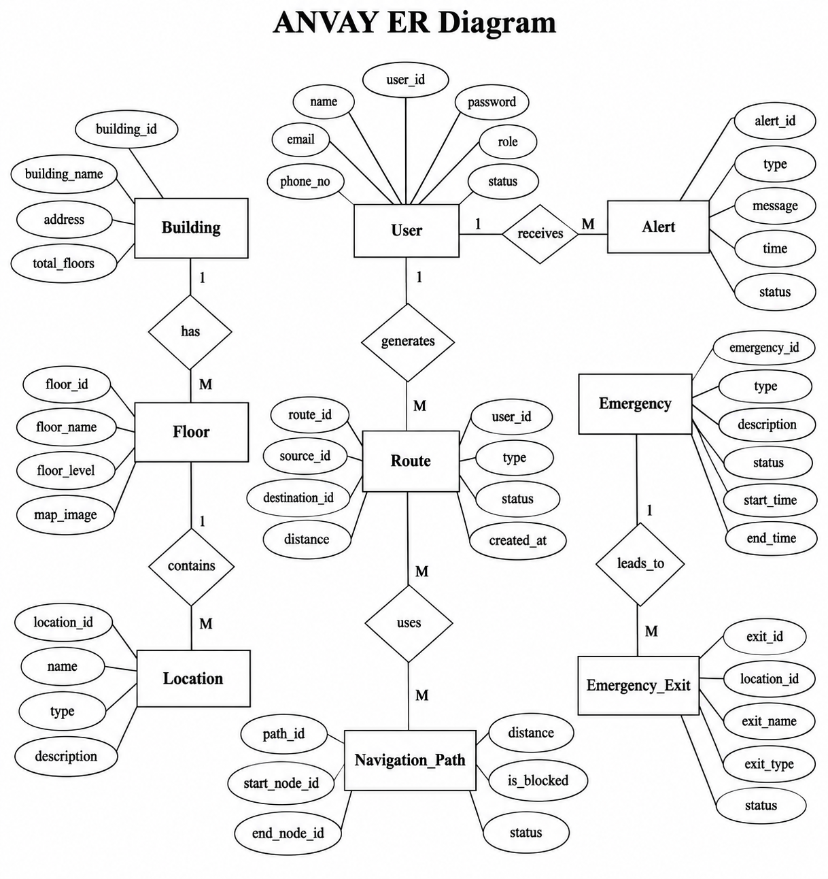

Figure 4.1: ANVAY — ER Diagram

  - 4.2 Use Case Diagram

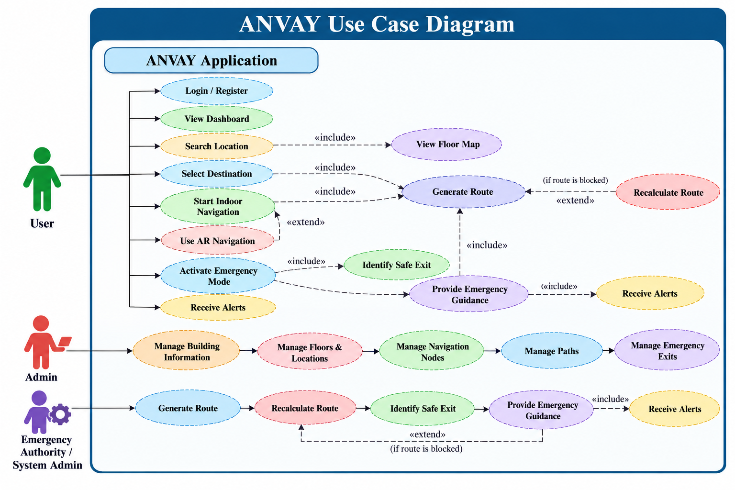

Figure 4.2: ANVAY — Use Case Diagram

4.3 Data Flow Diagram

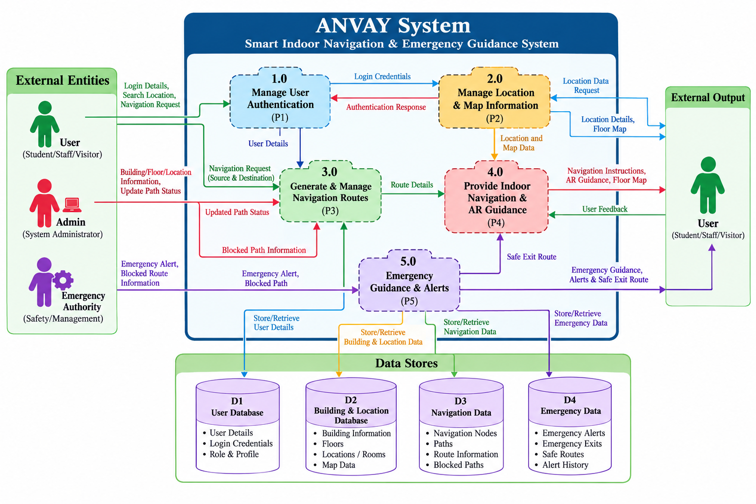
Figure 4.3: ANVAY — Data Flow Diagram

4.4 Sequence Diagram

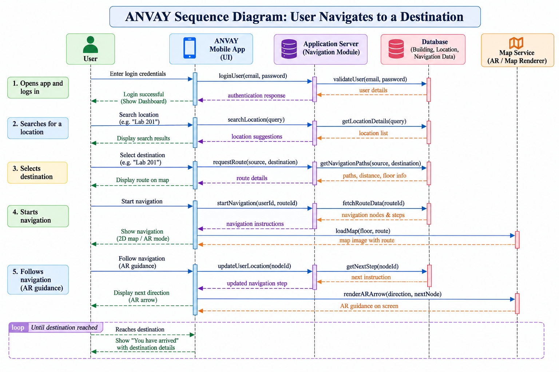
Figure 4.4: ANVAY — Sequence Diagram

4.5 Class Diagram

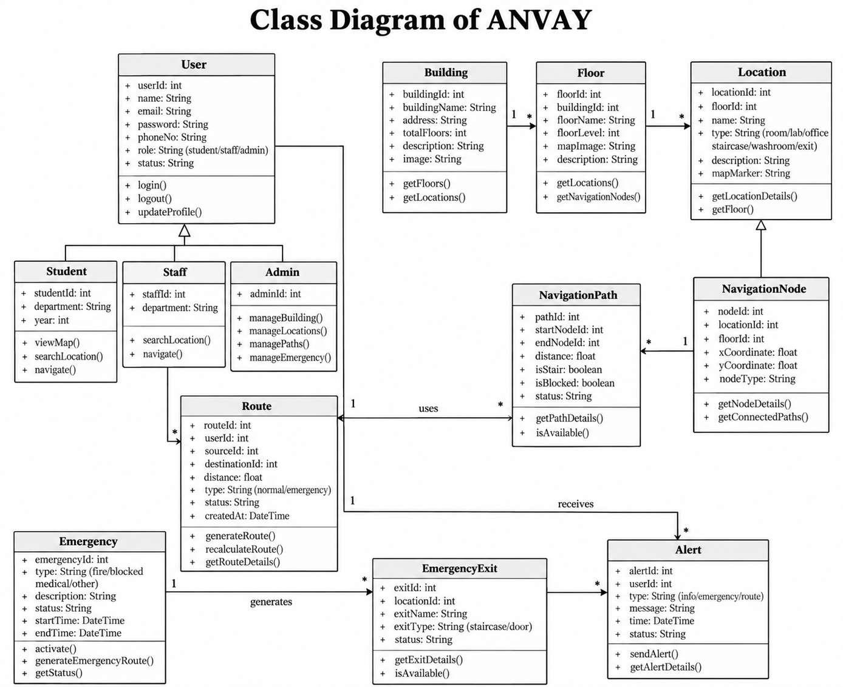
Figure 4.5: ANVAY — Class Diagram

CHAPTER 5: ANVAY — IMPLEMENTATION AND OUTPUT
5.1 Objectives
The primary objective of the ANVAY implementation is to develop a reliable, native Android-based indoor navigation and emergency guidance system for the Computer/IT Building of Government Polytechnic Pune. The specific implementation objectives include:
1. Developing an intuitive, accessible mobile interface tailored for students, faculty, and campus visitors.
2. Implementing high-performance indoor graph-based pathfinding for floor-level and multi-floor navigation.
3. Building an interactive digital floor mapping system for Ground, First, and Second floors.
4. Providing real-time dynamic route recalculation when pathways or corridors become obstructed.
5. Integrating Augmented Reality (AR) camera overlays to project 3D visual directional guidance.
6. Designing dedicated emergency mode protocols to navigate users to designated safe exits during hazards.
7. Creating an administrative management system to update room directories, route paths, and safety notices.
5.2 Technologies Used
• Platform / Operating System: Android (API Level 24 and above) for broad mobile compatibility across modern Android smartphones.
• Programming Language: Java (Object-Oriented Programming, strong concurrency handling, and native Android framework integration).
• User Interface Design: XML (eXtensible Markup Language), Material Design Components, ConstraintLayout, and Vector Drawables.
• Build & Dependency Tool: Gradle & Android Gradle Plugin (AGP) for automated dependency resolution and build compilation.
• Augmented Reality (AR): Sensor fusion, Device Camera API, and custom AR Overlay Canvas for real-time directional projection.
• Data Storage & Persistence: Local Room/Repository architecture, SharedPreferences for user session caching, and structured in-memory graph models.
• Development Tools: Android Studio, Antigravity IDE, Git version control, and GitHub repository management.
5.3 Modules of ANVAY
1. User Authentication & Profile Module: Manages user registration, login authentication, secure credential verification, and role-based access for students, faculty, and guests.
2. Home Dashboard Module: Central hub providing quick access cards, department directories, search shortcuts, emergency guidance triggers, and scheduled timetable links.
3. Location Search Module: Enables rapid keyword filtering and searching across classrooms, computer laboratories, faculty cabins, seminar halls, and administrative offices.
4. Interactive Floor Map Module: Renders structured multi-floor digital layouts representing rooms, corridors, staircases, and navigation nodes with interactive point selection.
5. Indoor Navigation Module: Calculates optimal indoor paths using graph algorithms and renders turn-by-turn routing instructions for single and multi-floor navigation.
6. Dynamic Routing Module: Continuously monitors corridor accessibility and automatically recalculates alternate paths when primary pathways are blocked.
7. AR Navigation Module: Projects 3D directional arrows onto live camera feeds to provide intuitive visual guidance in physical corridors.
8. Emergency Guidance Module: Activates emergency protocols, identifies the nearest hazard-free safe exits, and provides emergency contact hotlines.
9. Alerts & Notifications Module: Displays critical building announcements, safety alerts, corridor maintenance advisories, and administrative updates.
10. Admin Module: Provides administrative controls to add/edit rooms, configure navigation paths, broadcast notices, and update emergency contact directories.
5.4 Features of ANVAY
1. User-friendly mobile interface: Clean, accessible Material Design layout optimized for seamless touch navigation.
2. Location search: Real-time search bar with instant filtering by room name, lab number, or department facility.
3. Interactive floor maps: Clear, high-contrast floor plans with interactive room selection across Ground, First, and Second floors.
4. Indoor navigation: Step-by-step waypoint guidance connecting user origin to requested room destinations.
5. Multi-floor navigation: Integrated floor transition algorithms routing users through connecting staircases and lifts.
6. Dynamic route recalculation: Instant path recalculation avoiding simulated or reported corridor blockages.
7. AR-based guidance: Camera-augmented directional arrows indicating turns and straight paths in real time.
8. Emergency guidance: Dedicated one-tap emergency mode highlighting safe egress routes and safety instructions.
9. Safe-exit guidance: Intelligent shortest-path routing directing occupants to verified building fire exits.
10. Admin management: Secure portal allowing campus administrators to update building metadata and safety notices.
5.5 Application Output

CHAPTER 6: TESTING
6.1 Software Testing Methodology
Software testing is an essential phase in software engineering to ensure that the application operates correctly, reliably, and strictly adheres to specified functional requirements. For ANVAY, multiple testing levels were systematically executed:
• Unit Testing: Individual Java classes such as RouteCalculator, LocationRepository, and EmergencyManager were tested to verify path calculation formulas and data parsing.
• Integration Testing: Verification of interactions between UI activities, fragments, adapter classes, and underlying repositories.
• Functional Testing: Black-box validation of every user-facing feature including authentication, search filtering, floor map rendering, dynamic rerouting, AR overlays, and emergency guidance.
• System Testing: End-to-end testing of complete user and administrator workflows on real Android hardware devices and Android Virtual Device (AVD) emulators.
6.2 Test Cases and Results
The table below presents the comprehensive test suite executed for the ANVAY application, detailing test case objectives, input steps, expected outcomes, actual observations, and pass/fail statuses.
Table 6.1: ANVAY — Functional Test Case Report
Sr. No. | Test Case ID | Test Case Objective | Step / Input | Expected Result | Actual Result | Status
1 | TC-01 | Login with valid credentials | 1. Open Login screen  2. Enter valid email and password  3. Click 'Login' | User authenticated successfully and redirected to Home Dashboard | User authenticated and redirected to Home Dashboard | Pass
2 | TC-02 | Login with invalid credentials | 1. Open Login screen  2. Enter unregistered email / wrong password  3. Click 'Login' | Error message displayed; access denied | Error message displayed; access denied | Pass
3 | TC-03 | User registration | 1. Open Sign Up screen  2. Enter name, email, role, and password  3. Click 'Register' | New account created; user session initialized | Account created successfully; user session initialized | Pass
4 | TC-04 | Location search | 1. Open Search screen  2. Enter location name (e.g., 'Lab 1', 'Room 201') | Matching locations filtered and displayed in real time | Matching locations displayed correctly in real time | Pass
5 | TC-05 | Interactive floor map | 1. Open Floor Map view  2. Select Ground, 1st, or 2nd floor tab | Selected floor plan loaded with interactive room markers | Floor plan and interactive room markers loaded properly | Pass
6 | TC-06 | Route generation | 1. Select starting location  2. Select destination room  3. Tap 'Get Route' | Optimal path calculated and drawn across navigation nodes | Route generated and turn-by-turn guidance displayed | Pass
7 | TC-07 | Multi-floor navigation | 1. Select source on Ground Floor  2. Select destination on 2nd Floor  3. Start navigation | Route guides user to nearest staircase/lift and continues on destination floor | Multi-floor path generated with staircase transitions | Pass
8 | TC-08 | Dynamic route recalculation | 1. Start active route navigation  2. Simulate corridor blockage along route | System detects obstruction, triggers recalculation, and displays alternate route | Alternative path calculated avoiding blocked corridor | Pass
9 | TC-09 | AR navigation | 1. Select destination  2. Tap 'AR Navigation'  3. Grant camera permission | Camera feed displays 3D directional overlay pointing towards destination | AR arrows rendered smoothly on live camera feed | Pass
10 | TC-10 | Emergency guidance | 1. Tap 'Emergency' button on dashboard | Emergency mode activates; nearest safe exits and safety instructions displayed | Emergency mode activated; nearest exits highlighted | Pass
11 | TC-11 | Safe-exit guidance | 1. In Emergency mode, select 'Evacuate' / nearest safe exit | Hazard-free evacuation route to designated emergency exit generated | Safe exit evacuation route displayed clearly | Pass
12 | TC-12 | Alerts | 1. Trigger new building announcement / safety alert  2. Open Alerts screen | New notice appears in alert list with timestamp and severity tag | Alert displayed with title, timestamp, and details | Pass
13 | TC-13 | Admin functionality | 1. Login with Admin credentials  2. Open Admin Dashboard  3. Add/Edit room or route | Admin dashboard accessible; room/route modifications saved to repository | Admin dashboard loaded; modifications saved successfully | Pass

CHAPTER 7: APPLICATION OVERVIEW
7.1 Complete User Navigation Workflow
The ANVAY application is structured around an intuitive, sequential user workflow designed to guide users seamlessly from initial application launch to successful arrival at their indoor destination or emergency exit:
Step 1: Application Launch & Startup (SplashActivity): The user launches ANVAY on their Android smartphone. The application initializes local repositories, verifies cached preferences, and displays the welcome screen.
Step 2: Authentication & Onboarding (LoginActivity / SignUpActivity): Users can log in with their registered credentials, create a new profile, or enter immediately as a Guest for rapid wayfinding without account setup.
Step 3: Home Dashboard Hub (MainActivity): The dashboard presents top navigational categories, quick search access, emergency triggers, building notices, and department timetable links.
Step 4: Location Search & Discovery (SearchFragment / DirectoryFragment): The user searches for a destination by entering a keyword (e.g., 'Network Lab', 'Room 102') or browsing categorized directory lists across Ground, First, and Second floors.
Step 5: Destination Selection & Location Details (LocationDetailActivity): Selecting a location displays comprehensive metadata, including room description, floor number, faculty in charge, and interactive action buttons to start navigation.
Step 6: Indoor Route Generation (NavigationActivity): The navigation engine calculates the shortest valid graph path connecting the user's starting point to the destination, highlighting the path on the interactive floor map.
Step 7: Turn-by-Turn Waypoint Guidance: The user follows visual on-map route indicators and textual directional instructions as they move through building corridors and connecting staircases.
Step 8: AR-Based Directional Guidance (ARNavigationActivity): If the user activates AR mode, the device camera feed renders 3D directional arrows indicating exact turn directions and distance to destination.
Step 9: Dynamic Route Recalculation on Blockage: If a corridor along the route is obstructed or under maintenance, the user taps 'Reroute', prompting the system to recalculate an alternate hazard-free path in real time.
Step 10: Emergency Guidance & Safe-Exit Evacuation (EmergencyActivity): In an emergency, tapping the Emergency banner immediately activates safe-exit routing, identifying the closest fire exit and providing emergency contact helplines.
7.2 Administrator Workflow
ANVAY includes dedicated administrative capabilities to maintain accurate building information and ensure up-to-date navigational data:
Step 1: Admin Authentication: Authorized campus staff sign in using administrative credentials, granting access to restricted management tools.
Step 2: Admin Dashboard (AdminDashboardActivity): A specialized administrative portal displaying management tiles for Rooms, Routes, Emergency Exits, Alerts, and Timetables.
Step 3: Room & Facility Management (ManageRoomsActivity): Administrators can add new rooms, modify room designations, update floor numbers, and adjust facility descriptions.
Step 4: Route & Path Network Management (ManageRoutesActivity): Enables updating node connections, marking temporary corridor closures, and reconfiguring walkable pathways.
Step 5: Building Alerts & Notices Broadcast (ManageAlertsActivity): Campus authorities can post immediate safety alerts, maintenance advisories, and student announcements to all active app users.
Step 6: Emergency Safe-Exit Configuration (ManageEmergencyActivity): Allows safety officers to verify emergency exit statuses, configure evacuation paths, and update campus emergency contact numbers.

CHAPTER 8: ADVANTAGES AND LIMITATIONS
8.1 Advantages
1. Easy indoor navigation: Enables students, staff, and visitors to locate classrooms, labs, offices, and facilities effortlessly without asking for verbal directions.
2. Interactive floor maps: High-contrast, intuitive digital floor maps provide clear spatial awareness of building layouts across multiple floors.
3. Multi-floor navigation: Seamlessly handles floor transitions by incorporating staircase and lift nodes into computed routes.
4. Dynamic route recalculation: Provides real-time alternate routing when corridors are closed, blocked, or under repair, preventing user disorientation.
5. AR-based guidance: Leverages mobile camera overlays with 3D directional indicators for an intuitive, modern wayfinding experience.
6. Emergency guidance: Provides dedicated emergency evacuation capabilities that guide occupants away from hazards toward safety.
7. Safe-exit guidance: Automatically computes shortest hazard-free paths to designated building fire exits.
8. User-friendly interface: Modern Material Design interface accessible to users of all technical proficiency levels.
9. Centralized building information: Consolidates room directories, notices, timetable schedules, and emergency contacts into a single mobile app.
10. Admin management: Allows institutional administrators to maintain building layouts, update routes, and broadcast emergency alerts in real time.
8.2 Limitations
1. Limited to mapped building/areas: The current deployment is specifically tailored for the Computer/IT Building of Government Polytechnic Pune and requires manual mapping to expand to other campus blocks.
2. Requires a compatible Android device: The application requires an Android smartphone with camera and motion sensor support for full AR navigation functionality.
3. Navigation depends on predefined building/map data: Routing accuracy is reliant on the structural integrity and precision of pre-configured spatial graph models.
4. AR performance depends on environment and hardware: Augmented reality directional tracking can be affected by ambient lighting conditions, camera lens clarity, and sensor calibration quality.
5. Building changes require map/data updates: Physical renovations, room relocations, or structural modifications require administrative data updates in the application.
6. Emergency guidance depends on correctly configured exits: Safe evacuation guidance relies upon accurate administrative configuration of active fire exits and hazard zones.
7. Real-time indoor positioning infrastructure requirements: High-precision sub-meter indoor tracking without manual origin selection requires supplementary hardware such as BLE beacons or Wi-Fi fingerprinting grids.

CONCLUSION
ANVAY (Smart Indoor Navigation and Emergency Guidance System) provides a practical, robust, and user-friendly Android-based mobile solution for indoor navigation and emergency guidance within the Computer/IT Building of Government Polytechnic Pune. The application successfully addresses the inherent limitations of conventional GPS systems in indoor environments by utilizing structured digital floor maps, graph-based node-edge pathfinding, and intuitive Augmented Reality (AR) directional guidance.
Key capabilities demonstrated by ANVAY include fast location search, interactive multi-floor maps, turn-by-turn route generation, dynamic route recalculation during corridor obstructions, and dedicated emergency guidance directing occupants towards safe exits. By consolidating campus building directories, emergency hotlines, safety instructions, and administrative management tools into a single mobile platform, ANVAY substantially enhances campus accessibility, reduces navigational confusion for new students and visitors, and strengthens institutional emergency preparedness.
While the current implementation is tailored for the defined institutional campus building, the modular architecture lays a strong foundation for future enhancements. Future scope includes extending navigation across all college campus buildings, integrating Bluetooth Low Energy (BLE) beacon networks for automated sub-meter positioning, integrating real-time sensor fusion, and supporting automated dynamic crowd density management.

REFERENCES
1. Android Developers — Android Documentation & Architecture Components
https://developer.android.com/develop
2. Google Developers — ARCore Documentation & Augmented Reality APIs
https://developers.google.com/ar
3. Oracle — Java SE Documentation & Language Specification
https://docs.oracle.com/en/java/
4. GitHub Docs — Version Control and Collaborative Development Documentation
https://docs.github.com/en
5. Government Polytechnic Pune — Official Institutional Portal & Campus Information
https://www.gppune.ac.in
6. Dijkstra, E. W. — "A Note on Two Problems in Connexion with Graphs", Numerische Mathematik, foundational pathfinding algorithms.
7. MSBTE — Curriculum of Software Engineering and Testing (CM41206), Maharashtra State Board of Technical Education.

