Task-1
Directory created
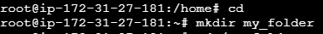
Two empty files created into directory
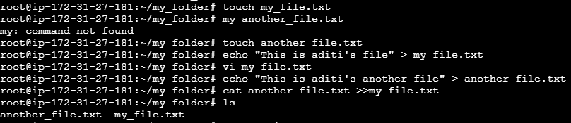
Concatenate the context of another_file to my_file
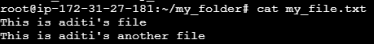
List all the files
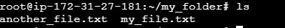

Task-2
Created 20 files with.txt format
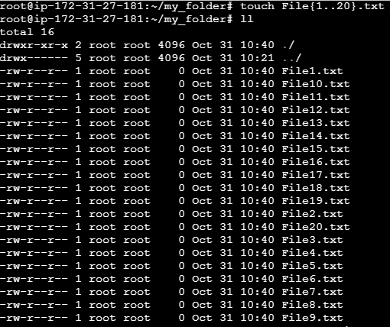

Rename first 5 files to yml extension
