Task Description:

Install docker on EC2 and explore the docker commands (docker images, containers, volumes, network)

Step 1- Launch an EC2 instance

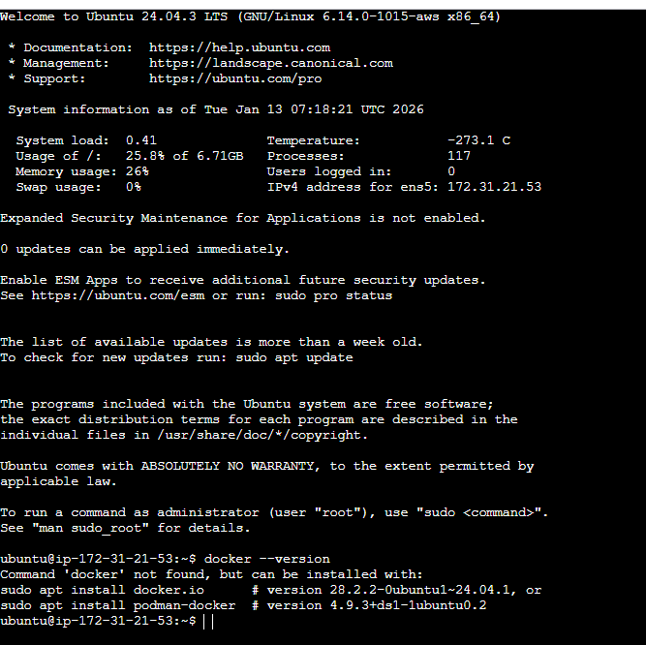

Step 2- Installing docker on ec2

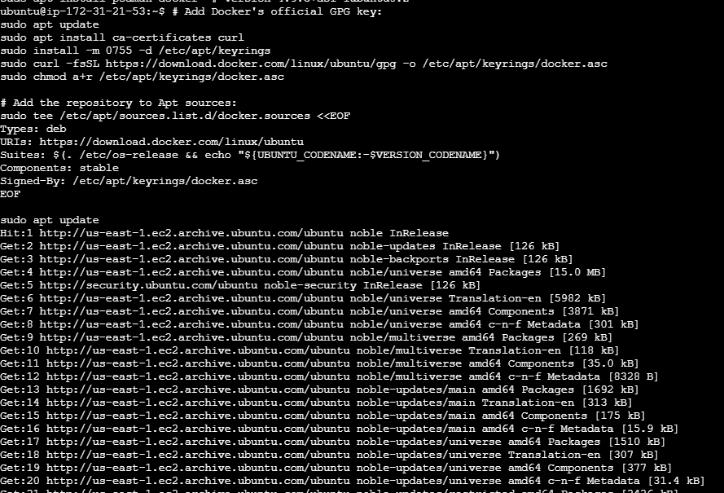

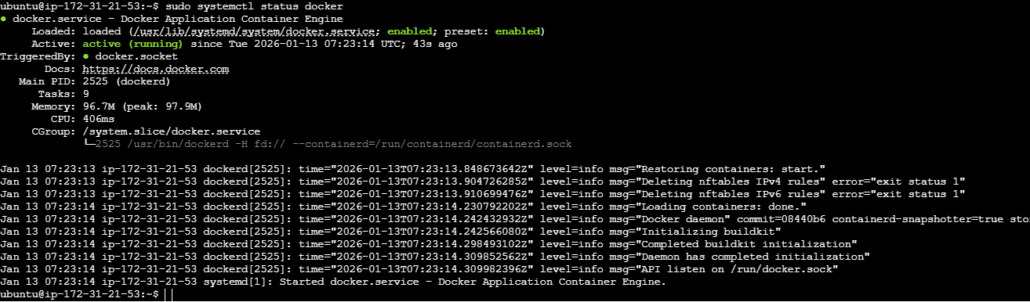

Explore docker commands

