Task Description:

Create a simple script file and push it to repo. Create a project in Jenkins connected to your GitHub repository. When a commit is made to your repo, automatically build must get triggered from Jenkins and the output must be shared to me via email.

Step 1- Launch an EC2 instance and install Jenkins
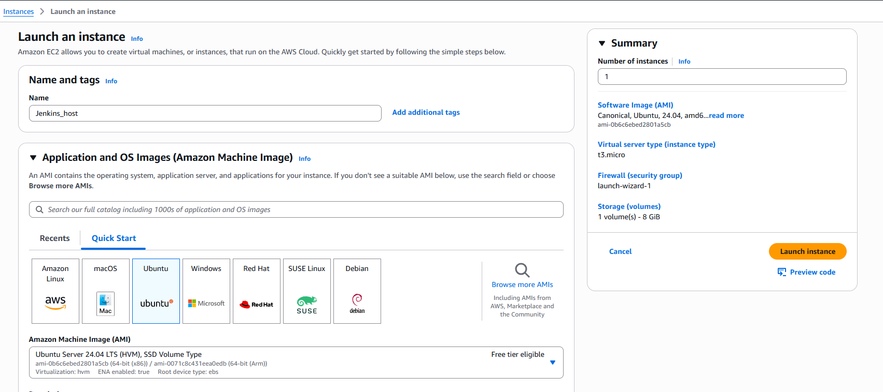
Connect to your Jenkins machine and install java as prerequisites for Jenkins
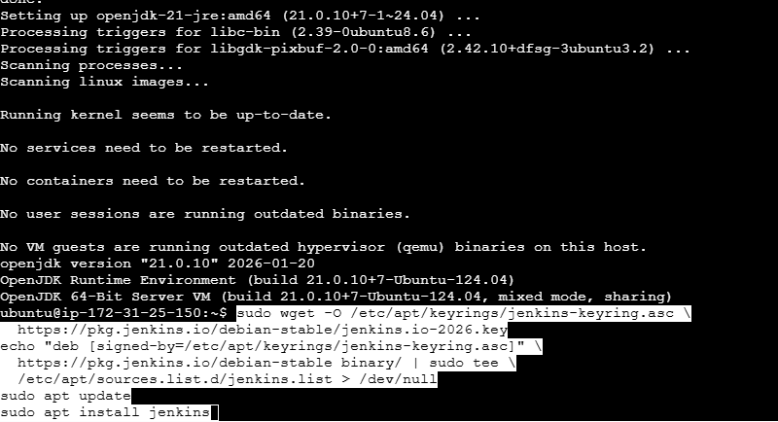

Step 2- Create a script file and push to git repo
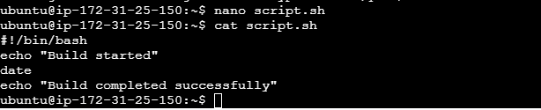
Now push script file to git repo
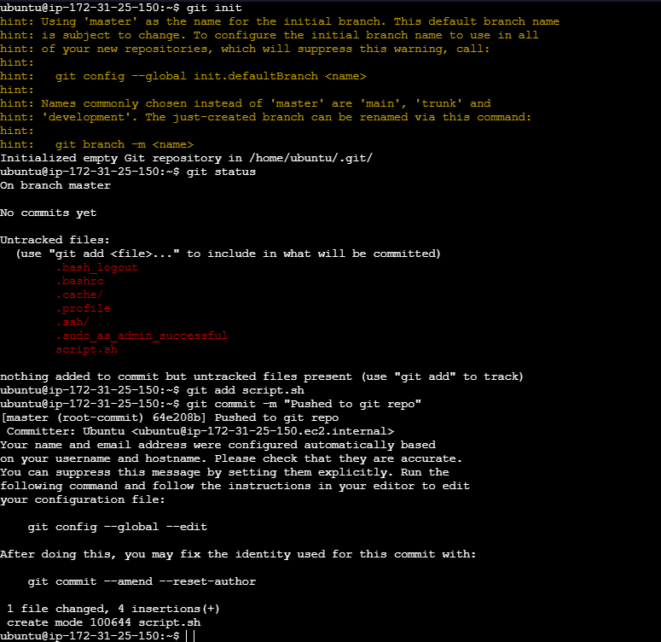
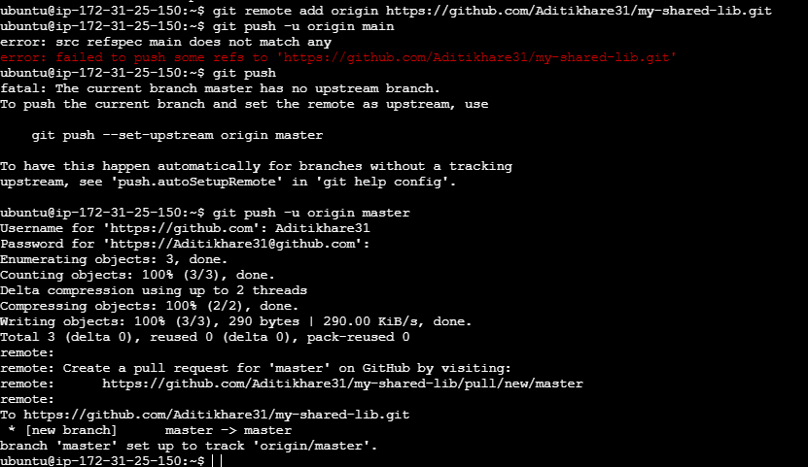
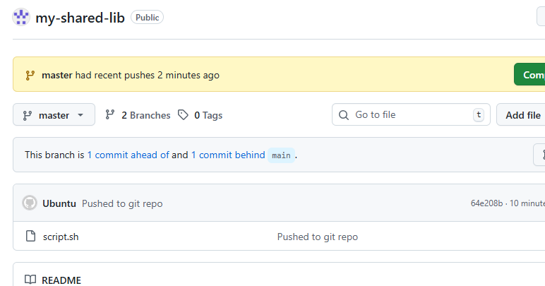

Step 3- Take Public Ip address of Ec2 instance and access the Jenkins default page http://<public_ip>:8080
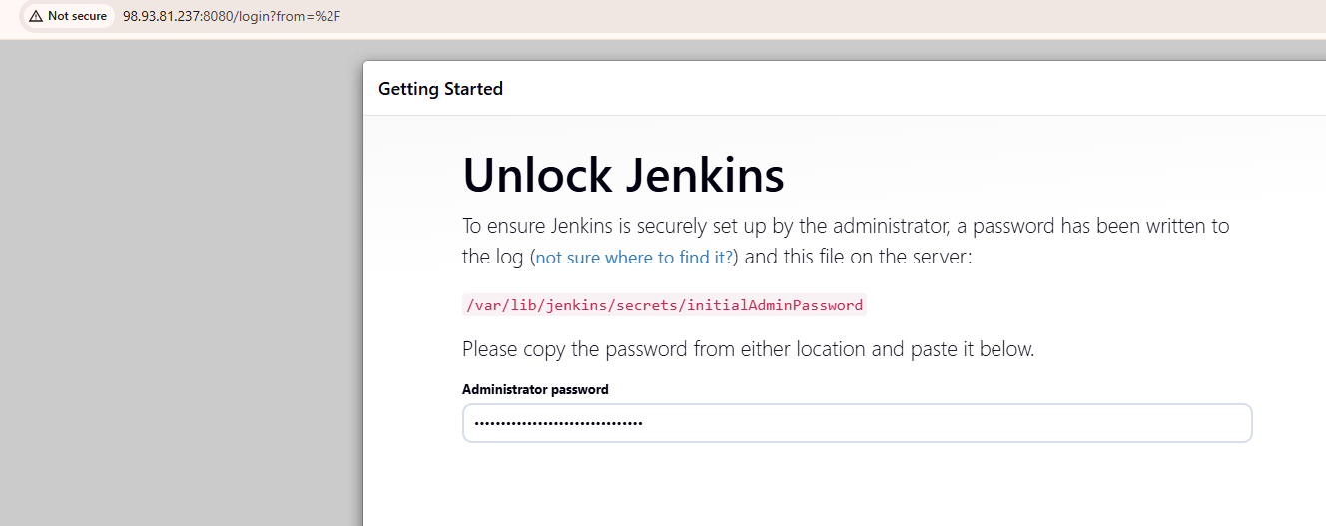

Step 4- Creating new project in Jenkins
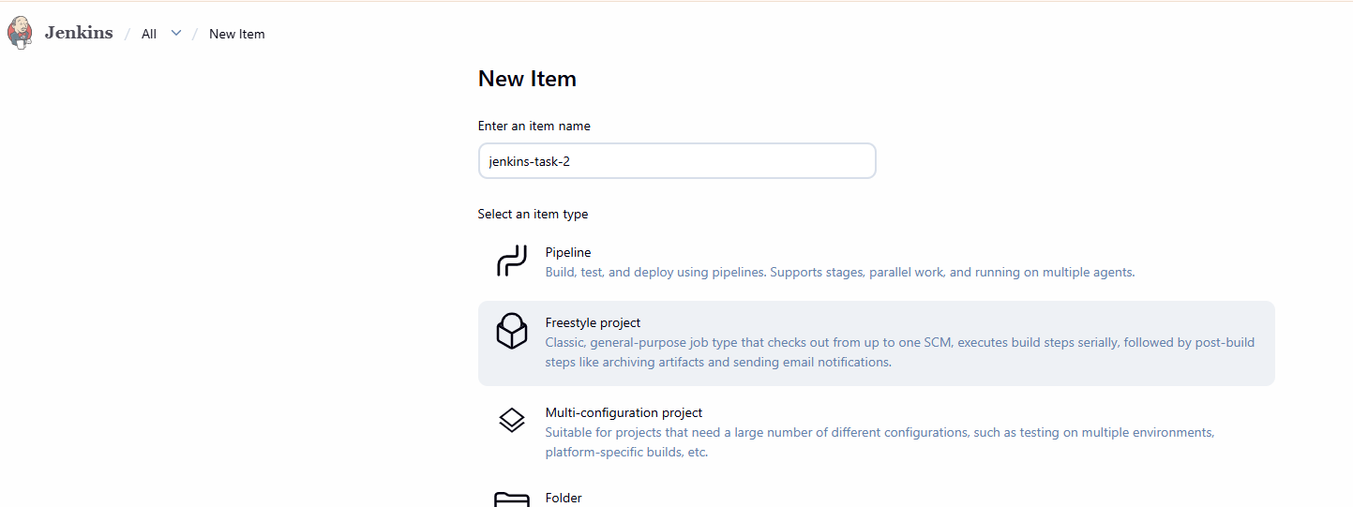
Configure github in project
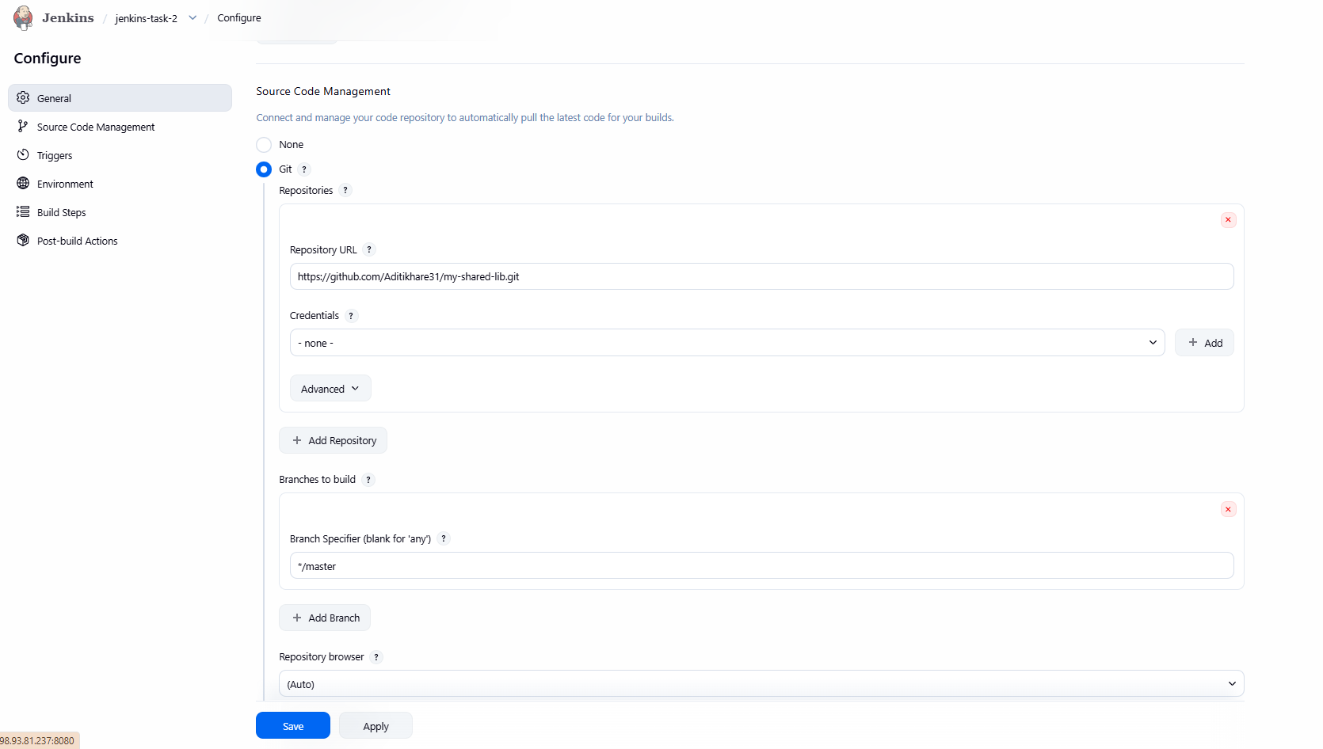
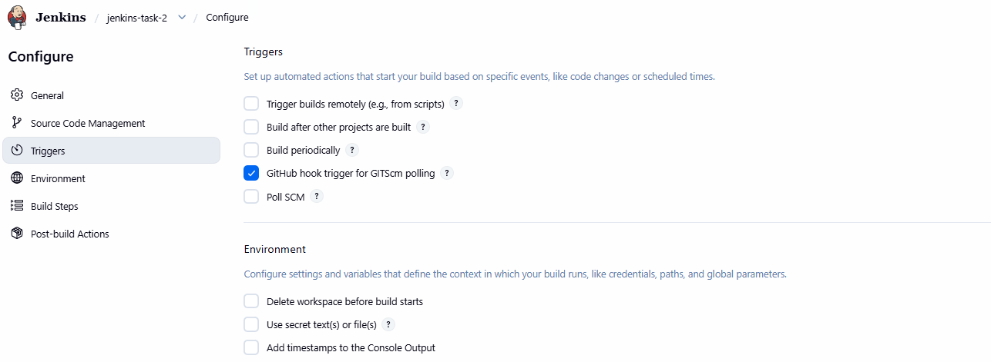

Step 5- Adding webhook in git
Go to your repo -> settings -> select webhook -> Add webhook
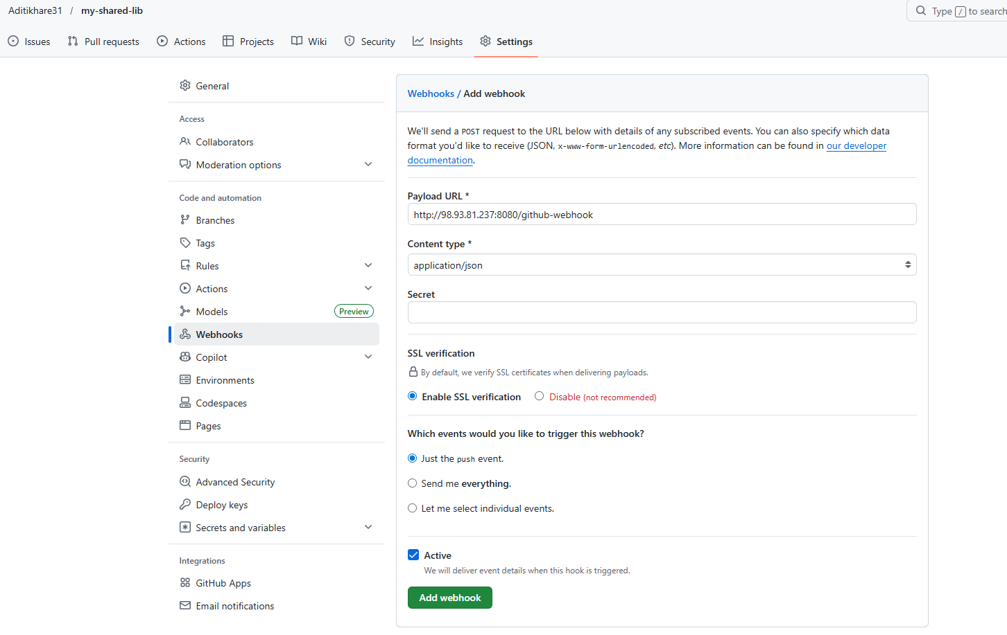

Step 5- Now clone the repo
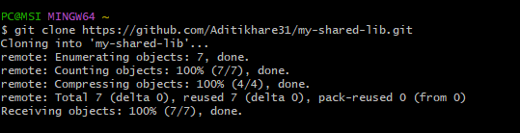
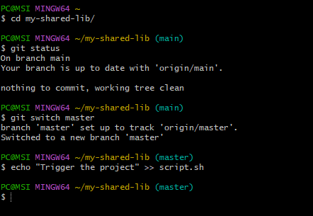
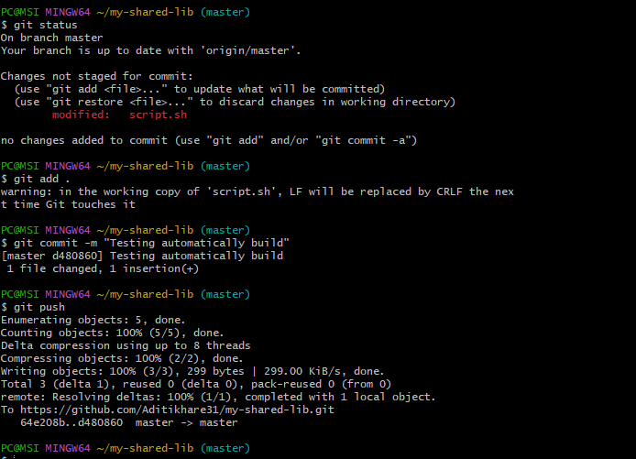

Step 6- Configure email notification
Go to AWS ->SES service and create a email notification service
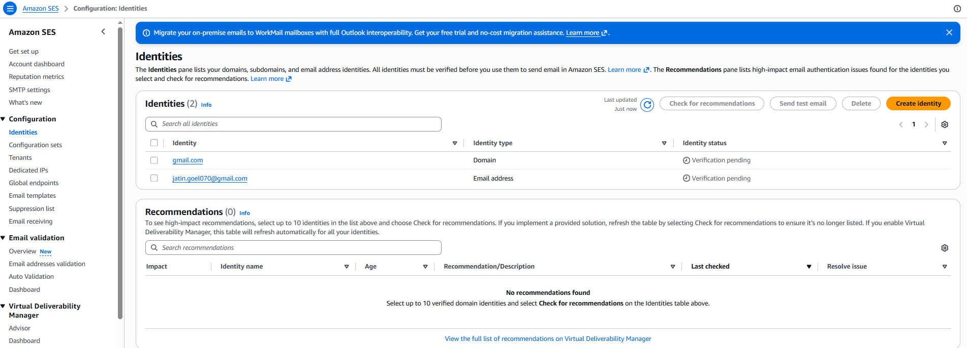
Now create SMTP identity
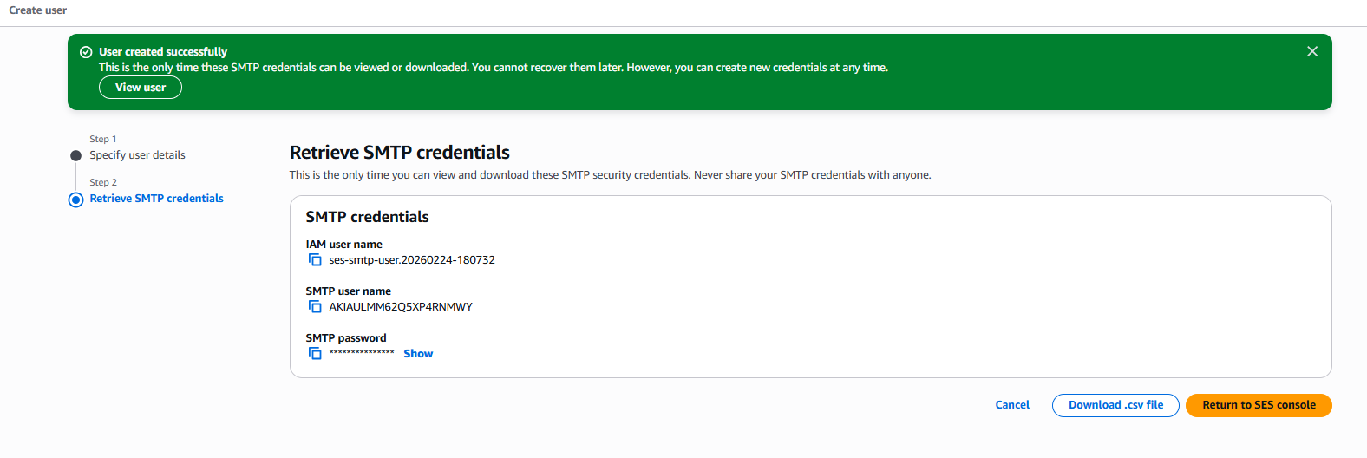
After this go to Jenkins -> manage -> settings and configure SMTP email notification
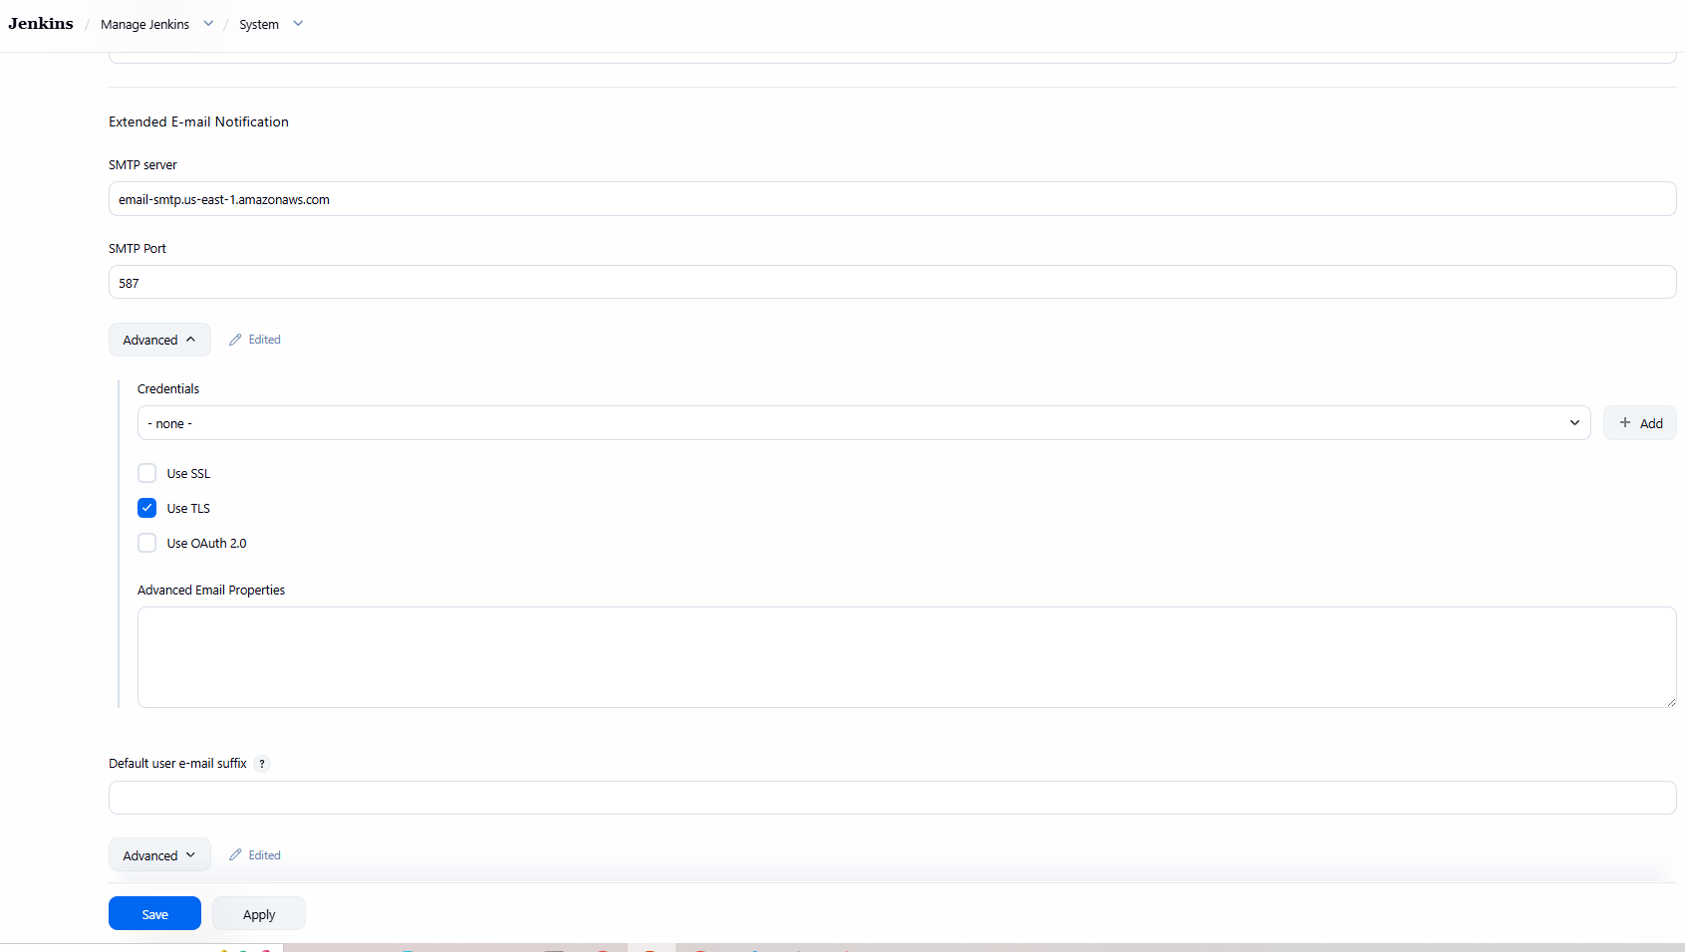
Apply and save
Step 7- Now create post build action
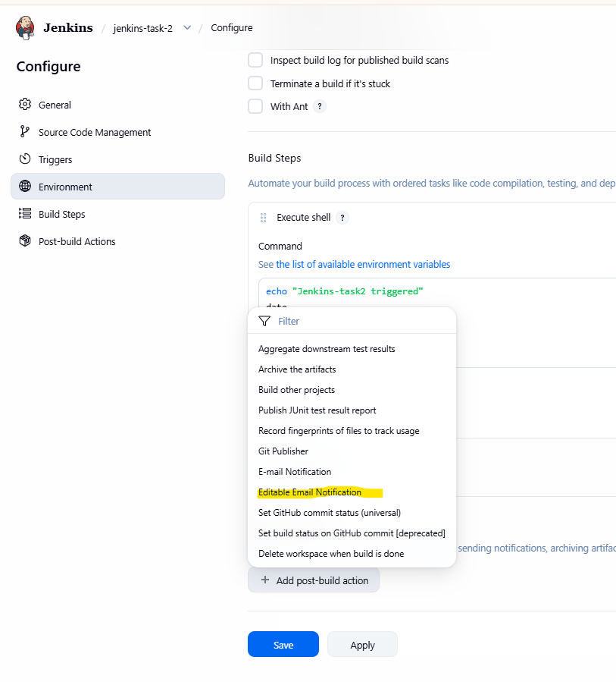
Now add triggers
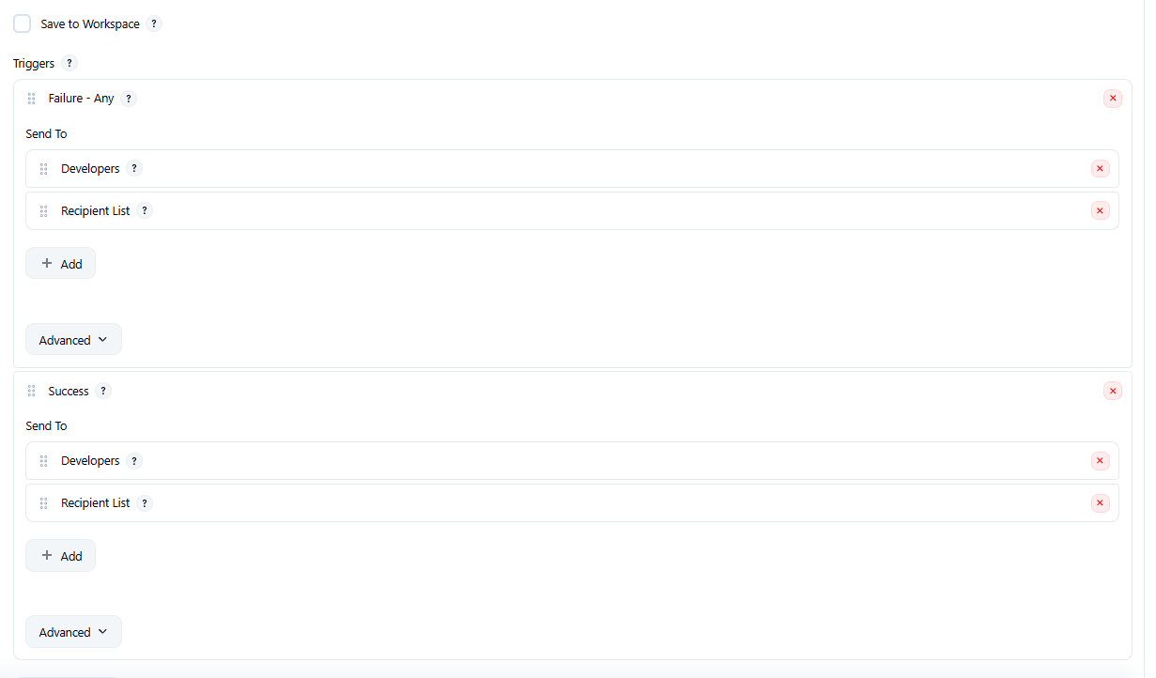

Step 9- Now again make some changes and test the connection
