Task Description:

Create a custom docker image for nginx and deploy it using docker compose, where the volume bind mount should be at /var/opt/nginx location. Push the created custom docker image to your docker-hub.

Step 1- Create a Dockerfile
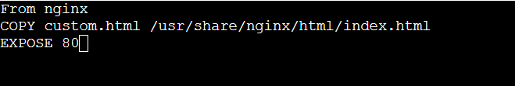
Step 2- Create docker-compose file
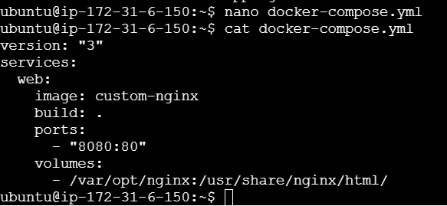
Running docker compose up –build to deploy the custom image

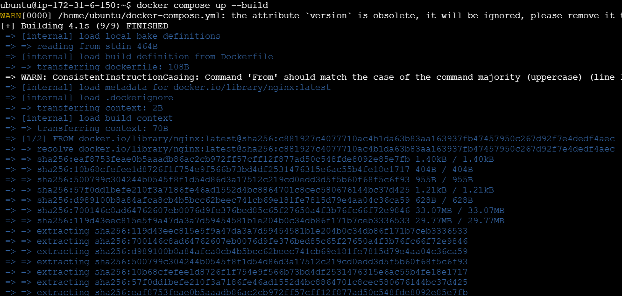
Step 3- create index.html file in /var/opt/nginx as we have mounted /var/opt/nginx to the default directory.
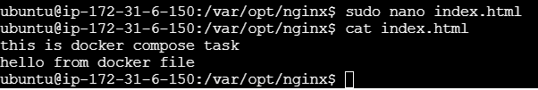
Step 4- Check the connection on web
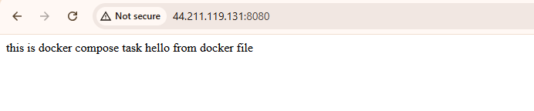
Step 5- Open your docker hub account and push image to docker hub
