Task Description:

Launch Linux EC2 instances in two regions using a single Terraform file.

Step 1: Setup aws cli in visual studio code with the IAM user and aws configure command
Step 2: Create a varaiable file
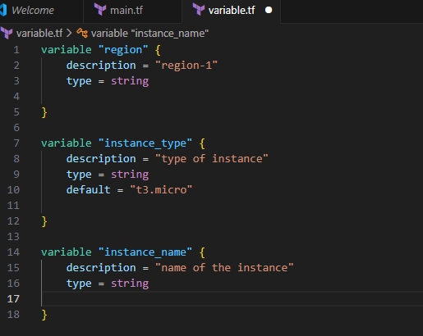

Step 3: Create a main.tf file
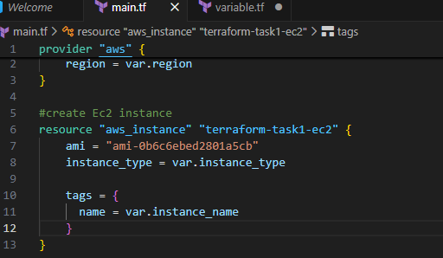

Step 4: Use terraform init command to initialize the providers
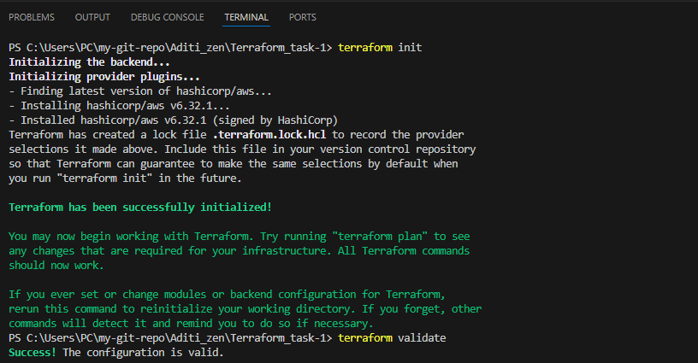

Step 5: Use terraform apply command for us-east-1 region

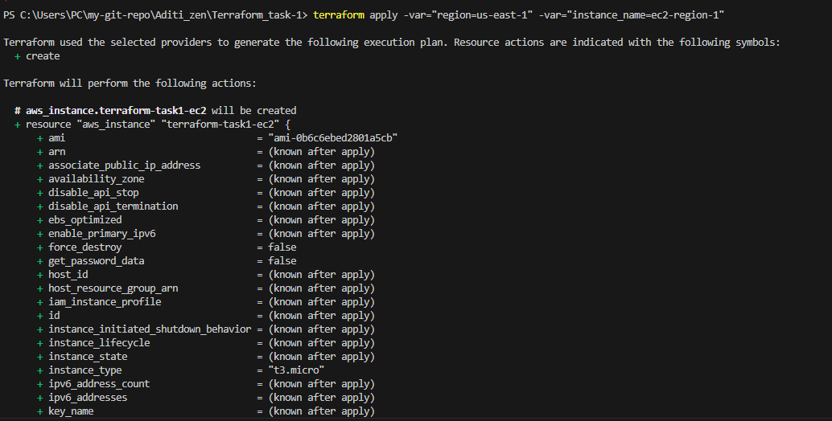
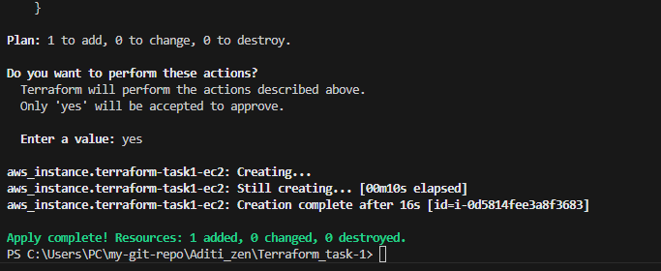
Instance is created
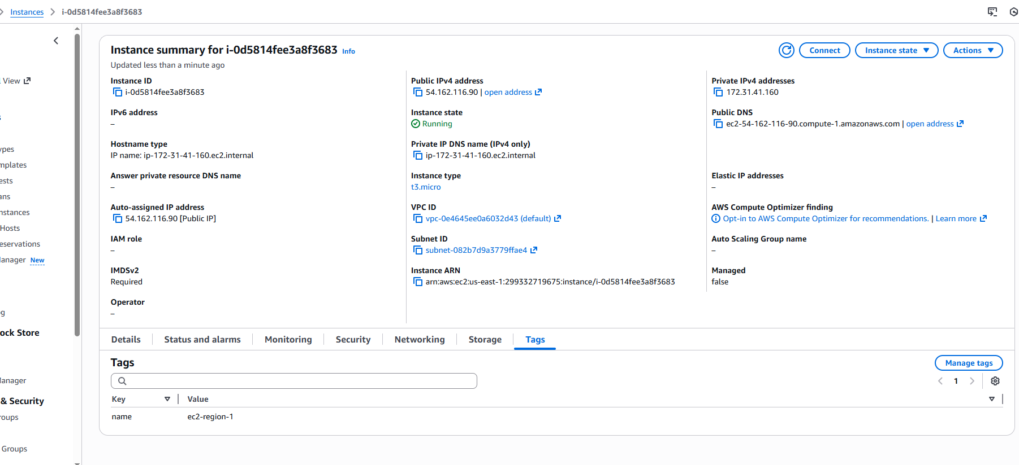

Apply same command for second region ap-south-1
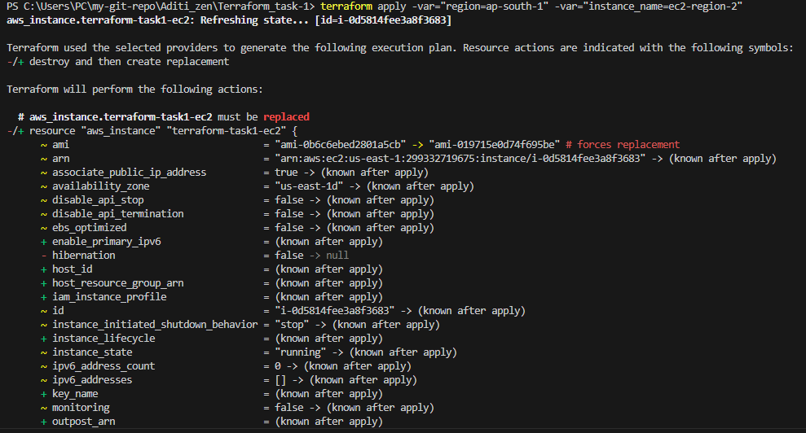
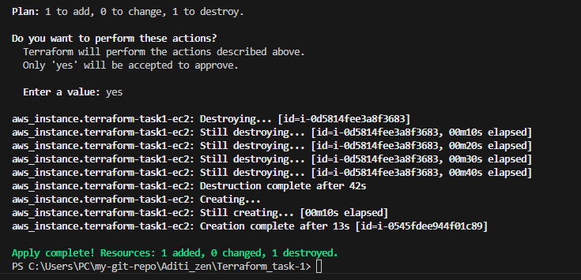

Check if server is created
