Task Description:

Install Prometheus and Grafana on a Linux EC2 machine, connect Prometheus to Grafana, and create a dashboard to view metrics.

Step 1- Launch two EC2 instance
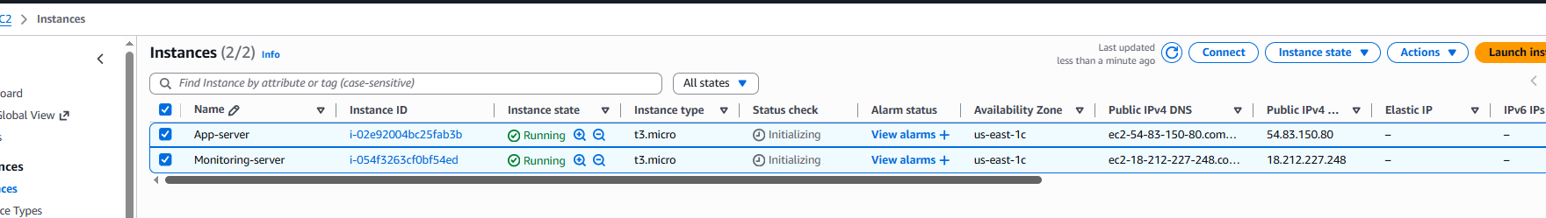

Step 2- On app server install Node Expoter
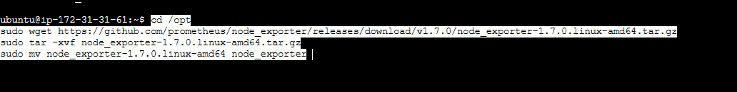
Once installed, start the node expoter and verify on web http:public_ip:9100/metrics
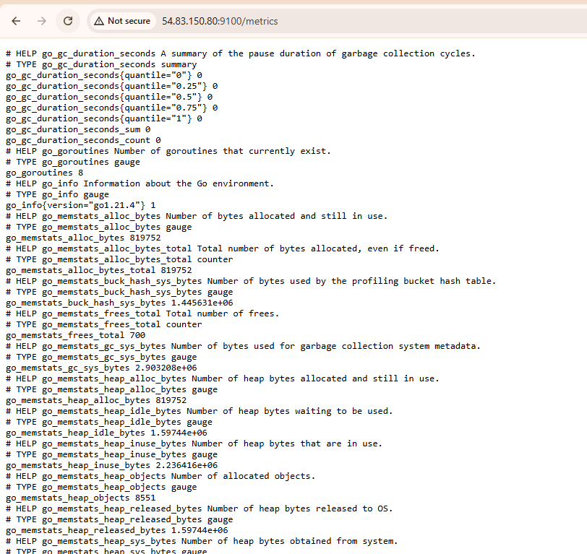
Step 3- On monitoring server, Installed Prometheus
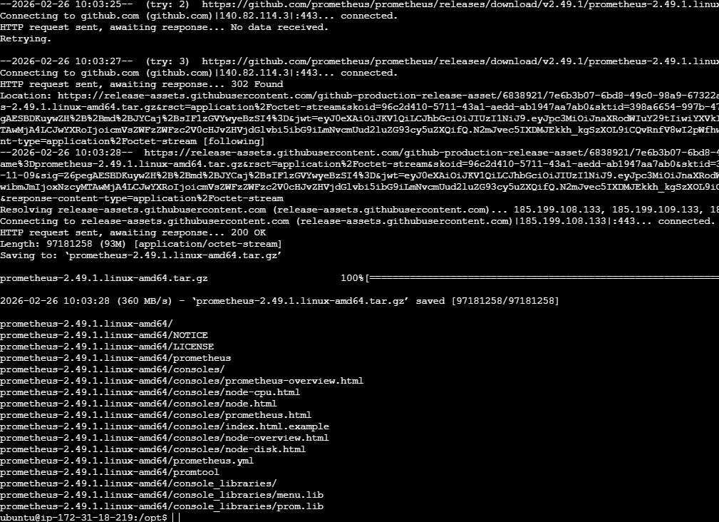

Step 4- Configure Prometheus to scrape App server
Do nano /opt/Prometheus/Prometheus.yml
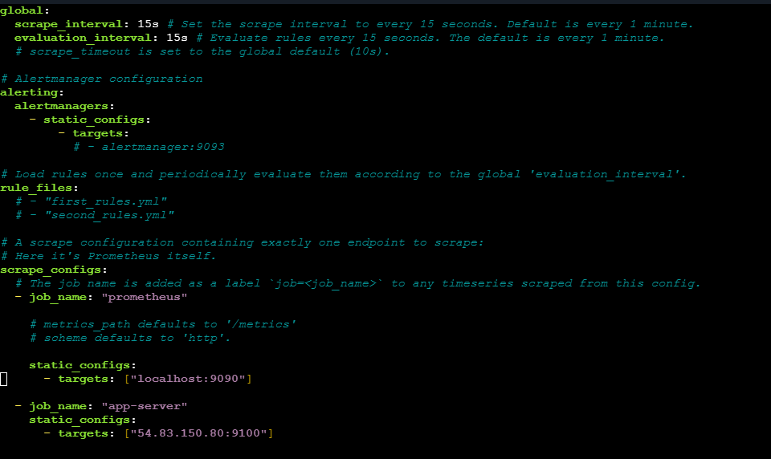
Start Prometheus and verify on web
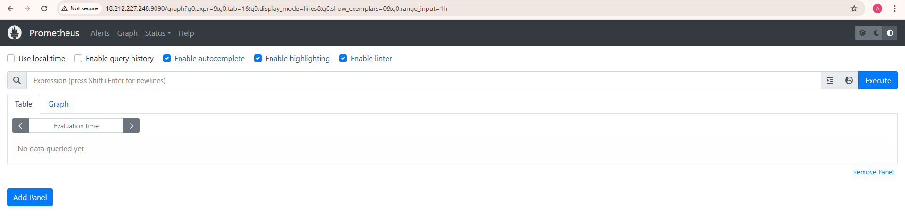

Step 5- Install Grafana on monitoring server
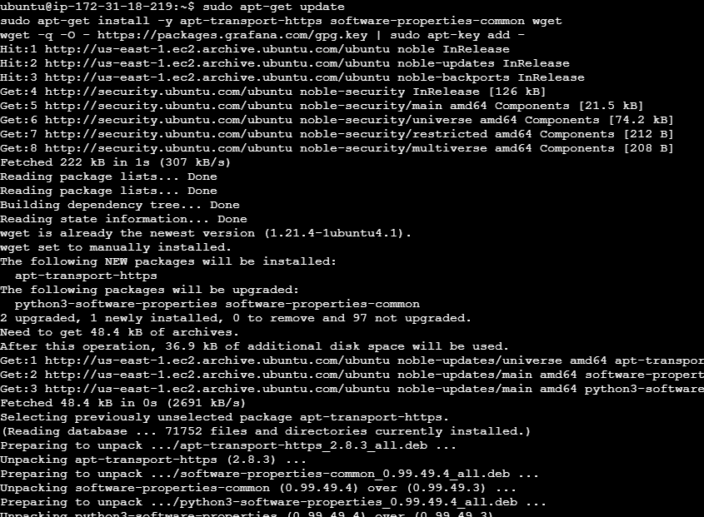
And verify on web
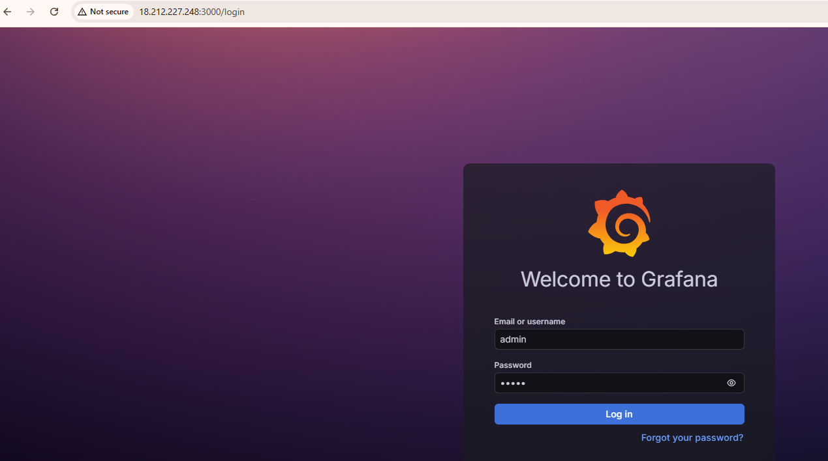

Step 6- Connect grafana and Prometheus
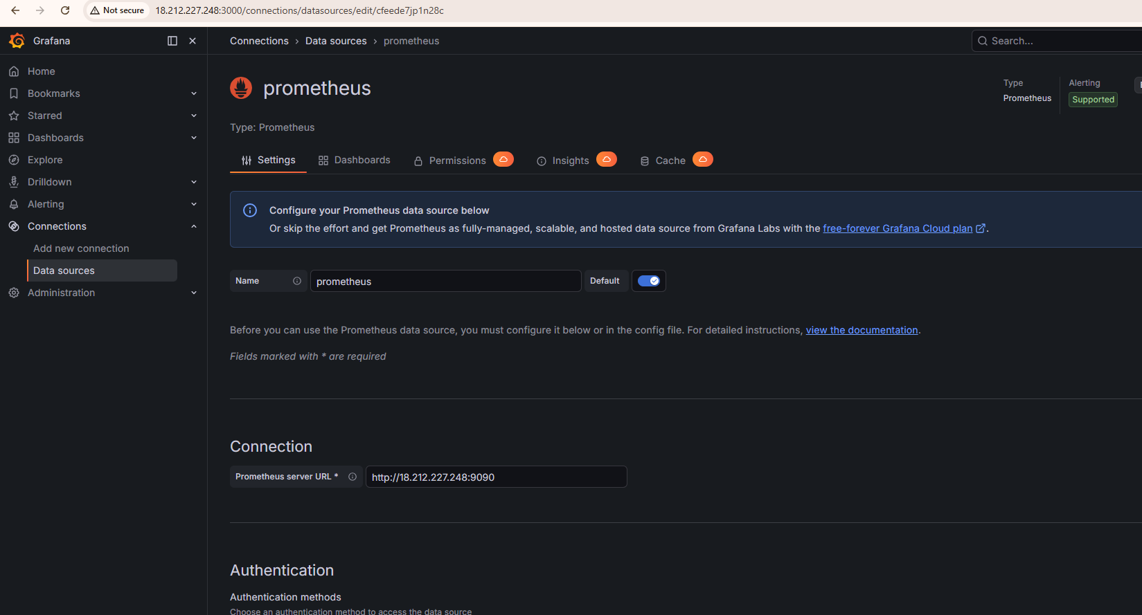
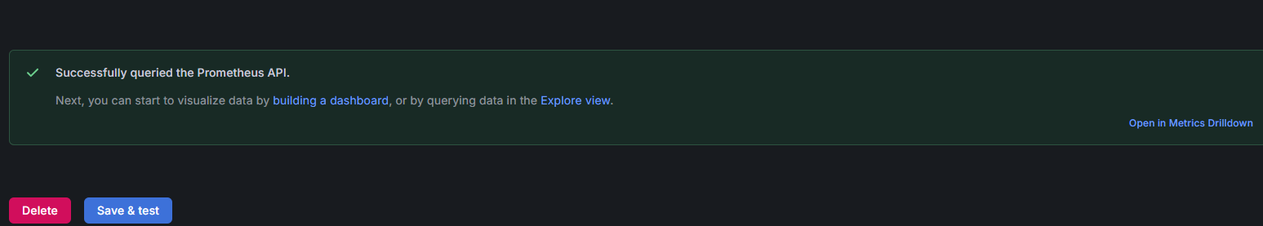

Step 7- Create a dashboard to view metrics
Go to dashboard-> create dashboard->import dashboard
