Task Description:
Create 2 EC2 instances on 2 different regions and install nginx using terraform script.

Step 1: create a provider.tf file
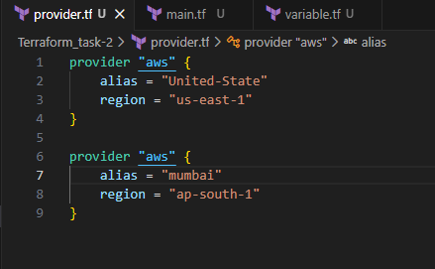

Step 2: create main.tf file
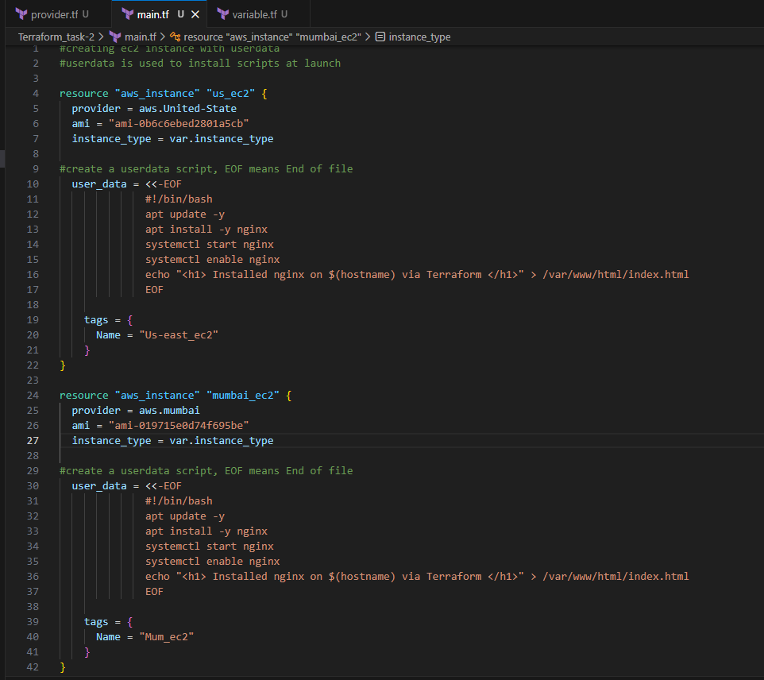

Step 3: create variable.tf file
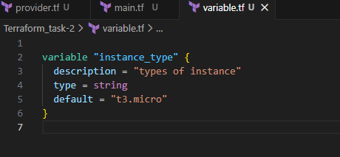

Step 4: run terraform init command
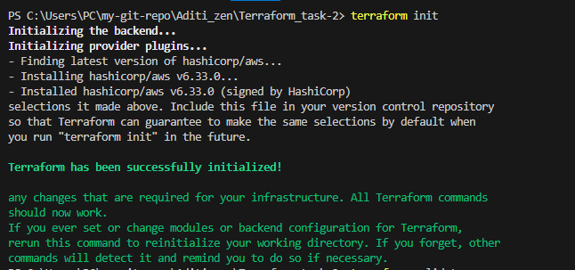

Step 5: Run terraform validate and terraform plan command
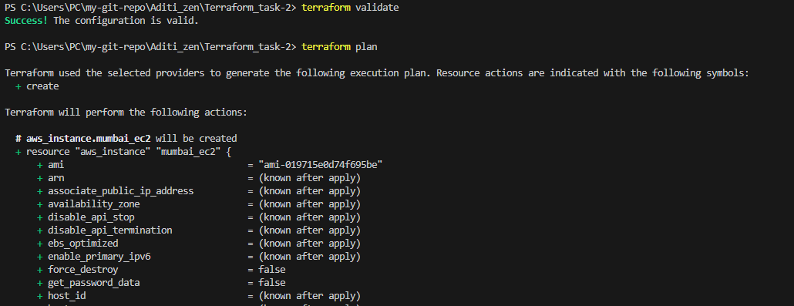

Step 6: Run terraform apply command
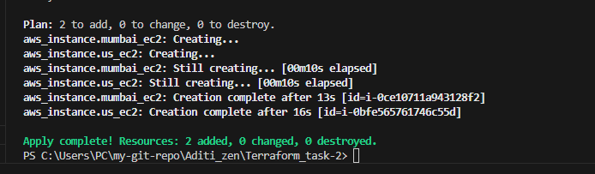

Server is created in us-east region
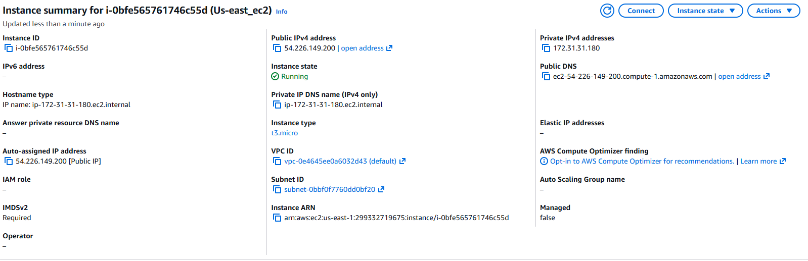
Check with public Ip if nginx is installed or not
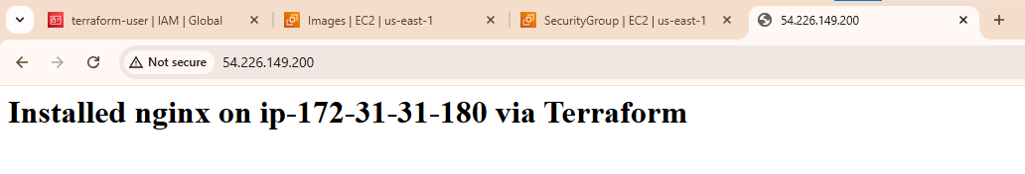

Server is created in ap-south region
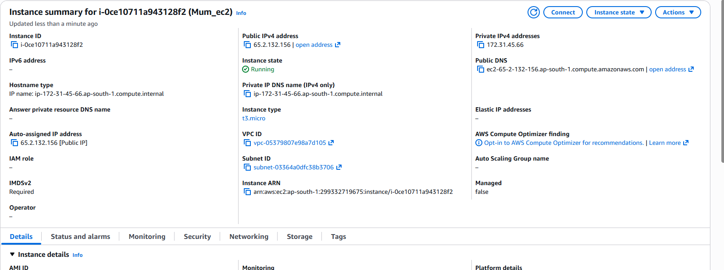

Check with public Ip if nginx is installed or not
