Task Description:

Create the K8s EKS,further you have to do the deployment of the Nginx application and access the application outside the cluster.

Step 1- Create a eks cluster
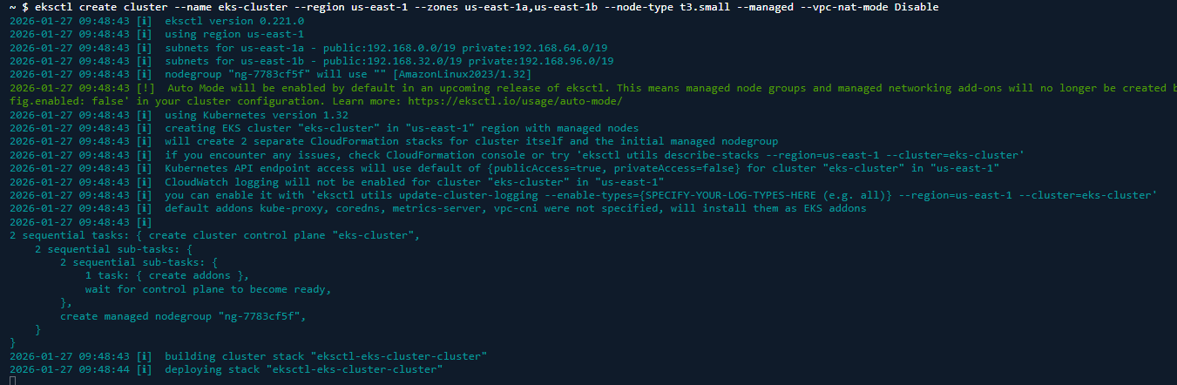
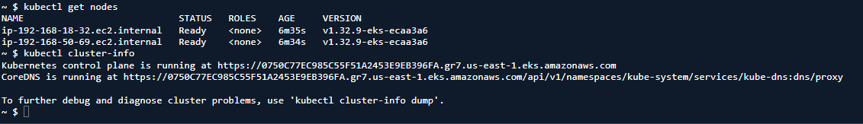

Step 2- Create a yaml file for deployment of nginx
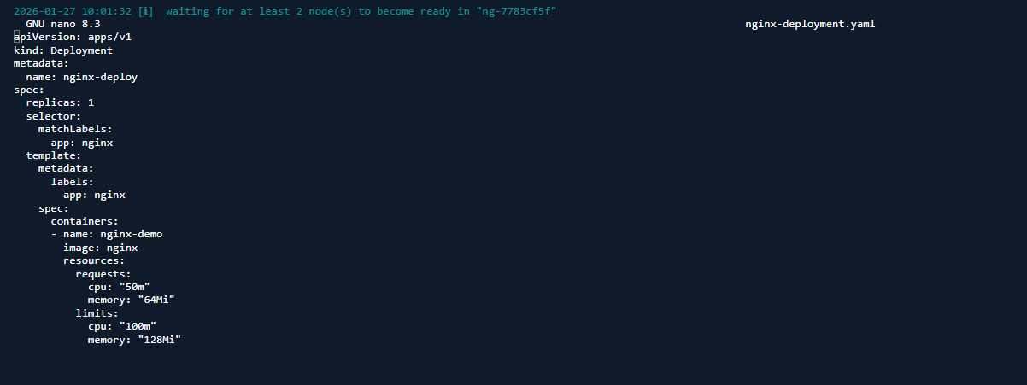
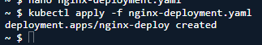

Step 3- create a Service.yaml file for accessing application outside
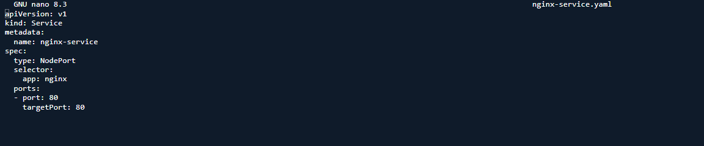
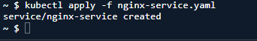
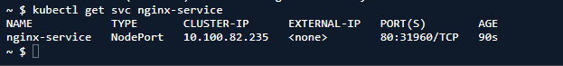

Step 4- edit the inbound rule of the node
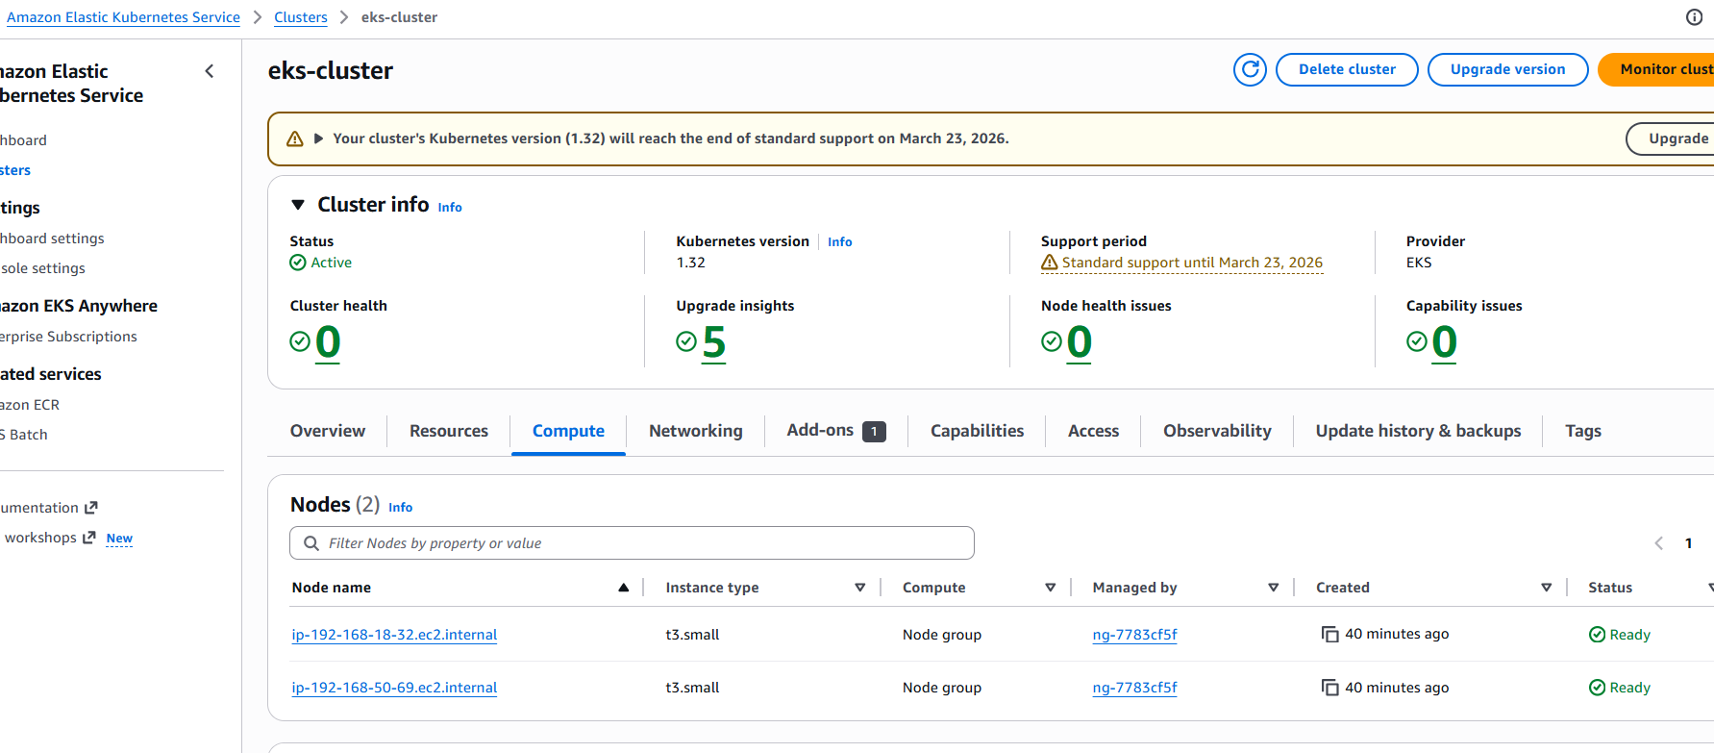
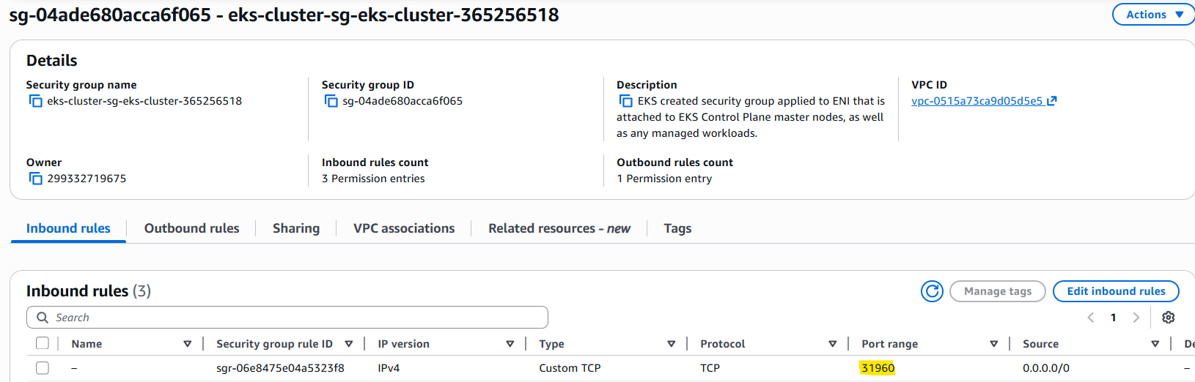

Step 5- access the application using Node IP+portrange
