Task Description:

Create a dockerfile, docker-compose file which when executed must display your basic details in the website.

Step 1- Launch an EC2 instance and install docker

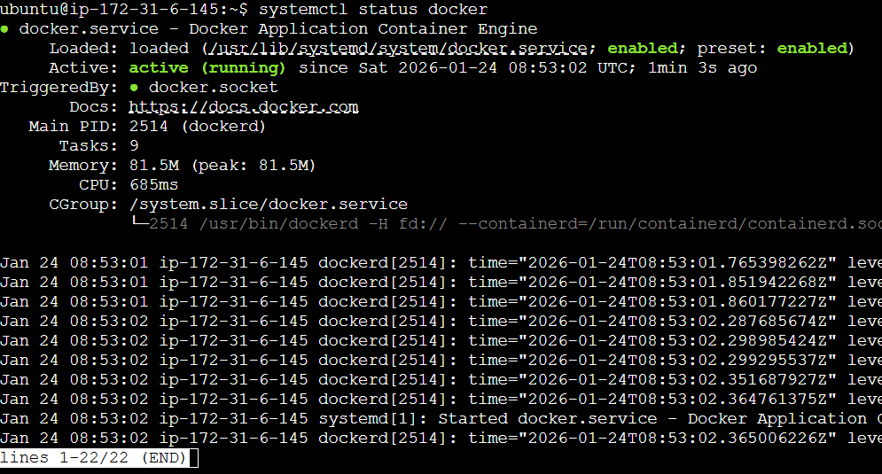

Step 2- Create a docker compose file
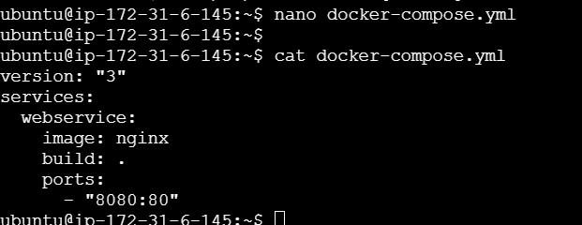

Step 3- Create a html file containing all the details
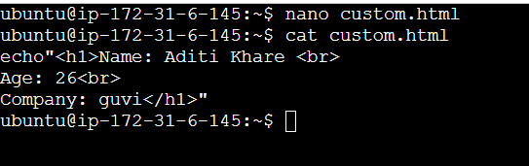

Step 4- Create a Dockerfile
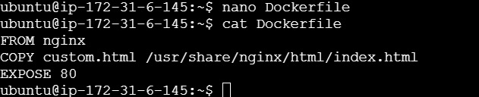

Step 5- Run docker compose up

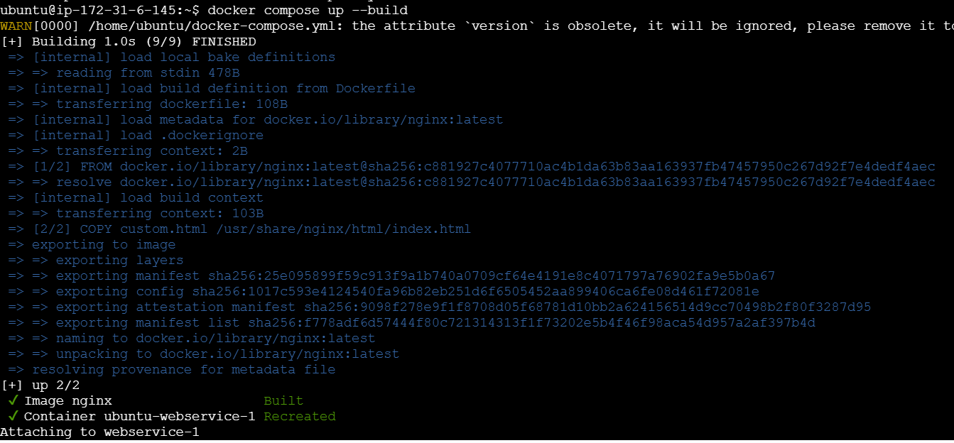

Step 6- run the public IP address on web
