Task Description:

Setup minikube at your local and explore creating namespaces (Go through official documentation).

Step 1: Launch and EC2 instance and install docker on it, after installing docker install kubernetes using the below command
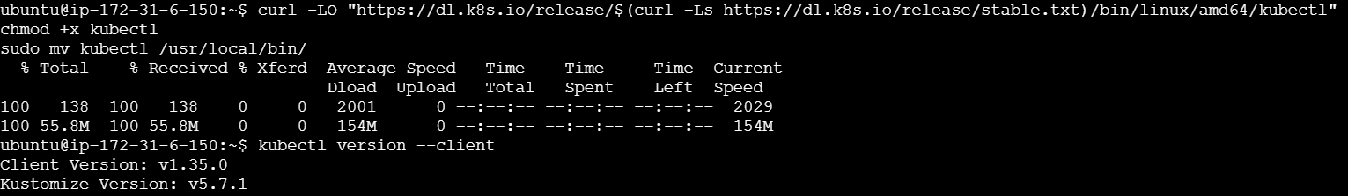
Step 2: Run minikube start command
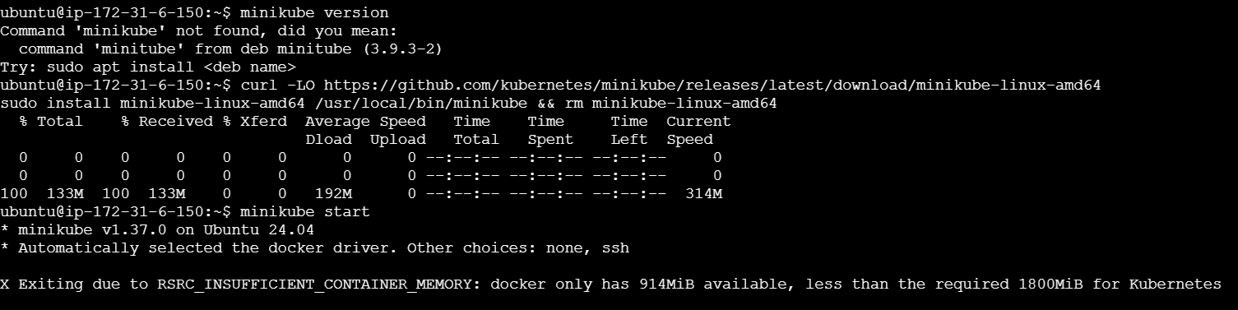

For creating namespace
Step 1: create a eks cluster and check for namespaces
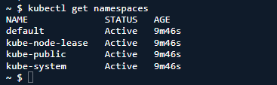
Step 2: create a namespace
