- Create a demo.txt file
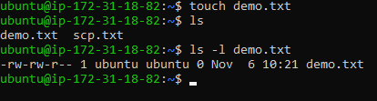

- Changing permission
