Questions:
1. Explain the difference between frontend, backend, and full-stack development with
suitable real-world examples.
2. Create a simple diagram showing how the client-server model works in web architecture.
3. Describe how a browser requests and displays a web page from a web server.
4. Identify and list the tools required to set up a web development environment. Explain the
purpose of each.
5. Explain what a web server is and give examples of commonly used servers.
6. Define the roles of a frontend developer, backend developer, and database administrator
in a project.
7. Install VS Code and configure it for HTML, CSS, and JavaScript development. Take a
screenshot of the setup.
8. Explain the difference between static and dynamic websites. Provide an example of
each.
9. Research and list five web browsers. Explain how rendering engines differ between
them.
10. Draw a labeled diagram showing the basic web architecture flow — client, server,
database, and APIs.
Answers:
1. Explain the difference between frontend, backend, and full-stack development with suitable real-world examples.
Frontend (Client-side)
Frontend is the part of a website that users can see and use. It is made using HTML, CSS, and JavaScript.
Example: On a shopping website, the product images, buttons, and menu are the frontend.
Backend (Server-side)
Backend is the part that works behind the scenes. It stores data, processes requests, and connects to the database.
Example: When you log in to a website, the backend checks your username and password.
Full-Stack Development
A full-stack developer works on both the frontend and backend of a website.
Example: A developer who creates both the website design and the login system.

2. Create a simple diagram showing how the client-server model works in web architecture.
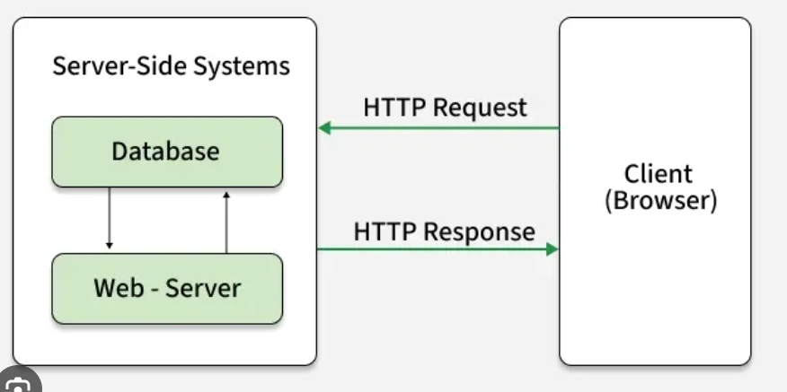
Explanation:
The client (browser) sends a request to the server. The server processes it and sends the webpage back to the client.

3. Describe how a browser requests and displays a web page from a web server.
- The user enters a website address (URL).
- The browser sends an HTTP request to the web server.
- The server processes the request.
- The server sends HTML, CSS, and JavaScript files.
- The browser reads these files and displays the webpage.

4. Identify and list the tools required to set up a web development environment. Explain the purpose of each.
Tool | Purpose
VS Code | To write and edit code.
Google Chrome | To test websites.
Live Server Extension | Runs the website locally.
Git | Tracks changes in code.
Node.js | Runs JavaScript outside the browser.

5. Explain what a web server is and give examples of commonly used servers.
A web server is software that stores websites and sends web pages to users when they request them.
Examples:
- Apache
- Nginx
- Microsoft IIS

6. Define the roles of a frontend developer, backend developer, and database administrator in a project.
Frontend Developer
Creates the design and user interface of the website.
Backend Developer
Develops the server, application logic, and connects the database.
Database Administrator (DBA)
Manages and secures the database.

7. Install VS Code and configure it for HTML, CSS, and JavaScript development. Take a screenshot of the setup.
Steps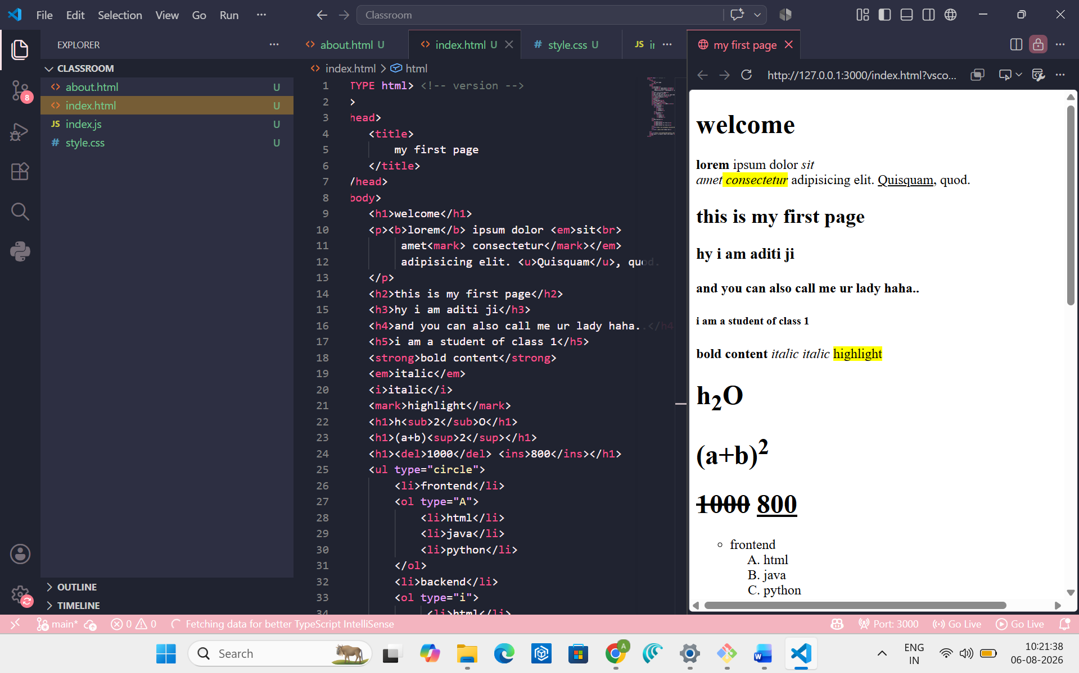

8. Explain the difference between static and dynamic websites. Provide an example of each.
Static Website | Dynamic Website
Content does not change automatically. | Content changes based on the user or database.
No database is needed. | Uses a database.
Easy to create. | More advanced to create.
Example of Static Website: Personal portfolio website.
Example of Dynamic Website: Facebook, Instagram, or Amazon.

9. Research and list five web browsers. Explain how rendering engines differ between them.
Five Web Browsers
- Google Chrome
- Mozilla Firefox
- Microsoft Edge
- Safari
- Opera
Rendering Engines
- Chrome → Blink
- Firefox → Gecko
- Safari → WebKit
- Edge → Blink
- Opera → Blink
Explanation:
A rendering engine reads HTML and CSS and displays the webpage. Different browsers use different rendering engines, so a webpage may look slightly different in each browser.

10. Draw a labeled diagram showing the basic web architecture flow: client, server, database, and APIs.
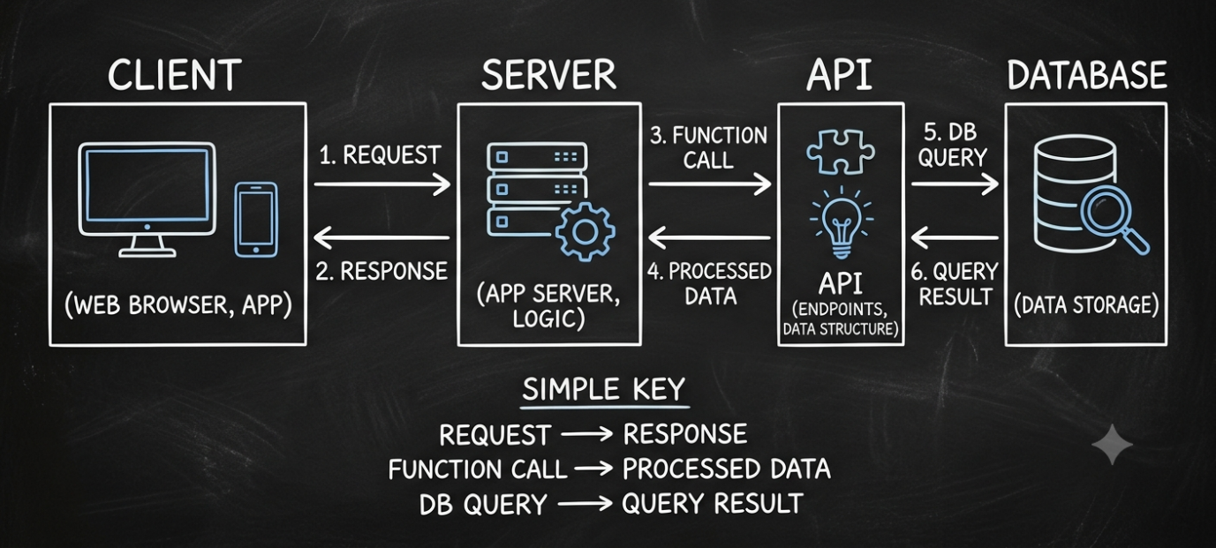
Explanation:
The client sends a request to the server. The server uses APIs and the database to process the request and sends the response back to the client.

