Array Operations
package nov19;

import java.util.Arrays;

public class ArrayOperations {

public static void main(String[] args) {

// Original Array
int arr[] = {10, 20, 30, 40, 50};
System.out.println("Original Array: " + Arrays.toString(arr));

// 1. Traversal
System.out.print("Traversal: ");
for (int x : arr) {
System.out.print(x + " ");
}
System.out.println();

// 2. Insertion (Insert 25 at index 2)
int insertIndex = 2;
int insertValue = 25;
int newArr1[] = new int[arr.length + 1];

for (int i = 0; i < insertIndex; i++)
newArr1[i] = arr[i];

newArr1[insertIndex] = insertValue;

for (int i = insertIndex; i < arr.length; i++)
newArr1[i + 1] = arr[i];

System.out.println("After Insertion: " + Arrays.toString(newArr1));

// 3. Deletion (Remove element at index 3)
int delIndex = 3;
int newArr2[] = new int[newArr1.length - 1];

for (int i = 0; i < delIndex; i++)
newArr2[i] = newArr1[i];

for (int i = delIndex; i < newArr2.length; i++)
newArr2[i] = newArr1[i + 1];

System.out.println("After Deletion: " + Arrays.toString(newArr2));

// 4. Searching (Linear Search)
int key = 25;
boolean found = false;

for (int i = 0; i < newArr2.length; i++) {
if (newArr2[i] == key) {
System.out.println("Search: " + key + " found at index " + i);
found = true;
break;
}
}

if (!found)
System.out.println("Search: " + key + " not found");

// 5. Sorting
int sortArr[] = newArr2.clone();
Arrays.sort(sortArr);
System.out.println("Sorted Array: " + Arrays.toString(sortArr));

// 6. Merging two arrays
int arrB[] = {60, 70, 80};
int merged[] = new int[sortArr.length + arrB.length];
int k = 0;

for (int x : sortArr)
merged[k++] = x;

for (int x : arrB)
merged[k++] = x;

System.out.println("Merged Array: " + Arrays.toString(merged));

// 7. Updating value at index 1
merged[1] = 99;
System.out.println("After Updating: " + Arrays.toString(merged));

// 8. Copying Array
int copied[] = Arrays.copyOf(merged, merged.length);
System.out.println("Copied Array: " + Arrays.toString(copied));

// 9. Reversing Array
for (int i = 0; i < copied.length / 2; i++) {
int temp = copied[i];
copied[i] = copied[copied.length - 1 - i];
copied[copied.length - 1 - i] = temp;
}
System.out.println("Reversed Array: " + Arrays.toString(copied));

// 10. Maximum & Minimum
int max = merged[0], min = merged[0];
for (int x : merged) {
if (x > max) max = x;
if (x < min) min = x;
}
System.out.println("Maximum Value: " + max);
System.out.println("Minimum Value: " + min);
}
}
OUTPUT
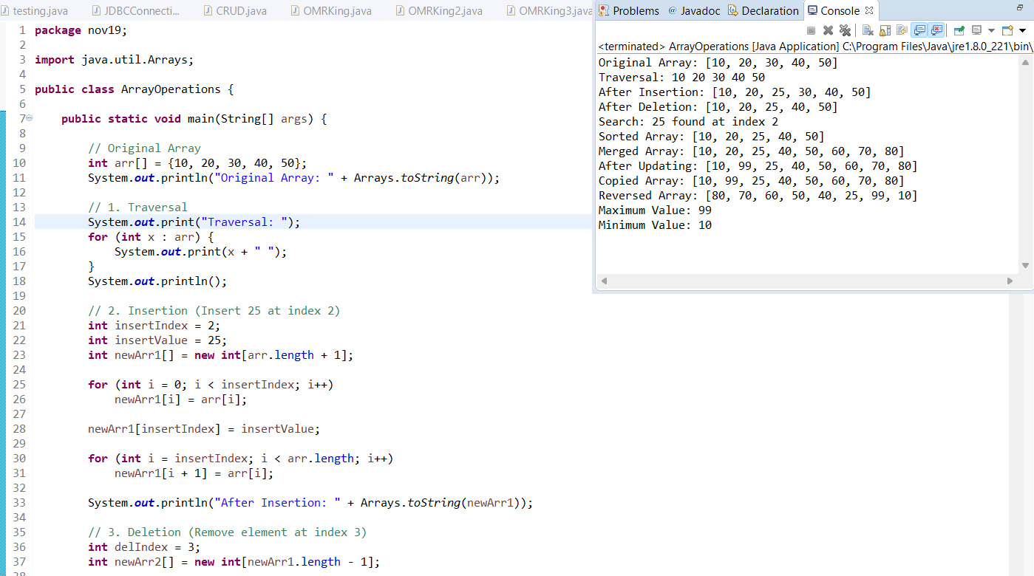
String Operations
package nov19;

public class StringOperations {
public static void main(String[] args) {

// toUpperCase() & toLowerCase()
String s = "Sachin";
System.out.println(s.toUpperCase());
System.out.println(s.toLowerCase());
System.out.println(s);

// trim()
String s2 = " Sachin ";
System.out.println(s2);
System.out.println(s2.trim());

// startsWith() & endsWith()
String s3 = "Sachin";
System.out.println(s3.startsWith("Sa"));
System.out.println(s3.endsWith("n"));
// charAt()
System.out.println(s3.charAt(0)); // S
System.out.println(s3.charAt(3)); // h

// length()
System.out.println(s3.length()); // 6

String s4 = new String("Sachin");
String s5 = s4.intern();
System.out.println(s5); // Sachin

// valueOf()
int a = 10;
String s6 = String.valueOf(a);
System.out.println(s6 + 10); // 1010

// replace()
String s7 = "Java is a programming language. Java is a platform. Java is an Island.";
String replaceString = s7.replace("Java", "Kava");
System.out.println(replaceString);

// Concatenation using +
String s8 = "Sachin" + " Tendulkar";
System.out.println(s8);

// concat() method
String c1 = "Sachin ";
String c2 = "Tendulkar";
String c3 = c1.concat(c2);
System.out.println(c3);

// equals() and equalsIgnoreCase()
String e1 = "Sachin";
String e2 = "Sachin";
String e3 = new String("Sachin");
String e4 = "Saurav";

System.out.println(e1.equals(e2)); // true
System.out.println(e1.equals(e3)); // true
System.out.println(e1.equals(e4)); // false

// == operator (reference comparison)
System.out.println(e1 == e2); // true
System.out.println(e1 == e3); // false

// compareTo()
String c4 = "Sachin";
String c5 = "Sachin";
String c6 = "Ratan";
System.out.println(c4.compareTo(c5)); // 0
System.out.println(c4.compareTo(c6)); // 1
System.out.println(c6.compareTo(c4)); // -1

// STRINGBUFFER METHODS
System.out.println("\n--- StringBuffer Examples ---");

StringBuffer sb1 = new StringBuffer("Hello ");
sb1.append("Java");
System.out.println(sb1); // Hello Java

StringBuffer sb2 = new StringBuffer("Hello ");
sb2.insert(1, "Java");
System.out.println(sb2); // HJavaello

StringBuffer sb3 = new StringBuffer("Hello");
sb3.replace(1, 3, "Java");
System.out.println(sb3); // HJavalo

StringBuffer sb4 = new StringBuffer("Hello");
sb4.delete(1, 3);
System.out.println(sb4); // Hlo

StringBuffer sb5 = new StringBuffer("Hello");
sb5.reverse();
System.out.println(sb5); // olleH

// STRINGBUILDER METHODS
System.out.println("\n--- StringBuilder Examples ---");

StringBuilder sbb1 = new StringBuilder("Hello ");
sbb1.append("Java");
System.out.println(sbb1); // Hello Java

StringBuilder sbb2 = new StringBuilder("Hello ");
sbb2.insert(1, "Java");
System.out.println(sbb2); // HJavaello

StringBuilder sbb3 = new StringBuilder("Hello");
sbb3.replace(1, 3, "Java");
System.out.println(sbb3); // HJavalo

StringBuilder sbb4 = new StringBuilder("Hello");
sbb4.delete(1, 3);
System.out.println(sbb4); // Hlo

StringBuilder sbb5 = new StringBuilder("Hello");
sbb5.reverse();
System.out.println(sbb5); // olleH
}
}
OUTPUT
