1.package nov19;
public class OMRKing {
void BMW520(){
System.out.println("King Car");
}
public static void main(String[] args) {

People1 k= new People1();
k.bike();
System.out.println(k.name_people1);
OMRKing king=new OMRKing();
king.BMW520();
}
}
class People1{
String name_people1="Karthik";
void car(){
System.out.println("People1 Car");
}
void bike(){
System.out.println("People1 Bike");
}
}
class People2{
String name_people1="Mahesh";
void car(){
System.out.println("People2 Car");
}
}
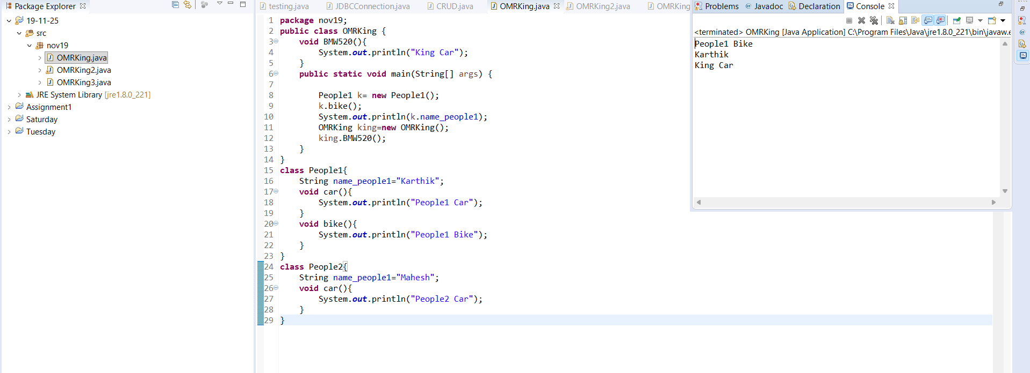
2.package nov19;
public class OMRKing2 {
public static void main(String[] args) {

Program1 program=new Program1(100);

program.addition();

}
}
class Program1{
int marks=95;
protected void addition(){
int result= marks*100;
System.out.println(result);
class InsideClass{
void division(){
System.out.println("method Local inner class output");
}
}
}
{
System.out.println("Welcome...!");
String date="19th Nov 2025";
System.out.println(date);
}

public Program1() {
System.out.println("Iam a def const..");
}
public Program1(int a){
a=marks+a;
System.out.println(a);
}

}
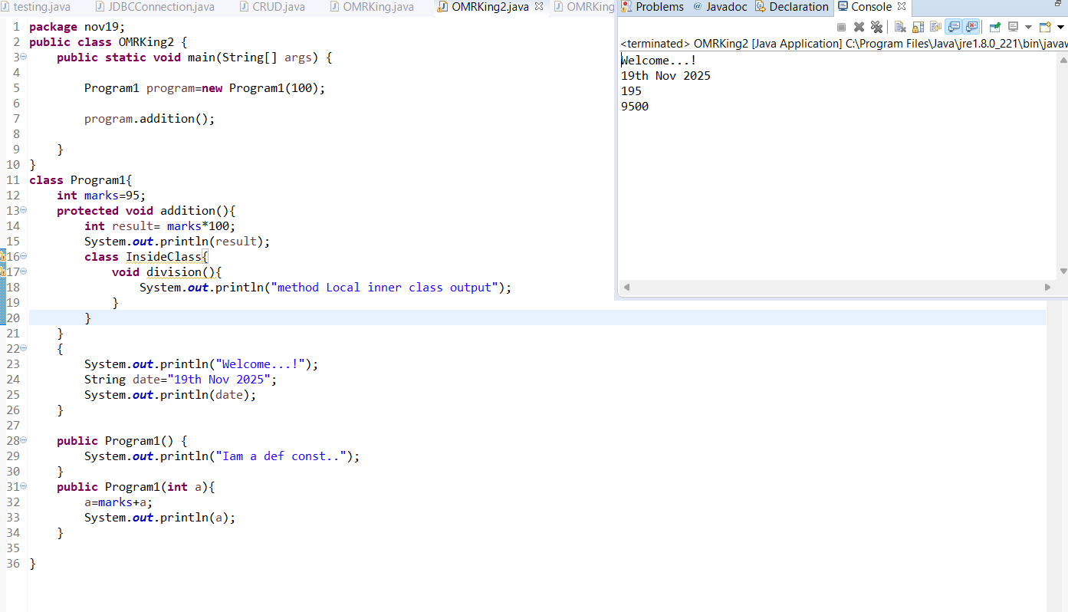
3.package nov19;
public class OMRKing3 {
public static void main(String[] args) {

Son1 s1=new Son1();
s1.bike();
Son2 s2=new Son2();
s2.bike();
s2.oldBike();
}
}
class GrandFather{
void oldBike(){
System.out.println("Royal Enfield 1983");
}
}

class Father extends GrandFather{
void oldBike(){
System.out.println("Royal Enfield 2002");
}
}

class Son1 extends Father{
void bike(){
System.out.println("KTM 390");
}
}

class Son2 extends Father{
void bike(){
System.out.println("RC KTM 390");
}
}
