ARRAY DATA STRUCTURE
• An array is a collection of items stored at contiguous memory locations. • The idea is to store multiple items of the same type together. • This makes it easier to calculate the position of each element by simply adding anoffset to a base value, i.e., the memory location of the first element of the array(generally denoted by the name of the array).
ARRAY
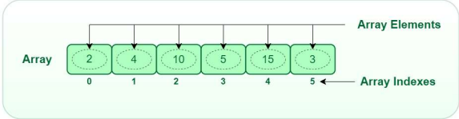
Types of Array operations:
• Traversal: Traverse through the elements of an array. • Insertion: Inserting a new element in an array. • Deletion: Deleting element from the array. • Searching: Search for an element in the array. • Sorting: Maintaining the order of elements in the array.
Insertion in Array:
We try to insert a value to a particular array index position, as the array provides random access it can be done easily using the assignment operator.
• Pseudo Code:
// to insert a value= 10 at index position 2;
arr[ 2 ] = 10;
Time Complexity:
O(1) to insert a single element
O(N) to insert all the array elements [where N is the size of the array]
Access elements in Array:
• Accessing array elements become extremely important, in order to perform operations on arrays.
Pseudo Code:
// to access array element at index position 2, we simply can writereturn arr[ 2 ] ;
• Time Complexity:O(1)
Loop from i = 0 to 5:
Searching in Array:
• We try to find a particular value in the array, in order to do that we need to access all the array elements and look for the particular value.
Pseudo Code:
// searching for value 2 in the array;
check if arr[i] = 2:
return true;
Time Complexity: O(N), where N is the size of the array.
Advantages of using arrays:
• Arrays allow random access to elements. This makes accessing elements by position faster.
• Arrays have better cache locality which makes a pretty big difference in performance.
• Arrays represent multiple data items of the same type using a single name.
• Arrays store multiple data of similar types with the same name.
• Array data structures are used to implement the other data structures like linked lists, stacks, queues, trees, graphs, etc.
Disadvantages of using arrays:
• As arrays have a fixed size, once the memory is allocated to them, it cannot be increased or decreased, making it impossible to store extra data if required. An array of fixed size is referred to as a static array.
• Allocating less memory than required to an array leads to loss of data.An array is homogeneous in nature so, a single array cannot store values of different data types.
• Arrays store data in contiguous memory locations, which makes deletion and insertion very difficult to implement. This problem is overcome by implementing linked lists, which allow elements to be accessed sequentially.
Applications on Array
• Array stores data elements of the same data type.
• Arrays are used when the size of the data set is known. • Used in solving matrix problems.
• Applied as a lookup table in computer.
• Databases records are also implemented by the array. • Helps in implementing sorting algorithm.
• The different variables of the same type can be saved under one name. • Arrays can be used for CPU scheduling.
• Used to Implement other data structures like Stacks, Queues, Heaps, Hash tables, etc
Types of arrays:
There are majorly two types of arrays
• One-dimensional array (1-D arrays): You can imagine a 1d array as a row, where elements are stored one after another.
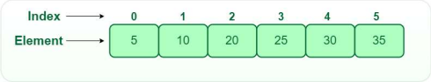
• Two-dimensional array: 2-D Multidimensional arrays can be considered as an array of arrays or as a matrix consisting of rows and columns.
• Three-dimensional array: A 3-D Multidimensional array contains three dimensions, so it can be considered an array of two-dimensional arrays.
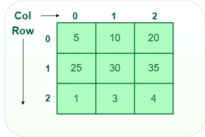2D array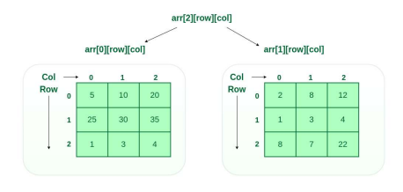 3D array
Calculating the address of any element In the 1-D array:
• A 1-dimensional array (or single-dimension array) is a type of linear array. Accessing its elements involves a single subscript that can either represent a row or column index.
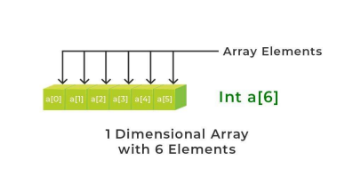
Calculate the address of any element in the 2-D array:
❑ The 2-dimensional array can be defined as an array of arrays.
❑ The 2-Dimensional arrays are organized as matrices which can be represented as the collection of rows and columns as array[M][N] where M is the number of rows and N is the number of columns.
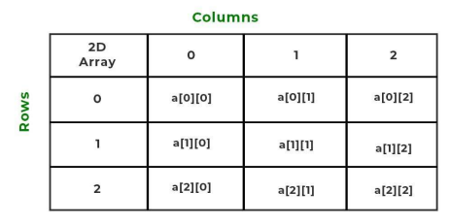
Address of A[I] = B + W * (I – LB)
Address of A[1700] = 1020 + 2 * (1700 – 1300)
• Example: Given the base address of an array A[1300 ………… 1900] as 1020 and the size of each element is 2 bytes in the memory, find the address of A[1700].
Given:
Base address B = 1020
Lower Limit/Lower Bound of subscript LB = 1300 Storage size of one element store in any array W = 2 Byte Subset of element whose address to be found I = 1700
Formula used:
Solution:
= 1020 + 2 * (400)
= 1020 + 800
Address of A[1700] = 1820
To find the address of any element in a 2-Dimensional array there are the following two ways
• Row Major Order
• Column Major Order
Address of A[I][J] = B + W * ((I – LR) * N + (J – LC))
Row Major Order:
• Row major ordering assigns successive elements, moving across the rows and then down the next row, to successive memory locations. In simple language, the elements of an array are stored in a Row-Wise fashion.
To find the address of the element using row-major order uses the following formula:
Example: Given an array, arr[1………10][1………15] with base value 100 and the size of each element is 1 Byte in memory. Find the address of arr[8][6] with the help of row-major order.
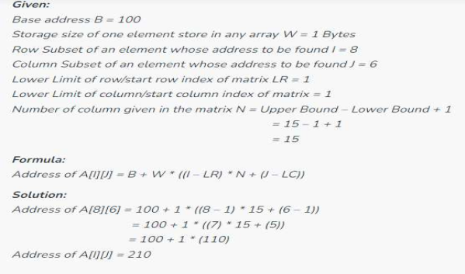
Address of A[I][J] = B + W * ((J – LC) * M + (I – LR))
2. Column Major Order:
• If elements of an array are stored in a column-major fashion means moving across the column and then to the next column then it’s in column-major order.
• To find the address of the element using column-major order use the following formula:
Example: Given an array arr[1………10][1………15] with a base value of 100 and the size of each element is 1 Byte in memory find the address of arr[8][6] with the help of column-major order.
