


Academic Year | Module | Assessment Number | Assessment Type
2026 | 5CS037– Concepts & Technologies of  AI | 1 | Report

Assignment - I
Statistical Interpretation and Exploratory Data Analysis : Human Development Index (HDI) Analysis Report

Student Id : 2501453
Student Name : Aditri Prajapati
Section : L5CG11
Module Leader : Siman Giri
Tutor : Robin Tuladhar
Submitted on : 10-01-2026
Word Count: 2325

Contents
1. Introduction 1
1.1. Overview of Human Development Index 1
1.2. Objectives of the Analysis 1
1.3. Scope and Limitations 2
2. Methodology 3
2.1. Data Sources and Description 3
2.2. Analytical Tools and Techniques 3
2.3. Data Processing Pipeline 3
3. Problem 1A: Single Year HDI Exploration (2022) 4
3.1. Methods and Approach 4
3.2. Key Results and Findings 4
3.3. Visualizations and Analysis 6
3.4. Interpretation and Discussion 9
4. Problem 1B: HDI Trend Analysis (2020–2022) 10
4.1. Methods and Approach 10
4.2. Key Results and Findings 10
4.3. Visualizations and Analysis 12
4.4. Interpretation and Discussion 14

5. Problem 2: Advanced HDI Exploration – South Asia Focus 15
5.1. Methods and Approach 15
5.2. Key Results and Findings 15
5.3. Visualizations and Analysis 16
5.4. Interpretation and Discussion 17
6. Problem 3: Comparative Regional Analysis 17
6.1. Methods and Approach 17
6.2. Key Results and Findings 17
6.3. Visualizations and Analysis 18
6.4. Interpretation and Discussion 19
7. Conclusion and Recommendations 20
7.1. Summary of Key Findings 20
7.2. Policy Implications 20
7.3. Limitations of the Study 20
7.4. Future Research Directions 20
8. References 21
9. Appendix 21
Appendix A: Complete Code Availability 21
Appendix B: Generated Datasets 21
Appendix C: Plagiarism Report 22

Table of Figures
Figure 1-Dataset Overview 6
Figure 2-HDI Statistics for 2022 7
Figure 3-HDI Category Distribution 8
Figure 4-Countries with HDI Comparison 9
Figure 5-Top 10 countries by GNI per capita among those with Very High HDI 10
Figure 6-Bar graph of Top 10 countries by GNI per capita among those with Very High HDI 10
Figure 7-Sample from each HDI category 11
Figure 8-Bar graph of Distribution of Countries by HDI category 12
Figure 9-Global HDI trends 13
Figure 10-Countries with the largest HDI improvements and declines 14
Figure 11-Illustrating HDI trends for selected countries 15
Figure 12-Showing regional average HDI values 16
Figure 13- Illustrating HDI vs GNI per Capita(2022) 16
Figure 14-Presenting HDI distributions using box plots 17
Figure 15-South Asian HDI rankings and composite score comparisons 18
Figure 16-Showing composite score rankings 19
Figure 17-Displaying HDI versus GNI per capita with outliers highlighted 19
Figure 18-Table comparing regional HDI statistics 20
Figure 19-Showing regional HDI comparisons 21
Figure 20- Comparing top and bottom performers 22

Introduction

Overview of Human Development Index
The United Nations Development Programme (UNDP) created the Human Development Index (HDI) in 1990, a composite indicator, to gauge a nation's general degree of human development.
In contrast to purely economic indicators like Gross Domestic Product(GDP), HDI takes a multifaceted approach by combining health, education and income dimensions. Life expectancy at birth is a measure of health; expected and mean years of schooling are a measure of education; and Gross National Income(GNI) per capita is a measure of standard of living. HDI offers a more comprehensive and people-centered evaluation of development outcomes by incorporating these dimensions.
The HDI score ranges between 0 and 1, where higher values indicate higher levels of human development. Countries are grouped into four development categories: Very High, High, Medium, and Low Human Development. This classification allows meaningful comparison across countries and regions while highlighting persistent inequalities in development outcomes.

Objectives of the Analysis
The main goal of this analysis is to use HDI data to investigate regional and global trends in human development.
In particular, the study aims to:
- Examine HDI levels across countries for a single year (2022)
- Analyze short-term HDI trends between 2020 and 2022
- Conduct an in-depth regional analysis focusing on South Asia
- Develop a composite development score using selected HDI-related indicators
- Compare development patterns across different global regions

Scope and Limitations
This analysis covers all countries for which HDI data is available from 1990-2022, with particular focus on 2020-2022 for trend analysis and South Asia/Middle East for regional comparisons.
This study utilizes secondary data derived from internationally recognized development datasets. Despite the dataset’s comprehensiveness, the analysis is constrained by the variables’ availability and the chosen time frame. In addition, proxy measures and normalization techniques are used because some indicators lack official index values, which may not precisely replicate UNDP's official HDI computation methodology.

Methodology

Data Sources and Description
The dataset used in this analysis contains country-level HDI values and associated indicators such as life expectancy, GNI per capita, and regional classifications. The data spans multiple years, allowing both cross-sectional and temporal analysis. The year 2022 is treated as the most recent reference point for single-year and comparative assessments.
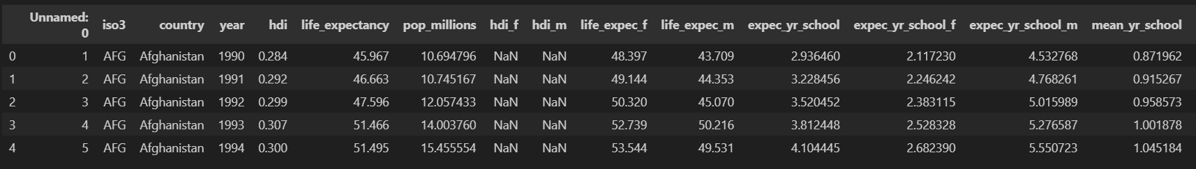
Figure 1-Dataset Overview

Analytical Tools and Techniques
The analysis was conducted using Python, primarily leveraging libraries such as Pandas for data manipulation, NumPy for numerical operations, and Matplotlib/Seaborn for data visualization. Statistical techniques include descriptive statistics, min–max normalization, ranking, interquartile range (IQR) analysis, and correlation analysis.

Data Processing Pipeline
The data processing workflow involved importing the dataset, inspecting data types, handling missing values, and filtering relevant subsets for each problem. Duplicate records were removed where identified, and missing values in critical variables were either excluded or justified based on analytical relevance. Missing values in key variables such as HDI were removed to maintain analytical validity, while other missing indicators were documented rather than imputed to avoid bias. With the help of feature engineering techniques, derived variables such as Composite Score and GNI-HDI Gap was created. The cleaned and processed data were then used for statistical analysis and visualization, followed by interpretation of results. This systematic pipeline ensured data quality and analytical reliability.

Problem 1A: Single Year HDI Exploration (2022)

Methods and Approach
In problem 1A, the data was filtered based on observations from 2022. Missing HDI data was filtered out for countries that did not have this data. Descriptive statistics were used to understand the data distribution for HDI, and countries were grouped based on the HDI criteria set by UNDP. Top-performing countries were further segmented based on GNI per capita.
Data Cleaning Decisions:
- Missing HDI values were dropped as HDI is the primary variable of interest
- Missing gender indicators were noted but not imputed due to potential bias
- Numeric columns were converted to appropriate data types
For facilitating a comparative analysis of development achievements, a new variable named HDI Category was developed for the year 2022. For determining these categories, four official groups of human development, as classified by UNDP, which include Low, Medium, High, and Very High, were used based on the values of HDI. All countries have been categorized based on their respective HDI values. Classification correctness was verified by inspecting category counts and reviewing sample country assignments.

Key Results and Findings
The 2022 dataset contains HDI values for 187 countries. The global mean HDI is 0.72, with a median of 0.73, indicating a slight left-skew in the distribution. While a majority of countries fall into the High and Very High HDI categories, a non-negligible proportion remains in Medium and Low development groups.
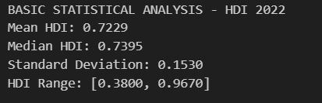
Figure 2-HDI Statistics for 2022
After applying the HDI classification rules, a new column titled “HDI Category” was successfully added to the 2022 dataset. Each country was assigned to one of the four UNDP development groups based solely on its HDI value.
To verify the correctness of the classification:
- The distribution of countries across HDI categories was examined.
- Sample rows containing country names, HDI values, and assigned categories were reviewed manually.
- The dataset structure was inspected to confirm the presence of the new column.
These verification steps ensured that all countries were classified accurately and that no records were left uncategorized.
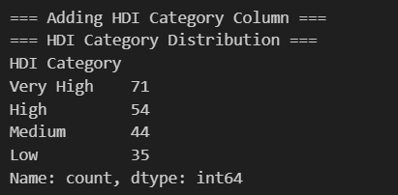
Figure 3-HDI Category Distribution

Visualizations and Analysis
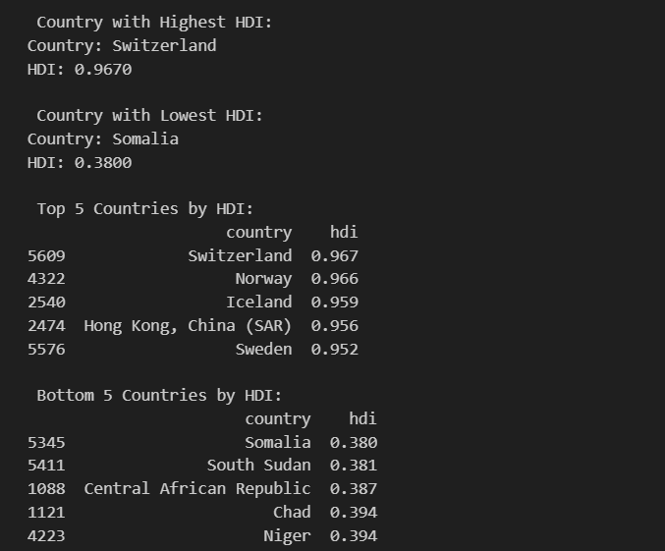
Figure 4-Countries with HDI Comparison

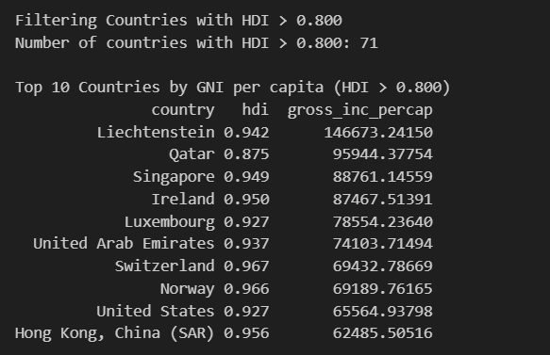
Figure 5-Top 10 countries by GNI per capita among those with Very High HDI

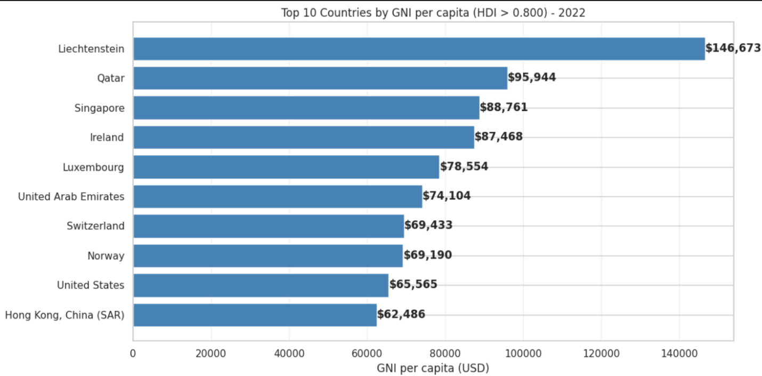
Figure 6-Bar graph of Top 10 countries by GNI per capita among those with Very High HDI

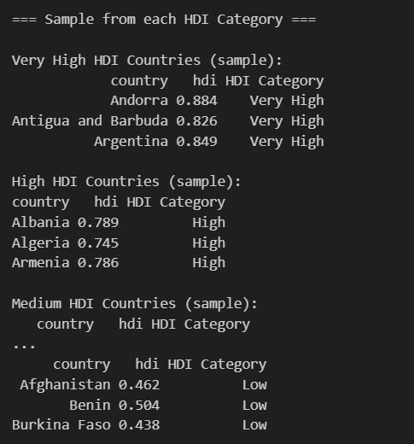
Figure 7-Sample from each HDI category
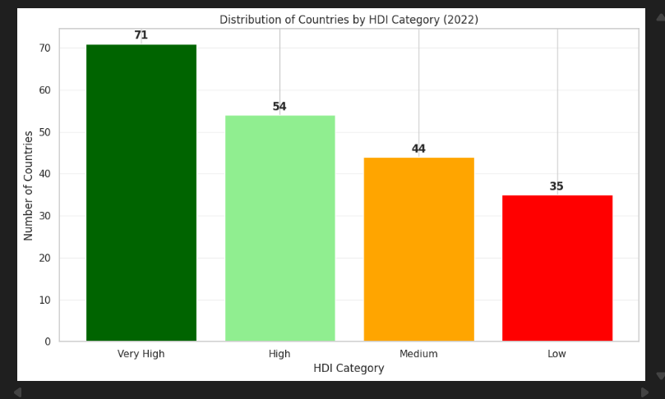
Figure 8-Bar graph of Distribution of Countries by HDI category

Interpretation and Discussion
The HDI category classification reveals clear global development inequalities. Countries classified under Very High Human Development typically demonstrate strong performance in health, education, and income indicators. In contrast, countries in the Low and Medium categories often face challenges related to limited healthcare access, lower educational attainment, and reduced economic capacity.
By converting continuous HDI values into categorical development groups, the analysis becomes more interpretable for policy discussion and comparative studies. This classification also facilitates subsequent regional and trend-based analyses conducted in later sections of the report.
Finally, the updated dataset containing the newly added HDI Category column was saved as “HDI category added.csv”, as required by the assignment, and included in the final submission.

Problem 1B: HDI Trend Analysis (2020–2022)

Methods and Approach
This section examines HDI trends during the period 2020–2022, capturing the impact of the COVID-19 pandemic. Only countries with complete HDI data for all three years were retained. Year-over-year changes were calculated, and regional averages were compared to assess recovery patterns.

Key Results and Findings
The global mean HDI declined in 2020 but showed gradual recovery in 2021 and 2022. While most countries experienced modest improvements by 2022, recovery was uneven across regions.
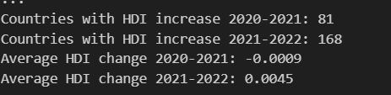
Figure 9-Global HDI trends

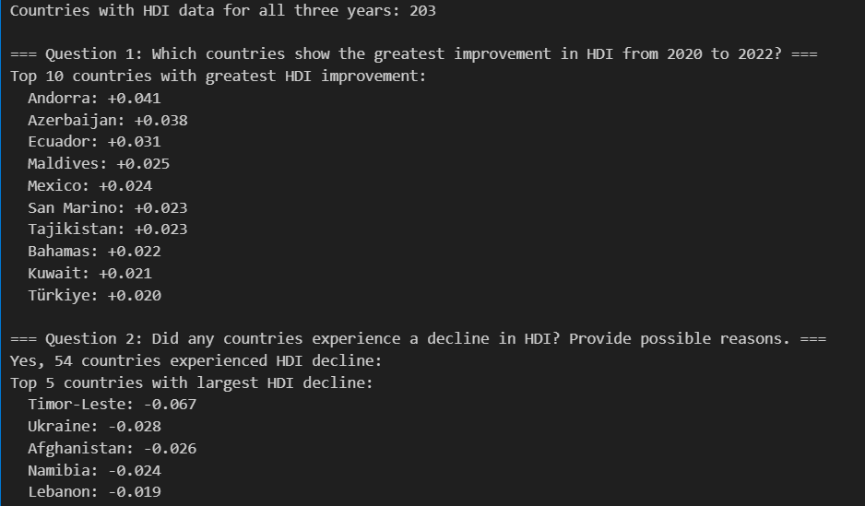
Figure 10-Countries with the largest HDI improvements and declines

Visualizations and Analysis
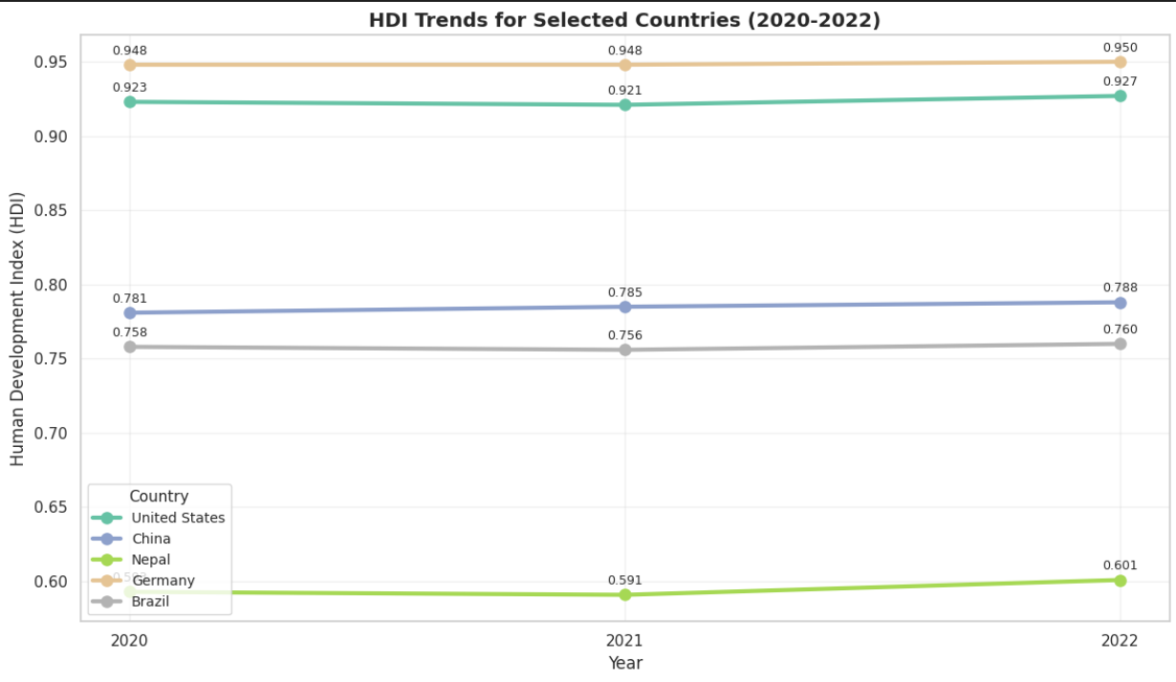
Figure 11-Illustrating HDI trends for selected countries

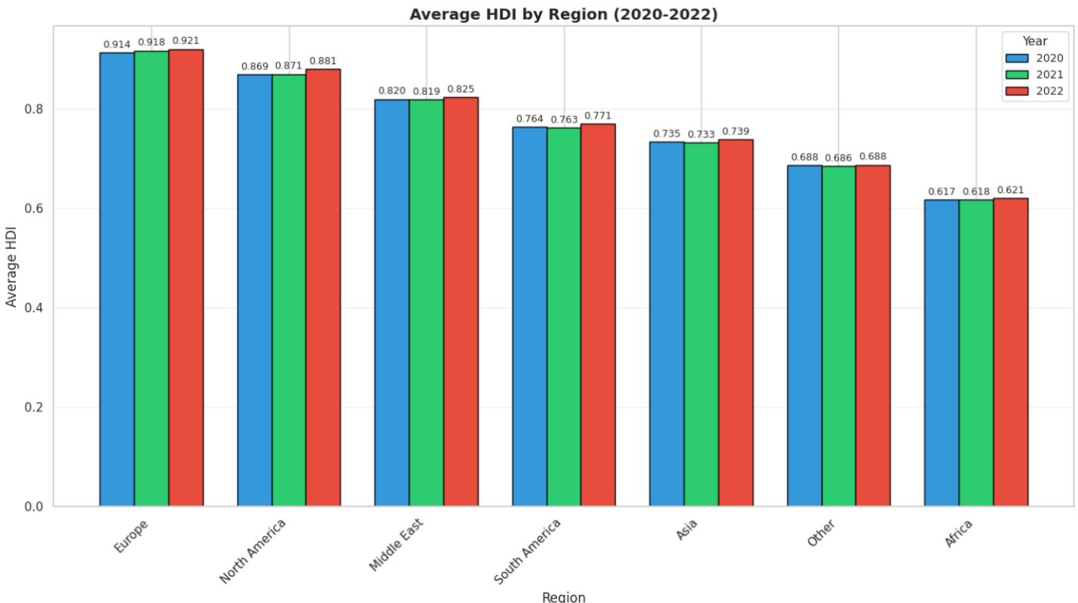
Figure 12-Showing regional average HDI values
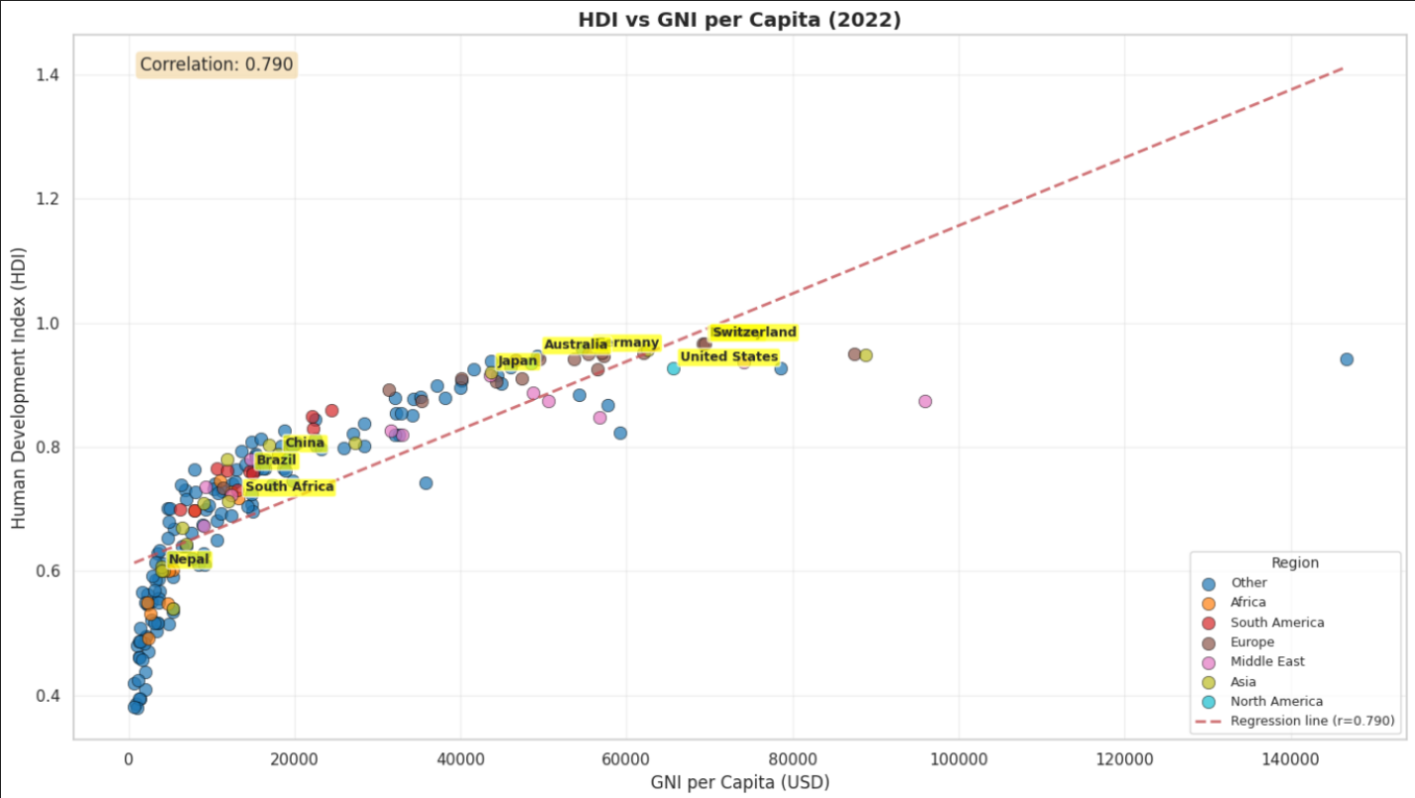
Figure 13- Illustrating HDI vs GNI per Capita(2022)

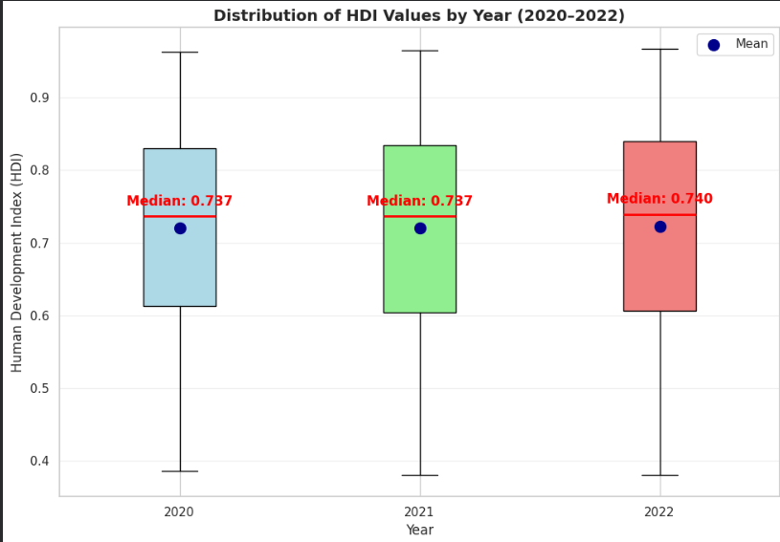
Figure 14-Presenting HDI distributions using box plots

Interpretation and Discussion
The pandemic caused the first recorded global decline in HDI since its inception. Recovery trajectories varied based on healthcare capacity, digital infrastructure, and economic diversification. Countries with resilient health systems and robust digital access recovered more quickly, highlighting the importance of systemic preparedness for future shocks.

Problem 2: Advanced HDI Exploration – South Asia Focus

Methods and Approach
South Asian countries were analysed in detail using a composite development score based on life expectancy and GNI per capita. These indicators were normalised using min–max scaling to ensure comparability. Additional analyses included outlier detection using IQR, percentile-based gap analysis, and correlation analysis between HDI and its components.

Key Results and Findings
South Asia exhibits wide variation in development outcomes, ranging from High HDI countries such as Sri Lanka to Low HDI countries such as Afghanistan. Differences between HDI rankings and composite score rankings highlight varying strengths across health, income, and education dimensions.
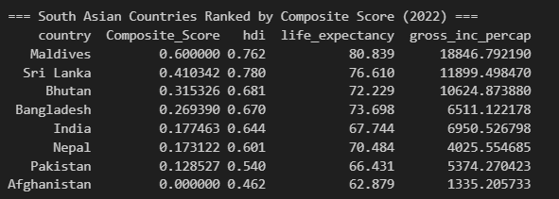
Figure 15-South Asian HDI rankings and composite score comparisons

Visualizations and Analysis
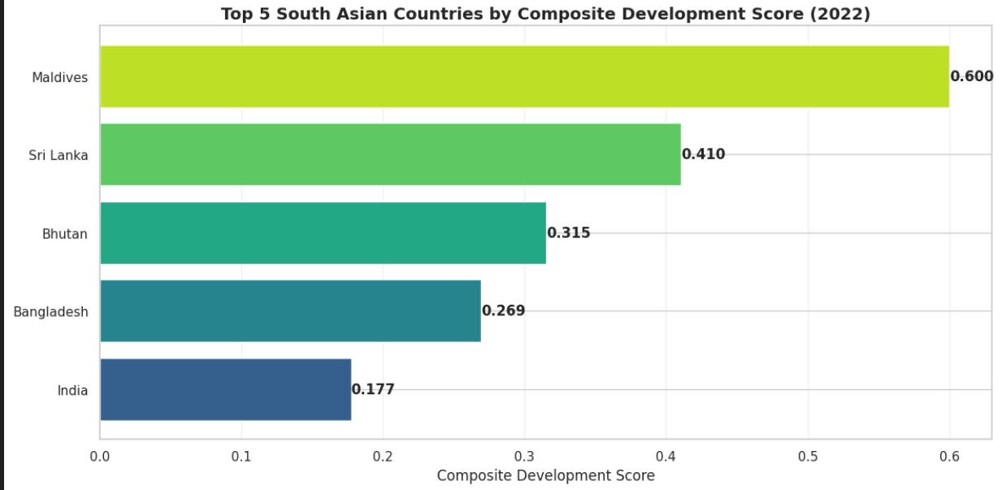
Figure 16-Showing composite score rankings
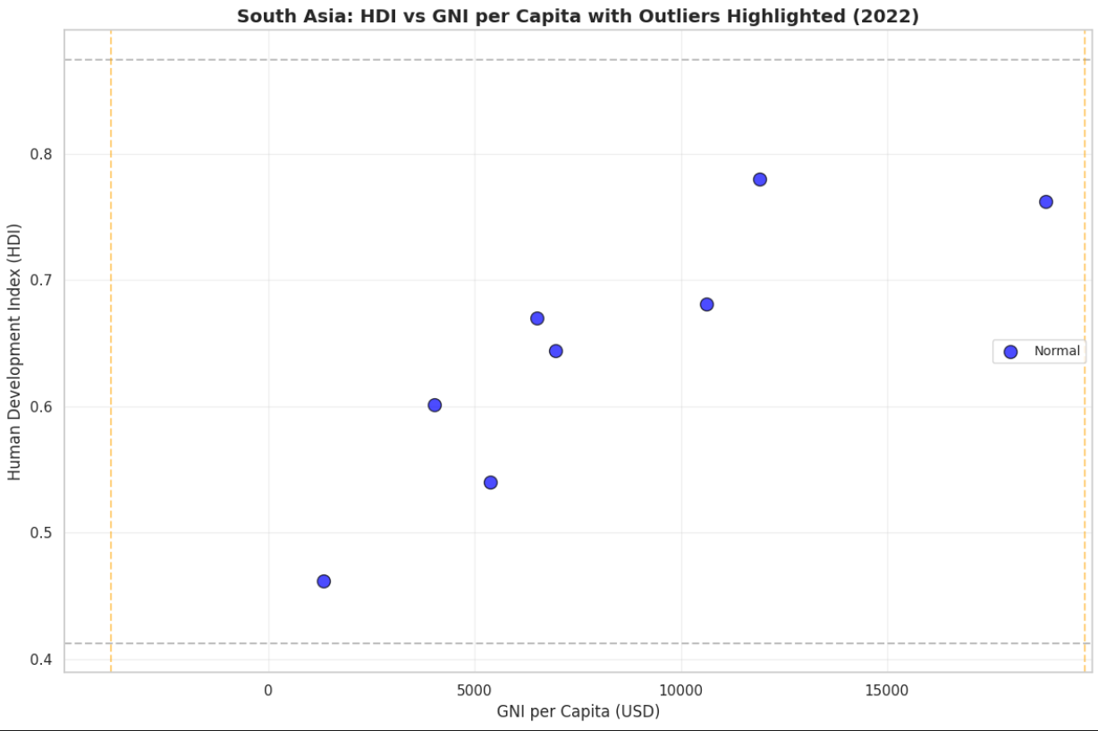
Figure 17-Displaying HDI versus GNI per capita with outliers highlighted

Interpretation and Discussion
The analysis reveals that some South Asian countries achieve relatively strong human development outcomes despite limited income levels, indicating efficient social policy implementation. Conversely, income-rich countries do not always translate economic resources into equivalent development gains.

Problem 3: Comparative Regional Analysis

Methods and Approach
A comparative analysis was conducted between South Asia and the Middle East using descriptive statistics, correlation analysis, and visual comparisons. Both regions were evaluated using identical metrics to ensure consistency.

Key Results and Findings
The Middle East outperforms South Asia in terms of average HDI, life expectancy, and income levels. However, internal disparities exist in both regions, particularly in conflict-affected countries.
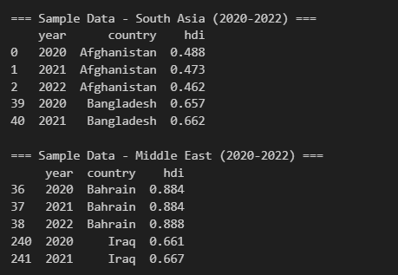
Figure 18-Table comparing regional HDI statistics

Visualizations and Analysis
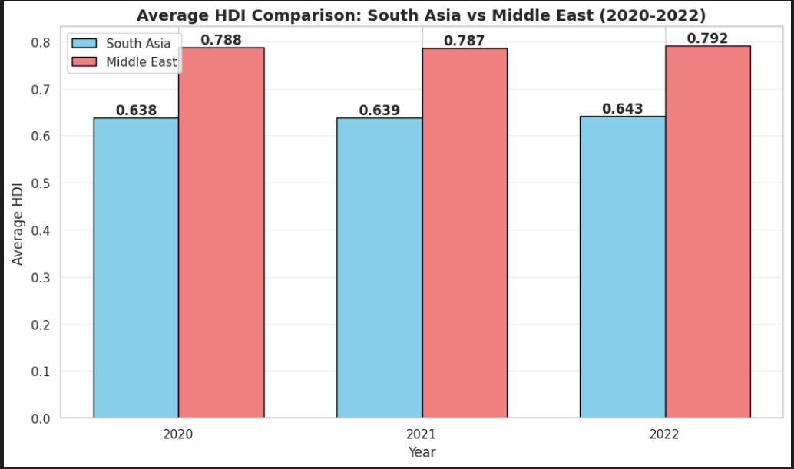
Figure 19-Showing regional HDI comparisons
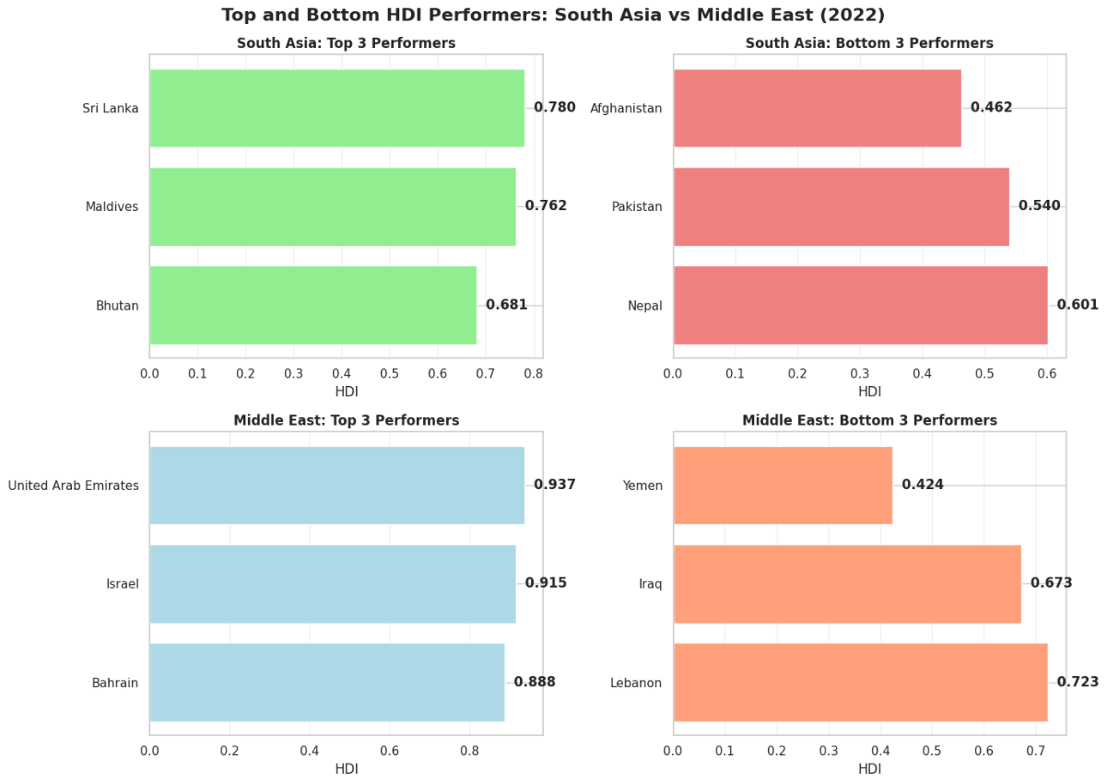
Figure 20- Comparing top and bottom performers

Interpretation and Discussion
Despite significant income advantages, the Middle East does not exhibit proportionally higher HDI gains compared to South Asia. This suggests that development efficiency and governance play a crucial role alongside economic resources.

Conclusion and Recommendations

Summary of Key Findings
This study analyzed Human Development Index (HDI) data from 1990–2022 to examine global and regional development patterns. The results show steady long-term global improvement in human development, with most countries now classified as High or Very High HDI. However, significant inequalities persist across and within regions. The COVID-19 period (2020–2022) caused temporary setbacks in HDI, particularly affecting health and income dimensions, though most countries demonstrated gradual recovery by 2022. The South Asia analysis highlighted wide internal disparities, while comparative analysis showed the Middle East outperforming South Asia in income but not proportionally in overall human development outcomes(UNDP, 2023),
(Yukiolmafuko, 2024).

Policy Implications
The findings suggest that economic growth alone is insufficient to achieve high human development. Policymakers should prioritize investments in healthcare, education, and gender equality to ensure balanced development. Countries that perform well despite limited income levels demonstrate the importance of efficient social policies. For conflict-affected nations, restoring political stability and basic services is essential before sustainable development gains can occur.

Limitations of the Study
This analysis is subject to several limitations. First, missing or incomplete data for certain countries, particularly those affected by conflict, may reduce accuracy. Second, the use of country-level averages masks sub-national inequalities. Third, the Composite Score used in South Asia focuses only on health and income, excluding education, which may oversimplify development measurement.

Future Research Directions
Future studies could extend this work by analysing longer-term HDI trends, incorporating sub-national or inequality-adjusted HDI measures, and applying machine learning techniques to predict development trajectories. Including environmental sustainability indicators would also provide a more holistic view of human development in the context of global challenges such as climate change.

References
UNDP, U. N. D. P., 2023. Human Development Report 2023/2024, s.l.: s.n.
Yukiolmafuko, L., 2024. Human_Development_Index_Dataset.csv [Modified dataset for academic use].

Appendix

Appendix A: Complete Code Availability
The complete Jupyter notebook with all analysis code is available at:
https://github.com/AditriPrajapati1/AI_Assignment-I

Appendix B: Generated Datasets
The following datasets were generated during the analysis and are included in the submission folder and GitHub repository:
1.HDI category added.csv
2.HDI problem1B.csv
3.HDI SouthAsia.csv
4.HDI SouthAsia 2020 2022.csv
5.HDI MiddleEast 2020 2022.csv

Appendix C: Plagiarism Report
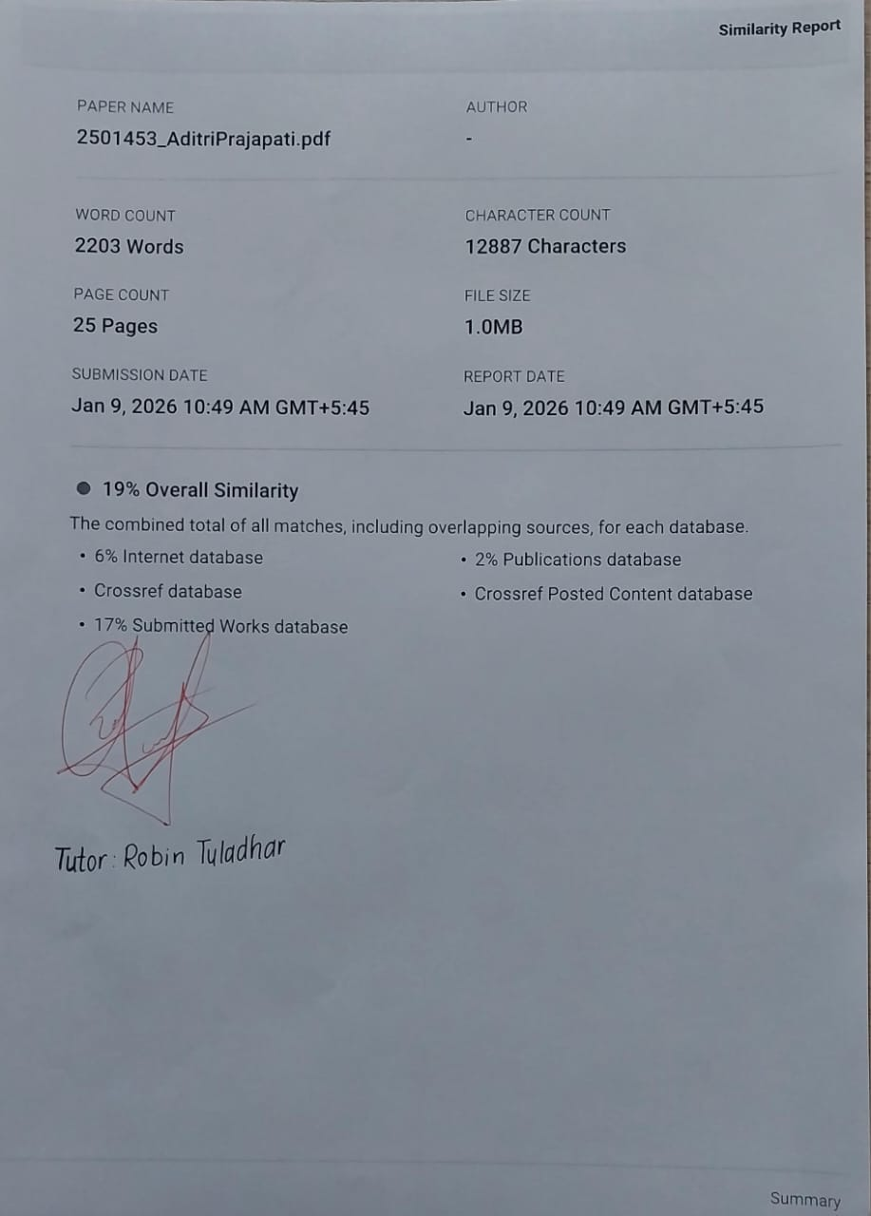
The similarity report was generated using Canvas plagiarism detection. The overall similarity index is within the acceptable academic threshold.

