Workshop -7
Student Grade Portal with Authentication and State Management

1.DataBase Design (herald_db)
- Queries.sql
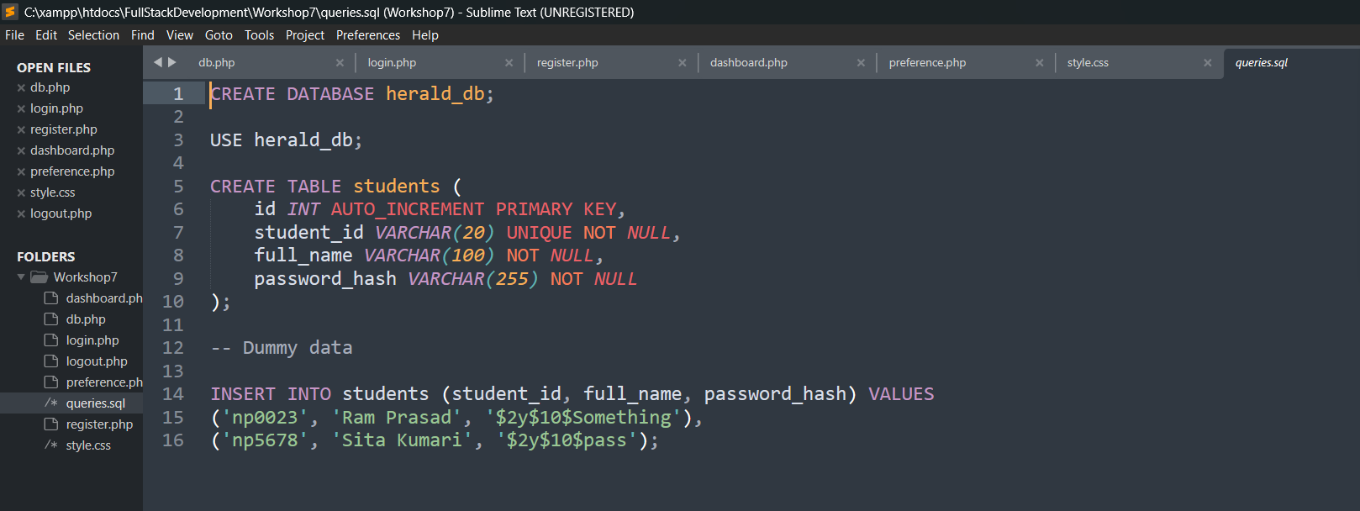
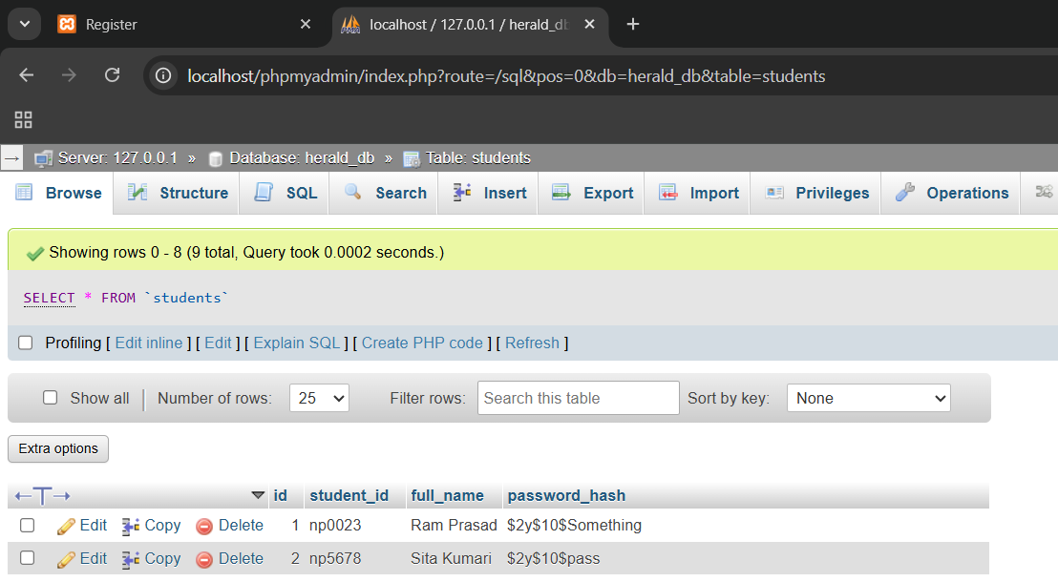

2. Home Page(register.php)
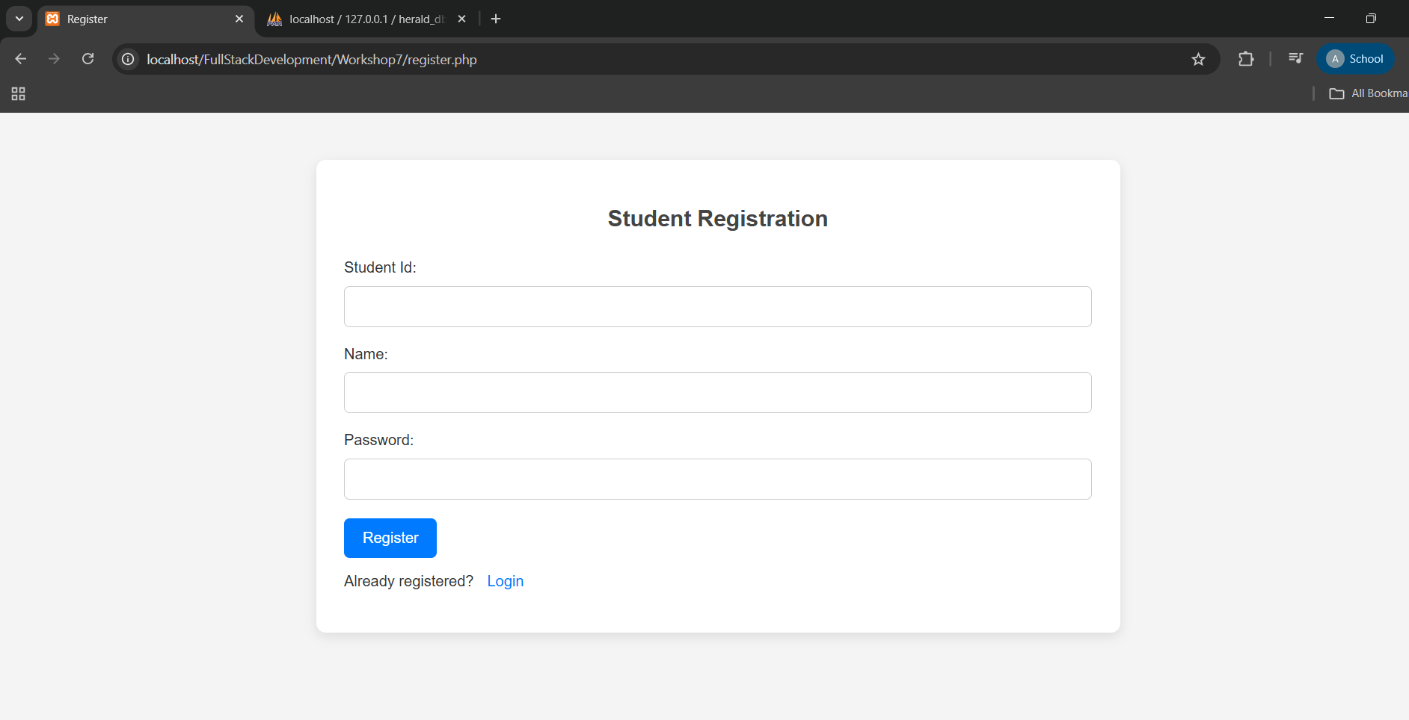
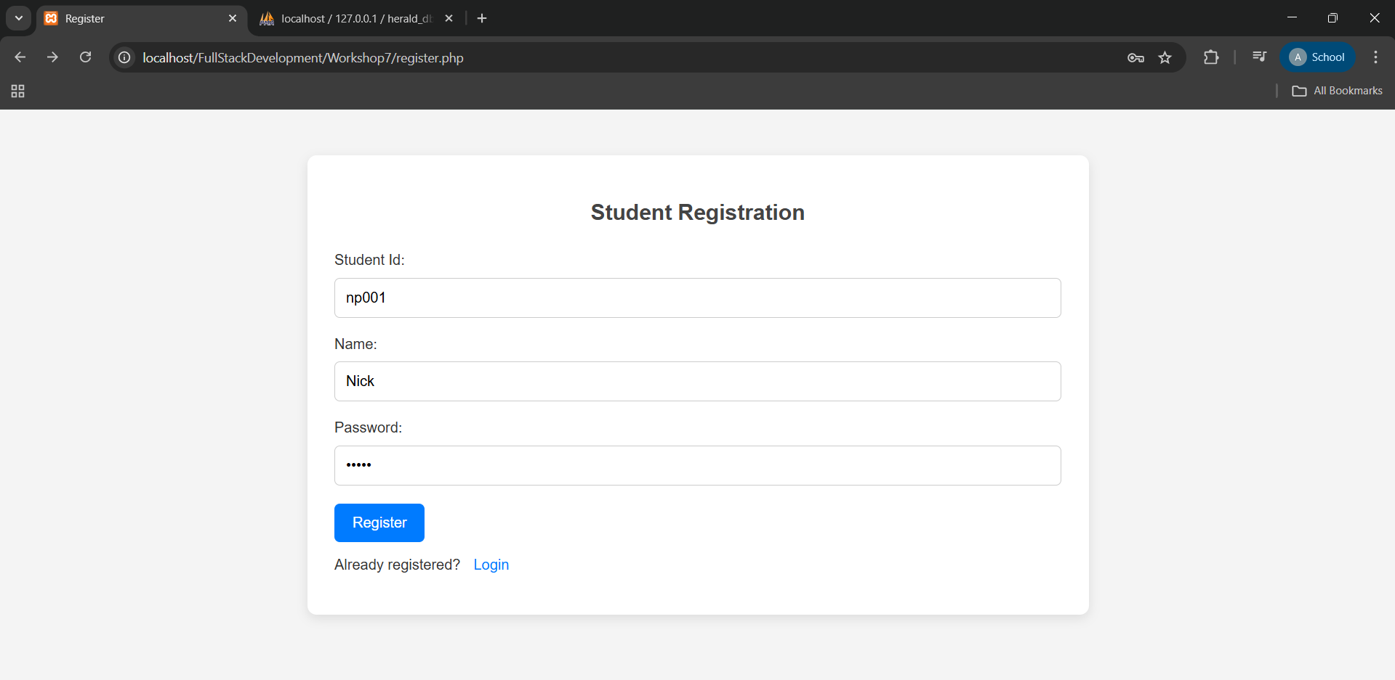
3. Successful Registration(login.php)
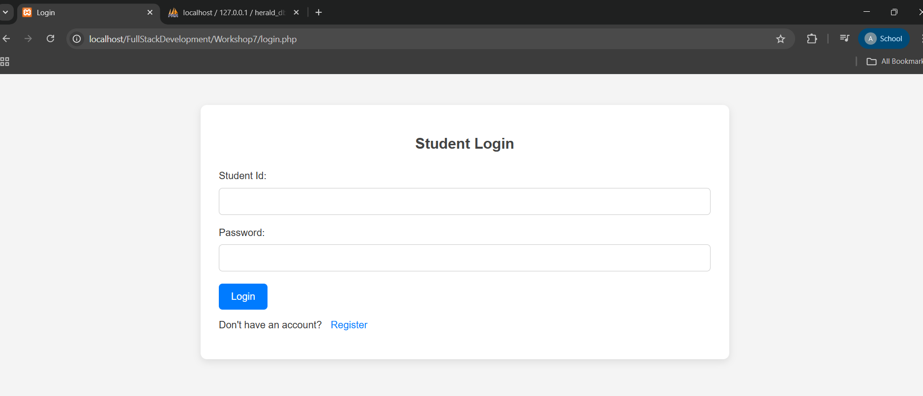
4. Testing Login Logic (login.php)
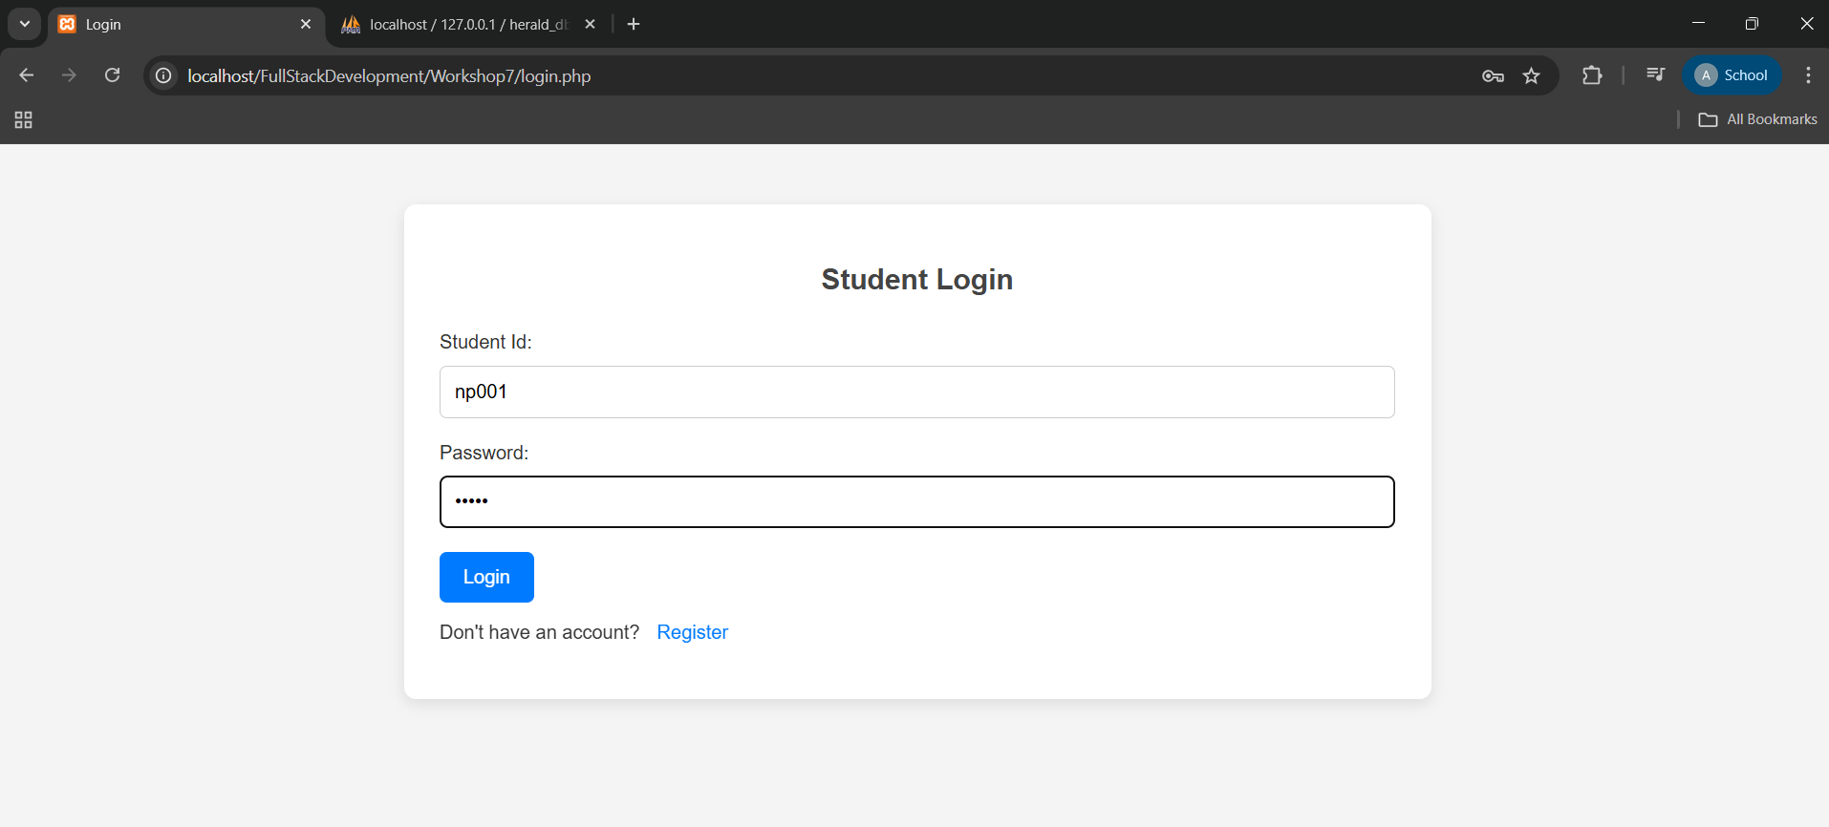

5. Successful Login(dashboard.php)
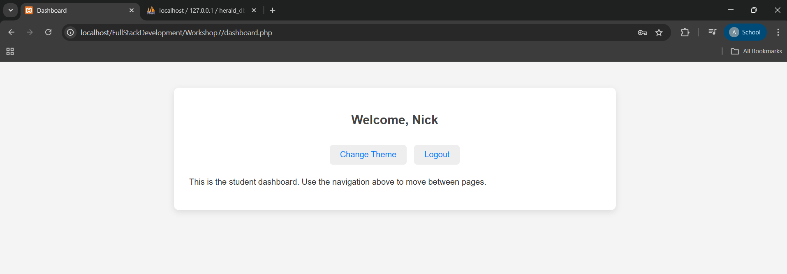
6. Changing Preference(dashboard.php)
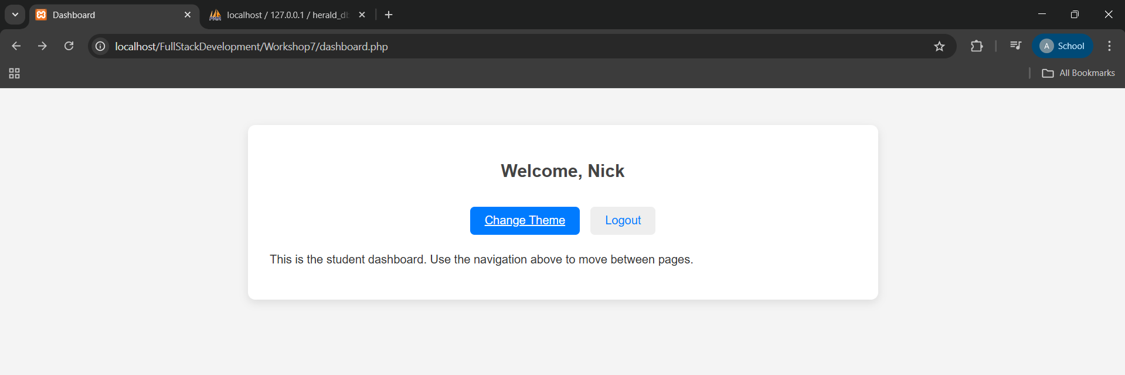
7. Selecting Theme(preference.php)
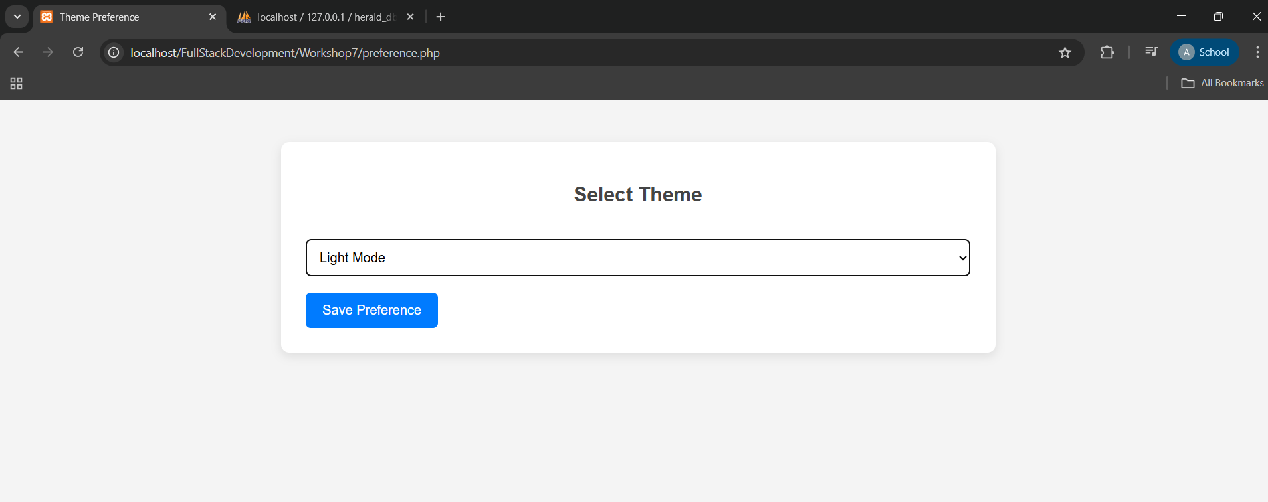
8. Successful Changing Preference(dashboard.php)
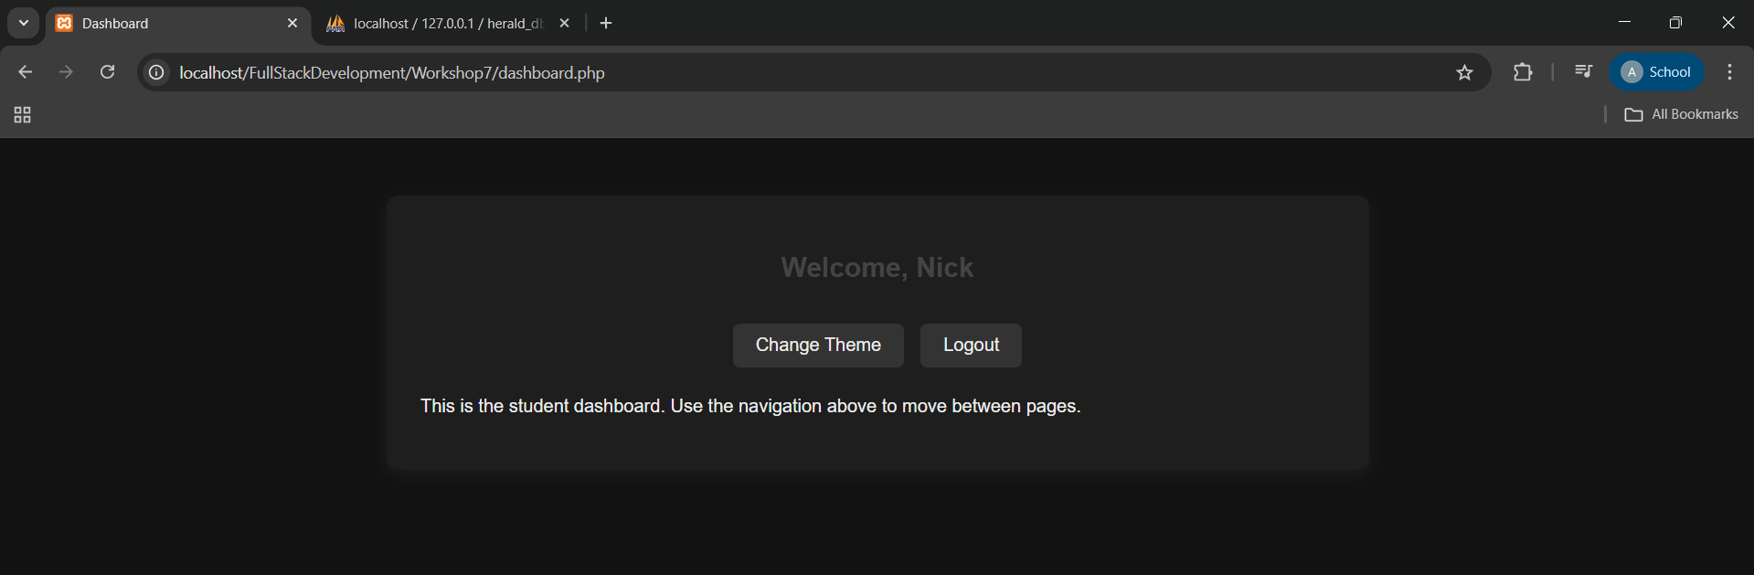
9.Logging Out(dashboard.php)
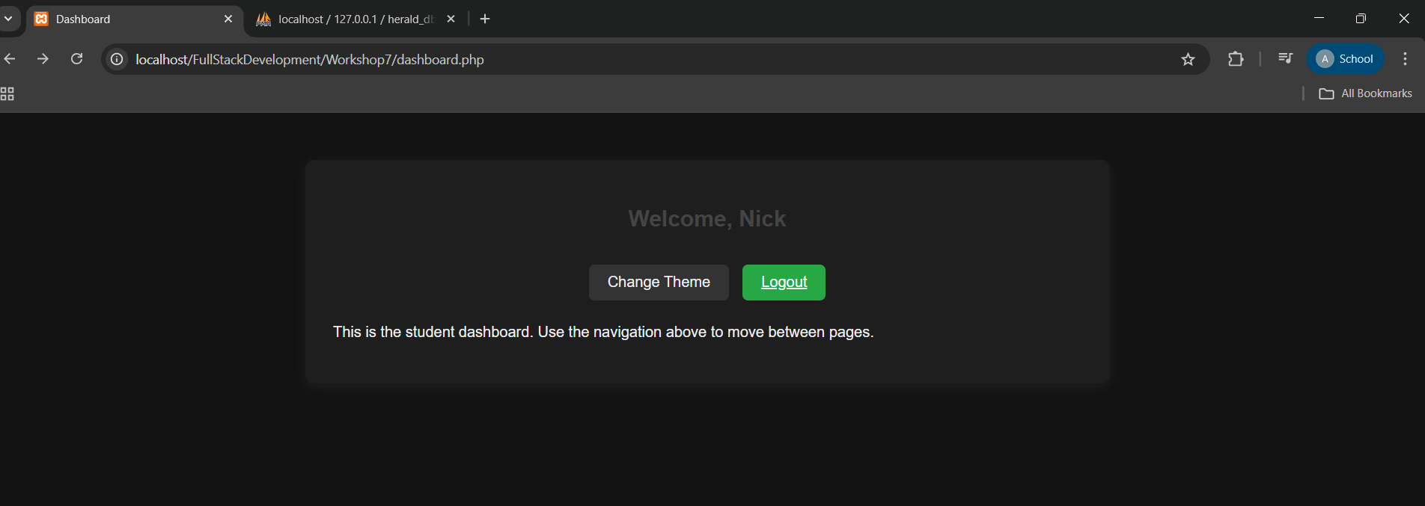
10. Successful Logout(login.php)
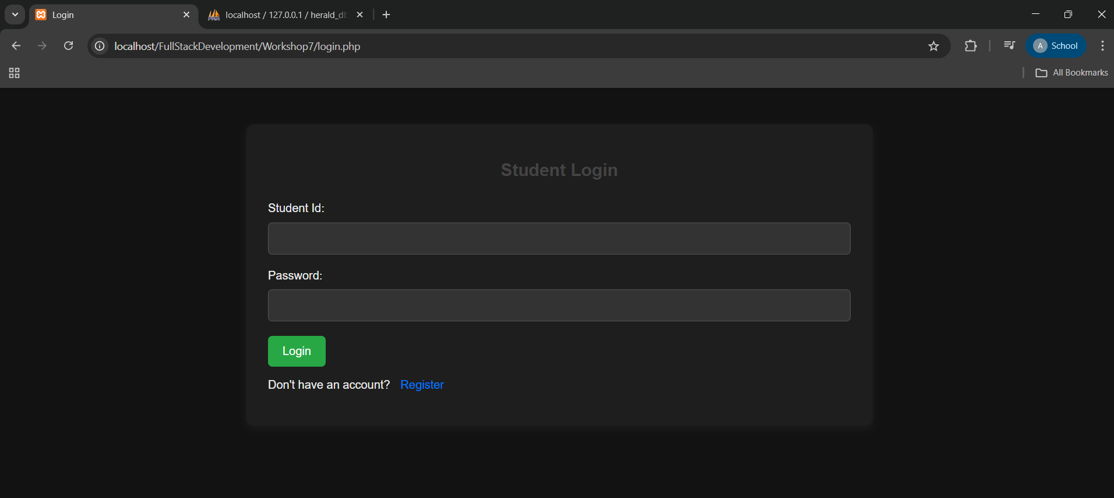
11. For Invalid StudentId(login.php)
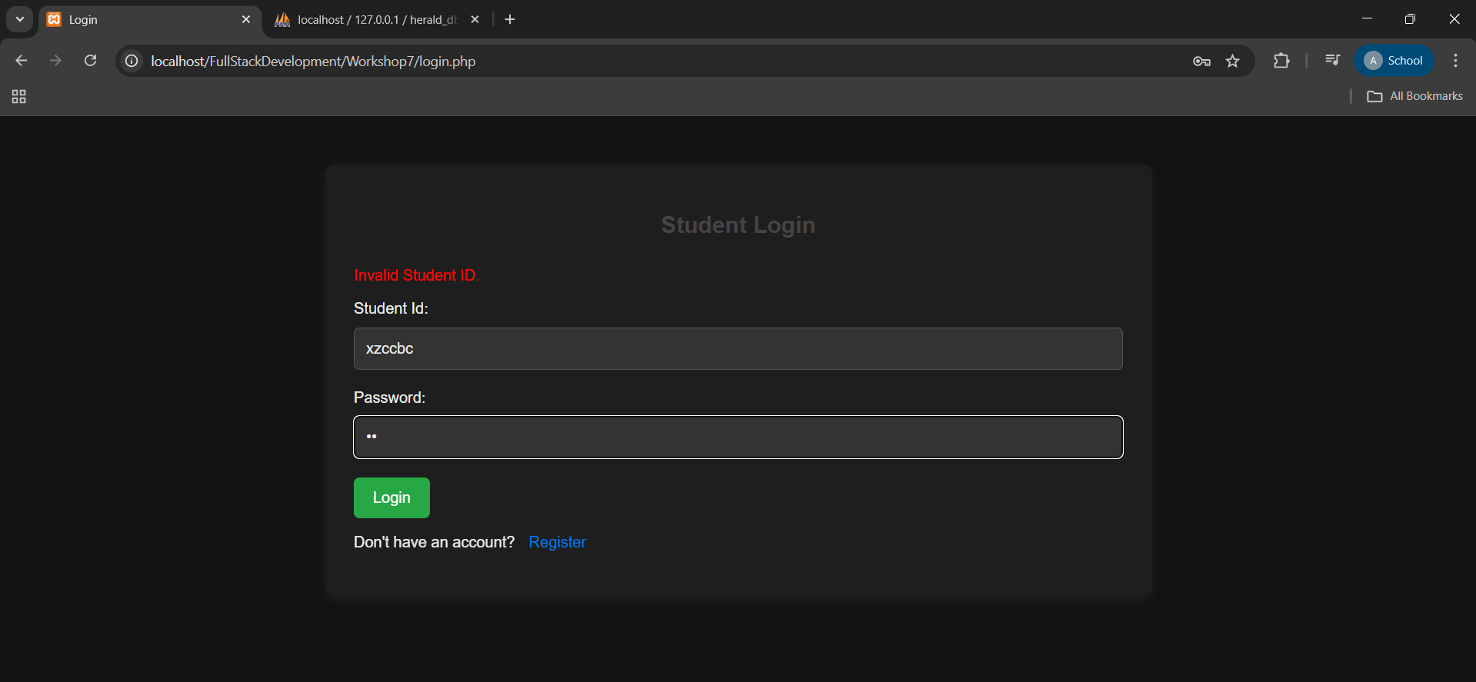

12. For Invalid Password(login.php)
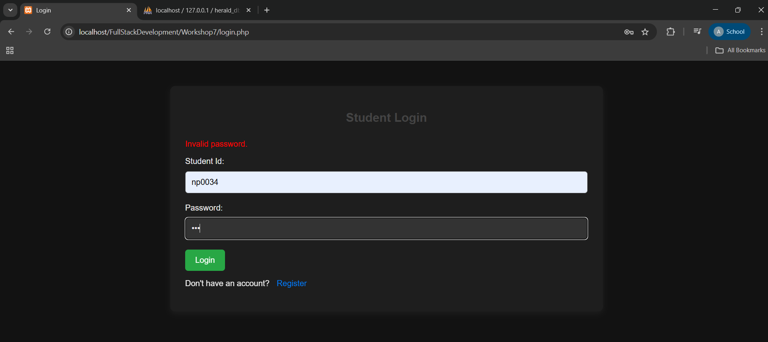
13. For Unregistered Account(login.php through Register Button)
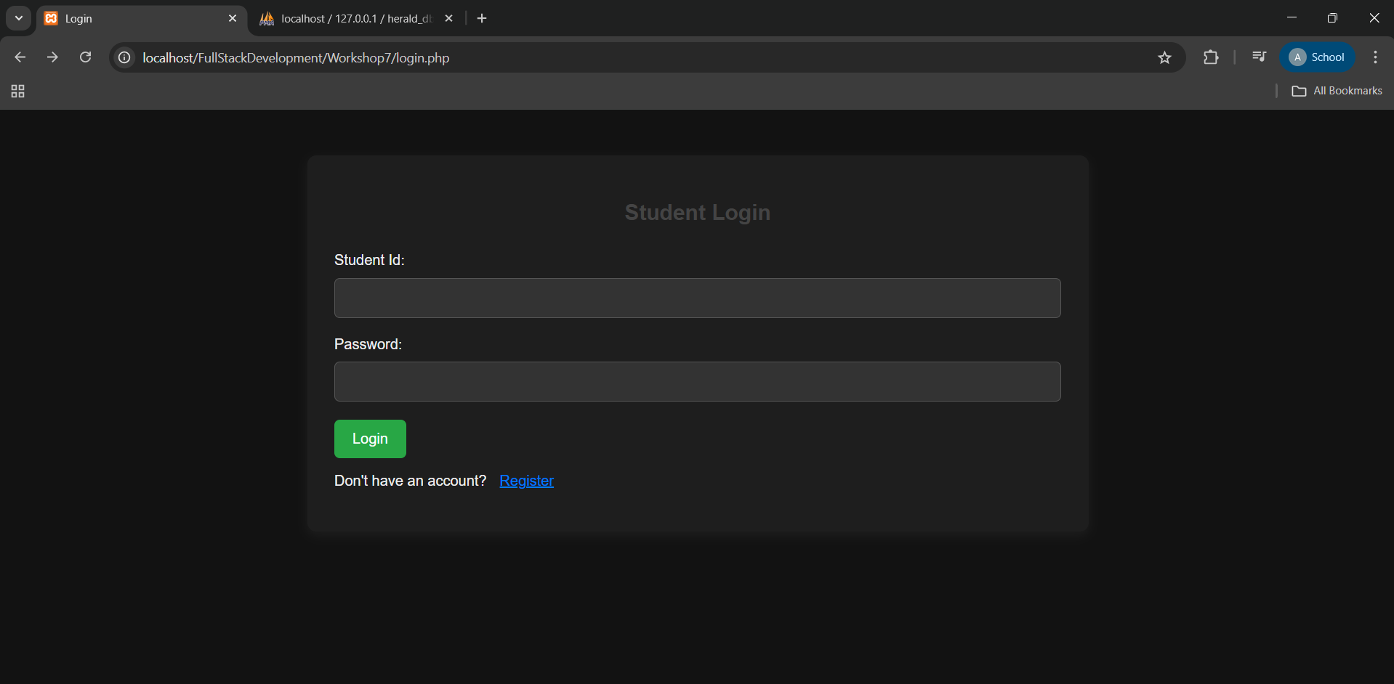

14. Redirect to Register Page(register.php)
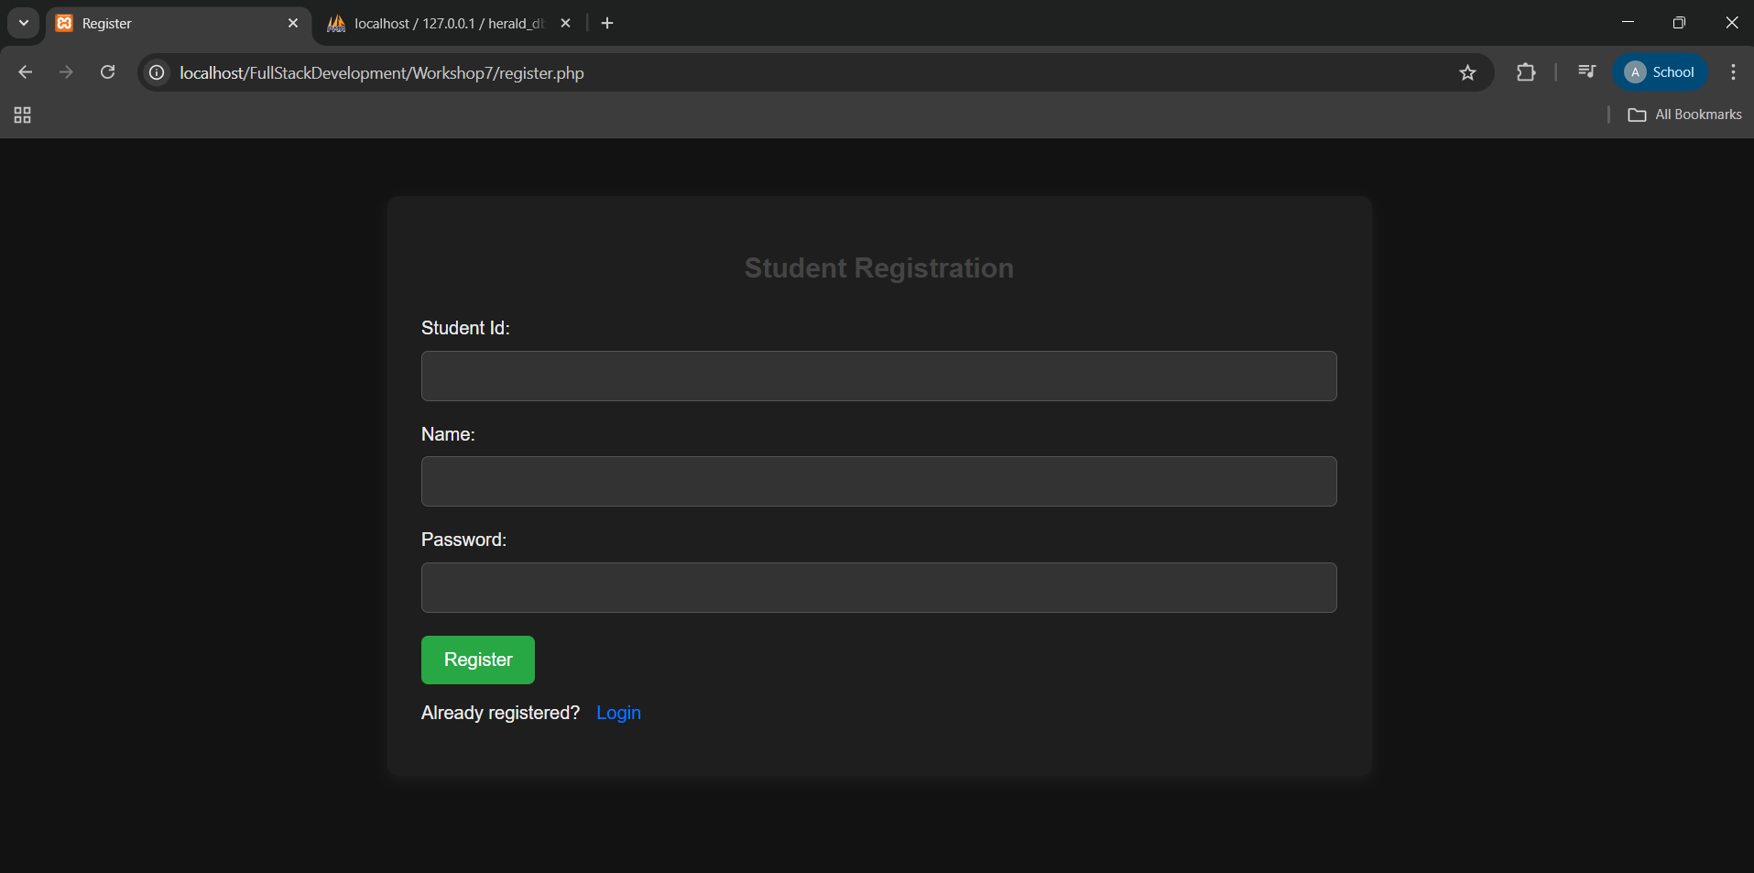

15. For Logging Into An Registered Account(register.php through Login Button)
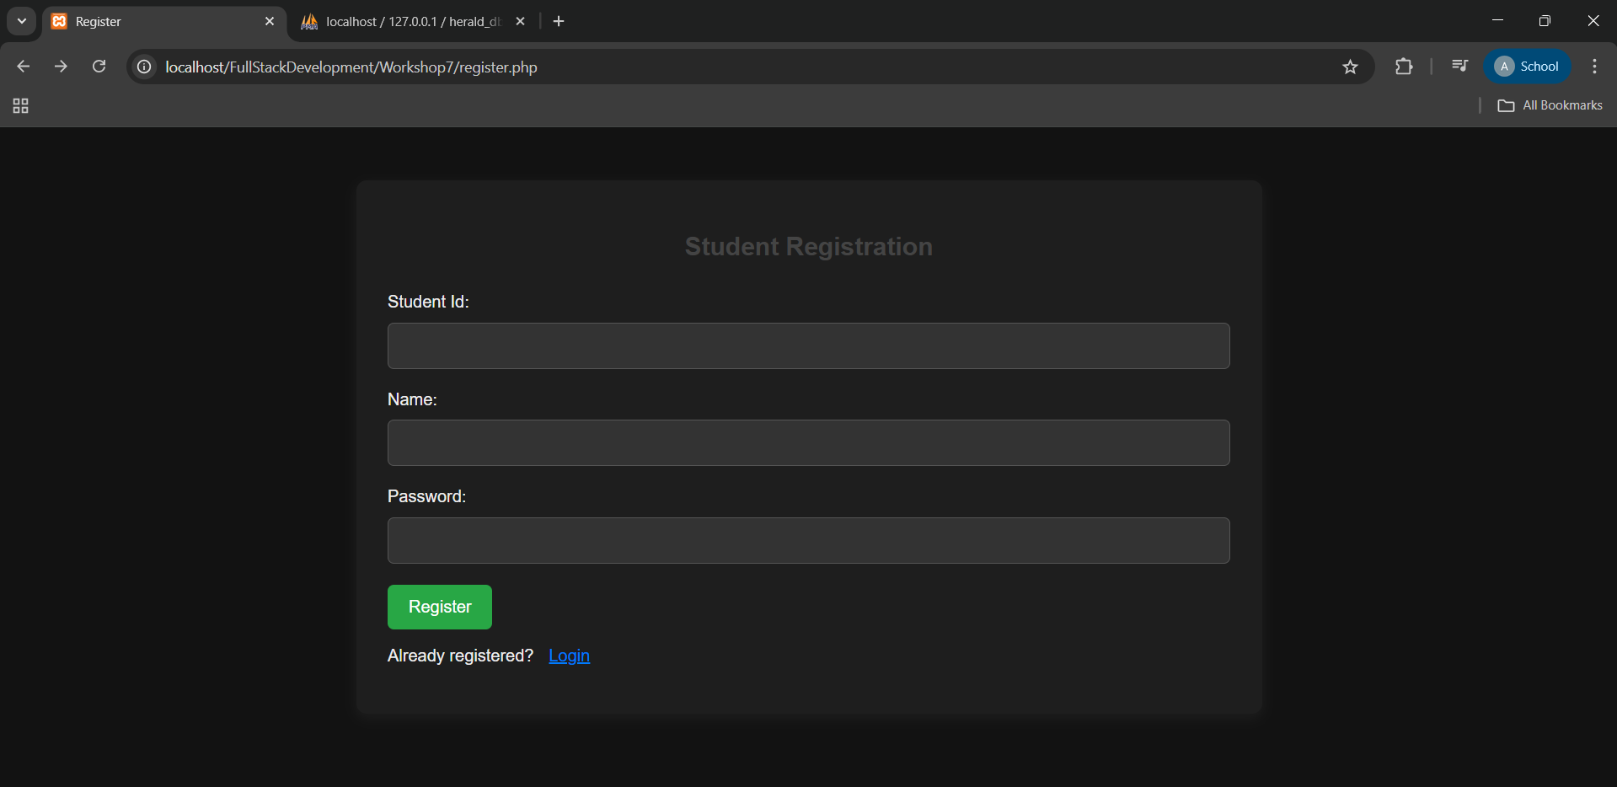
16. Redirecting to Login Page(login.php)
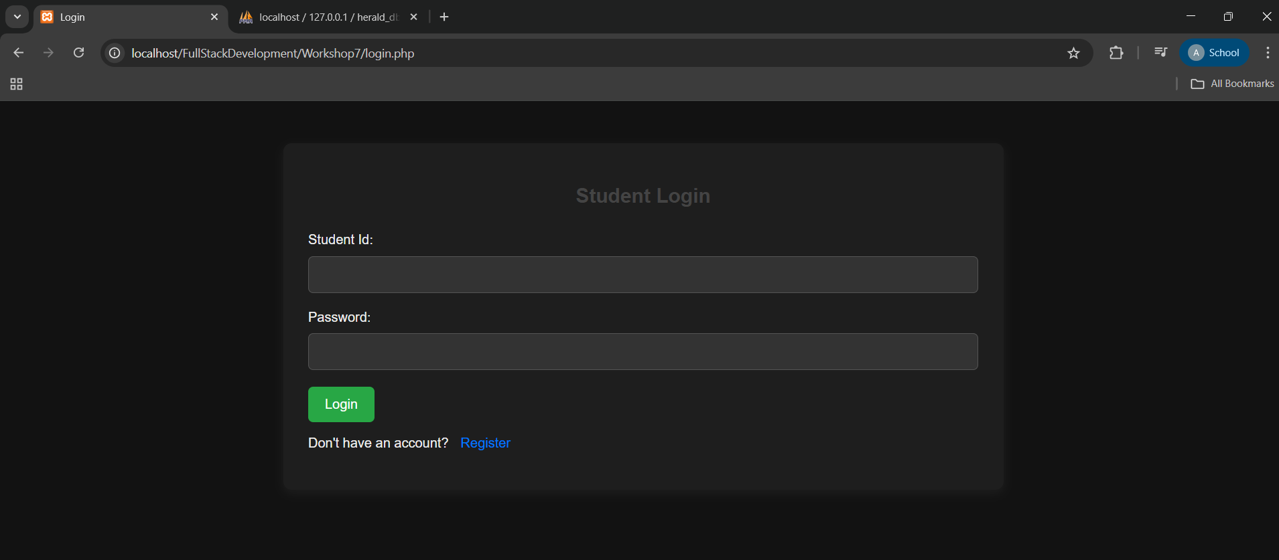
17. Database(herald_db)
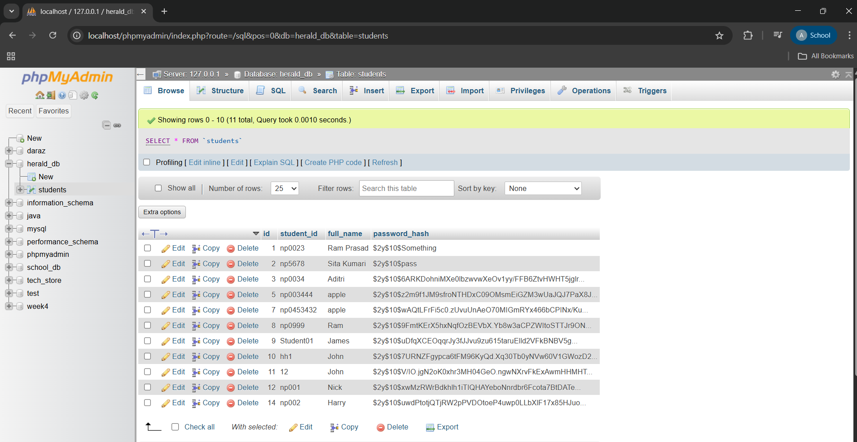
Github Repository Link:

