CSE370 : Database Systems
Assignment 01 | Spring 2026
ID : 24101404| Name : Adittya Dey

No 1 Query  (as Plain Text) | CREATE TABLE runners (  -> student_id INT PRIMARY KEY,  -> student_name VARCHAR(100),  -> email VARCHAR(100),  -> distance_covered INT,  -> time_taken_mins INT  -> );
No 1 SS  (of Query & Output  in Shell) | 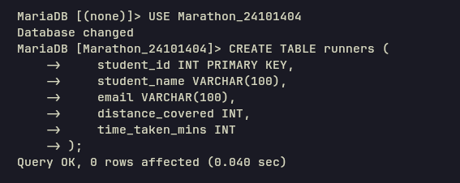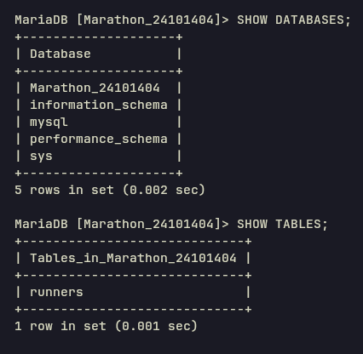
No 2 Query  (as Plain Text) | INSERT INTO runners (student_id, student_name, email, distance_covered, time_taken_mins) VALUES  -> (101, 'Mikasa Ackerman', 'mikasa.a@g.bracu.ac.bd', 5, 35),  -> (102, 'Edward Elric', 'e.elric@iub.ac.bd', 10, 59),  -> (103, 'Riza Hawkeye', 'riza.h@ewu.ac.bd', 5, 38),  -> (104, 'Bruce Wayne', 'b.wayne@g.bracu.ac.bd', 10, 63),  -> (105, 'Peter Parker', 'p.parker@iub.ac.bd', 5, 33),  -> (106, 'Alphonse Elric', 'a.elric@iub.ac.bd', 10, 55),  -> (107, 'Son Goku', 'son.goku@g.bracu.ac.bd', 5, 46),  -> (108, 'Gon Freecss', 'gon.f@g.bracu.ac.bd', 10, 68),  -> (109, 'Tanjiro Kamado', 'tanjiro.k@g.bracu.ac.bd', 5, 29),  -> (110, 'Roy Mustang', 'roy.m@ewu.ac.bd', 10, 83);
No 2 SS  (of Query & Output  in Shell) | 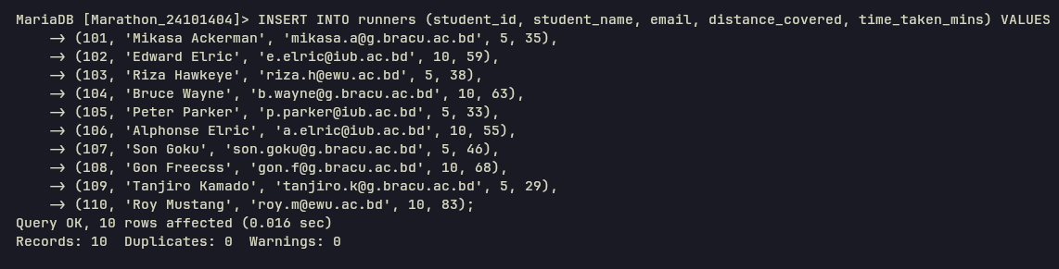
No 3 Query  (as Plain Text) | SELECT * FROM runners WHERE distance_covered > 6;
No 3 SS  (of Query & Output  in Shell) | 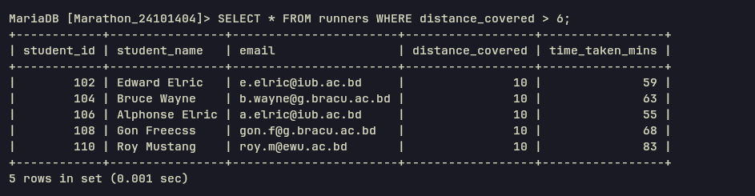
No 4 Query  (as Plain Text) | SELECT UPPER(student_name) FROM runners ORDER BY time_taken_mins DESC;
No 4 SS  (of Query & Output  in Shell) | 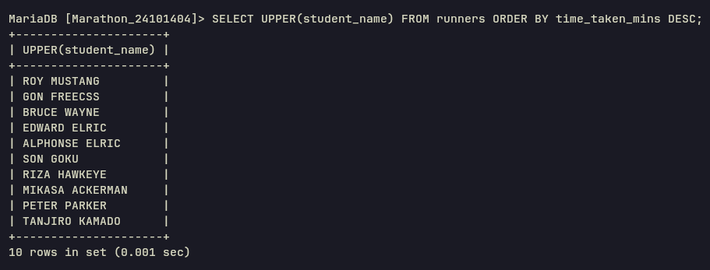
No 5 Query  (as Plain Text) | ALTER TABLE runners CHANGE distance_covered total_distance DECIMAL(3,1);
No 5 SS
(of Query & Output
in Shell)
No 6 Query  (as Plain Text) | ALTER TABLE runners ADD kmh DECIMAL(3,1);
No 6 SS  (of Query & Output  in Shell) | 
No 7 Query  (as Plain Text) | UPDATE runners SET kmh = (total_distance * 60) / time_taken_mins;
No 7 SS  (of Query & Output  in Shell) | 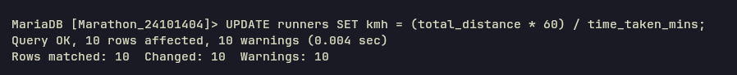
No 8 Query  (as Plain Text) | SELECT student_id, student_name, kmh, (total_distance / 10) * (time_taken_mins / 60) * 100 AS points FROM runners;
No 8 SS  (of Query & Output  in Shell) | 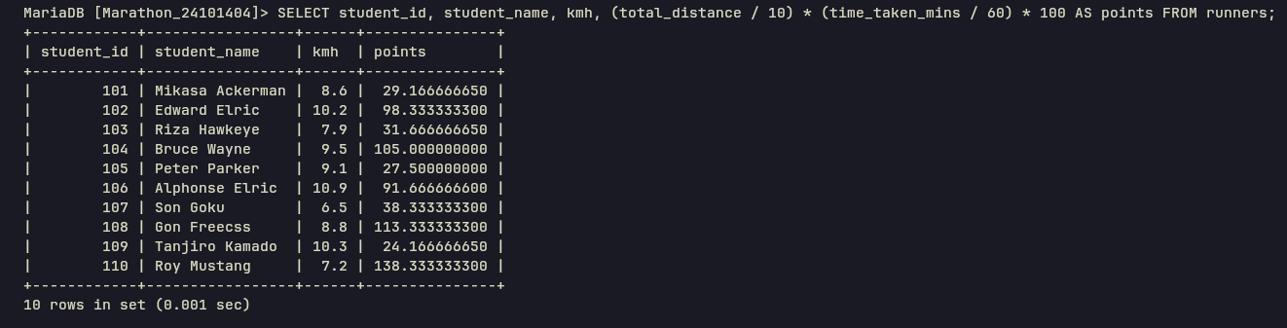
No 9 Query  (as Plain Text) | SELECT student_name FROM runners WHERE total_distance = 10 AND time_taken_mins BETWEEN 40 AND 60;
No 9 SS  (of Query & Output  in Shell) | 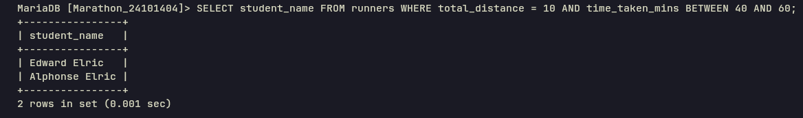
No 10 Query  (as Plain Text) | SELECT student_name FROM runners WHERE email LIKE '%@g.bracu.ac.bd';
No 10 SS  (of Query & Output  in Shell) | 