CSE370 : Database Systems
Assignment 03| Summar26
ID : 24101404 | Name : Adittya Dey

No 1 Query  (as Plain Text) | select c.customer_name , l.loan_number from customer c join borrower b on c.customer_id = b.customer_id join loan l on  -> b.loan_number = l.loan_number where l.branch_name = 'Downtown';
No 1 SS  (of Query & Output  in Shell) | 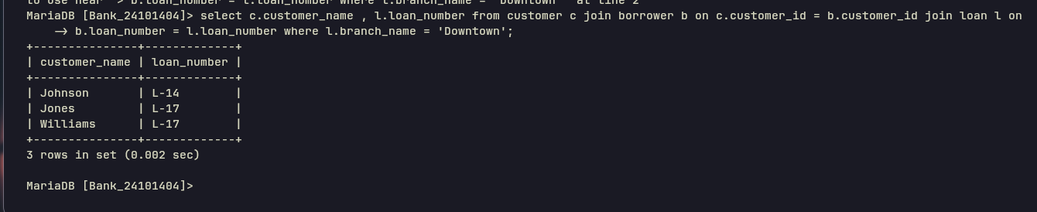
No 2 Query  (as Plain Text) | select distinct c.customer_name from customer c join borrower b on c.customer_id = b.customer_id ;
No 2 SS  (of Query & Output  in Shell) | 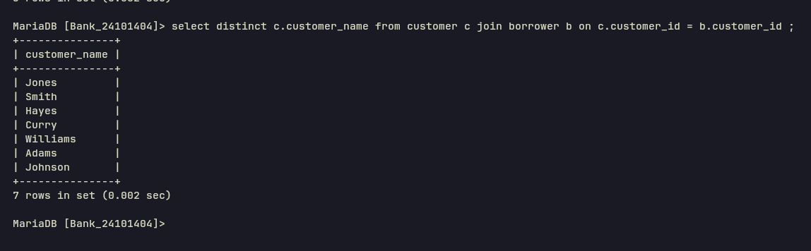
No 3 Query  (as Plain Text) | select c.customer_name from customer c left join borrower b on c.customer_id = b.customer_id where b.loan_number is null ;
No 3 SS  (of Query & Output  in Shell) | 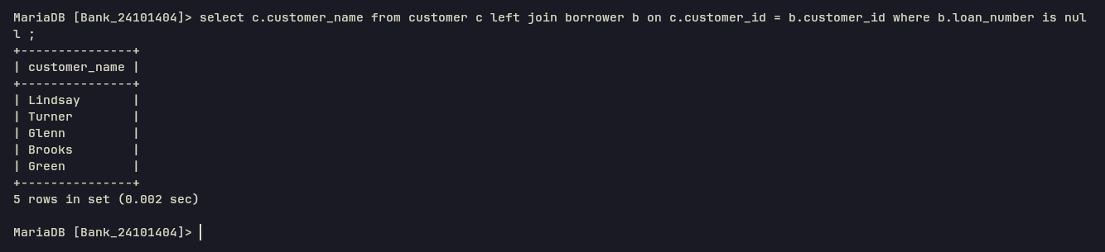
No 4 Query  (as Plain Text) | select  -> c1.customer_name as customer1,  -> c2.customer_name as customer2,  -> c1.customer_city as city  -> from customer c1  -> join customer c2  -> on c1.customer_city = c2.customer_city  -> and c1.customer_id < c2.customer_id;
No 4 SS  (of Query & Output  in Shell) | 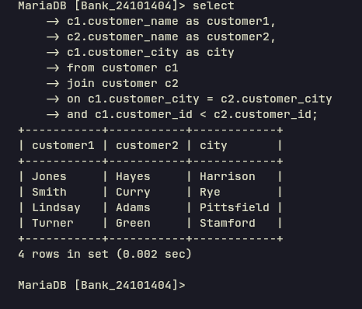
No 5 Query  (as Plain Text) | select a.branch_name, round(sum(a.balance*0.04),2) as total_interest from account a group by a.branch_name;
No 5 SS  (of Query & Output  in Shell) | 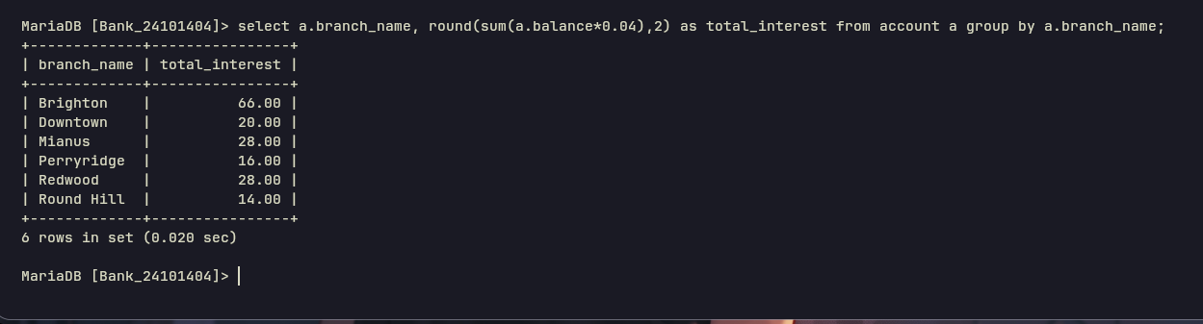
No 6 Query  (as Plain Text) | select a.account_number, c.customer_city, a.balance  -> from customer c, depositor d, account a  -> where c.customer_id = d.customer_id  -> and d.account_number = a.account_number  -> and a.balance = (  -> select max(a2.balance)  -> from customer c2, depositor d2, account a2  -> where c2.customer_id = d2.customer_id  -> and d2.account_number = a2.account_number  -> and c2.customer_city = c.customer_city  -> );
No 6 SS  (of Query & Output  in Shell) | 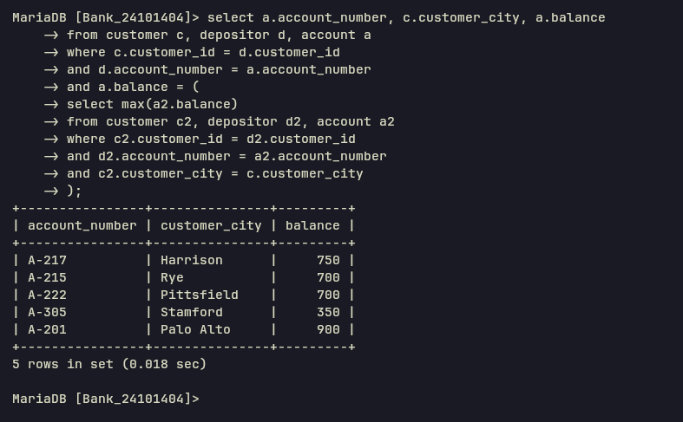
No 7 Query  (as Plain Text) | select *  -> from (  -> select l.loan_number, l.amount, c.customer_name  -> from loan l  -> join borrower b on l.loan_number = b.loan_number  -> join customer c on b.customer_id = c.customer_id  -> order by l.amount desc, l.loan_number desc  -> limit 5  -> ) as toploans  -> order by amount asc, loan_number desc;
No 7 SS  (of Query & Output  in Shell) | 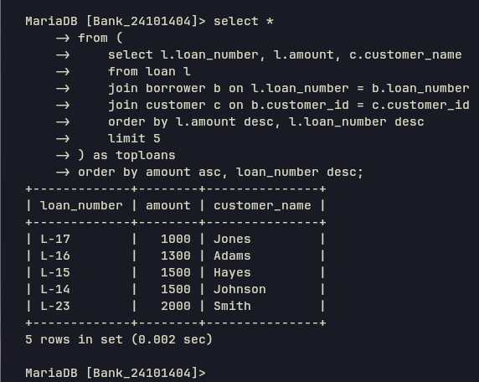
No 8 Query  (as Plain Text) | select distinct c.customer_name  -> from customer c  -> join depositor d on c.customer_id = d.customer_id  -> join account a on d.account_number = a.account_number  -> join borrower b on c.customer_id = b.customer_id  -> join loan l on b.loan_number = l.loan_number  -> where a.branch_name = 'Perryridge'  -> and l.branch_name = 'Perryridge';
No 8 SS  (of Query & Output  in Shell) | 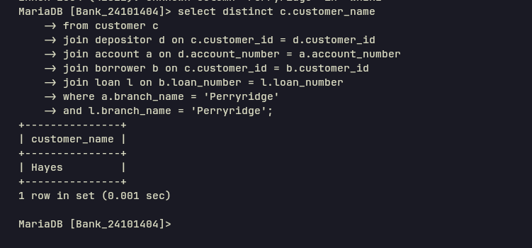
No 9 Query  (as Plain Text) | select c.customer_name, sum(l.amount) as total_loan  -> from customer c  -> join borrower b ON c.customer_id = b.customer_id  -> join loan l on b.loan_number = l.loan_number  -> group by c.customer_id, c.customer_name  -> having count(l.loan_number) >= 2;
No 9 SS  (of Query & Output  in Shell) | 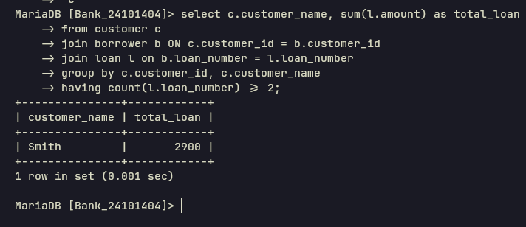
No 10 Query  (as Plain Text) | select d.customer_id, sum(a.balance) as total_balance  from depositor d  join account a on d.account_number = a.account_number  group by d.customer_id  having count(d.account_number) > 1;
No 10 SS  (of Query & Output  in Shell) | 