CSE370 : Database Systems
Assignment 02 | Spring26
ID : 24101404| Name : Adittya Dey

No 1 Query  (as Plain Text) | CREATE TABLE employees (  -> e_id CHAR(4),  -> first_name VARCHAR(20),  -> last_name VARCHAR(20),  -> hire_date DATE,  -> job_id CHAR(10),  -> salary INT,  -> commission_pct DECIMAL(5,3),  -> manager_id CHAR(4),  -> department_id CHAR(3)  -> );
No 1 SS  (of Query & Output  in Shell) | 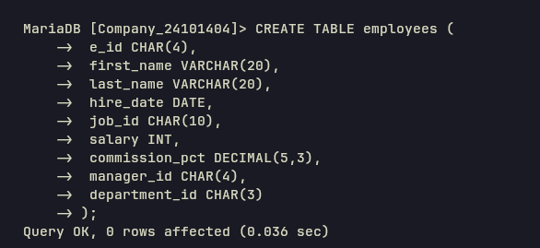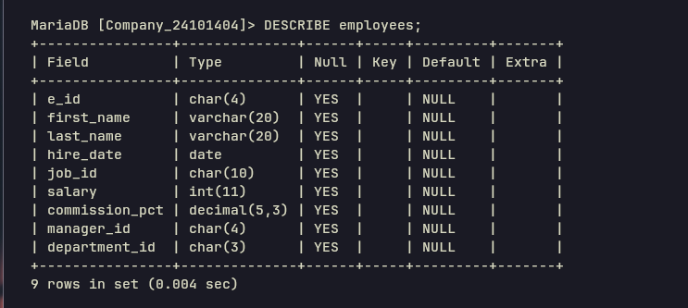
No 2 Query  (as Plain Text) | INSERT INTO employees VALUES  -> ('E001','John','Doe','2020-01-15','IT_PROG',65000,NULL,'E010','D01'),  -> ('E002','Jane','Smith','2019-03-22','SA_REP',55000,0.150,'E011','D02'),  -> ('E003','Michael','Johnson','2021-06-10','IT_PROG',62000,NULL,'E010','D01'),  -> ('E004','Emily','Davis','2018-11-05','SA_REP',58000,0.200,'E011','D02'),  -> ('E005','David','Wilson','2022-02-14','IT_PROG',60000,NULL,'E010','D01'),  -> ('E006','Sarah','Brown','2020-07-30','HR_REP',50000,0.150,'E012','D03'),  -> ('E007','James','Taylor','2019-09-18','SA_REP',60000,0.180,'E011','D02'),  -> ('E008','Lisa','Anderson','2021-04-25','FI_ACC',52000,NULL,'E013','D04'),  -> ('E009','Robert','Martinez','2020-12-01','IT_PROG',67000,NULL,'E010','D01'),  -> ('E010','Patricia','Garcia','2017-05-10','IT_MAN',85000,NULL,NULL,'D01'),  -> ('E011','Thomas','Lee','2016-08-20','SA_MAN',80000,0.100,NULL,'D02'),  -> ('E012','Maria','White','2018-02-15','HR_MAN',75000,NULL,NULL,'D03'),  -> ('E013','Daniel','Harris','2019-10-30','FI_MAN',78000,NULL,NULL,'D04'),  -> ('E014','Jessica','Clark','2021-01-20','HR_REP',48000,0.100,'E012','D03'),  -> ('E015','Kevin','Lewis','2022-03-12','FI_ACC',51000,NULL,'E013','D04');
No 2 SS  (of Query & Output  in Shell) | 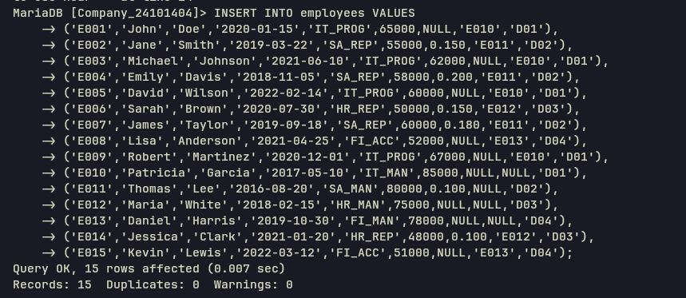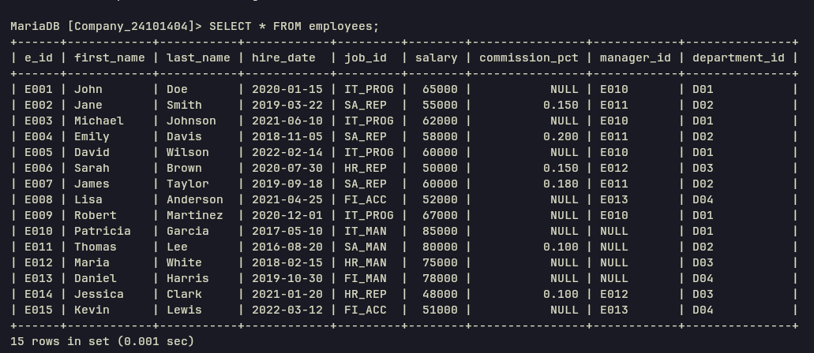
No 3 Query  (as Plain Text) | SELECT first_name, last_name, hire_date, department_id  -> FROM employees  -> WHERE hire_date = (SELECT MAX(hire_date) FROM employees);
No 3 SS  (of Query & Output  in Shell) | 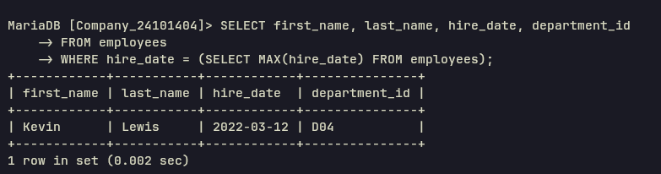
No 4 Query  (as Plain Text) | SELECT first_name, last_name, e_id, salary, department_id  -> FROM employees e1  -> WHERE salary = (  -> SELECT MAX(salary)  -> FROM employees e2  -> WHERE e2.department_id = e1.department_id  -> );
No 4 SS  (of Query & Output  in Shell) | 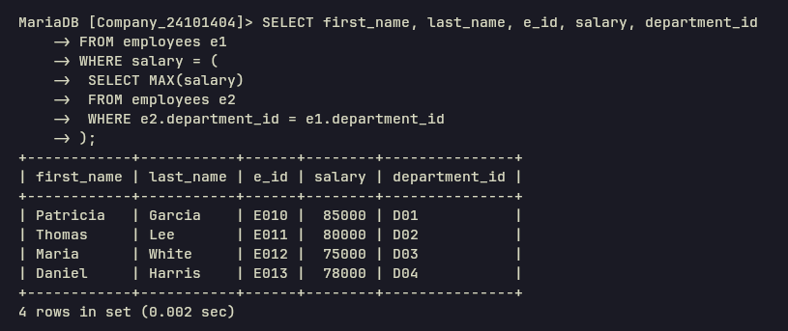
No 5 Query  (as Plain Text) | SELECT first_name, last_name, e_id, commission_pct, department_id  -> FROM employees  -> WHERE department_id = 'D02'  -> AND commission_pct > ALL (  -> SELECT commission_pct  -> FROM employees  -> WHERE department_id = 'D01'  -> );
No 5 SS  (of Query & Output  in Shell) | 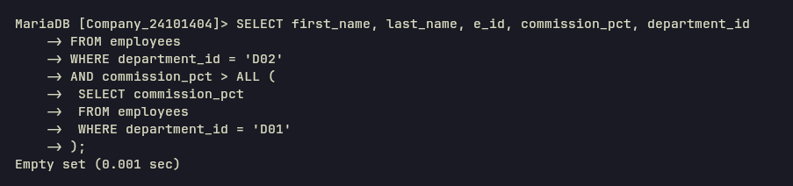
No 6 Query  (as Plain Text) | SELECT department_id, COUNT(*)  -> FROM employees  -> GROUP BY department_id  -> HAVING MAX(salary) <= 70000;
No 6 SS  (of Query & Output  in Shell) | 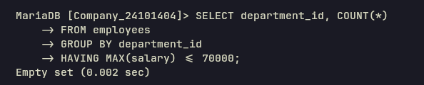
No 7 Query  (as Plain Text) | SELECT department_id, job_id, salary  -> FROM employees e1  -> WHERE salary < ANY (  -> SELECT salary  -> FROM employees e2  -> WHERE e2.department_id = e1.department_id  -> );
No 7 SS  (of Query & Output  in Shell) | 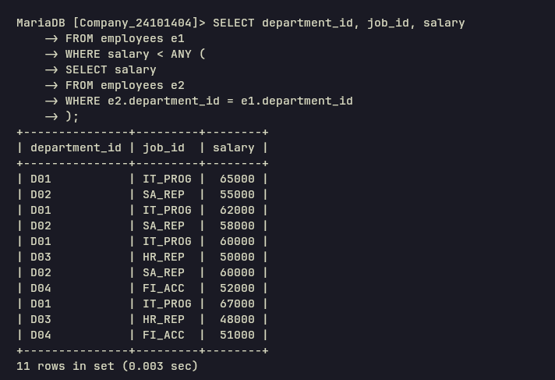
No 8 Query  (as Plain Text) | SELECT DISTINCT manager_id  -> FROM employees e1  -> WHERE manager_id IS NOT NULL  -> AND NOT EXISTS (  -> SELECT *  -> FROM employees e2  -> WHERE e2.manager_id = e1.manager_id  -> AND e2.salary < 55000  -> );
No 8 SS  (of Query & Output  in Shell) | 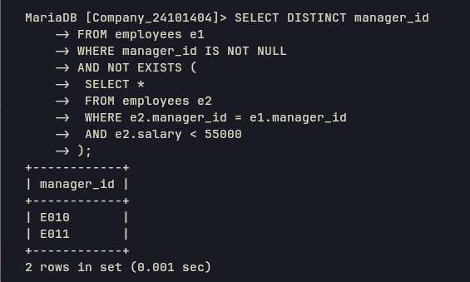
No 9 Query  (as Plain Text) | SELECT first_name, last_name, e_id, salary, department_id, commission_pct  -> FROM employees e1  -> WHERE commission_pct = (  -> SELECT MAX(commission_pct)  -> FROM employees e2  -> WHERE e2.manager_id = e1.manager_id  -> );
No 9 SS  (of Query & Output  in Shell) | 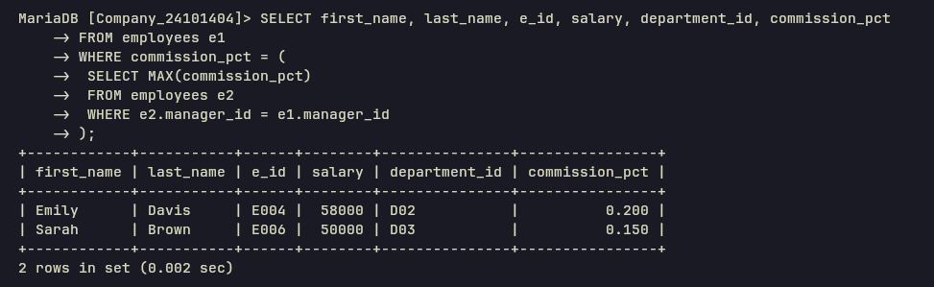
No 10 Query  (as Plain Text) | SELECT job_id, AVG(salary)  -> FROM employees  -> GROUP BY job_id  -> HAVING AVG(salary) < (SELECT AVG(salary) FROM employees);
No 10 SS  (of Query & Output  in Shell) | 