root

Database Assignment

1 Note : Use Emp, dept and salgrade table

1. To list all records with sal > 2000 and comm>200

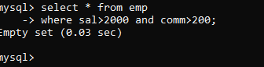

2. To list all record with job=’Clerk’ or sal>2000

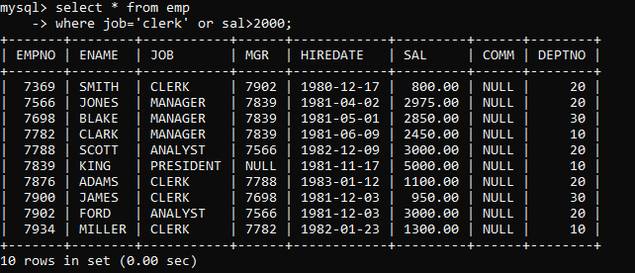

3. To list all the record with sal=1250 or 1100 or 2850

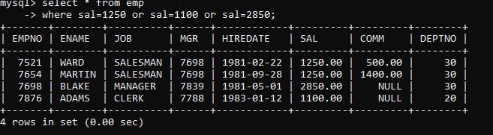

4. To list all employees with sal>1250 and <2850

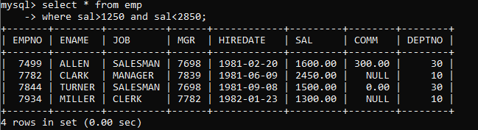

5. To list all employees with name ends with AS

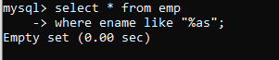

6. To list all employees with job starts with C and ends with K

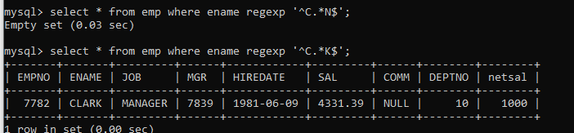

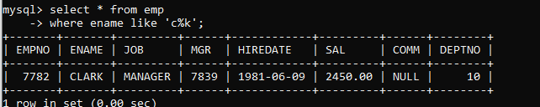



7. To list all employees with job contains L at third position and M at third last position

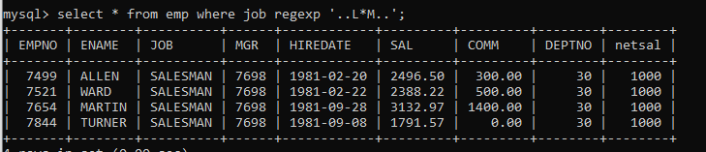



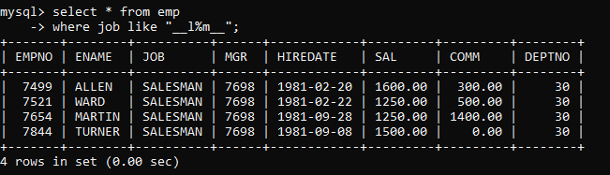



8. To list all the record with sal not equal to 1250 or 1100 or 2850

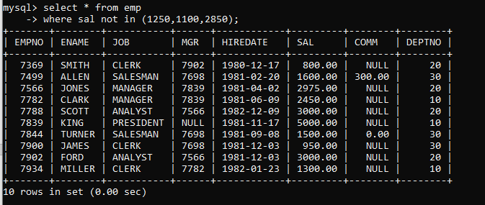



9.To list all employees with sal not >1250 and <2850

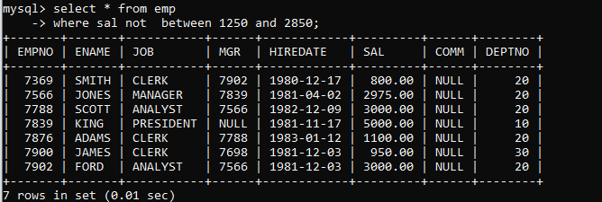

10. To list all employees with job starts with C , E at 3rd position and ends with K

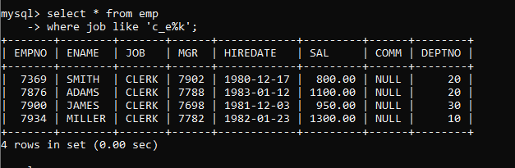



11. To list all rows with comm is null

aw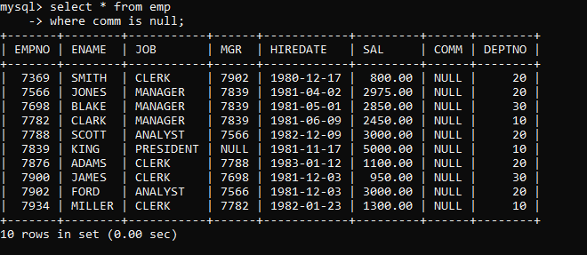



12. To list all employees with sal is null and name starts with ‘S’





13. To list all employees with job contains 5 characters

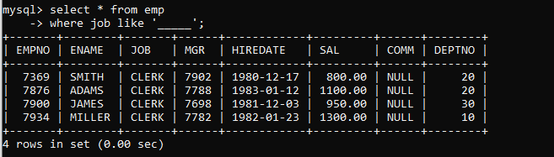

14. To list all employees with name contain ‘A’ at 1 position and job Contains 5 characters

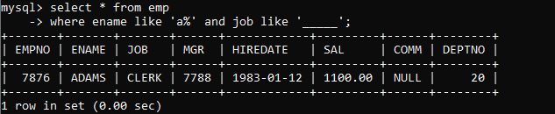

Q2. Solve the following 1. Retrieve the details (Name, Salary and dept no) of the emp who are working in department code 20, 30 and 40.

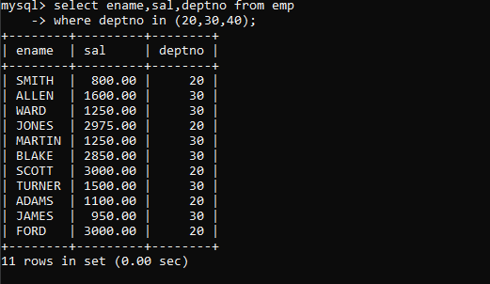

2. Display the total salary of all employees . Total salary will be calculated as sal+comm+sal*0.10

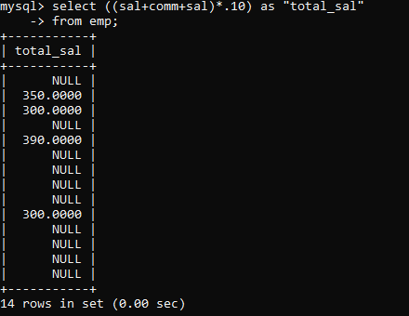

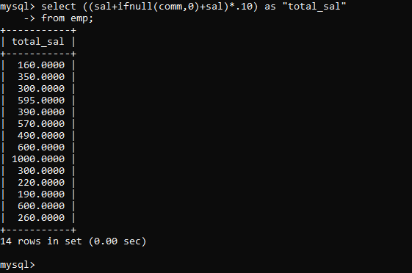



3. List the Name and job of the emp who have joined before 1 jan 1986 and whose salary range is between 1200and 2500. Display the columns with user defined Column headers.

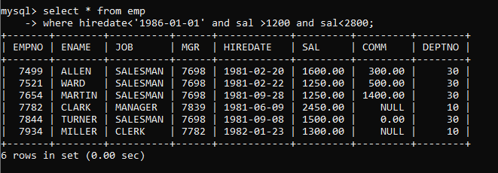



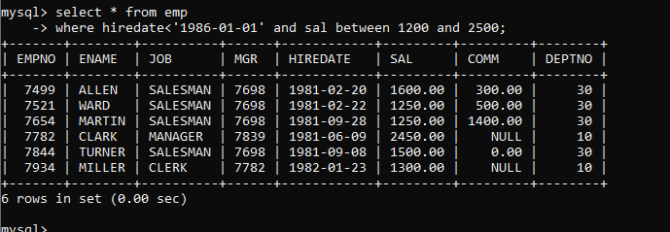

4. List the empno, name, and department number of the emp works under manager with id 7698

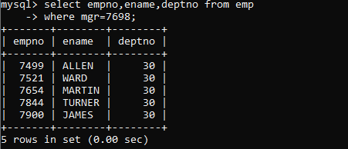



5. List the name, job, and salary of the emp who are working in departments 10 and 30.

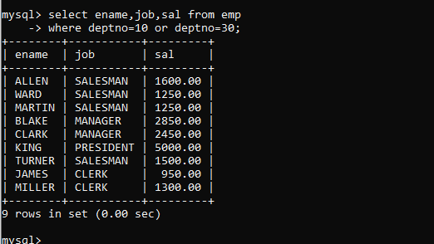



6. Display name concatenated with dept code separated by comma and space. Name the column as ‘Emp info’.

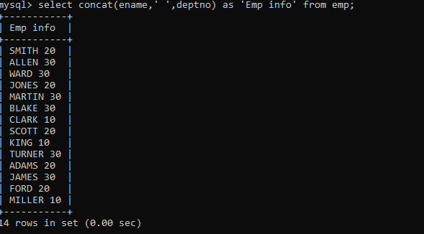



7. Display the emp details who do not have manager.

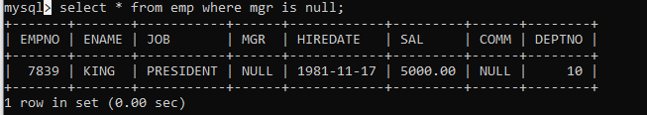



8. Write a query which will display name, department no and date of joining of all employee who were joined January 1, 1981 and March 31, 1983. Sort it based on date of joining (ascending).

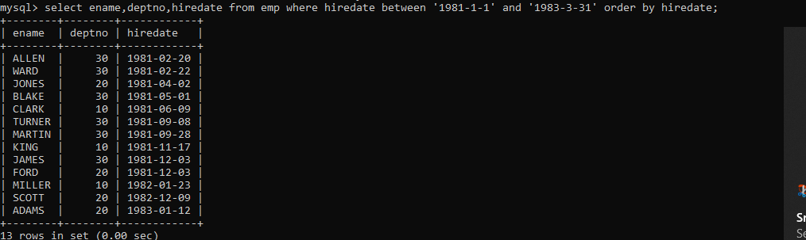



9. Display the employee details where the job contains word ‘AGE’ anywhere in the Job

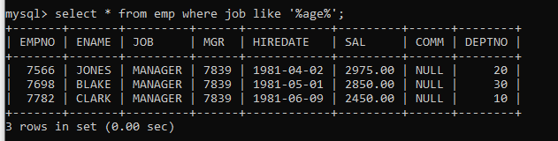



11. List the details of the employee , whose names start with ‘A’ and end with ‘S’ or whose names contains N as the second or third character, and ending with either ‘N’ or ‘S’

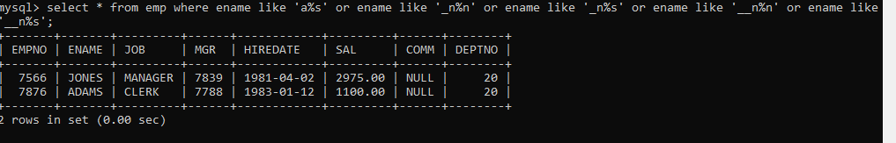

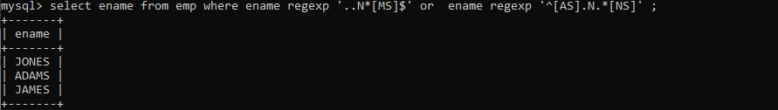

12. List the names of the emp having ‘_’ character in their name



seSingle Row functions



1. To list all employees and their email, to generate email use 2 to 5 characters from ename Concat it with 2 to 4 characters in job and then concat it with ‘@mycompany.com’



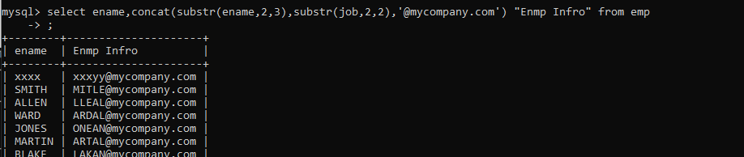



2. List all employees who joined in September.

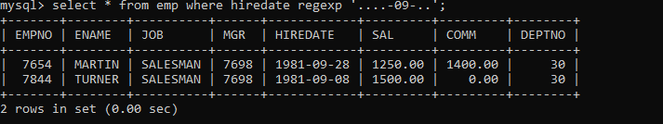



3. List the empno, name, and department number of the emp who have experience of 18 or more years and sort them based on their experience

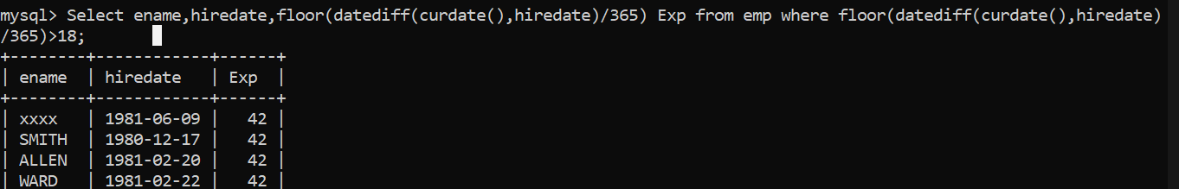

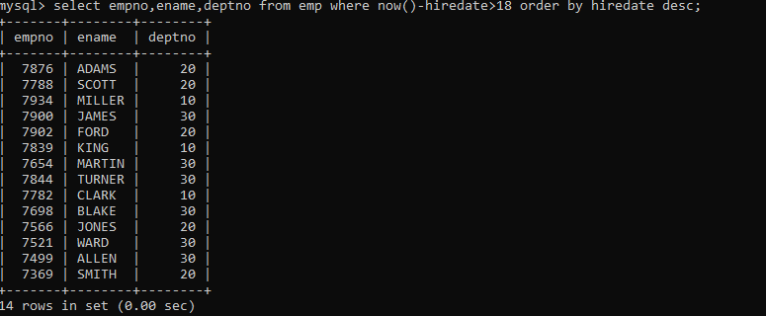

4. Display the employee details who joined on 3rd of any month or any year

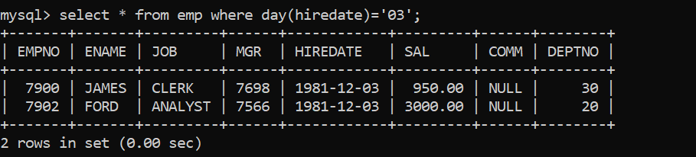

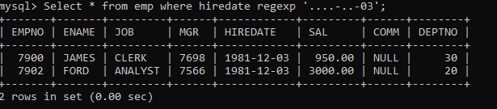

5. Display all employees who joined between years 1981 to 1983.

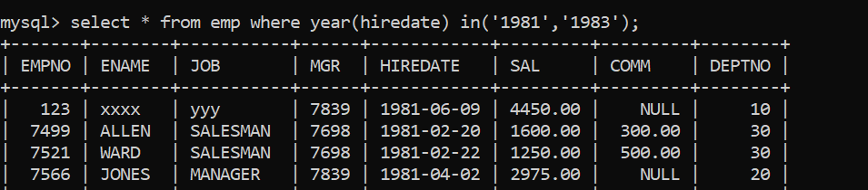

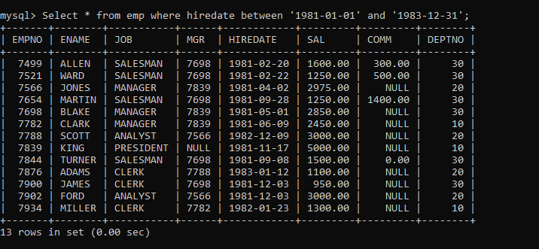

Group functions

6. Display the Highest, Lowest, Total & Average salary of all employee. Label the columns Maximum, Minimum, Total and Average respectively for each Department. Also round the result to the nearest whole number

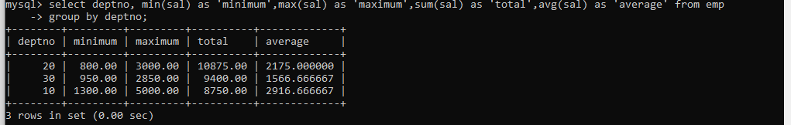

7. Display Department no and number of managers working in that department. Label the column as ‘Total Number of Managers’ for each department

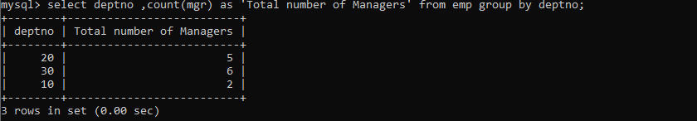

8. Get the Department number, and sum of Salary of all non managers where the sum is greater than 20000

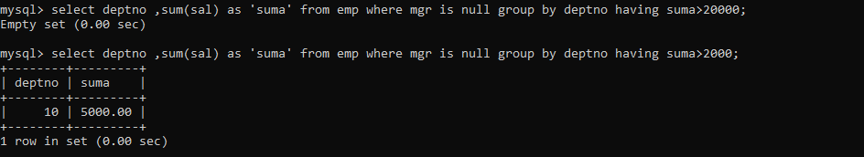

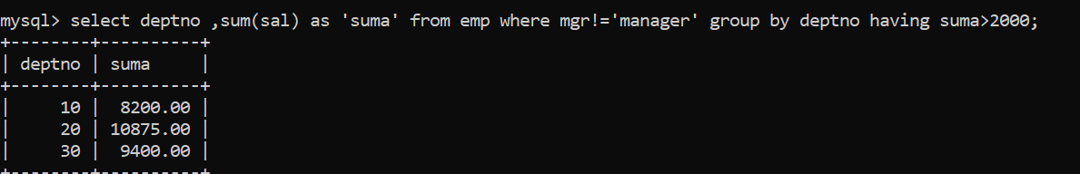

==============================Day 3=====================Asssignment+++++

1. Write a query to display the first day of the month (in datetime format) three months before the current month. Sample current date : 2014-09-03 Expected result : 2014-06-01

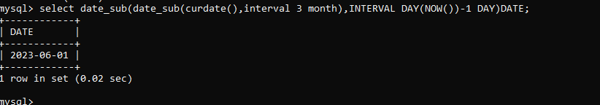

2. Write a query to display the last day of the month (in datetime format) three months before the current month

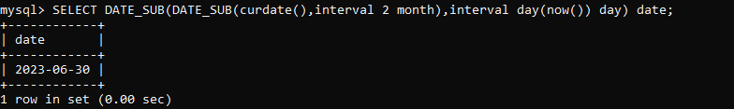

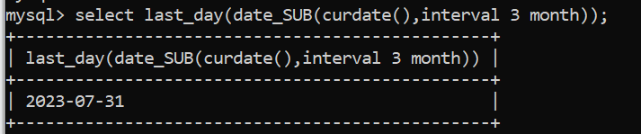

3. Write a query to get the distinct Mondays from hiredate in emp table

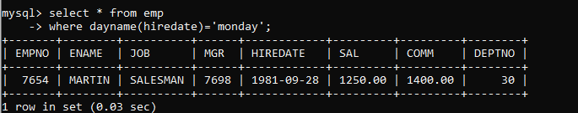

4. Write a query to get the first day of the current year.

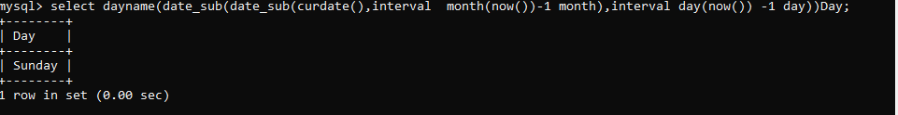

5. Write a query to get the last day of the current year.

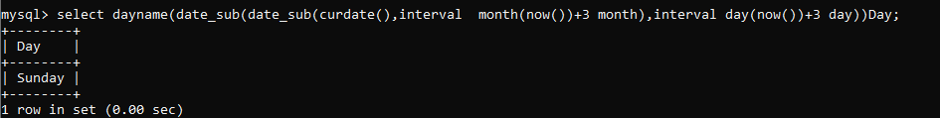

6. Write a query to calculate your age in year.

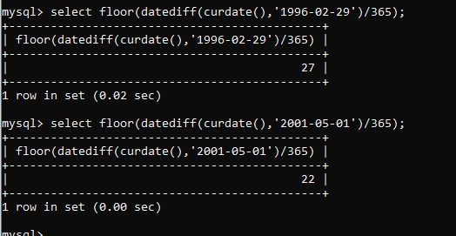

7. Write a query to get the current date in the following format

. Sample date : 04-sep-2014 Output : September 4, 2014

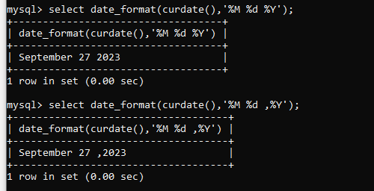

8. Write a query to get the current date in Thursday September 2014 format.

Thursday September 2014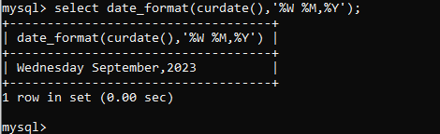

9. Write a query to extract the year from the current date

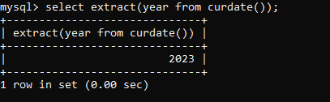

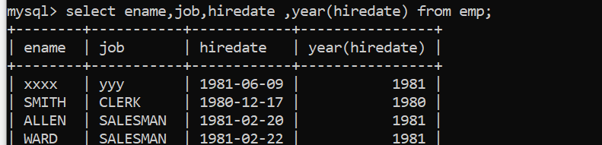

10. Write a query to get the first name and hire date from employees table where hire date between '1987-06-01' and '1987-07-30'

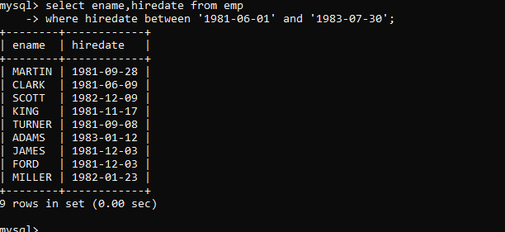

11. Write a query to display the current date in the following format. Sample output: Thursday 4th September 2014 00:00:00

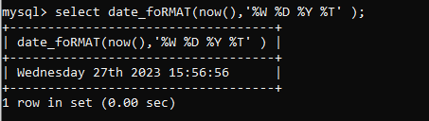

12. Write a query to display the current date in the following format. Sample output: 05/09/2014

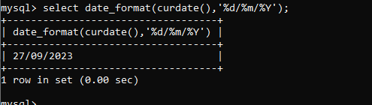

13. Write a query to display the current date in the following format. Sample output: 12:00 AM Sep 5, 2014

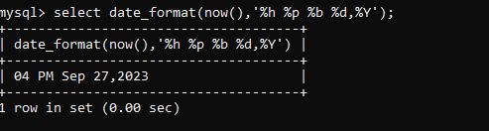

14. Write a query to get the employees who joined in the month of June

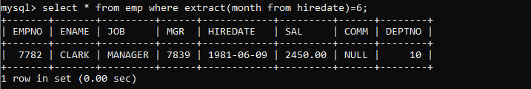

15. Write a query to get the years in which more than 10 employees joined.

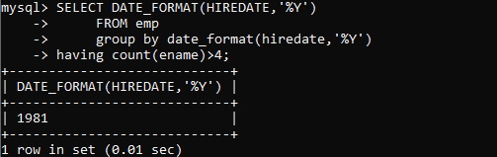

QUS: Perosonal qus

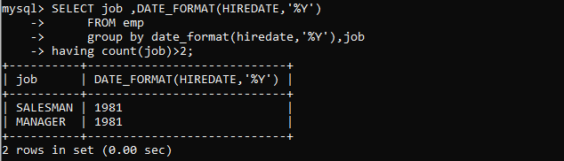

**16. Write a query to get first name of employees who joined in 1987.**

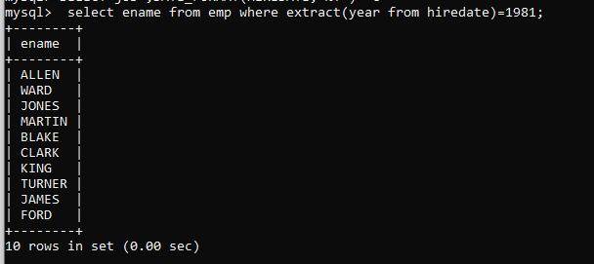

**17. Write a query to get employees whose experience is more than 5 years.**

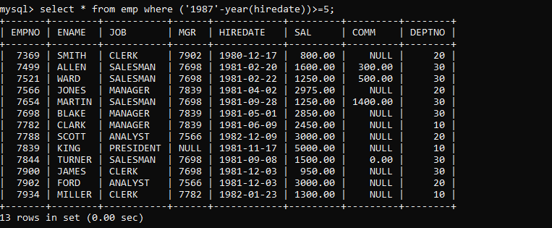

**18. Write a query to get employee ID, last name, and date of first salary of the employees.**

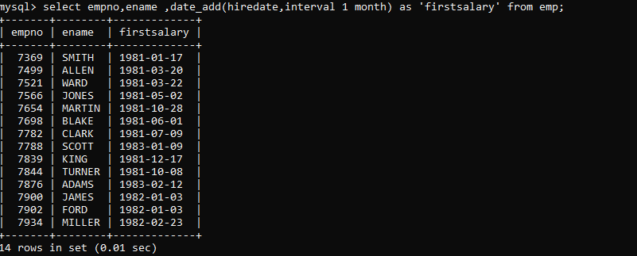

**19. Write a query to get first name, hire date and experience of the**

**employees.**

**Sample table: employees**

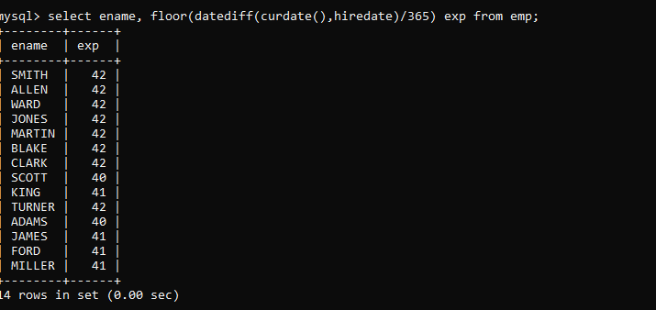

**20. Write a query to get the department ID, year, and number of employees joined.**

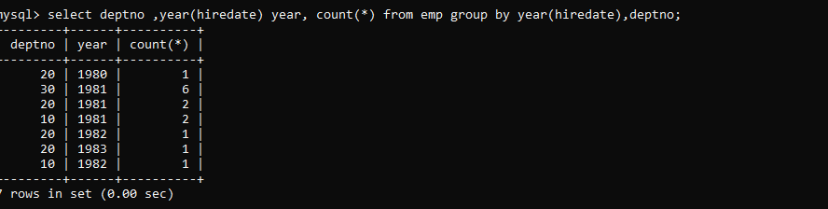

**Day 3**

Q1:-create table mydept_DBDA (

deptid number primary key,

dname varchar2(20) not null unique, dloc varchar2(20)

)

insert into mydept_DBDA values(30,'Purchase','Mumbai');

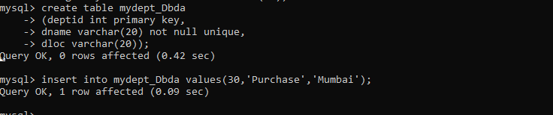

Q2. create table myemployee (

empno number(5) primary key,fname varchar(15) not null, mname varchar(15),

lname varchar(15) not null,

sal number(9,2) check(sal >=1000), doj date default sysdate, passportnum varchar(15) unique,

deptno number constraint fk_deptno references mydept_DBDA(deptid) on delete cascade

)

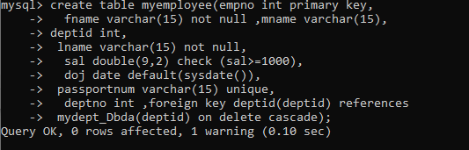

Q3 .Create following tables Student, Course

Student (sid,sname) ---------------- sid ---primary key

Course(cid,cname)-------------- cid ---primary key

Marks(studid,coursed,marks) Sample data for marks table studid,courseid,marks

|  |  |  |
| --- | --- | --- |
| 1 | 1 | 99 |
| 1 | 3 | 98 |
| 2 | 1 | 95 |
| 2 | 2 | 97 |

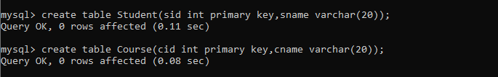



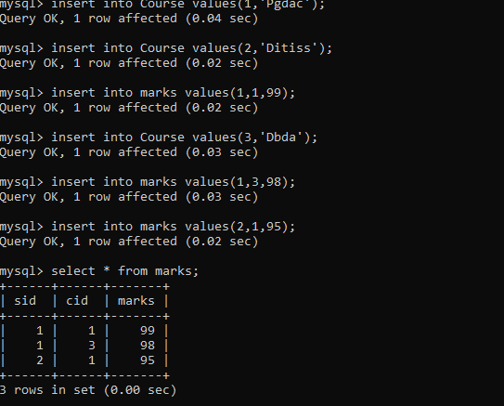

Q4. Create empty table emp10 with table structure same as emp table. create table emp10 as

(

select * from emp where 1=2;

)

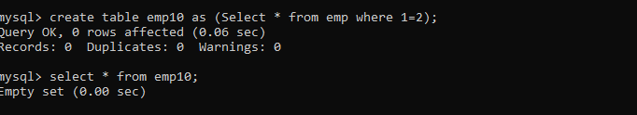

Q5. Solve following using alter table

add primary key constraint on emp,dept,salgrade emp ----🡪 empno

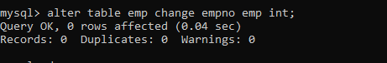

dept---🡪 deptno

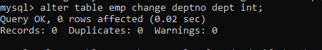

salgrade---🡪 grade

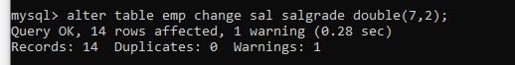

add foreign key constarint in emp

deptno --->> dept(deptno)





add new column in emp table netsal with constraint default 1000

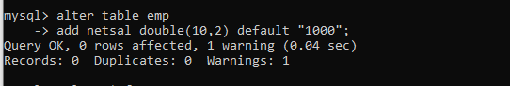

Q6.Update employee sal increase sal of each employee by 15 % sal +comm, change the job

to manager and mgr to 7777 for all employees in deptno 10.

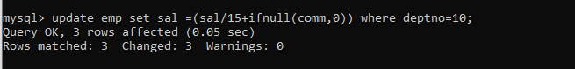

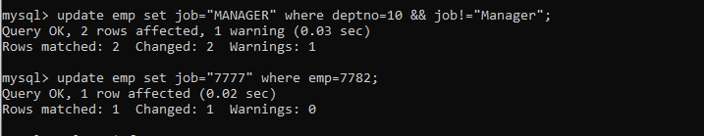

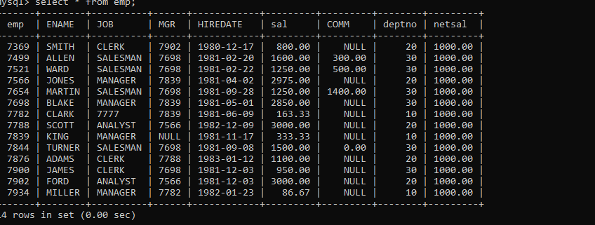

Q7.change job of smith to senior clerk

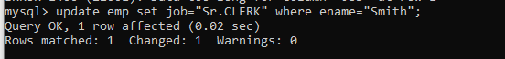

Q8. increase salary of all employees by 15% if they are earning some commission

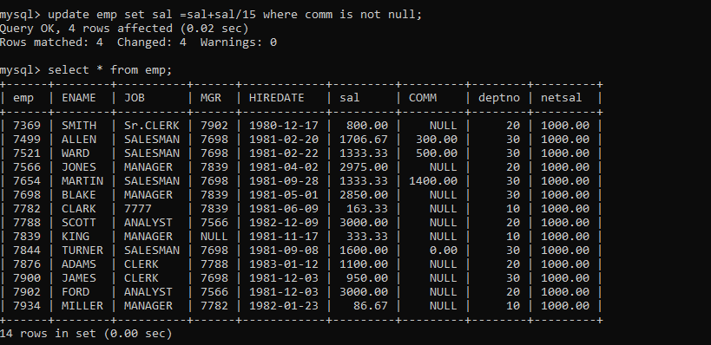

10. To find all managers with salary >1500

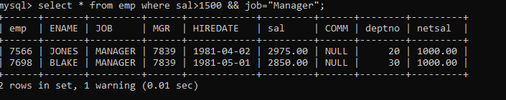

11.list all employees with sal >1200 and < 2000

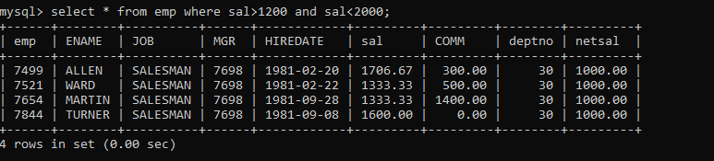

12. list all employees with sal is 1600 or sal is 800 or sal is 1900

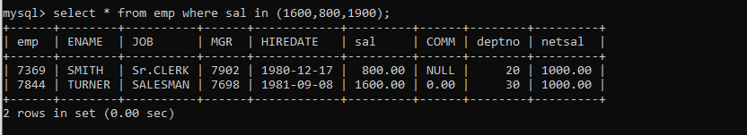

1. 13. list all employees with R at second last position in name

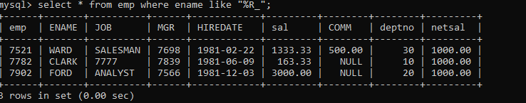

14. List all employees with name starts with A and ends with N

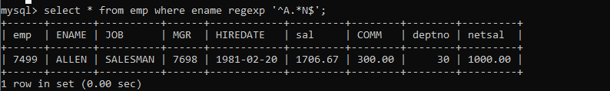

15. list all employees with salary > 1250 and dept no=30

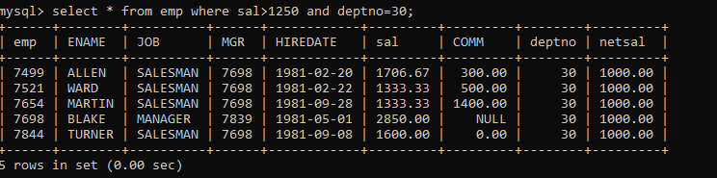

16.list all employees with salary >=1250 and <= 3000

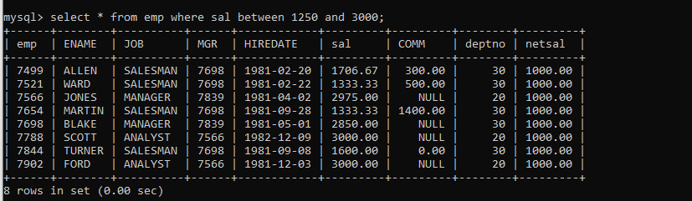

17. list all employees with salary either equal to 3000 or 1250 or 2500

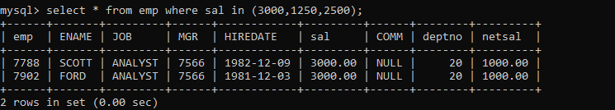

18. list all employee with name=SMITH

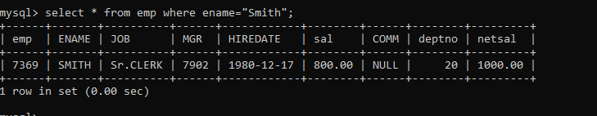

19. list all employees with name starting with S

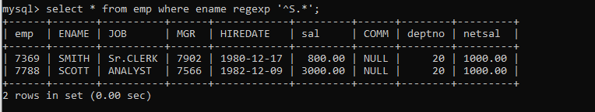

20. list all employees with name ending with S

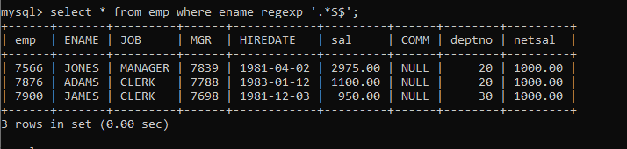

21. list all employees with name contains I at 2nd position

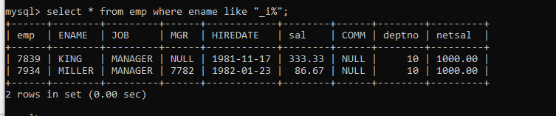

22.list all employees with name starts with A ends witn N and somewhere in between L is there

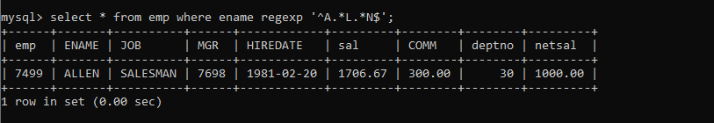

23. list all employees with name starts with A and B at 3 rd position and P at second last position

==================================Day5============================================

38. list all employees with sal>smith's sal

select * from emp where sal>(select ename from emp where ename='Smith');

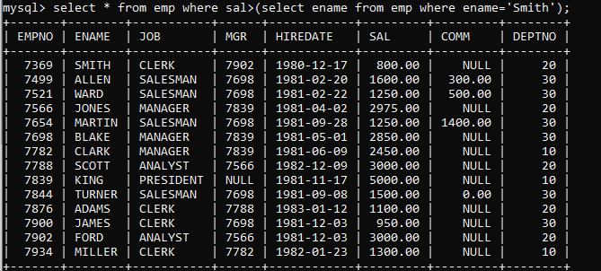

39. . list all employees who are working in smith's department

select * from emp where deptno=(select deptno from emp where ename='Smith');

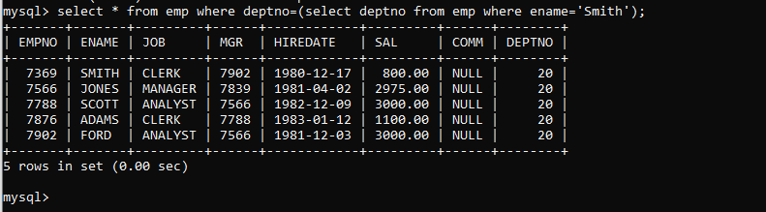

40. list all employees with sal < rajan's sal and salary > revati's sal

select * from emp where sal between (select sal from emp where ename='smith') and (select sal from emp where ename='scott');

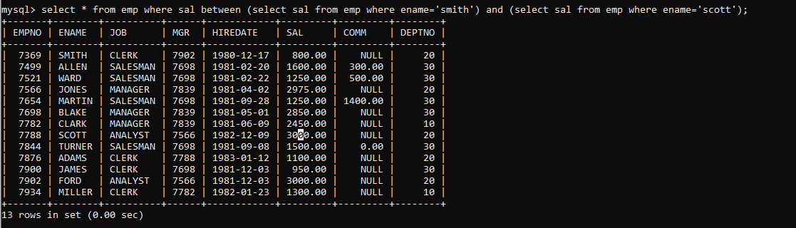

Q 41.delete from emp where dept is of allen



Q 42 allen sal to miller change

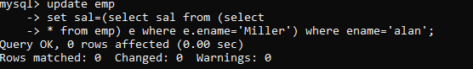

44. list all employees with salary > either Smith's salary or alan's sal

select * from emp

-> where sal >(select sal from emp where ename in('smith','alan'));

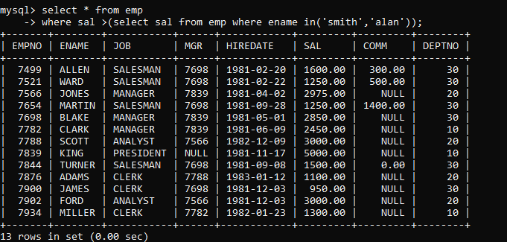

45. list all employees who earn more than average sal of dept 10

select * from emp where sal>(select avg(sal) from emp where deptno=10);

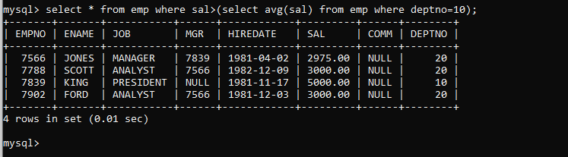

46, list all employees who earn more than average sal of Alan's department

select * from emp where sal>(select avg(sal) from emp where deptno=(select ename from emp where ename='alan'));

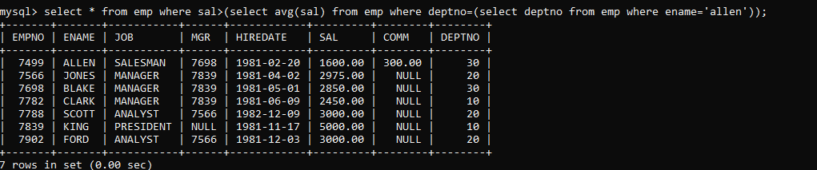

47. list all employees who are working in purchase department

select * from emp where deptno=(select deptno from dept where dname='sales');

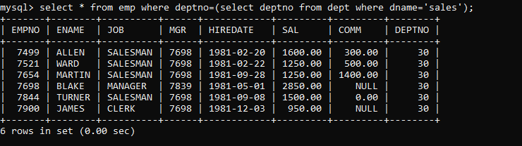

Self

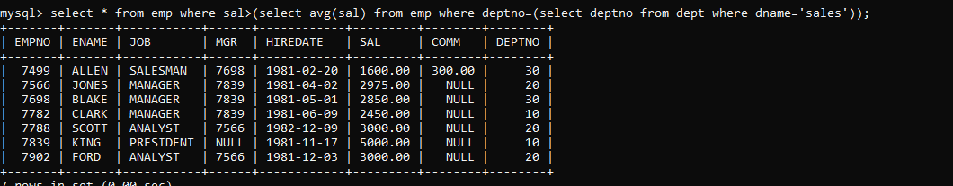

48. list all employees who earn more than average salary of their own department

select * from emp e

-> where sal>(select avg(sal) from emp m where e.deptno=m.deptno);

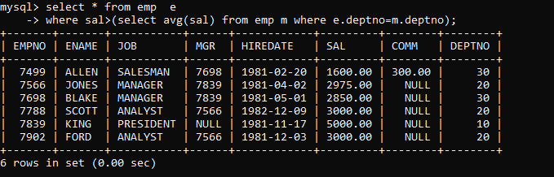

49.list all employees who earn sal < than their managers salary

select * from emp e where sal>(select sal from emp m where m.mgr=e.mgr);

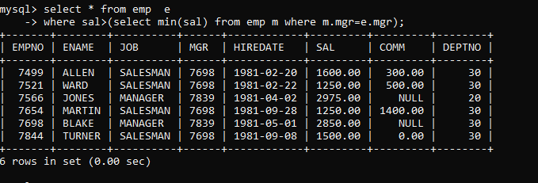

50. list all employees who are earning more than average salary of their job

select * from emp e

-> where sal>(select avg(sal) from emp m where m.job=e.job);

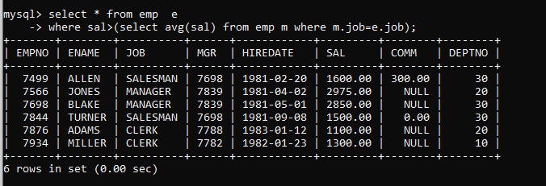

51.display employee name and department

51.display employee name and department

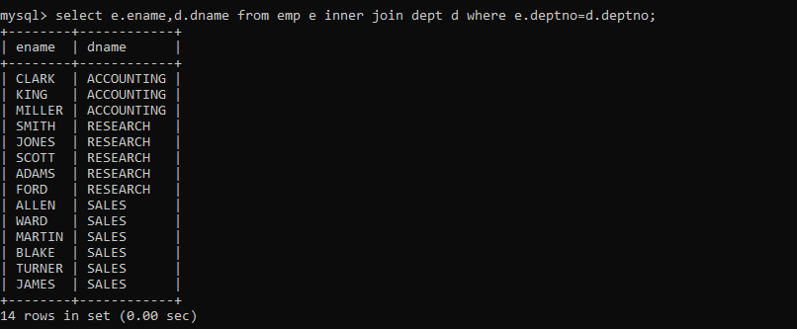52.display empno,name,department name and grade (use emp,dept and salgrade table)

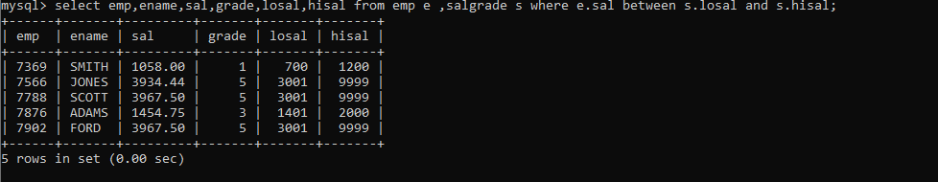

53.list all employees number,name, mgrno and manager name

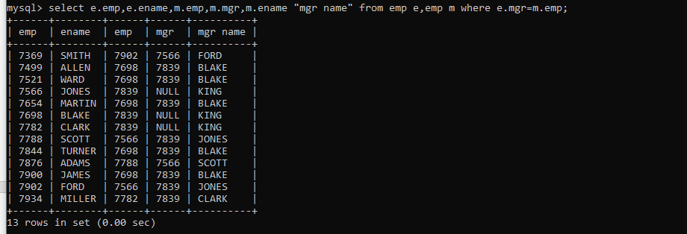

54. 4. create following tables and solve following questions(primary keys are marked in yellow) foreign keys are marked in green product(pid,pname,price,qty,cid,sid) salesman (sid,sname,address) category(cid,cnam,descritpion) 1. list all product name,their category name and name of a person, who sold that product 2. list all product name and salesman name for all salesman who stays in pune 3. list all product name and category name

create table salesman(

sid int primary key, sname varchar(25) not null, address varchar(70) default "pune");

create table category(

cid int primary key, cname varchar(25) not null, descr varchar(70) default "This is a product");

create table product (

pid int primary key,

pname varchar(50),

price int,

qty int,

cid int,

sid int,

constraint cust foreign key fk(cid) references category(cid)

on delete cascade

on update cascade, constraint sale foreign key(sid) references salesman(sid)

on delete cascade on update cascade);

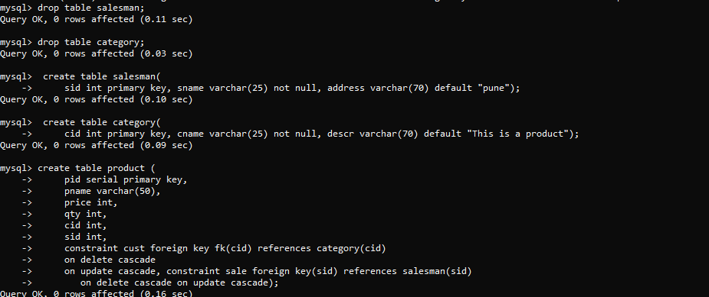

55.

create table faculty(

fid int primary key,

fname varchar(20) not null,

sp_skill1 varchar(20),

sp_skill2 varchar(20)

);

create table room(

roomid int primary key,

rname varchar(20) not null,

rloc varchar(20)

);

create table course1(

cid int primary key,

cname varchar(20),

rid int,

fid int,

constraint fk_rid foreign key(rid)

references room(roomid)

on update cascade

on delete set null,

constraint fk_fid foreign key(fid)

references faculty(fid)

on update cascade

on delete set null

);

insert into faculty values(10,'kjzhcjhz','a','b'),

(11,'sdd','x','z'),(12,'lksjk','a','x'),

(13,'13 ksdjlkj','a','b');

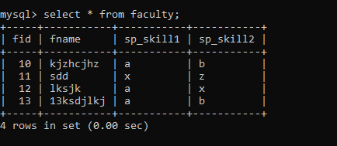

insert into room values(100,'Jasmine','1st floor'),

(101,'Rose','2nd floor'),(105,'Lotus','1st floor'),

(103,'Mogra','1st floor');

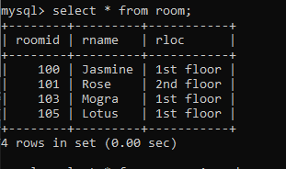

insert into course1 values(121,'DBDA',100,10);

insert into course1(cid,cname,rid) values(131,'DAC',101);

insert into course1(cid,cname) values(141,'DITISS');

insert into course1 values(151,'DIOT',105,12);

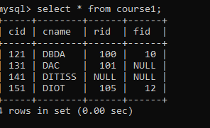

55.1 list all courses for which no room is assigned. And all rooms for which are available

select cid,cname,rid,null roomid,null rname,null rloc

from course1 where rid is null

union

select null,null,null,roomid,rname,rloc

from room r where not exists(

select *from course1 c where c.rid=r.roomid);

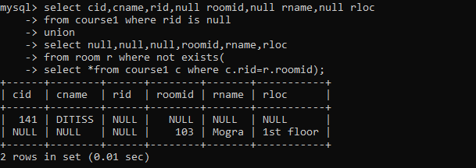

55.2 list all faculties who are not allocated to any course and rooms which are not allocated to any course

select f.fid,fname,null roomid,null rname,null rloc

from faculty f where not exists

(select *from course1 c where c.fid=f.fid)

union

select null,null,roomid,rname,rloc

from room r where not exists(

select *from course1 c where c.rid=r.roomid);

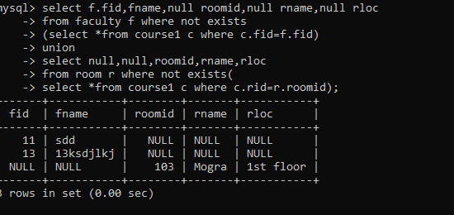

55.3 list all rooms which are allocated or not allocated to any courses

select r.*,c.cname from room r left join course1 c on c.rid=r.roomid;

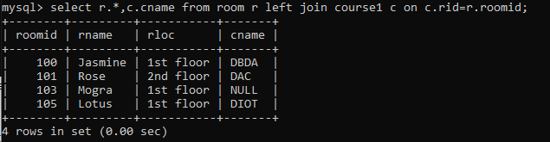

55.4 list all rooms which are not allocated to any courses

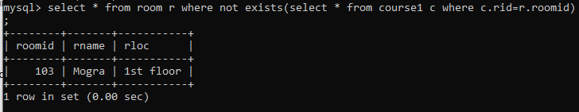

* 1. display courses and faculty assigned to those courses whose special skill is database

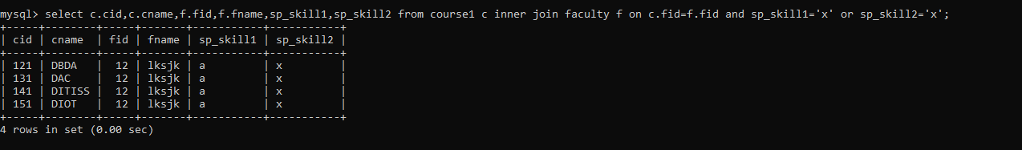

55.6 display time table --- it should contain course details , faculty and room details

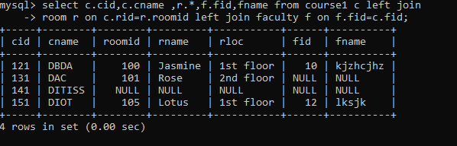

56.create following tables with given constraints product---- qty >0, default 20.00,pname not null and unique

prodid pname qty price catid sid

|  |  |  |  |  |  |
| --- | --- | --- | --- | --- | --- |
| 123 | lays | 30 | 30.00 | 1 | 12 |
| 111 | pepsi | 40 | 50.00 | 4 | 11 |
| 134 | nachos | 50 | 50.00 | 1 | 12 |
| 124 | dairy milk | 40 | 60.00 | 2 | 14 |
| 124 | pringles 40 | 60.00 | 1 14 |  |  |



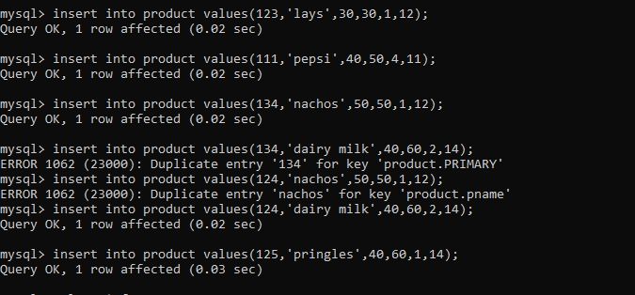

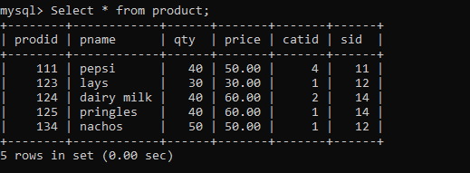

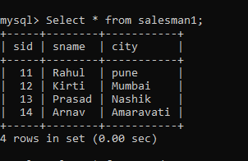

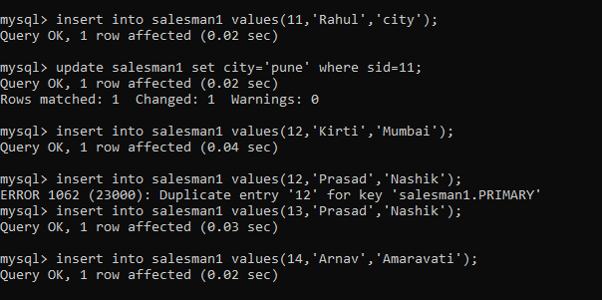

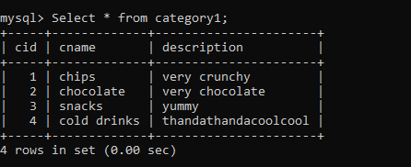

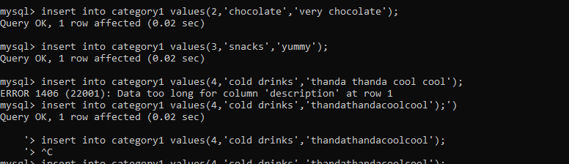

1. List all products with category chips

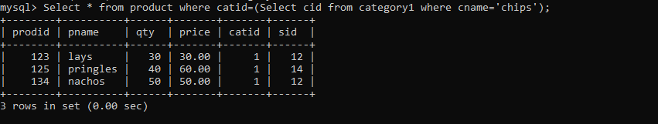

2.display all products sold by kirti

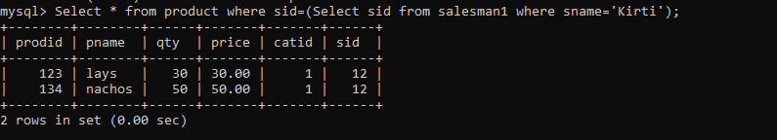

1. display all salesman who do not sold any product

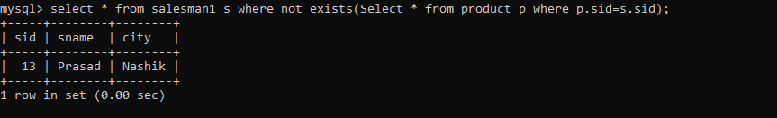

4.display all category for which no product is there

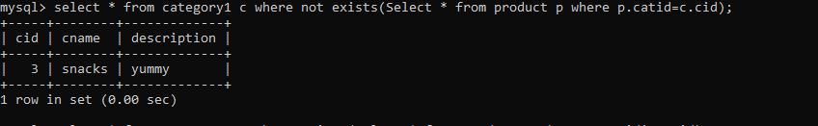

5.display all products with no category assigned



6.list all salesman who stays in city with name starts with P or N

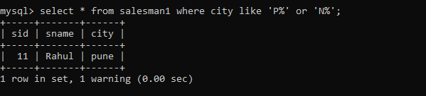

7.add new column in salesman table by name credit limit

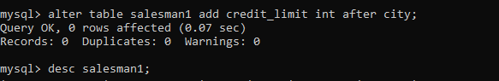

==============================Day 7=============================================

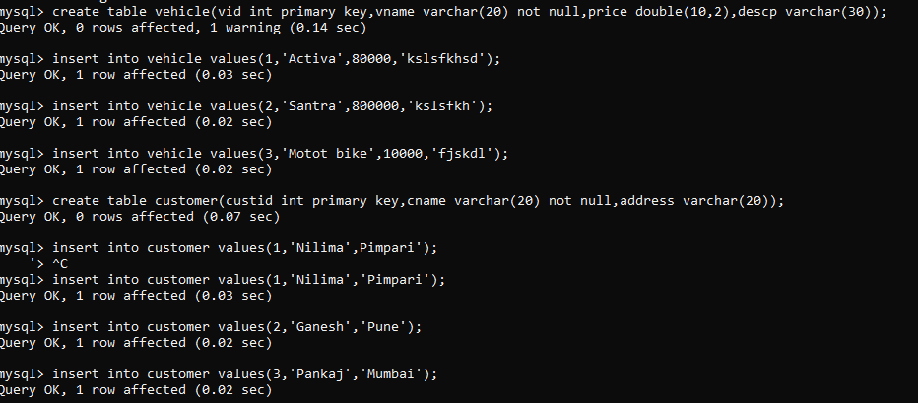

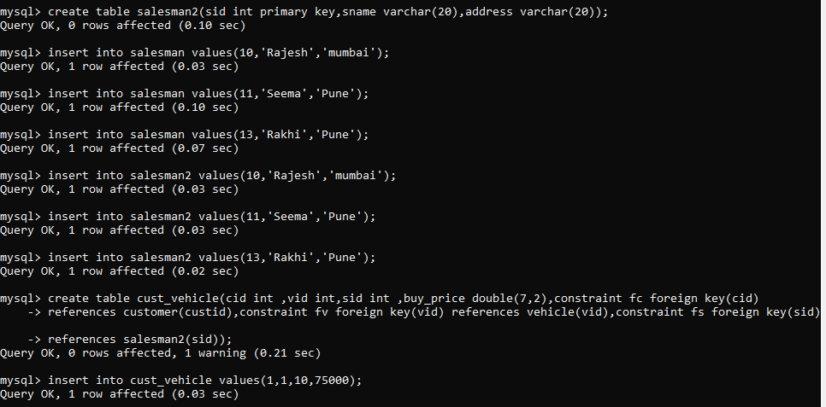

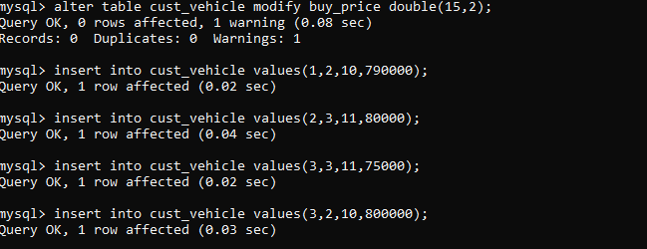

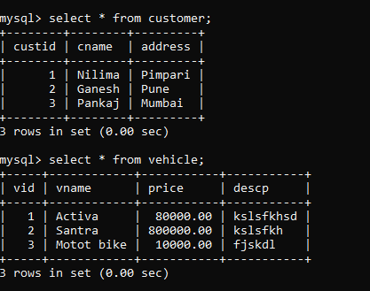

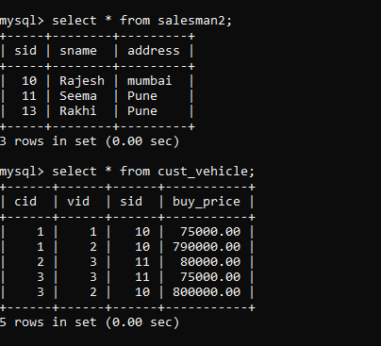

2.create index on vehicle based on price

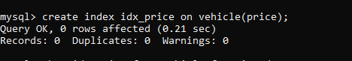

1. find all customer name vehicle name salesman2 name discount earn by all customer
2. 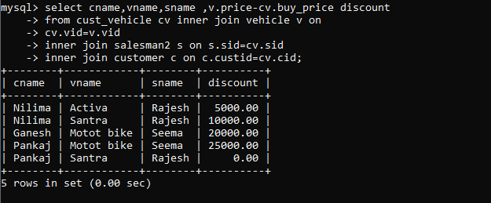

4. find all customer name,vehicle name,salesman name for all salesman who stays in pune

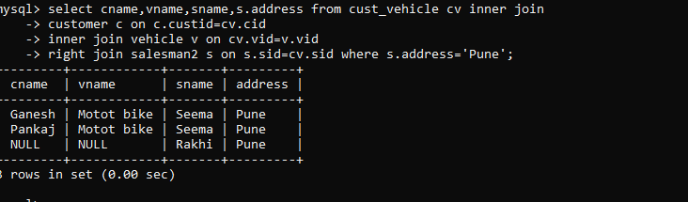

5.find how many customers bought motor bike

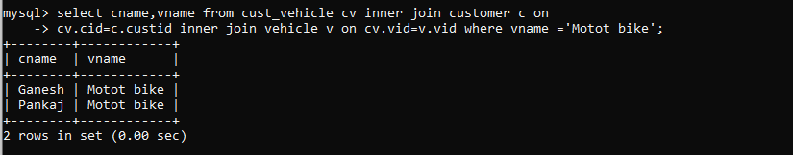

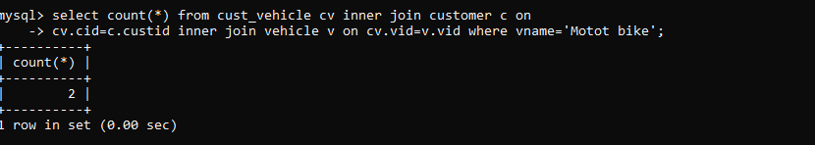

6.create a view find_discount which displays output

-------to create view create view find_discount as

select cname,vname,price,buying_price,price-buying_price “discount”

from customer c inner join cust_vehicle cv on c.custid=cv.cid inner join vehicle v on v.vid=cv.vid

--------to display discount

select * from find_discount;

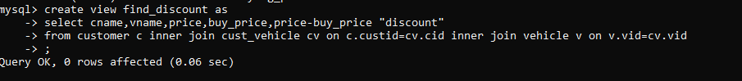

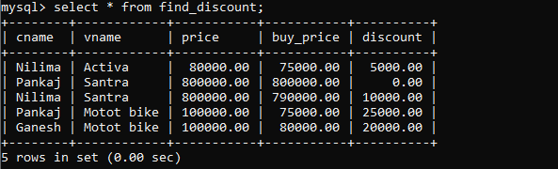

7.find all customer name, vehicle name, salesman name, discount earn by all customer

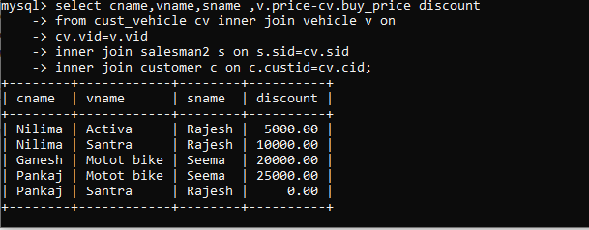

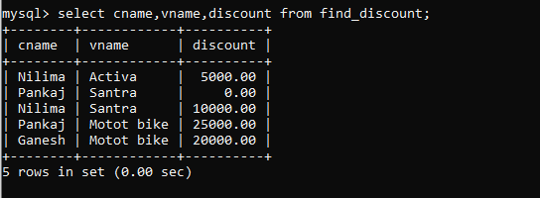

8.create view my_hr to display empno,ename,job,comm for all employees who earn commission

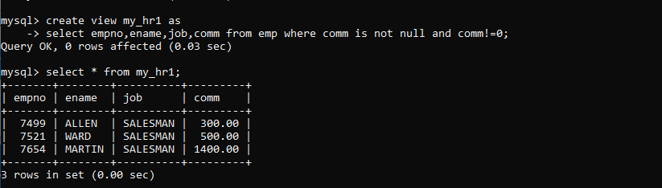

1. create view mgr30 to display all employees from department 30

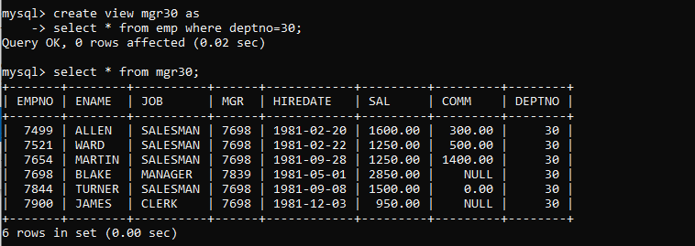

10. insert 3 employees in view mgr30 check whether insertion is possible

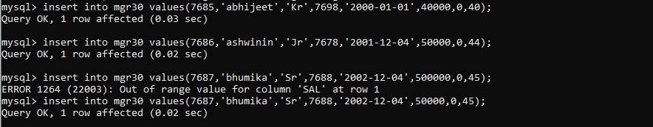

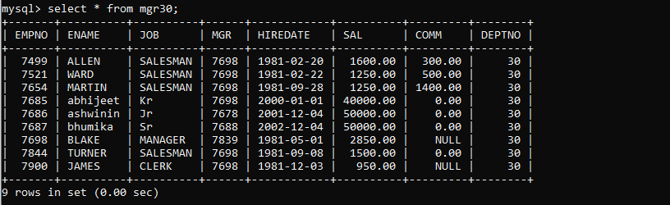

11. insert 3 records in dept and display all records from dept

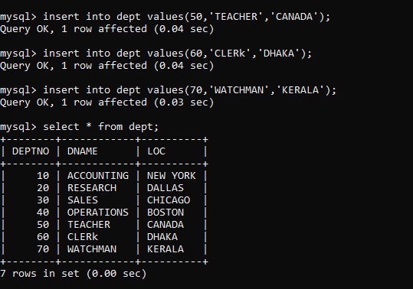

1. do the following

insert row in emp with empno 100 insert row in emp with empno 101 insert row in emp with empno 102 add savepoint A

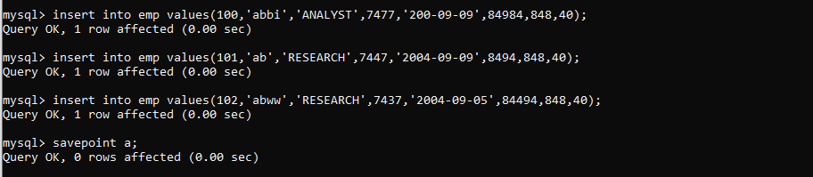

insert row in emp with empno 103 insert row in emp with empno 104 insert row in emp with empno 105 add savepoint B

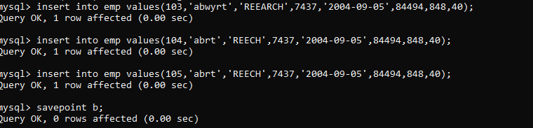

delete emp with empno 100 delete emp with emp no 104 rollback upto svaepoint B

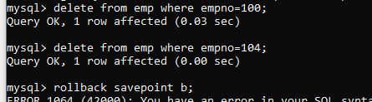

check what all records will appear in employee table

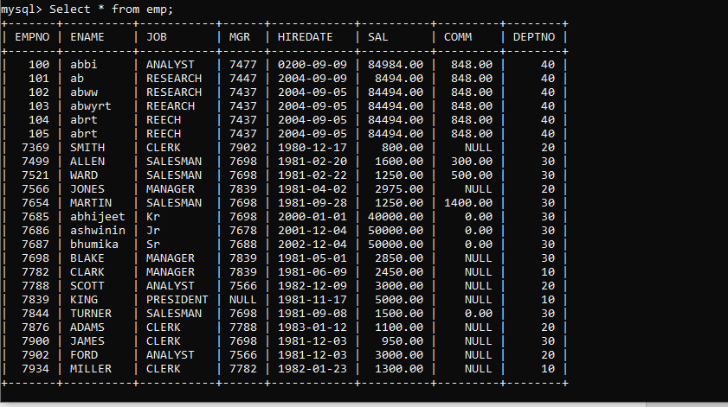

rollback upto A

check what all records will appear in employee table

commit all changes

check what all records will appear in employee table check whether you can roll back the contents.

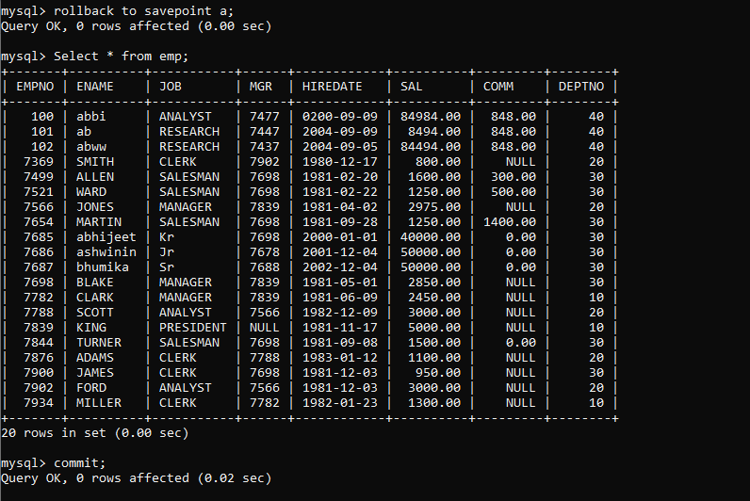

1. create a procedure getMin(deptno,minsal) to find minimum salary of given table.

==========================DAY 8===

1. write a procedure to insert record into employee table.

the procedure should accept empno, ename, sal, job, hiredate as input parameter write insert statement inside procedure insert_rec to add one record into table

create procedure insert_rec(peno int,pnm varchar(20),psal decimal(9,2),pjob varchar(20),phiredate date)

begin

insert into emp(empno,ename,sal,job,hiredate) values(peno,pnm,psal,pjob,phiredate)

end//

mysql> Delimiter //

mysql> Create procedure insert_rec(empno int,pname varchar(20),psal double(9,2),

-> pjob varchar(20), phiredate date)

-> begin

-> insert into emp(emp,ename,sal,job,hiredate) values(empno,pname,psal,pjob,phiredate);

-> end//

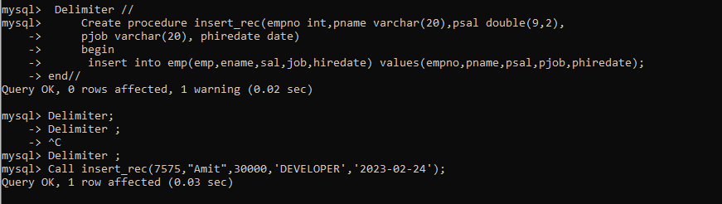

2.write a procedure to delete record from employee table. the procedure should accept empno as input parameter.

write delete statement inside procedure delete_emp to delete one record from emp table

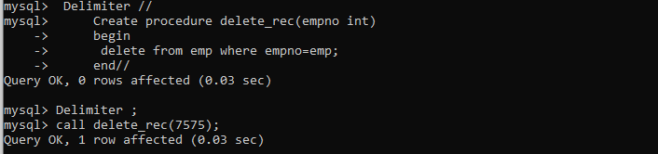

Delimiter //

mysql> Delimiter //

mysql> Create procedure delete_rec(empno int)

-> begin

-> delete from emp where empno=emp;

-> end//

Query OK, 0 rows affected (0.03 sec)

mysql> Delimiter ;

3.write a procedure to display empno,ename,deptno,dname for all employees with sal

> given salary. pass salary as a parameter to procedure

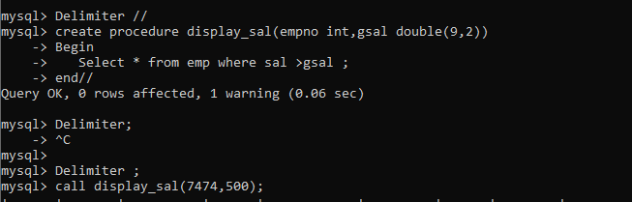

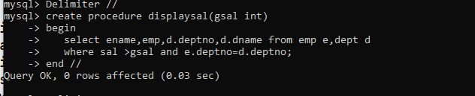

4.write a procedure to find min,max,avg of salary and number of employees in the given deptno.

deptno --🡪 in parameter

min,max,avg and count ---🡪 out type parameter

execute procedure and then display values min,max,avg and count

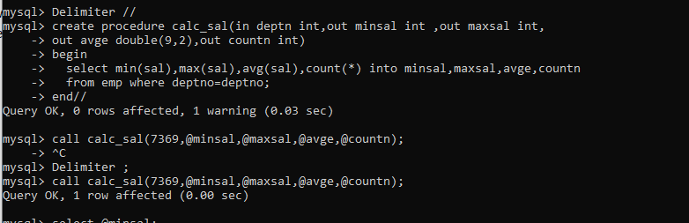

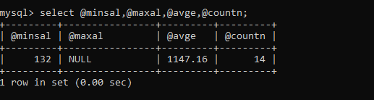

\

5.write a procedure to display all pid,pname,cid,cname and salesman name(use product,category and salesman table)

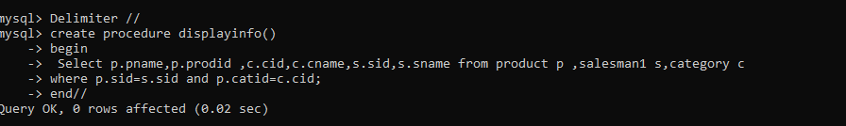

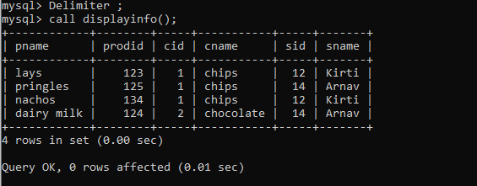

6.write a procedure to display all vehicles bought by a customer. pass cutome name as a parameter.(use vehicle,salesman,custome and relation table)

7.Write a procedure that displays the following information of all emp Empno,Name,job,Salary,Status,deptno

Note: - Status will be (Greater, Lesser or Equal) respective to average salary of their own department. Display an error message Emp table is empty if there is no matching record.

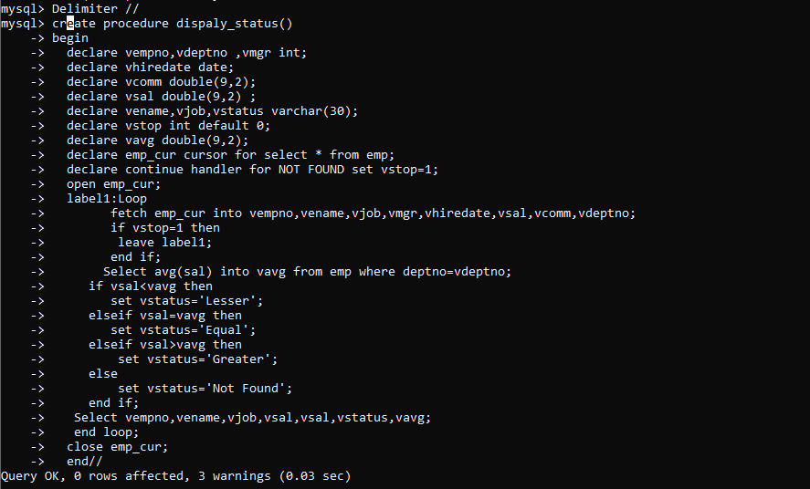

Delimiter //

mysql> create procedure dispaly_status()

-> begin

-> declare vempno,vdeptno ,vmgr int;

-> declare vhiredate date;

-> declare vcomm double(9,2);

-> declare vsal double(9,2) ;

-> declare vename,vjob,vstatus varchar(30);

-> declare vstop int default 0;

-> declare vavg double(9,2);

-> declare emp_cur cursor for select * from emp;

-> declare continue handler for NOT FOUND set vstop=1;

-> open emp_cur;

-> label1:Loop

-> fetch emp_cur into vempno,vename,vjob,vmgr,vhiredate,vsal,vcomm,vdeptno;

-> if vstop=1 then

-> leave label1;

-> end if;

-> Select avg(sal) into vavg from emp where deptno=vdeptno;

-> if vsal<vavg then

-> set vstatus='Lesser';

-> elseif vsal=vavg then

-> set vstatus='Equal';

-> elseif vsal>vavg then

-> set status='Greater';

-> else

-> set status='Not Found';

-> end if;

-> Select vempno,vename,vjob,vsal,vsal,vstatus,vavg;

-> end loop;

-> close emp_cur;

-> end//

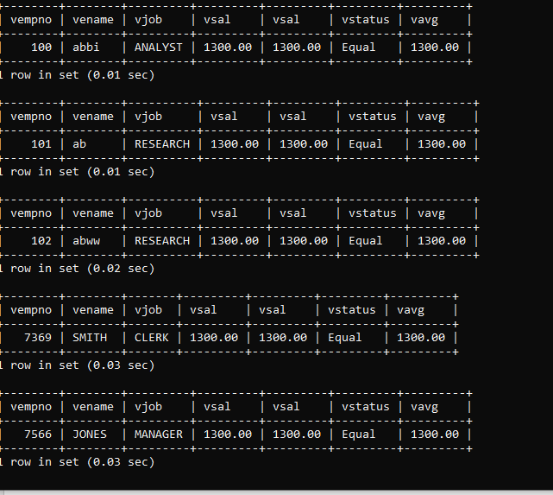

8.Write a procedure to update salary in emp table based on following rules. Exp< =35 then no Update

Exp> 35 and <=38 then 20% of salary

Exp> 38 then 25% of salary

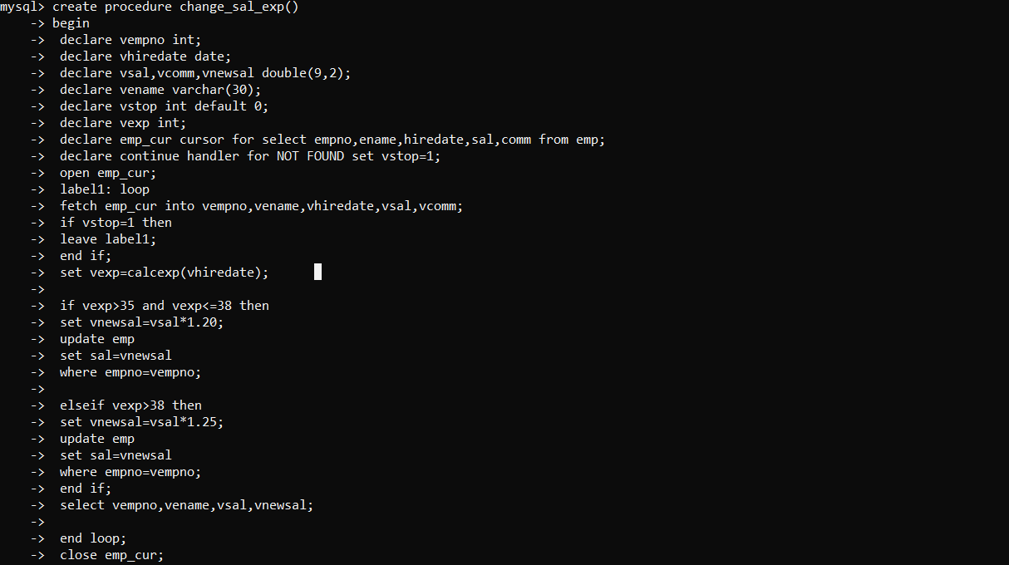

1. Write a procedure and a function.

Function: write a function to calculate number of years of experience of employee.(note: pass hiredate as a parameter)

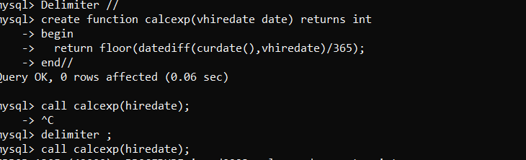

10.Write a function to compute the following. Function should take sal and hiredate as i/p and return the cost to company.

DA = 15% Salary, HRA= 20% of Salary, TA= 8% of Salary.

Special Allowance will be decided based on the service in the company.

< 1 Year Nil

>=1 Year< 2 Year 10% of Salary

>=2 Year< 4 Year 20% of Salary

>4 Year 30% of Salary

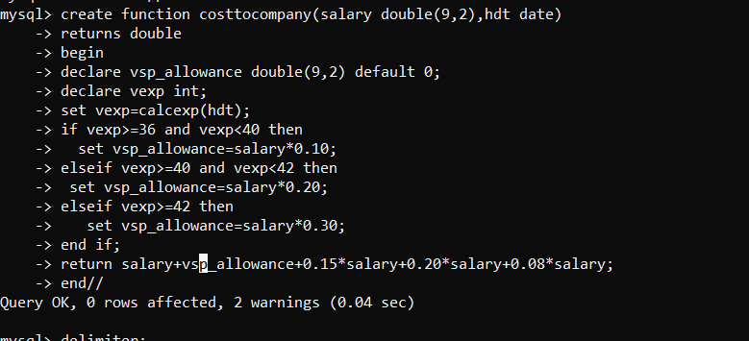

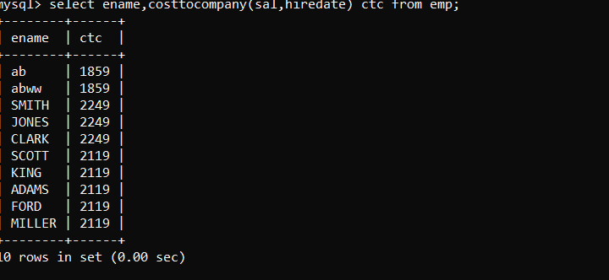

*=== MONGODB=======*

*connecting to the server*

*mongod --dbpath D:\Mongodb\mongodbnew*

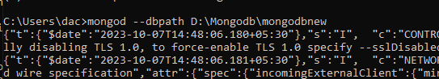

launching mongosh

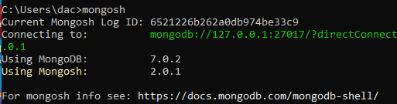

mongoimport --db iacsd0923 --collection movie --file D:\Mongodb\mongodbnew\movie.json



in MongoSh

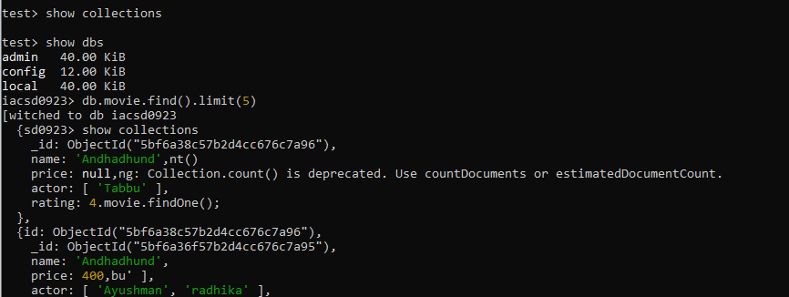

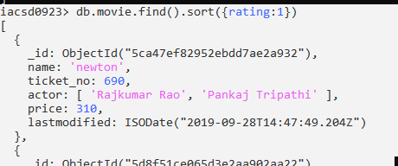

iacsd0923> db.movie.find().pretty()

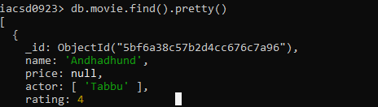

Creating new employee collection



db.movie.emp.insertMany([{emp:1,ename:'kishoriji',exp:4,subject:'science'},{emp:5,ename:'kisshan',eno:123,},{emp:1,emp:2,emp:3,emp:4}])

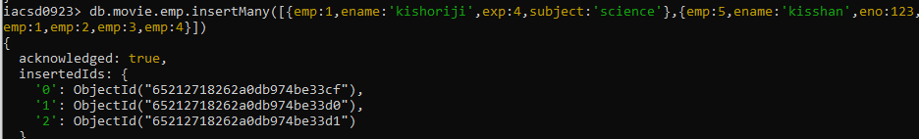

Qus 1.

iacsd0923> db.samplerestaurent.count()

76077

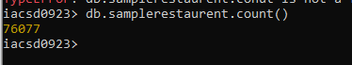

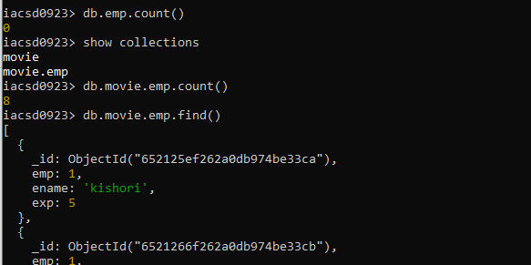

qus 2

