PRIMARY KEY & FOREGIN KEY constraint



Step 1: first we create the cities table than we have create students tabales

create table cities (

id int primary key,

name varchar(50) not null

)



;



INSERT INTO CITIES (id,name)



VALUES

(01,'GONDIA'),



(02,'ZOO'),

(03,'LOLODILE'),



(04,'ZODIAC'),



(05,'VILLA');



--------------------------------------------------------



CREATE TABLE students

(

id INT NOT NULL AUTO_INCREMENT,



name VARCHAR(40) NOT NULL,

age INT NOT NULL,



city INT NOT NULL,



PRIMARY KEY (id),

FOREIGN KEY (city) REFERENCES cities(id

);

INSERT INTO students (id, name, age, city)

VALUES (01, 'aditya', 23, 01),

(02, 'yolo', 23, 02),

(03, 'robin', 24, 03),

(04, 'vudo', 25, 03),

(05, 'lolo', 24, 05),

(06, 'decth', 22, 04);



-----------------------------output-------------------------------------------------------------------------

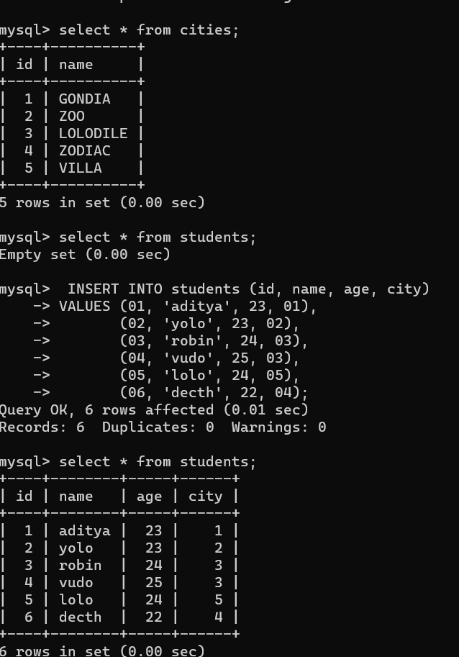



Joins (inner, outer and cross)



1. Inner Join