**DTI Project – SentiBot(Your Virtual Friend)**

**Milestone2**

**Write Your Name**

Aditya Raj

**Write your BU Email Address**

[E22CSEU0649@bennett.edu.in](mailto:E22CSEU0649@bennett.edu.in)

**Write your Mobile Number**

7004230852

**Select your team's batch**

22

**Your team number [check LMS for the same]. If your team is not listed then write N/A**

2

**Team member names [separated by comma]**

Aditya Raj, Shivam Garg, Sanjana Nayak

**Team member enrolment# [separated by comma]**

e22cseu0649, e22cseu1506, e22cseu0644

**Bennett email ID of Team Members [separated by comma]**

[e22cseu0649@bennett.edu.in](mailto:e22cseu0649@bennett.edu.in), [e22cseu1506@bennett.edu.in](mailto:e22cseu1506@bennett.edu.in), [e22cseu0644@bennett.edu.in](mailto:e22cseu0644@bennett.edu.in)

**Project Title:** SentiBot – Your Virtual Friend

**User Interface Design: *Salient Points/ How it meets the characteristics of User-Centered Design etc. (Minimum 500 characters and maximum 1000 character and at least 4 figures of the User interface or other related figures of your project via a tool [e.g., mockflow]). This Question Carries Two Mark.***

***Upload a User Interface Design File. Create a PDF with all images and upload the single PDF. This is part of the above question.***

The User Interface design for our sentiment analysis web app follows the principles of UCD, here are some points: The app offers multiple user-friendly inputs including voice and video interactions, making it accessible to users. The speech to text technology ensures accurate transcription of spoken words, enhancing usability.

The users get real time feedback with the app on their expressed sentiments through facial recognition.

Throughout the design process, we conducted user testing sessions to gather feedback to improve on user’s needs.

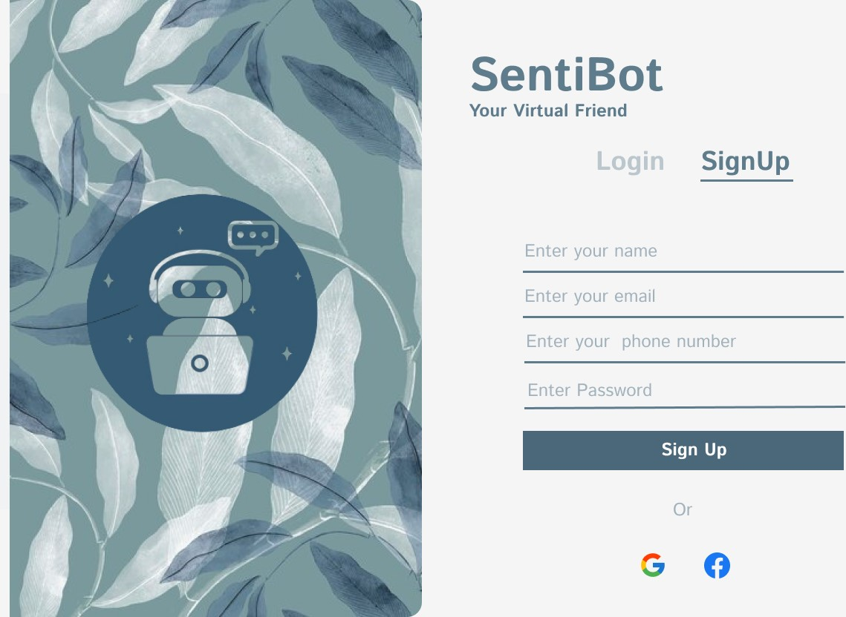

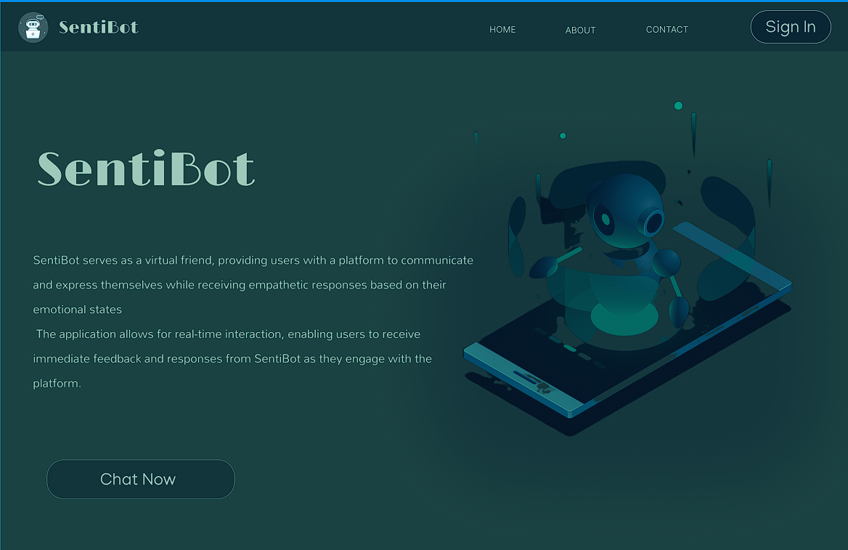

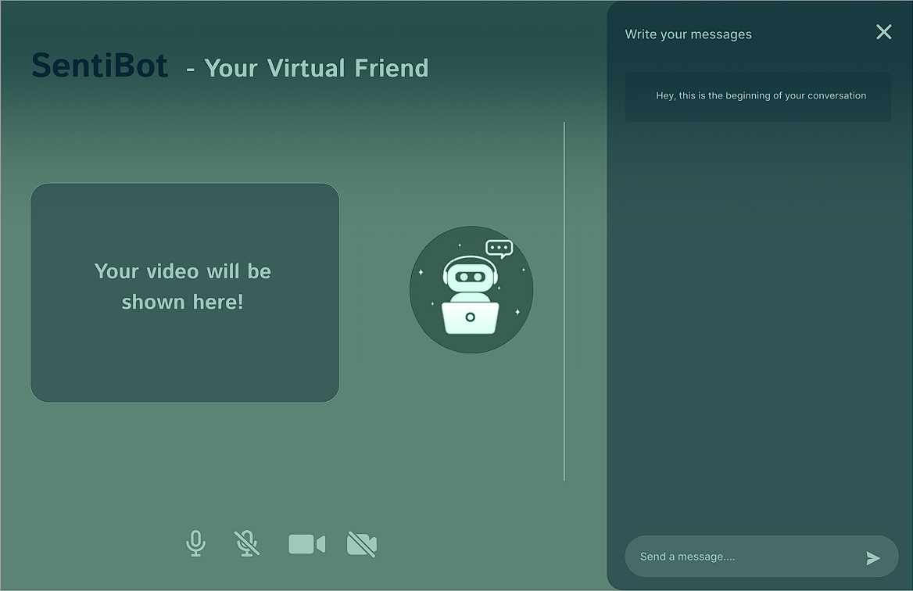

***Potential User Feedback This feedback should be collected from potential user in person or by phone.***

Potential User 1 Feedback: As a student, navigating the academic world can be overwhelming at times, leading to stress and anxiety. SentiBot's multifaceted approach to emotion analysis, having text, voice, and video inputs, presents a promising solution. Its ability to provide empathetic responses specific to my emotional state can serve as a valuable resource in times of need, offering support and guidance when academic pressures and personal challenges weigh heavy on my mind.

Potential User 2 Feedback: With the demands of work often leaving me feeling overwhelmed, SentiBot emerges as a beacon of support. Its potential to act as a compassionate companion, capable of listening and offering words of encouragement, resembles deeply with my need for emotional relief. By understanding my feelings and providing guidance, SentiBot could play a pivotal role in helping me manage stress and maintain a healthy work-life balance.

Potential User 3 Feedback: As I navigate through the later stages of life, feelings of loneliness can often creep in, particularly in the solitude of my home. SentiBot offers a beacon of hope, embodying the qualities of a friendly companion. Its potential to engage in meaningful conversation and provide companionship could alleviate the sense of isolation, fostering a sense of connection and belonging in my daily life.

Potential User 4 Feedback: Struggling with mental health challenges can be an isolating experience, compounded by the difficulty in expressing one's emotions. SentiBot's promise of understanding and support resonates deeply with my need for empathy and validation. By recognizing and responding to my emotions, SentiBot could serve as a source of solace during moments of distress, offering comfort and reassurance in times of need.

Potential User 5 Feedback: As a caregiver, understanding the emotional needs of others is paramount to providing effective support. SentiBot's potential to enhance my understanding of their feelings through its advanced emotion recognition capabilities is incredibly promising. By gaining insights into their emotional state, I can tailor my caregiving approach to better meet their needs, fostering a deeper sense of empathy and connection in our interactions.

***At least 50 words for each feedback This Question Carries One Mark.***

***Design Documents: (Overall Architecture Diagram/ Use-case Diagram/ Activity Diagram/ Solution Diagram, etc.) (As Applicable) . Please write Minimum 500 and Maximum 1000 Characters. This Question Carries Three Mark.* Upload a Design Document as PDF file (you may use a tool like Lucidchart to create them easily). This is part of above question. (You are supposed to upload a single file, If you have multiple files then merge them into a single file, convert it into PDF and then upload.)**

***Use Case Diagram-***

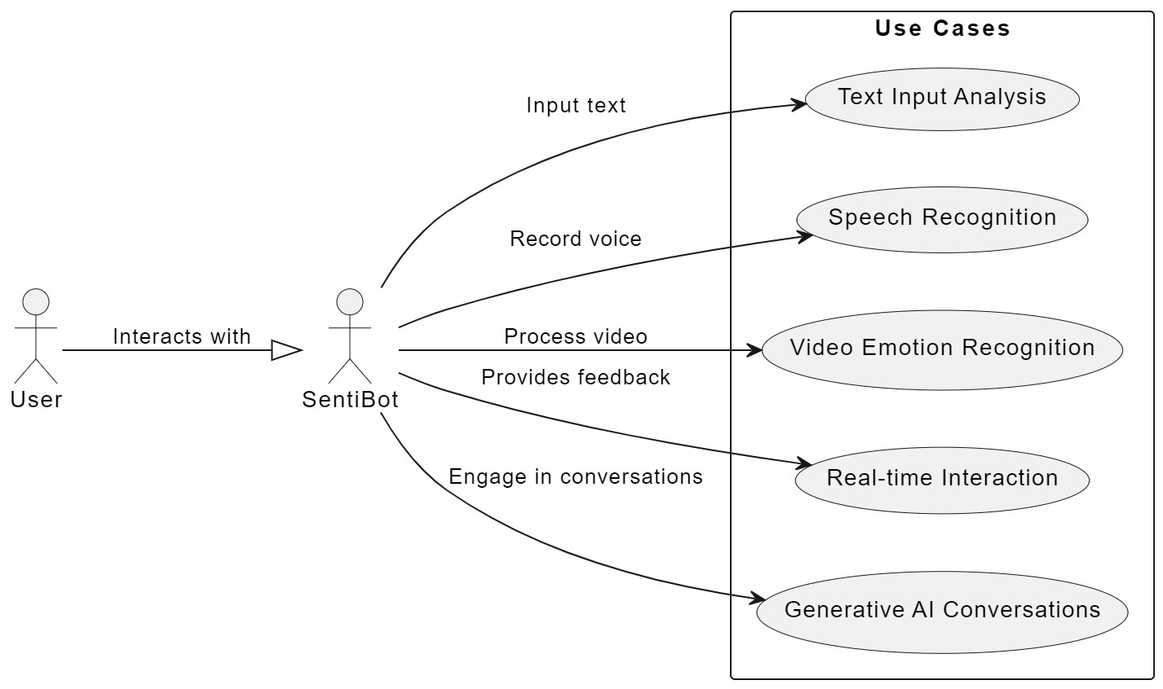

The provided use case diagram illustrates the various interactions between actors and the sentiment analysis web application. The primary actors include the User and the System itself. The User interacts with the system through actions such as providing voice/video input, receiving sentiment analysis results. The System, on the other hand, encompasses functionalities such as converting speech to text, analysing facial expressions, performing sentiment analysis, and generating responses based on the user's expressed sentiments.

***Activity Diagram-***

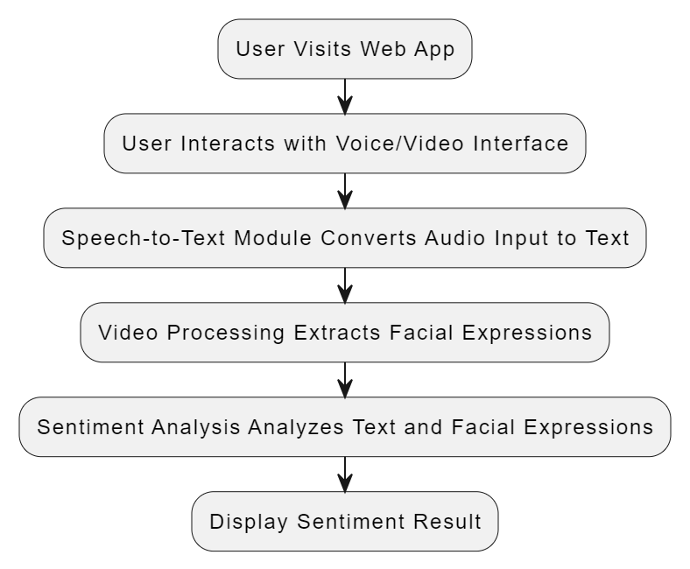

The given activity diagram outlines the sequential flow of actions within the sentiment analysis web app. It begins with the user interacting with the voice/video interface, followed by the modules responsible for converting audio input to text and extracting facial expressions from video data. This diagram helps visualize the step-by-step process involved in analyzing user sentiments through the web app.

**Ethical and legal/privacy/terms and conditions * *Actual Text of such issues that will be put before the user to agree. Please write minimum 2000 and maximum 10000 Characters. This Question Carries Three Mark.***

Data Privacy is focused on Users' spoken words and video that must be treated with utmost confidentiality. We will assure users that their data will not be shared with third parties without their explicit consent.

User Consent clearly states that by using the application, users consent to their spoken words and video data being processed for sentiment analysis purposes.

Intellectual Property Rights clarify that users retain ownership of their spoken words and video content. However, by using the web app, they grant the platform the right to analyze and process this data for improving the service.

Prohibited Activities specify activities that are prohibited on the platform, such as sharing offensive or inappropriate content, violating others' privacy, or attempting to manipulate sentiment analysis results.

Limitations of Liability explains the limitations of liability for the platform regarding the accuracy of sentiment analysis results and any potential consequences of relying on this analysis.

Dispute Resolution outlines the procedures for resolving disputes between users and the platform, including arbitration or mediation processes.

Termination of Service reserves the right to terminate or suspend user’s account in case of violations of the terms and conditions or misuse of the platform.

Changes to Terms and Conditions notify users that the terms and conditions may be updated from time to time, and their continued use of the platform constitutes acceptance of these changes.

Contact Information for users to reach out for questions, concerns, or requests regarding their data or the platform's services.

Compliance with Laws ensures that the application complies with relevant laws and regulations regarding data privacy, consumer rights, and online services.

Transparency in Algorithmic Processes, we can provide users with information about how their data is being processed, including details about the training data, model architecture, and any biases that may exist.

By addressing these points in ethical and legal considerations, privacy policies, and terms and conditions, we can build trust with our users while also protecting the interests of our sentiment analysis web application.

**Feasibility study/ Business Context of the idea/ Monetization/ Opportunity Analysis * Please write Minimum 1000 Maximum 2000 Characters. This Question Carries two Mark.**

Feasibility Study:

Advanced speech-to-text and facial recognition technologies are available and are being integrated into the webapp.

The cost of developing and maintaining the web app is reasonable compared to potential revenue streams.

The webapp's operation aligns with user expectations for intuitive interfaces and real-time feedback.

Business Context:

Individuals seeking to express their sentiments verbally or visually, as well as businesses wanting to understand customer feedback.

While sentiment analysis tools exist, our webapp's focus on voice and video interactions offers a unique selling point.

Monetization:

Users can pay a monthly or annual fee to access advanced sentiment analysis features, additional insights, or premium support.

We can make partner with advertising networks to display targeted ads within our web app. By analysing user sentiments and behaviour, we can serve relevant ads that are more likely to resonate with our audience, thus increasing ad revenue.

Opportunity Analysis:

The increasing needs of chat bot can be used, this website can be used in terms of medical too to interact with the people who want to talk, have no one to communicate, are facing from mental issue like depression or loneliness, etc.

**Project cost estimation \*** *Please write the estimated cost [think about COCOMO model from last semester and other possible costs] that your project required in 3 years or completion of the project. A cost estimate is a summation of all the costs involved in successfully finishing a project, from inception to completion (project duration). Common types of expenses include Labor, Materials, Equipment, Services, Software, Hardware. Please write Minimum of 500 Maximum 1000 Characters. This Question Carries one Mark.*

Labor Costs: Salaries for a team of 2 developers and 1 data scientist for three years: ₹500,000

Project manager salary for three years: ₹150,000

Total labour costs: ₹650,000

Materials: Hardware components (servers, computers): ₹50,000

Software licenses (AI frameworks, development tools): ₹30,000

Total materials costs: ₹80,000

Services: Cloud computing resources (AWS, Azure): ₹50,000

Consulting services: ₹20,000

Total services costs: ₹70,000

Equipment: Specialized equipment (microphones, cameras): ₹10,000

Total equipment costs: ₹10,000

Training and Education: Workshops and training programs: ₹15,000

Total training costs: ₹15,000

Miscellaneous: Travel and communication expenses: ₹5,000

Utilities and contingencies: ₹10,000

Total miscellaneous costs: ₹15,000

Total Estimated Cost for Three Years: ₹900,000

**Partial Implementation/ Draft Code** * *Give Link of Github Repository URL where your partial code is available to see. Minimum 25% of the code should be declare in this answer. This Question Carries Three Marks.*

Link : https://github.com/Aditya-0009/SentiBot.git

**Week wise Updates/ Diary/ Proportional achievement of stated outcomes/ Graded Functionality, etc. You may use a tool (e.g., Hugo) to keep your meeting notes handy. * ( At least 300 characters in each week) Week 1 Week 2 Week 3 Week 4 Week 5 Week 6 Week 7 Week 8. This Question Carries Two Marks.**

In week 1, we first tried to get a project that satisfy the time limit like 3 to 4 months, that includes the topics we are currently studying and working on. So, we decided to make a website including speech to text, video to text, detecting facial expression and telling the moods of the users.

In week 2, we divided our project into parts allocating each part one each member, in which one member is given the part to code for speech to text and video to text system, one to code for real time emotion detection system and one to make it user friendly at last by using generative ai.

In week 3, we started to find the dataset for our project. For emotion detection system dataset has been taken from Kaggle FER-2013, which includes the training set of 28,709 examples and the public test set of 3,589 examples. The speech to text ......

In week 4, we were finding the code and learning the languages use in it like python and libraries for deep learning approaches like TensorFlow, Py Torch, and Keras for building and training models for sentiment analysis, speech recognition, emotion detection, and video analysis tasks. And, html, CSS, JavaScript for website making and integrating.

In week 5, we started to code using our knowledge, learnings, or taking references from git hub, chat gpt for errors. During this we conducted group meetings to discuss the updates of our project, for presentation, for filling milestone forms.

In week 6, till this code for speech to text was completed. And so thought to include little more like video to text. So, the work on that also was started. And the code for emotion detection was going on.

In week 7, the code for speech, video to text was completed. And code for emotion detection has also been completed but as it includes the images and the dataset is too large, so it's not accurate, either the dataset has to be reduced or needs the access of supercomputer.

In week 8, till this we faced many difficulties in our code but still currently working on it. We have implemented one part to the website and for our website used front end, and another part has to be implemented in the future. Our work became slower because of our mid-term examination but will make progress soon.

**Week Wise Plan for the remaining time to complete the Project * ( At least 300 Character in each week) Week 9 Week 10 Week 11 Week 12. This Question Carries Two Mark.**

Week 9, we are having the problem in the code of emotion detection as it requires the access of supercomputers so we will try to solve it. Or can reduce the dataset and check the efficiency.

Week 10, the frontend for our website is basic as got the feedback from our senior. So will try to improve the frontend by using more designs or features. And will try to start the code for generative AI to make it user interactive.

Week 11, we will try to find users for our website, make it user interactive, then update according to their feedback, can find people or ask the institute for fundings in our website. We can ask the people to rate our product and collect the feedback, if performing well, we can go on more global scale getting licence from international organization to promote our product. The premium version can be purchased that will be a personalized assistant knowing all the details about the user based on the user previous data.

Week 12, we can do the same as week 11 and make funding out of it.

**One impressive post on LinkedIn regarding your Project [submit the URL of your post]. *\* ( At least 300 Characters and one Image and 5 hashtags). This Question Carries one Mark.***

**Link :** https://www.linkedin.com/posts/aditya-raj-88657a24b_sentibot-ai-virtualfriend-activity-7167976117423816704-OYZk?utm_source=share&utm_medium=member_desktop

**Is your idea/Project/Product is applicable for patent? *If Yes then, Why do you think it can be submitted for patent? How do you plan to proceed for Patent? Even if your answer is no, explain why do you think it cannot be submitted for patent? (Minimum 300 characters maximum 1000, this question carry 1 Mark)***

While SentiBot incorporates innovative features and utilizes cutting-edge technologies, it may not be suitable for a patent due to several reasons. Firstly, the concept of emotion recognition and virtual companionship, while novel, may not meet the criteria of patentability as it involves a combination of existing technologies rather than a completely new invention. Additionally, the underlying algorithms and methodologies used in SentiBot may not be considered sufficiently unique or non-obvious to warrant patent protection. Moreover, the field of artificial intelligence and emotion recognition is rapidly evolving, with numerous similar solutions already available in the market, making it challenging to establish the novelty and inventiveness required for a successful patent application. Therefore, pursuing a patent may not be feasible or necessary given the current state of the technology.

**Feedbacks**

**Senior students and others Discuss your Project with at least three students of your senior batches of Bennett University and ask them how they rate your project from 1 to 10 scale. They should be ready to confirm if they are called on their mobile number. (At least 200 Character feedback from each of them, Positive or negative feedback will not determine the marks but the quality of the feedback will) This question carry 2 Mark.**

**Feedback 1 - Name, Enrolment#, email and mobile# of student along with the description of the feedback.**

**Devank Garg, 8448046072,**

**Feedback-The Senti Bot project is truly fascinating— It's like having a virtual therapist right at your fingertips! One thing I really love about Senti Bot is how it combines different ways of communication. You can talk to it, and it'll understand what you're saying. And then there's the ethical side of things. They'll need to be really careful about how they use all that data they're collecting. People's privacy is super important, so they'll need to make sure they're following all the rules and keeping everything safe and secure.**

**rating 1 - 8**

**Feedback 2 - Name, Enrolment#, email and mobile# of student along with the description of the feedback.**

**Priyanshu Pandey, E21CSEU0074,** [**e21cseu0074@bennett.edu.in**](mailto:e21cseu0074@bennett.edu.in)**, 7080201729,**

**feedback: Saw the project demo on the LinkedIn post, it was impressive on how the algorithm was able to converse with the subject. If the algorithm is backed with a good frontend, it would surely result in improving overall user experience.**

**Rating 2 – 7**

**Feedback 3- Name, Enrolment#, email and mobile# of student along with the description of the feedback.**

**Pulkit Mathur, E21CSEU0102,** [**e21cseu0102@bennett.edu.in**](mailto:e21cseu0102@bennett.edu.in)**, 7995466120**

**Great beginner project for getting into NLP domain. The option of both speech to text and direct text input is a plus. The website is also well designed with an easy-to-use interface and appropriate gifs along with moods to enhance the user experience.**

**Rating 3 – 8**

**Discuss your project with two people outside the Bennett University (apart from your family members and preferably from industry) and and ask them how they rate your project and its progress from 1 to 10 scale. They should be ready to confirm if they are called on their mobile number. (1+1 mark for each of two).( At least 200 Characters feedback from each of them, Positive or negative feedback will not determine the marks but the quality of the feedback will)**

**Feedback 1 - Name, who they are, email and mobile# of those along with the description of the feedback.**

**Ayush , Software Engineer at JP Morgan ,** [ayushkumarmishra.1998@gmail.com](mailto:ayushkumarmishra.1998@gmail.com) , 88717 22647 ,   
He told that the overall project idea is brilliant just need to be more focussed on front end part and also train the model time by time to make the SentiBot more effective and useful.

**Rating 1 – 8**

**Feedback 2 - Name, who they are, email and mobile# of those along with the description of the feedback.**

**Rashmi , Senior Developer at John Deere ,** [rashmi.mishra2095@gmail.com](mailto:rashmi.mishra2095@gmail.com) , 8319655241   
**Her feedback goes like this, “I'm quite impressed with your SentiBot project! The integration of advanced technologies like natural language processing, sentiment analysis, and facial recognition into a single platform shows a high level of technical sophistication. Overall , Great Work !”.**

**Rating 2 –**9