Employee Attrition Prediction System
A Machine Learning Based Approach for Predicting Employee Attrition

Internship Project Report
Submitted in partial fulfillment of the requirements for the successful completion of the
Summer Internship Programme – 2026

Submitted By
Aditya Verma
B.Tech – Computer Science and Engineering (Artificial Intelligence & Machine Learning)

Internship Organization
IIHMF
Motilal Nehru National Institute of Technology (MNNIT), Prayagraj

Academic Session
2026–2027

July 2026

Acknowledgement
I would like to express my sincere gratitude to IIHMF, Motilal Nehru National Institute of Technology (MNNIT), Prayagraj for providing me with the opportunity to undertake this Machine Learning internship. This internship gave me practical exposure to data analysis, machine learning model development, and real-world problem solving.
I would also like to thank all the mentors and faculty members associated with the internship for their valuable guidance, continuous support, and constructive feedback throughout the project. Their suggestions and encouragement helped me understand the practical aspects of implementing machine learning techniques.
I am grateful to my college, United College of Engineering & Research (UCER), Prayagraj, for providing a strong academic foundation that enabled me to apply theoretical concepts in this project.
Finally, I would like to thank everyone who directly or indirectly contributed to the successful completion of this project.

Date: July 2026
Place: Prayagraj, Uttar Pradesh

Aditya Verma

Abstract

Employee attrition is one of the major challenges faced by organizations as it affects productivity, increases recruitment costs, and impacts overall business performance. Predicting employee attrition in advance enables organizations to identify employees who may be at risk of leaving and implement appropriate retention strategies. This project focuses on developing a Machine Learning-based Employee Attrition Prediction System using the IBM HR Analytics Employee Attrition dataset.
The project involved various stages, including data collection, exploratory data analysis, data preprocessing, feature engineering, model training, evaluation, and deployment. During preprocessing, irrelevant features such as EmployeeCount, EmployeeNumber, and StandardHours were removed. Categorical variables were converted into numerical form using One-Hot Encoding, and numerical features were standardized using StandardScaler to improve model performance.
Three machine learning algorithms—Logistic Regression, Random Forest, and XGBoost—were trained and evaluated using performance metrics such as Accuracy, Precision, Recall, F1-Score, and ROC-AUC. After comparing the performance of all three models, Logistic Regression was selected as the final model because it achieved the best overall performance on the given dataset, with an accuracy of approximately 86.05%.
To make the model accessible and user-friendly, it was integrated into an interactive web application developed using Streamlit. The application allows users to enter employee-related information and instantly predicts whether an employee is likely to stay in the organization or leave, along with the prediction confidence.
Overall, this project demonstrates the practical application of machine learning techniques in solving a real-world Human Resource problem. It also provides a foundation for future improvements, such as handling class imbalance, hyperparameter tuning, and integrating explainable AI techniques to further enhance prediction performance and interpretability.

Table of Contents

Acknowledgement ........................................ 2

Abstract ...................................................... 3

Chapter 1 Introduction ............................... 5

Chapter 2 Problem Statement ..................... 6

Chapter 3 Objectives .................................. 7

Chapter 4 Dataset Description ................. 8

Chapter 5 Exploratory Data Analysis ........ 10

Chapter 6 Data Preprocessing ................. 13

Chapter 7 Machine Learning Models ...... 16

Chapter 8 Model Evaluation ...................... 20

Chapter 9 Streamlit Application ............... 24

Chapter 10 Results ................................... 27

Chapter 11 Future Scope ......................... 29

Chapter 12 Conclusion ............................. 30

References .............................................. 31

Chapter 1
Introduction

Employee attrition refers to the situation in which employees leave an organization voluntarily or involuntarily. A high attrition rate can negatively affect an organization's productivity, increase recruitment and training costs, and disrupt ongoing projects. For this reason, many organizations focus on identifying employees who may be at risk of leaving so that appropriate retention strategies can be implemented.
With the growth of data-driven decision making, Machine Learning has become an effective approach for solving business problems such as employee attrition prediction. By analyzing historical employee data, machine learning models can identify patterns and relationships that help predict whether an employee is likely to stay with the organization or leave.
The main objective of this project is to develop a Machine Learning model capable of predicting employee attrition using employee-related information. The project utilizes the IBM HR Analytics Employee Attrition Dataset, which contains demographic information, job-related details, salary information, work environment characteristics, and career progression data for employees.
The project follows a complete machine learning workflow, beginning with data preprocessing and exploratory data analysis, followed by feature engineering, model training, performance evaluation, and deployment. Multiple machine learning algorithms, including Logistic Regression, Random Forest, and XGBoost, were trained and compared using different evaluation metrics. Based on the comparative analysis, Logistic Regression was selected as the final model due to its better overall performance on the dataset.
To improve the usability of the trained model, an interactive web application was developed using Streamlit. The application enables users to enter employee details through a simple interface and instantly obtain an attrition prediction along with the corresponding confidence score.
This project demonstrates how machine learning can be applied to a real-world Human Resource problem and highlights the importance of data-driven approaches in supporting organizational decision-making.
CHAPTER 2
Problem Statement

Employee attrition is a significant challenge for organizations because losing experienced employees increases recruitment costs, training expenses, and affects overall productivity. Employees may leave an organization due to various reasons such as job dissatisfaction, poor work-life balance, low salary, limited career growth opportunities, or unfavorable work environments. Identifying employees who are likely to leave before they resign is a difficult task when relying solely on manual analysis.
Traditional methods of predicting employee attrition often depend on human judgment and historical observations, which may not always be accurate. As organizations generate large amounts of employee-related data, machine learning provides an opportunity to analyze this information and identify patterns that may indicate future employee attrition.
The problem addressed in this project is to develop a machine learning model capable of predicting whether an employee is likely to stay with the organization or leave based on various employee-related attributes. The prediction system is intended to assist Human Resource (HR) departments by providing data-driven insights that can support employee retention strategies and improve organizational decision-making.

CHAPTER 3
Objectives

The primary objective of this project is to develop a machine learning-based prediction system that can identify employees who are likely to leave an organization using historical employee data.
The specific objectives of the project are:
- To study and understand the IBM HR Analytics Employee Attrition dataset.
- To perform exploratory data analysis for identifying important trends and patterns.
- To preprocess the dataset by handling unnecessary features, encoding categorical variables, and scaling numerical features.
- To train multiple machine learning models including Logistic Regression, Random Forest, and XGBoost.
- To evaluate and compare the performance of different models using appropriate evaluation metrics.
- To select the best-performing model for deployment.
- To develop an interactive web application using Streamlit for real-time employee attrition prediction.
- To provide a user-friendly interface that enables users to obtain predictions based on employee information.

CHAPTER 4
Dataset Description

The dataset used in this project is the IBM HR Analytics Employee Attrition Dataset, which is widely used for studying employee attrition and developing machine learning models for prediction. The dataset contains historical information about employees, including their personal details, job-related information, salary, work environment, and career progression. Using this information, the model predicts whether an employee is likely to leave the organization.
The dataset consists of 1470 employee records and 35 attributes, where each record represents an individual employee. The target variable in the dataset is Attrition, which contains two categories:
- Yes – Employee is likely to leave the organization.
- No – Employee is likely to stay in the organization.
The dataset includes both numerical and categorical features. Numerical features include attributes such as Age, Monthly Income, Daily Rate, Hourly Rate, Distance From Home, and Total Working Years. Categorical features include Department, Job Role, Business Travel, Education Field, Marital Status, and OverTime.
Before training the machine learning models, the dataset was carefully analyzed to understand its structure and identify features that would contribute to the prediction process.

Important Features Used
Some of the important features available in the dataset are:
- Age
- Department
- Job Role
- Business Travel
- Distance From Home
- Education
- Education Field
- Gender
- Marital Status
- Monthly Income
- Daily Rate
- Hourly Rate
- Monthly Rate
- Job Level
- Job Satisfaction
- Environment Satisfaction
- Relationship Satisfaction
- Work Life Balance
- OverTime
- Total Working Years
- Years At Company
- Years In Current Role
- Years Since Last Promotion
- Years With Current Manager
- Training Times Last Year
- Number of Companies Worked

Dataset Characteristics
Attribute | Description
Dataset Name | IBM HR Analytics Employee Attrition Dataset
Total Records | 1470
Total Features | 35
Target Variable | Attrition
Target Classes | Yes, No
Numerical Features | 26
Categorical Features | 9

Initial Observations
During the initial analysis of the dataset, it was observed that there were no missing values, which simplified the preprocessing stage. However, the dataset was imbalanced, with a significantly larger number of employees staying in the organization than leaving. This imbalance was considered while evaluating the performance of different machine learning models.
Additionally, some features such as EmployeeCount, EmployeeNumber, and StandardHours were found to have little or no predictive value. These features were removed before model training to improve the efficiency of the learning process.

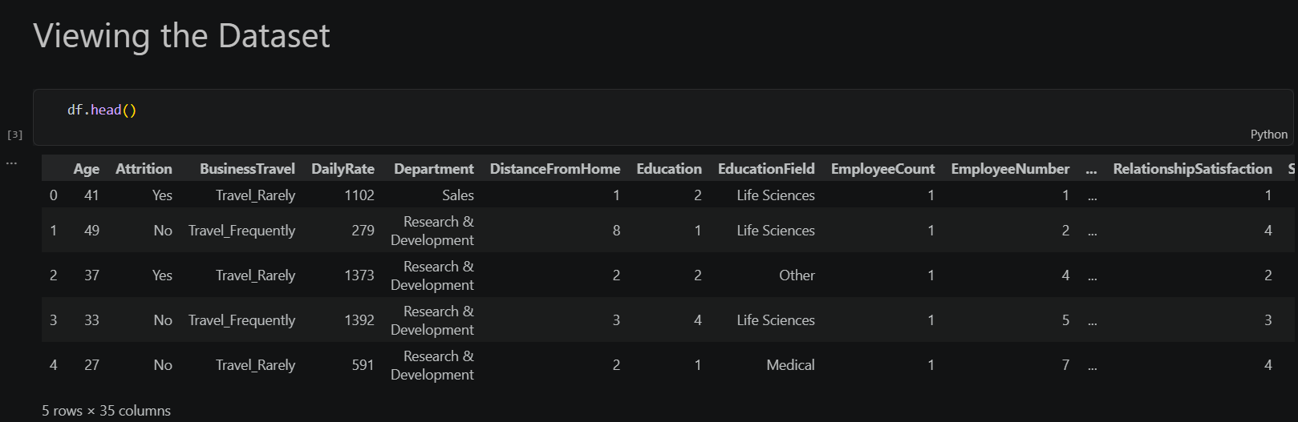
Figure 4.1: IBM HR Analytics Employee Attrition Dataset

CHAPTER 5
Exploratory Data Analysis (EDA)

Exploratory Data Analysis (EDA) is an important step in any machine learning project as it helps in understanding the dataset before model training. It provides insights into the distribution of data, relationships among different features, and potential issues such as class imbalance, outliers, or unnecessary attributes.
In this project, several visualizations and statistical analyses were performed to understand the characteristics of the IBM HR Analytics Employee Attrition dataset. The analysis helped identify important patterns that influenced the employee attrition prediction process.

Class Distribution
The first step in the analysis was to examine the distribution of the target variable Attrition.
The dataset contains two classes:
- No (Employee Stays): 1233 employees
- Yes (Employee Leaves): 237 employees
This shows that the dataset is imbalanced, with a significantly larger number of employees staying than leaving the organization. This imbalance was considered while interpreting the performance of the machine learning models.
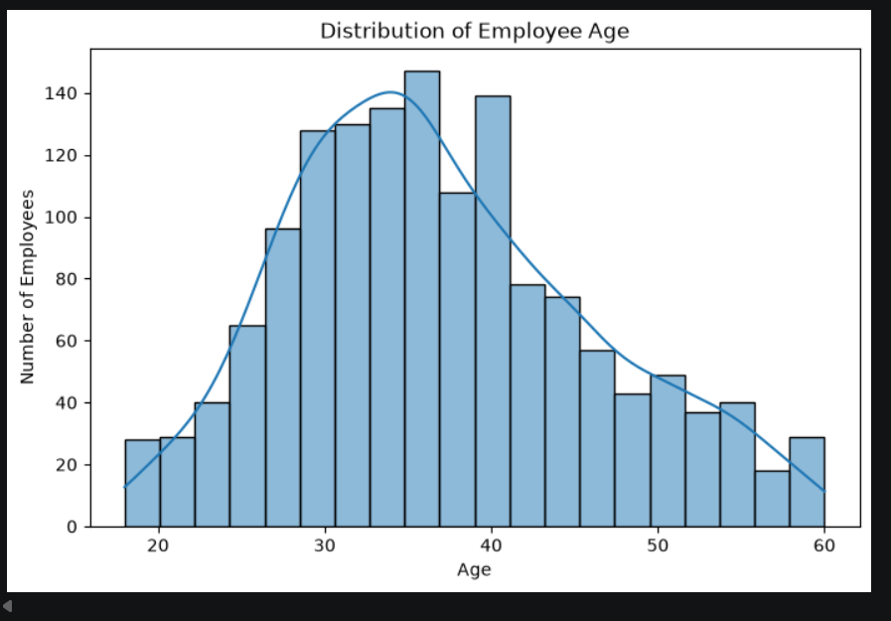
Figure 5.1: Distribution of Employee Attrition
Correlation Analysis
A correlation heatmap was generated to understand the relationships among numerical features in the dataset.
The heatmap showed that most features have weak to moderate correlations with each other, indicating that multicollinearity is limited. Some career-related features such as Years At Company, Years In Current Role, and Years With Current Manager exhibited positive relationships, which is expected because these variables are naturally related.
Understanding feature correlations helped in interpreting the dataset before training the machine learning models.

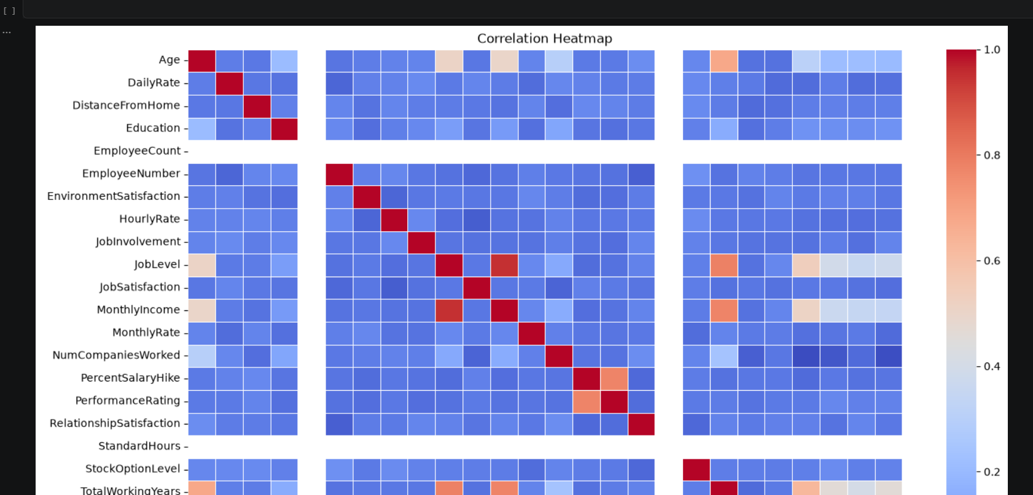Figure 5.2: Correlation Heatmap of Numerical Features

Important Observations
The exploratory analysis provided several useful insights:
- The dataset is imbalanced, with considerably more employees staying than leaving.
- Salary-related features such as Monthly Income showed noticeable variation across employees.
- Career-related variables, including Total Working Years and Years At Company, demonstrated meaningful relationships with employee attrition.
- Employee satisfaction factors such as Environment Satisfaction, Job Satisfaction, and Work Life Balance appeared to influence attrition.
- Features like OverTime and Distance From Home also showed potential importance in predicting employee attrition.
These observations helped in selecting appropriate preprocessing techniques and machine learning algorithms for the project.

Summary
Exploratory Data Analysis provided a better understanding of the dataset and highlighted the characteristics that influence employee attrition. The insights obtained during this stage guided the preprocessing process and supported the development of an effective prediction model.

CHAPTER 6
Data Preprocessing

Data preprocessing is one of the most important stages of a machine learning project because the quality of the input data directly affects the performance of the trained model. Before training the models, the dataset was carefully preprocessed to remove unnecessary information, convert categorical variables into numerical format, and prepare the data for machine learning algorithms.
The preprocessing steps performed in this project are described below.

Removal of Unnecessary Features
During the initial analysis, it was observed that some features did not contribute to the prediction of employee attrition.
The following columns were removed:
- EmployeeCount – Contains the same value for every employee.
- EmployeeNumber – A unique identifier with no predictive value.
- StandardHours – Contains a constant value for all employees.
Removing these columns reduced unnecessary information and improved the efficiency of the machine learning models.

Handling Categorical Variables
The dataset contained several categorical features such as:
- Department
- Job Role
- Business Travel
- Education Field
- Gender
- Marital Status
- OverTime
Since machine learning algorithms require numerical input, these categorical variables were converted into numerical form using One-Hot Encoding.
The following command was used:
pd.get_dummies(drop_first=True)
Using drop_first=True reduced redundant columns and helped avoid multicollinearity.

Feature Scaling
The dataset contains numerical features with different ranges.
For example:
- Age ranges between approximately 18 and 60
- Monthly Income ranges from 1000 to over 19000
If these features are used directly, variables with larger values can dominate the learning process.
To overcome this issue, StandardScaler was applied to standardize all numerical features.
StandardScaler transforms the data using the formula:
$$z=\frac{x-μ}{σ}$$
where:
- x = Original value
- μ = Mean
- σ = Standard deviation
After scaling, all numerical features have approximately:
- Mean = 0
- Standard Deviation = 1
This preprocessing step improves the performance of algorithms such as Logistic Regression.

Train-Test Split
After preprocessing, the dataset was divided into training and testing sets using an 80:20 ratio.
- Training Data: Used for learning the model.
- Testing Data: Used to evaluate the model on unseen data.
The dataset sizes obtained were:
Dataset | Shape
Training Features | (1176, 44)
Testing Features | (294, 44)
Training Target | (1176,)
Testing Target | (294,)

Final Prepared Dataset
After preprocessing:
- Unnecessary columns were removed.
- Categorical variables were encoded.
- Numerical features were standardized.
- Training and testing datasets were prepared.
The processed dataset was then used for training multiple machine learning algorithms.
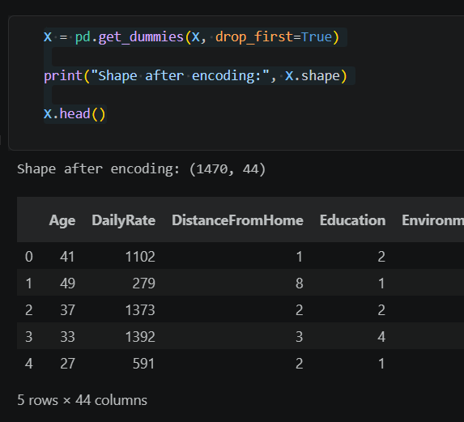
Figure 6.1: Data Preprocessing Pipeline
Summary
The preprocessing stage transformed the raw employee data into a structured numerical format suitable for machine learning. These preprocessing steps ensured that the models received clean and standardized input, resulting in more reliable predictions.

CHAPTER 7
Machine Learning Models

The primary objective of this project is to predict whether an employee is likely to leave an organization based on historical employee data. Since this is a binary classification problem, multiple supervised machine learning algorithms were trained and evaluated to identify the model that provides the best prediction performance.
The following machine learning algorithms were implemented in this project:
- Logistic Regression
- Random Forest Classifier
- XGBoost Classifier
Each model was trained using the same preprocessed dataset and evaluated using common classification metrics such as Accuracy, Precision, Recall, F1-Score, and ROC-AUC.

Logistic Regression
Logistic Regression is a supervised machine learning algorithm used for binary classification problems. It predicts the probability that an observation belongs to a particular class using the logistic (sigmoid) function.
In this project, Logistic Regression was trained using the standardized employee data after preprocessing. The model demonstrated the best overall performance among all the evaluated models and was therefore selected as the final model for deployment.
Advantages
- Simple and computationally efficient.
- Easy to interpret.
- Performs well on binary classification problems.
- Produces probability scores for predictions.

Random Forest
Random Forest is an ensemble learning algorithm that combines multiple decision trees to improve prediction accuracy and reduce overfitting. Each tree is trained on a randomly selected subset of the data, and the final prediction is determined through majority voting.
Random Forest was implemented to compare its performance with Logistic Regression. Although it achieved good overall accuracy, its ability to correctly identify employees who were likely to leave was relatively low.
Advantages
- Reduces overfitting compared to a single decision tree.
- Handles nonlinear relationships effectively.
- Works well with both numerical and categorical features.

XGBoost
XGBoost (Extreme Gradient Boosting) is an advanced ensemble learning algorithm based on gradient boosting. It builds decision trees sequentially, where each new tree attempts to correct the errors made by previous trees.
XGBoost is widely used in machine learning competitions due to its high predictive performance and efficient implementation. In this project, XGBoost produced competitive results but did not outperform Logistic Regression on the IBM HR Analytics dataset.
Advantages
- High predictive performance.
- Handles complex relationships effectively.
- Includes regularization to reduce overfitting.
- Efficient implementation for large datasets.

Model Training Process
The training process followed the same workflow for all three models:
- Load the preprocessed dataset.
- Split the data into training and testing sets.
- Train each machine learning model using the training dataset.
- Generate predictions on the testing dataset.
- Evaluate the models using Accuracy, Precision, Recall, F1-Score, and ROC-AUC.
- Compare the performance of all models.
- Select the best-performing model for deployment.
This systematic approach ensured a fair comparison between all the implemented machine learning algorithms.

Model Selection
After evaluating all three models, Logistic Regression was selected as the final model for deployment.
The decision was based on the following observations:
- It achieved the highest overall performance on the testing dataset.
- It provided the best balance between Accuracy, Precision, Recall, and ROC-AUC.
- It produced stable and reliable predictions for employee attrition.
- It is computationally efficient and easy to deploy in a real-time web application.
Therefore, Logistic Regression was integrated into the Streamlit application for real-time employee attrition prediction.
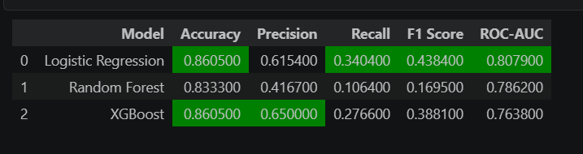Figure 7.1: Training of Machine Learning Models

Summary
Three different machine learning algorithms were implemented and evaluated for employee attrition prediction. A comparative analysis showed that Logistic Regression provided the best overall performance for the given dataset. Consequently, it was selected as the final model for deployment in the developed Streamlit application.

CHAPTER 8
Model Evaluation and Performance Comparison

After training the three machine learning models, their performance was evaluated using several classification metrics. Since employee attrition prediction is a binary classification problem and the dataset is imbalanced, relying solely on accuracy is not sufficient. Therefore, additional evaluation metrics such as Precision, Recall, F1-Score, and ROC-AUC were also considered.
The performance of each model was evaluated using the testing dataset to ensure that the results reflected the model's ability to generalize to unseen data.

Evaluation Metrics
The following metrics were used for evaluating the models:
- Accuracy: Measures the overall percentage of correctly classified instances.
- Precision: Indicates how many employees predicted to leave actually leave the organization.
- Recall: Measures how many employees who actually leave are correctly identified by the model.
- F1-Score: Represents the balance between Precision and Recall.
- ROC-AUC: Evaluates the model's ability to distinguish between the two classes.
These metrics provide a comprehensive assessment of model performance.

Performance Comparison
Model | Accuracy | Precision | Recall | F1-Score | ROC-AUC
Logistic Regression | 86.05% | 61.54% | 34.04% | 43.84% | 80.79%
Random Forest | 83.33% | 41.67% | 10.64% | 16.95% | 78.62%
XGBoost | 86.05% | 65.00% | 27.66% | 38.81% | 76.38%

Performance Analysis
The comparison shows that all three machine learning models achieved relatively high accuracy. However, because the dataset is imbalanced, accuracy alone does not provide a complete picture of model performance.
Although XGBoost achieved an accuracy similar to Logistic Regression, its Recall and ROC-AUC values were lower. Random Forest produced the lowest Recall, indicating that it failed to identify many employees who were actually likely to leave the organization.
Among all three models, Logistic Regression provided the best overall balance across the evaluation metrics. It achieved the highest ROC-AUC score and better overall Recall than the other ensemble models, making it more suitable for employee attrition prediction on this dataset.
Based on this comparative analysis, Logistic Regression was selected as the final model for deployment.

Confusion Matrix Analysis
A confusion matrix was generated for each model to analyze the classification performance in greater detail.
The confusion matrices helped identify:
- Correctly predicted employees who stayed.
- Correctly predicted employees who left.
- False predictions made by each model.
- Areas where the models struggled because of dataset imbalance.
The analysis showed that Logistic Regression correctly classified a larger number of employees while maintaining a better balance between false positives and false negatives compared to the other models.

Classification Report
The classification reports further confirmed the performance differences among the three models. Logistic Regression demonstrated a better balance between Precision and Recall, while Random Forest and XGBoost showed lower Recall for the minority class due to the imbalance in the dataset.
These results indicate that Logistic Regression is more reliable for identifying employees who are likely to leave the organization.

Final Model Selection
Considering all evaluation metrics, Logistic Regression was selected as the final prediction model because:
- It achieved the highest overall performance.
- It maintained a better balance between Precision and Recall.
- It produced the highest ROC-AUC score among the evaluated models.
- It is computationally efficient and suitable for real-time deployment.
- It integrated effectively with the Streamlit web application developed in this project.

Summary
A detailed comparison of three machine learning algorithms demonstrated that Logistic Regression provided the most balanced and reliable performance for predicting employee attrition. Consequently, it was selected as the final model and deployed in the Employee Attrition Prediction System.

CHAPTER 9
Streamlit Application

After selecting Logistic Regression as the final prediction model, an interactive web application was developed using Streamlit to provide a simple and user-friendly interface for employee attrition prediction.
The application allows users to enter employee information through different input fields and instantly predicts whether an employee is likely to stay in the organization or leave. Along with the prediction, the application also displays the confidence score generated by the trained machine learning model.
The trained Logistic Regression model, feature names, and StandardScaler were saved using the Joblib library and loaded into the application during execution. The user inputs are preprocessed in the same way as the training data before being passed to the model for prediction.
The application is divided into multiple sections to improve usability and organize employee information efficiently.
Personal Information
This section collects basic employee details such as Age, Gender, Marital Status, Education, Education Field, and Distance From Home.
Job Information
This section includes Department, Job Role, Business Travel, Job Level, OverTime, and Number of Companies Worked.
Salary and Performance
Salary-related attributes such as Monthly Income, Daily Rate, Hourly Rate, Monthly Rate, Performance Rating, Salary Hike, and Stock Option Level are collected in this section.
Career Information
Career-related details include Total Working Years, Years At Company, Years In Current Role, Years Since Last Promotion, Years With Current Manager, and Training Times Last Year.
Work Environment
The final section collects employee satisfaction information including Environment Satisfaction, Job Satisfaction, Relationship Satisfaction, Work Life Balance, and Job Involvement.
The application provides an easy-to-use interface that allows users to perform real-time employee attrition prediction without interacting directly with the machine learning code.
Features of the Application
- User-friendly graphical interface
- Real-time prediction
- Prediction confidence score
- Input validation
- Professional layout using Streamlit
- Fast and lightweight deployment
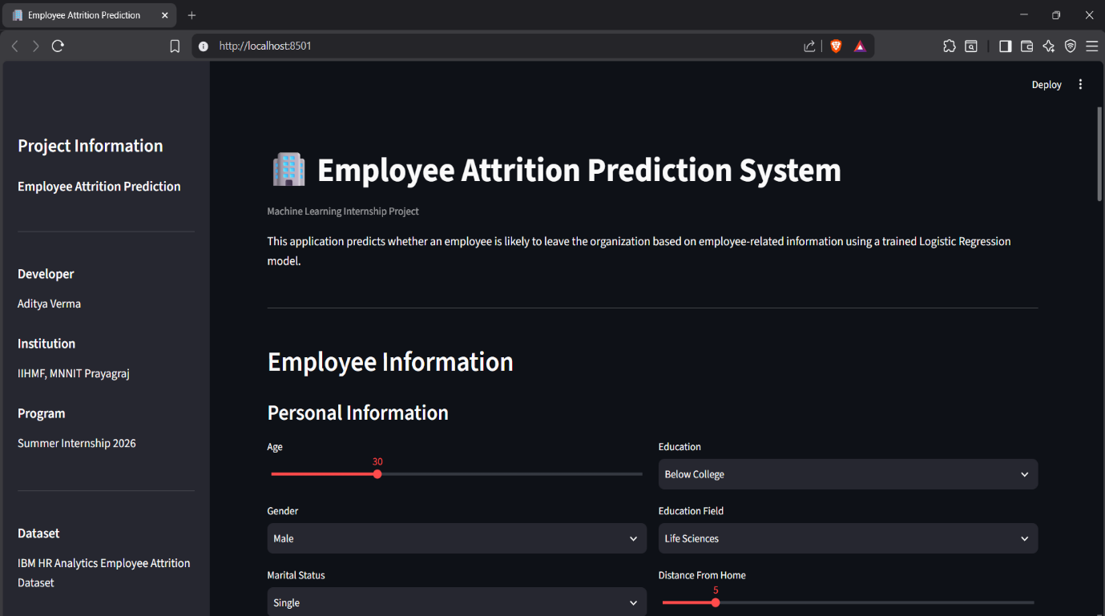
Figure 9.1: Employee Attrition Prediction System Home Page

CHAPTER 10
Results
The developed Employee Attrition Prediction System successfully predicts whether an employee is likely to stay in the organization or leave based on employee-related information.
Three machine learning algorithms were implemented and evaluated during this project. Among them, Logistic Regression demonstrated the best overall performance and was selected for deployment.
The Streamlit application successfully integrates the trained model and provides predictions in real time. The application accepts employee information as input, preprocesses the data using the same pipeline applied during training, and generates predictions along with the corresponding confidence score.
The project demonstrates that machine learning can effectively support Human Resource departments by providing data-driven insights for employee retention.
Key Outcomes
- Successfully trained and evaluated three machine learning models.
- Achieved approximately 86.05% accuracy using Logistic Regression.
- Developed an interactive Streamlit web application.
- Enabled real-time employee attrition prediction.
- Created a complete end-to-end machine learning solution from data preprocessing to deployment.

CHAPTER 11
Future Scope
Although the developed prediction system performs well on the IBM HR Analytics dataset, there are several opportunities for further improvement.
Future enhancements include:
- Handling class imbalance using SMOTE or class weighting techniques.
- Performing hyperparameter tuning to improve model performance.
- Applying cross-validation for more reliable evaluation.
- Integrating SHAP or LIME for explainable AI and prediction interpretation.
- Deploying the application on cloud platforms such as Streamlit Community Cloud or AWS.
- Connecting the application to a database for managing employee records.
- Extending the system to support larger and real-world organizational datasets.
These improvements can increase both the predictive performance and practical usability of the system.

CHAPTER 12
Conclusion
This project successfully developed a Machine Learning-based Employee Attrition Prediction System using the IBM HR Analytics Employee Attrition Dataset.
The project involved the complete machine learning pipeline, including data preprocessing, exploratory data analysis, feature engineering, model training, evaluation, and deployment. Three machine learning algorithms—Logistic Regression, Random Forest, and XGBoost—were implemented and compared using multiple evaluation metrics.
Based on the comparative analysis, Logistic Regression was selected as the final prediction model because it achieved the best overall performance on the dataset.
To improve usability, the trained model was deployed using Streamlit, allowing users to perform real-time employee attrition prediction through an interactive web interface.
Overall, this project demonstrates how machine learning techniques can be applied to solve a practical Human Resource problem and support data-driven decision-making.

References

Use these references:
- IBM HR Analytics Employee Attrition Dataset (Kaggle)
- Pedregosa et al., Scikit-learn: Machine Learning in Python, Journal of Machine Learning Research, 2011.
- Streamlit Documentation
- XGBoost Documentation
- Python Software Foundation. Python Documentation.

